Decoding Urban Mobility: Insights from bike rental data
Kaoyan, Chen
Joao Filipe, Rodrigues Dos Santos Natal Marques
Lizet Viviana, Silva Lizarro
Oussama, Touhami
2025-11-11
Abstract
This is the abstract of the report. It should be a short summary of the project, the data, the analysis and the results. It should be concise and to the point. It should not be longer than 250 words.

Introduction

Background and Motivation
We selected this topic aiming to explore the demand patterns of bike rental, because it directly contributes to smarter and greener city planning. By examining when and why people use shared bikes, the bike sharing company or the city can better allocate resources, reduce congestion, and promote eco-friendly mobility. From a data science perspective, the dataset presents diverse variable types and analytical challenges, making it a rich context for applying rigorous data cleaning and exploratory methods.
This scientific project is good for humanity because bike sharing delivers evidence-based societal benefits: it saves 46,000 tons of CO₂ and 200 tons of air pollutants annually, helps prevent 1,000 chronic diseases, and leads to €40 million in healthcare savings each year. By shifting urban mobility away from personal cars, bike sharing eases congestion,saving 760,000 hours of productivity, which is valued at €30 million, and supports 6,000 full-time equivalent jobs all across Europe. Every euro invested in bike sharing offers at least 10% annual return in measurable positive externalities, making these systems highly efficient and sustainable. Learning about this topic is especially interesting because it combines environmental impact, public health improvement, and economic growth, all backed by recent large-scale data analyses.

Project Objectives
Our goals are:
- Explore and visualize usage patterns on an hourly basis (e.g. by hour of day, day of week, season).
- Build a regression model to estimate the number of bike rentals (cnt) given features such as weather, season, hour, and other contextual variables.
- Interpret model results to understand which factors most strongly influence demand.
- Provide insight and recommendations for operational decisions (for example, anticipating peak hours, adjusting supply).
- More specifically, we aim to combine exploratory data analysis (EDA), explore the correlationship between dependent variables and independent variables, and create a model to predict the future trend, eventually to provide some managerial advice for the company.

Research Questions
- What are the typical hourly demand patterns (e.g. morning peaks, evening peaks)?
- How do weather conditions (temperature, humidity, wind, etc.) correlate with bike rentals?
- Which features (hour, season, holiday, working day, weather) are the strongest predictors of demand?
- How can insights from the model help in resource planning (e.g. pre-positioning bikes, increasing revenue, maintenance schedules)?

Data

Sources
Dataset: UCI Machine Learning Repository - Bike Sharing Dataset

Description
The dataset used in this project is the “Bike Sharing Dataset (hour.csv)”, obtained from https://archive.ics.uci.edu/dataset/275/bike+sharing+dataset. hour.csv contains hourly records of bike rentals along with various temporal and environmental factors that influence demand. The data captures user activity across different weather conditions, seasons, and times of the day, providing a rich foundation for both exploratory analysis and predictive modeling.

Loading Data
Data loaded: (17379, 17)
 | instant | dteday | season | yr | mnth | hr | holiday | weekday | workingday | weathersit | temp | atemp | hum | windspeed | casual | registered | cnt
0 | 1 | 2011-01-01 | 1 | 0 | 1 | 0 | 0 | 6 | 0 | 1 | 0.24 | 0.2879 | 0.81 | 0.0 | 3 | 13 | 16
1 | 2 | 2011-01-01 | 1 | 0 | 1 | 1 | 0 | 6 | 0 | 1 | 0.22 | 0.2727 | 0.80 | 0.0 | 8 | 32 | 40
2 | 3 | 2011-01-01 | 1 | 0 | 1 | 2 | 0 | 6 | 0 | 1 | 0.22 | 0.2727 | 0.80 | 0.0 | 5 | 27 | 32
3 | 4 | 2011-01-01 | 1 | 0 | 1 | 3 | 0 | 6 | 0 | 1 | 0.24 | 0.2879 | 0.75 | 0.0 | 3 | 10 | 13
4 | 5 | 2011-01-01 | 1 | 0 | 1 | 4 | 0 | 6 | 0 | 1 | 0.24 | 0.2879 | 0.75 | 0.0 | 0 | 1 | 1

Wrangling

General Transformations
Document the data preprocessing steps taken, including cleaning, transformation, and any merging of datasets.
Confirm that the type is datetime64[ns] and that years 2011–2012 appear as expected:
Converted data type: datetime64[ns]
Unique years in dataset: [2011 2012]
 | dteday | hr | hour_group | weekday_name | season_name | is_weekend | weather_name
0 | 2011-01-01 | 0 | Night | Saturday | Winter | 1 | Clear
1 | 2011-01-01 | 1 | Night | Saturday | Winter | 1 | Clear
2 | 2011-01-01 | 2 | Night | Saturday | Winter | 1 | Clear
3 | 2011-01-01 | 3 | Night | Saturday | Winter | 1 | Clear
4 | 2011-01-01 | 4 | Night | Saturday | Winter | 1 | Clear
5 | 2011-01-01 | 5 | Night | Saturday | Winter | 1 | Mist
6 | 2011-01-01 | 6 | Morning | Saturday | Winter | 1 | Clear
7 | 2011-01-01 | 7 | Morning | Saturday | Winter | 1 | Clear
8 | 2011-01-01 | 8 | Morning | Saturday | Winter | 1 | Clear
9 | 2011-01-01 | 9 | Morning | Saturday | Winter | 1 | Clear
10 | 2011-01-01 | 10 | Morning | Saturday | Winter | 1 | Clear
11 | 2011-01-01 | 11 | Morning | Saturday | Winter | 1 | Clear
12 | 2011-01-01 | 12 | Afternoon | Saturday | Winter | 1 | Clear
13 | 2011-01-01 | 13 | Afternoon | Saturday | Winter | 1 | Mist
14 | 2011-01-01 | 14 | Afternoon | Saturday | Winter | 1 | Mist
15 | 2011-01-01 | 15 | Afternoon | Saturday | Winter | 1 | Mist
16 | 2011-01-01 | 16 | Afternoon | Saturday | Winter | 1 | Mist
17 | 2011-01-01 | 17 | Afternoon | Saturday | Winter | 1 | Mist
18 | 2011-01-01 | 18 | Evening | Saturday | Winter | 1 | Light Snow/Rain
19 | 2011-01-01 | 19 | Evening | Saturday | Winter | 1 | Light Snow/Rain
20 | 2011-01-01 | 20 | Evening | Saturday | Winter | 1 | Mist
21 | 2011-01-01 | 21 | Evening | Saturday | Winter | 1 | Mist
22 | 2011-01-01 | 22 | Evening | Saturday | Winter | 1 | Mist
23 | 2011-01-01 | 23 | Evening | Saturday | Winter | 1 | Mist

Encoding complete. New shape: (17379, 32)
 | instant | dteday | season | yr | mnth | hr | holiday | weekday | weathersit | temp | ... | hour_group_Evening | weather_name_Mist | weather_name_Light Snow/Rain | weather_name_Heavy Rain/Thunderstorm | weekday_name_Monday | weekday_name_Saturday | weekday_name_Sunday | weekday_name_Thursday | weekday_name_Tuesday | weekday_name_Wednesday
0 | 1 | 2011-01-01 | 1 | 0 | 1 | 0 | 0 | 6 | 1 | 0.24 | ... | False | False | False | False | False | True | False | False | False | False
1 | 2 | 2011-01-01 | 1 | 0 | 1 | 1 | 0 | 6 | 1 | 0.22 | ... | False | False | False | False | False | True | False | False | False | False
2 | 3 | 2011-01-01 | 1 | 0 | 1 | 2 | 0 | 6 | 1 | 0.22 | ... | False | False | False | False | False | True | False | False | False | False
3 | 4 | 2011-01-01 | 1 | 0 | 1 | 3 | 0 | 6 | 1 | 0.24 | ... | False | False | False | False | False | True | False | False | False | False
4 | 5 | 2011-01-01 | 1 | 0 | 1 | 4 | 0 | 6 | 1 | 0.24 | ... | False | False | False | False | False | True | False | False | False | False

 | count | mean | std | min | 25% | 50% | 75% | max
temp | 17379.0 | 0.496987 | 0.192556 | 0.02 | 0.3400 | 0.5000 | 0.6600 | 1.0000
atemp | 17379.0 | 0.475775 | 0.171850 | 0.00 | 0.3333 | 0.4848 | 0.6212 | 1.0000
hum | 17379.0 | 0.627229 | 0.192930 | 0.00 | 0.4800 | 0.6300 | 0.7800 | 1.0000
windspeed | 17379.0 | 0.190098 | 0.122340 | 0.00 | 0.1045 | 0.1940 | 0.2537 | 0.8507

Summary of Transformations
Step | Transformation | Justification | Validation
1 | Load dataset | Import raw data into DataFrame | Confirmed shape (≈17k × 16)
2 | Convert dteday to datetime | Enable time-based analysis | Checked data type & years
3 | Add derived features (season_name, is_weekend, hour_group, wheather_name, ‘weekday_name’) | Improve interpretability & grouping | Reviewed sample outputs
4 | Encode categorical variables | Prepare data for ML | Verified shape and columns
5 | Check feature ranges | Validate normalized columns | Confirmed 0–1 range consistency

All transformations are justified, documented, reproducible, and validated, ensuring a transparent preprocessing workflow.
(17379, 21)
 | instant | dteday | season | yr | mnth | hr | holiday | weekday | weathersit | temp | ... | hum | windspeed | casual | registered | cnt | season_name | weekday_name | is_weekend | hour_group | weather_name
0 | 1 | 2011-01-01 | 1 | 0 | 1 | 0 | 0 | 6 | 1 | 0.24 | ... | 0.81 | 0.0 | 3 | 13 | 16 | Winter | Saturday | 1 | Night | Clear
1 | 2 | 2011-01-01 | 1 | 0 | 1 | 1 | 0 | 6 | 1 | 0.22 | ... | 0.80 | 0.0 | 8 | 32 | 40 | Winter | Saturday | 1 | Night | Clear
2 | 3 | 2011-01-01 | 1 | 0 | 1 | 2 | 0 | 6 | 1 | 0.22 | ... | 0.80 | 0.0 | 5 | 27 | 32 | Winter | Saturday | 1 | Night | Clear
3 | 4 | 2011-01-01 | 1 | 0 | 1 | 3 | 0 | 6 | 1 | 0.24 | ... | 0.75 | 0.0 | 3 | 10 | 13 | Winter | Saturday | 1 | Night | Clear
4 | 5 | 2011-01-01 | 1 | 0 | 1 | 4 | 0 | 6 | 1 | 0.24 | ... | 0.75 | 0.0 | 0 | 1 | 1 | Winter | Saturday | 1 | Night | Clear
<class 'pandas.core.frame.DataFrame'>
RangeIndex: 17379 entries, 0 to 17378
Data columns (total 21 columns):
# Column Non-Null Count Dtype
--- ------ -------------- -----
0 instant 17379 non-null int64
1 dteday 17379 non-null datetime64[ns]
2 season 17379 non-null int64
3 yr 17379 non-null int64
4 mnth 17379 non-null int64
5 hr 17379 non-null int64
6 holiday 17379 non-null int64
7 weekday 17379 non-null int64
8 weathersit 17379 non-null int64
9 temp 17379 non-null float64
10 atemp 17379 non-null float64
11 hum 17379 non-null float64
12 windspeed 17379 non-null float64
13 casual 17379 non-null int64
14 registered 17379 non-null int64
15 cnt 17379 non-null int64
16 season_name 17379 non-null category
17 weekday_name 17379 non-null category
18 is_weekend 17379 non-null object
19 hour_group 17379 non-null category
20 weather_name 17379 non-null category
dtypes: category(4), datetime64[ns](1), float64(4), int64(11), object(1)
memory usage: 2.3+ MB
 | instant | dteday | season | yr | mnth | hr | holiday | weekday | weathersit | temp | atemp | hum | windspeed | casual | registered | cnt
count | 17379.0000 | 17379 | 17379.000000 | 17379.000000 | 17379.000000 | 17379.000000 | 17379.000000 | 17379.000000 | 17379.000000 | 17379.000000 | 17379.000000 | 17379.000000 | 17379.000000 | 17379.000000 | 17379.000000 | 17379.000000
mean | 8690.0000 | 2012-01-02 04:08:34.552045568 | 2.501640 | 0.502561 | 6.537775 | 11.546752 | 0.028770 | 3.003683 | 1.425283 | 0.496987 | 0.475775 | 0.627229 | 0.190098 | 35.676218 | 153.786869 | 189.463088
min | 1.0000 | 2011-01-01 00:00:00 | 1.000000 | 0.000000 | 1.000000 | 0.000000 | 0.000000 | 0.000000 | 1.000000 | 0.020000 | 0.000000 | 0.000000 | 0.000000 | 0.000000 | 0.000000 | 1.000000
25% | 4345.5000 | 2011-07-04 00:00:00 | 2.000000 | 0.000000 | 4.000000 | 6.000000 | 0.000000 | 1.000000 | 1.000000 | 0.340000 | 0.333300 | 0.480000 | 0.104500 | 4.000000 | 34.000000 | 40.000000
50% | 8690.0000 | 2012-01-02 00:00:00 | 3.000000 | 1.000000 | 7.000000 | 12.000000 | 0.000000 | 3.000000 | 1.000000 | 0.500000 | 0.484800 | 0.630000 | 0.194000 | 17.000000 | 115.000000 | 142.000000
75% | 13034.5000 | 2012-07-02 00:00:00 | 3.000000 | 1.000000 | 10.000000 | 18.000000 | 0.000000 | 5.000000 | 2.000000 | 0.660000 | 0.621200 | 0.780000 | 0.253700 | 48.000000 | 220.000000 | 281.000000
max | 17379.0000 | 2012-12-31 00:00:00 | 4.000000 | 1.000000 | 12.000000 | 23.000000 | 1.000000 | 6.000000 | 4.000000 | 1.000000 | 1.000000 | 1.000000 | 0.850700 | 367.000000 | 886.000000 | 977.000000
std | 5017.0295 | NaN | 1.106918 | 0.500008 | 3.438776 | 6.914405 | 0.167165 | 2.005771 | 0.639357 | 0.192556 | 0.171850 | 0.192930 | 0.122340 | 49.305030 | 151.357286 | 181.387599

Spotting Mistakes and Missing Data
Missing values per column:
instant 0
dteday 0
season 0
yr 0
mnth 0
hr 0
holiday 0
weekday 0
weathersit 0
temp 0
atemp 0
hum 0
windspeed 0
casual 0
registered 0
cnt 0
season_name 0
weekday_name 0
is_weekend 0
hour_group 0
weather_name 0
dtype: int64
Remaining missing values: 0
=== BASIC DOMAIN CHECKS ===
hr in [0,23]: True
mnth in [1,12]: True
weekday in [0..6] (0=Sunday..6=Saturday): True
yr in {0,1}: True
=== CONSISTENCY WITH dteday ===
mnth matches dteday.month: True
weekday(Sun0) matches dteday: True
yr (0->2011, 1->2012) matches dteday.year: True
=== HOURLY COVERAGE PER DAY (expect 0..23 each day) ===
Days with missing hours: 76
dteday
2011-01-02 [5]
2011-01-03 [2, 3]
2011-01-04 [3]
2011-01-05 [3]
2011-01-06 [3]
Name: hr, dtype: object
Days with extra/out-of-range hours: 0
No mismatches found between encoded variables and dteday (for checked columns).
hr
24 655
23 62
22 6
18 2
16 1
12 1
8 1
17 1
1 1
11 1
Name: count, dtype: int64
------------------------------------------
2011-01-02 00:00:00: missing hours [5]
2011-01-03 00:00:00: missing hours [2, 3]
2011-01-04 00:00:00: missing hours [3]
2011-01-05 00:00:00: missing hours [3]
2011-01-06 00:00:00: missing hours [3]
2011-01-07 00:00:00: missing hours [3]
2011-01-11 00:00:00: missing hours [3, 4]
2011-01-12 00:00:00: missing hours [3, 4]
2011-01-14 00:00:00: missing hours [4]
2011-01-18 00:00:00: missing hours [0, 1, 2, 3, 4, 5, 6, 7, 8, 9, 10, 11]
2011-01-19 00:00:00: missing hours [3]
2011-01-22 00:00:00: missing hours [5]
2011-01-23 00:00:00: missing hours [4]
2011-01-24 00:00:00: missing hours [2]
2011-01-25 00:00:00: missing hours [3]
2011-01-26 00:00:00: missing hours [3, 4, 18, 19, 20, 21, 22, 23]
2011-01-27 00:00:00: missing hours [0, 1, 2, 3, 4, 5, 6, 7, 8, 9, 10, 11, 12, 13, 14, 15]
2011-01-28 00:00:00: missing hours [4]
2011-01-29 00:00:00: missing hours [5]
2011-01-30 00:00:00: missing hours [6]
2011-02-01 00:00:00: missing hours [4]
2011-02-03 00:00:00: missing hours [4]
2011-02-04 00:00:00: missing hours [4]
2011-02-09 00:00:00: missing hours [4]
2011-02-10 00:00:00: missing hours [3]
2011-02-11 00:00:00: missing hours [3, 4]
2011-02-13 00:00:00: missing hours [5]
2011-02-15 00:00:00: missing hours [3]
2011-02-16 00:00:00: missing hours [2]
2011-02-20 00:00:00: missing hours [5]
2011-02-22 00:00:00: missing hours [0, 1, 2, 3, 4, 5]
2011-02-23 00:00:00: missing hours [4]
2011-02-24 00:00:00: missing hours [4]
2011-02-25 00:00:00: missing hours [4]
2011-02-27 00:00:00: missing hours [5]
2011-02-28 00:00:00: missing hours [2, 4]
2011-03-06 00:00:00: missing hours [5]
2011-03-07 00:00:00: missing hours [2]
2011-03-10 00:00:00: missing hours [3, 4]
2011-03-11 00:00:00: missing hours [4]
2011-03-13 00:00:00: missing hours [2]
2011-03-14 00:00:00: missing hours [4]
2011-03-15 00:00:00: missing hours [3]
2011-03-16 00:00:00: missing hours [2]
2011-03-18 00:00:00: missing hours [4]
2011-03-21 00:00:00: missing hours [4]
2011-03-23 00:00:00: missing hours [4]
2011-03-27 00:00:00: missing hours [5]
2011-03-28 00:00:00: missing hours [4]
2011-04-11 00:00:00: missing hours [3]
2011-08-27 00:00:00: missing hours [18, 19, 20, 21, 22, 23]
2011-08-28 00:00:00: missing hours [0, 1, 2, 3, 4, 5, 6]
2011-09-06 00:00:00: missing hours [1]
2011-09-08 00:00:00: missing hours [2]
2011-09-12 00:00:00: missing hours [3]
2011-10-19 00:00:00: missing hours [3]
2011-11-28 00:00:00: missing hours [2]
2011-12-25 00:00:00: missing hours [4]
2011-12-26 00:00:00: missing hours [3]
2011-12-28 00:00:00: missing hours [4]
2012-01-02 00:00:00: missing hours [3]
2012-01-10 00:00:00: missing hours [3]
2012-01-17 00:00:00: missing hours [3]
2012-02-06 00:00:00: missing hours [3]
2012-02-20 00:00:00: missing hours [4]
2012-02-21 00:00:00: missing hours [3]
2012-02-29 00:00:00: missing hours [4]
2012-03-11 00:00:00: missing hours [2]
2012-04-02 00:00:00: missing hours [3]
2012-04-11 00:00:00: missing hours [4]
2012-10-29 00:00:00: missing hours [1, 2, 3, 4, 5, 6, 7, 8, 9, 10, 11, 12, 13, 14, 15, 16, 17, 18, 19, 20, 21, 22, 23]
2012-10-30 00:00:00: missing hours [0, 1, 2, 3, 4, 5, 6, 7, 8, 9, 10, 11, 12]
2012-11-08 00:00:00: missing hours [3]
2012-11-29 00:00:00: missing hours [3]
2012-12-24 00:00:00: missing hours [4]
2012-12-25 00:00:00: missing hours [3]

Listing Anomalies and Outliers
This section identifies and analyzes anomalies or outliers in the Bike Sharing Dataset.
Outlier detection is important for understanding data quality, variability, and rare events.
Outliers are evaluated using: - Visual inspection: box plots and scatter plots
- Statistical methods: Interquartile Range (IQR) and Z-scores
- Domain knowledge: contextual judgment (e.g., rental counts, weather extremes)
Not all outliers are removed — some represent real and meaningful phenomena (e.g., holidays, weather shocks).
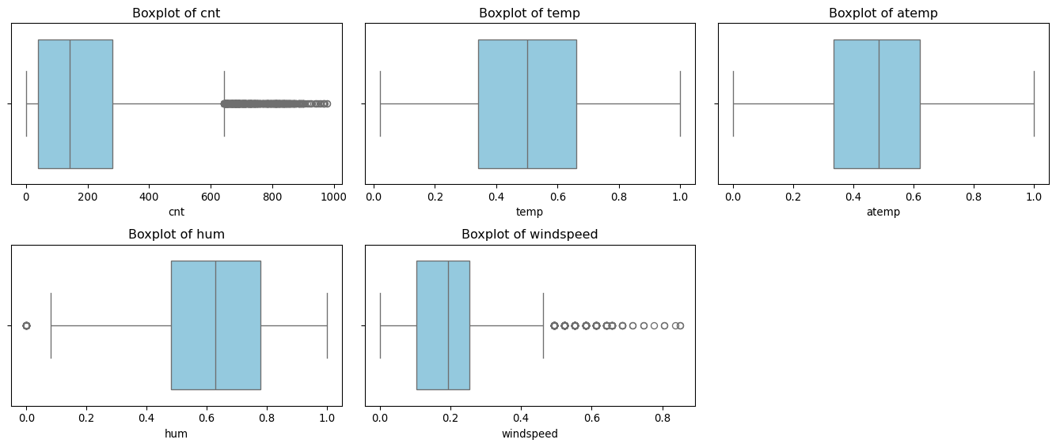
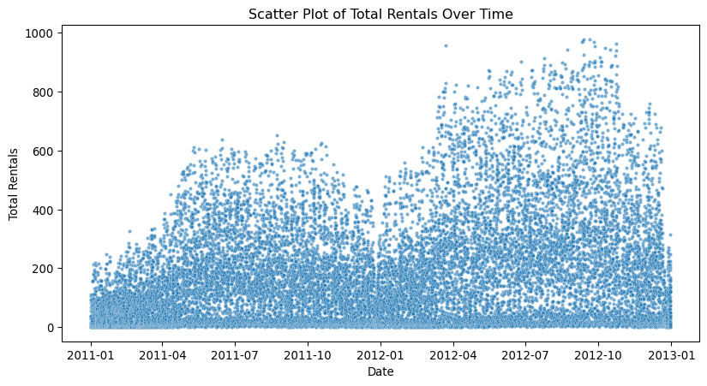

Interpretation of Boxplots
The boxplots above visualize the spread and potential outliers among the main numerical variables (cnt, temp, atemp, hum, and windspeed).
- cnt (total rentals): Shows several high-end points beyond the upper whisker, representing peak demand hours (e.g., weekday commutes or summer weekends). These are not data errors but valid extreme values.
- temp and atemp: Both are normalized between 0 and 1, showing smooth distributions without extreme deviations, suggesting well-scaled temperature measures.
- hum (humidity): Displays a slightly skewed distribution with upper-end values near 1.0, likely corresponding to humid or rainy days — realistic rather than anomalous.
- windspeed: Contains a few high-end outliers, possibly due to sensor measurement spikes or rare weather conditions. These are few and not impactful on model training.
Conclusion:
Most outliers represent real phenomena rather than data-entry errors.
Thus, they will be retained for further exploratory analysis and modeling to preserve the natural variability of bike rental behavior.
##Data Cleaning Checklist Before moving to analysis, verify:
✓ All column names are clean and consistent ✓ Data types are appropriate for each variable ✓ Missing values are identified and handled ✓ Outliers are investigated and documented ✓ Categorical variables are properly encoded ✓ Duplicate rows are checked and removed if needed ✓ Date/time variables are in proper format ✓ Cleaned data is saved for reproducibility
Column names:
['instant', 'dteday', 'season', 'yr', 'mnth', 'hr', 'holiday', 'weekday', 'weathersit', 'temp', 'atemp', 'hum', 'windspeed', 'casual', 'registered', 'cnt', 'season_name', 'weekday_name', 'is_weekend', 'hour_group', 'weather_name']
Data types:
instant int64
dteday datetime64[ns]
season int64
yr int64
mnth int64
hr int64
holiday int64
weekday int64
weathersit int64
temp float64
atemp float64
hum float64
windspeed float64
casual int64
registered int64
cnt int64
season_name category
weekday_name category
is_weekend object
hour_group category
weather_name category
dtype: object
Missing values per column:
instant 0
dteday 0
season 0
yr 0
mnth 0
hr 0
holiday 0
weekday 0
weathersit 0
temp 0
atemp 0
hum 0
windspeed 0
casual 0
registered 0
cnt 0
season_name 0
weekday_name 0
is_weekend 0
hour_group 0
weather_name 0
dtype: int64
Outlier summary:
Extreme rental values already checked — valid high peaks retained.
Categorical and datetime validation:
Categorical columns: ['is_weekend']
Datetime column: datetime64[ns]
Duplicate rows count: 0
Date range: 2011-01-01 00:00:00 → 2012-12-31 00:00:00
Cleaned dataset saved successfully as 'bike_cleaned.csv'

EDA – Exploring Variable Distributions
We start by examining how individual variables behave (their variation).
Following Module 3, we visualize both numeric and categorical variables
to understand their shape, spread, and possible outliers.

Hourly Demand Patterns Analysis
Understanding the behavior of the bike-sharing system requires an analytical approach that considers multiple temporal scales. The analysis begins with the Distribution of Bike Rentals to provide an overview of overall usage levels, and then moves to the examination of hourly, daily, and monthly patterns, which reveal variations across the day, week, and year. A subsequent analysis of seasonal trends helps clarify how climatic conditions shape demand throughout the year. Finally, contrasting hourly patterns with seasonal effects allows us to understand how short-term and long-term temporal dynamics interact to define overall system usage.

Distribution of Bike Rentals
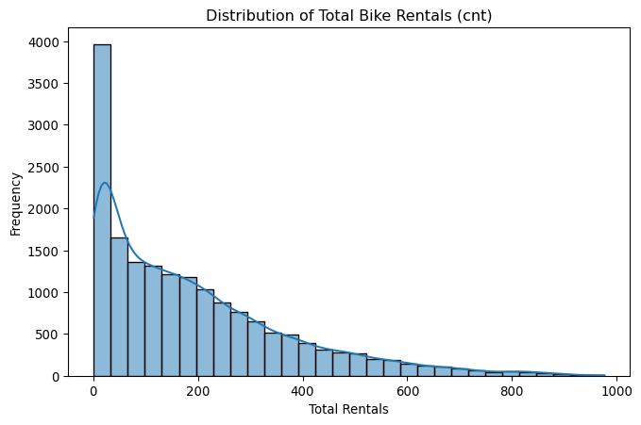
The distribution of total bike rentals (cnt) is strongly right-skewed, indicating that most hours record relatively low to moderate rental activity, while a smaller number of hours reach very high demand peaks.
This pattern suggests that: - Bike usage is not constant throughout the day, there are specific times (likely rush hours or weekends) with much higher demand. - The skewness reflects contextual influences such as weather, working days, and time of day. - The majority of hours have fewer than 200 rentals, showing that high-demand situations (over 600 rentals) are exceptional events rather than the norm.
Overall, the shape highlights high variability and strong temporal effects in bike-sharing demand, justifying deeper exploration by time and external conditions.

Variations across the day, week, and year
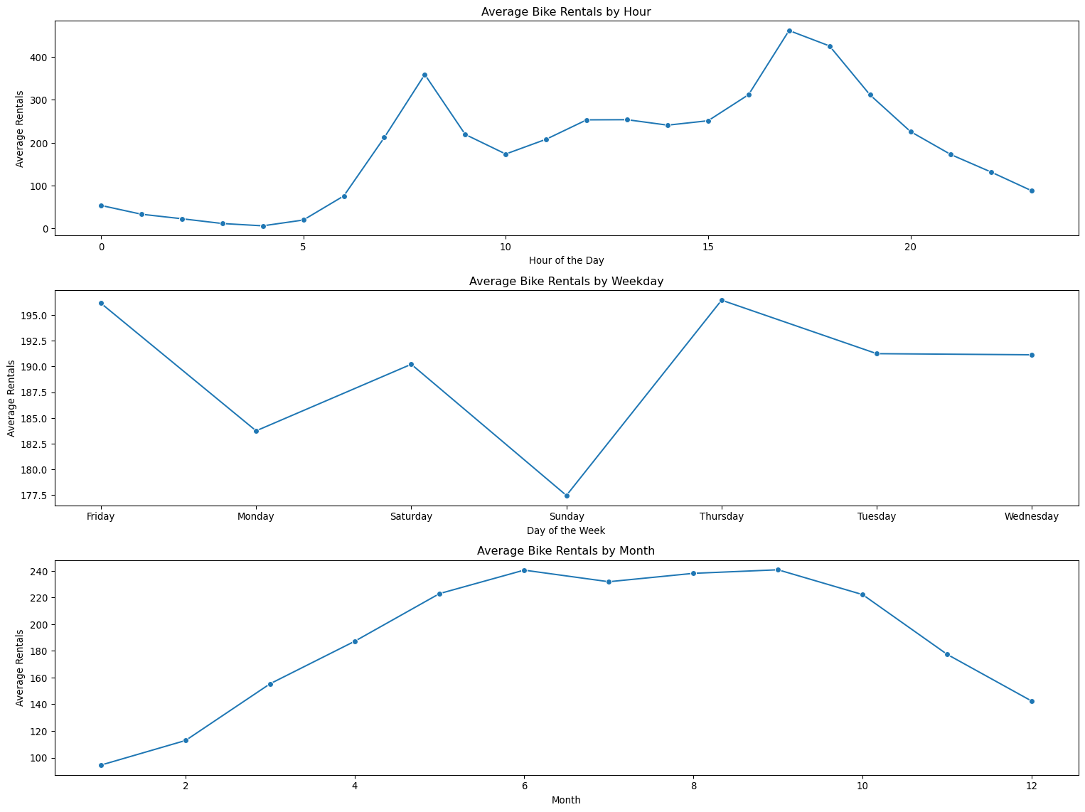
Average Bike Rentals by Hour
The hourly pattern shows two clear peaks one around 8 AM and another near 5–6 PM, corresponding to morning and evening commuting hours. Early morning periods (before 6 AM) and late night hours (after 9 PM) show minimal activity. This behavior indicates that bike sharing is primarily used for work- or school-related travel, reflecting strong time-of-day dependencies and typical urban mobility rhythms.
Average Bike Rentals by Weekday
Bike rentals tend to be higher on working days, particularly Thursday and Friday, and lower on weekends, especially Sunday. This pattern reinforces the idea that the system is mainly used for functional weekday transportation rather than leisure. The moderate usage observed on Saturdays suggests some recreational use but at a lower intensity compared to weekdays.
Average Bike Rentals by Month
The monthly pattern reveals a strong seasonal trend: rentals increase steadily from February to June, remain high throughout summer (June–September), and decline sharply from October onward. This reflects the influence of weather and temperature, as warmer conditions generally promote cycling, while colder months reduce usage due to less favorable conditions.
Taken together, these visualizations show that bike rental demand follows clear temporal cycles: daily (commuting peaks), weekly (higher weekday usage), and seasonal (weather-driven fluctuations). Understanding these patterns is essential for resource allocation, system planning, and operational decision-making.

Demand by Season

Boxplot of total rentals by season
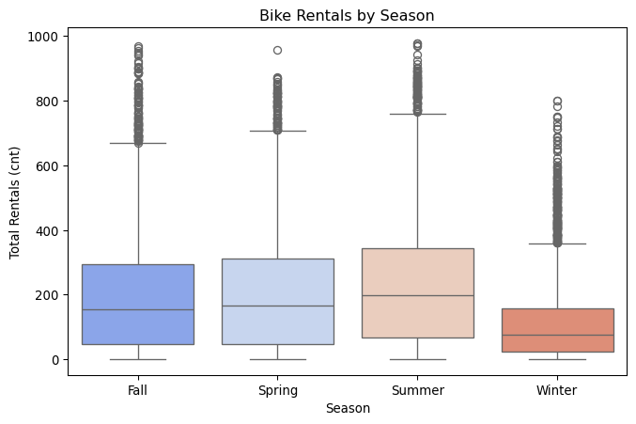
The boxplot shows clear seasonal differences in total bike rentals: - Summer and Fall display the highest median rental counts and the widest interquartile ranges (IQR), indicating both higher and more variable demand. - Spring presents moderate rental levels, reflecting the gradual return of favorable weather. - Winter has by far the lowest median and spread, showing that cold and harsh conditions drastically reduce bike usage.
The presence of outliers in all seasons — especially in Summer and Fall — suggests that certain peak days or hours experience unusually high demand, possibly due to special events or ideal weather.
Bike rental activity is strongly seasonal, peaking in warm months and dropping sharply in winter, confirming that weather and temperature are major drivers of usage in bike-sharing systems.

Interaction Between Hourly Patterns and Seasonal Variations
Building on these findings, it becomes essential to examine not only how demand varies across seasons but also how seasonal conditions influence the hourly distribution of rentals. By comparing hourly patterns within each season, we can determine whether the characteristic morning and evening peaks observed throughout the year intensify, weaken, or shift depending on weather conditions. This combined perspective allows for a deeper understanding of how short-term (hourly) and long-term (seasonal) temporal dynamics interact, and it sets the stage for the comparative analysis that follows.
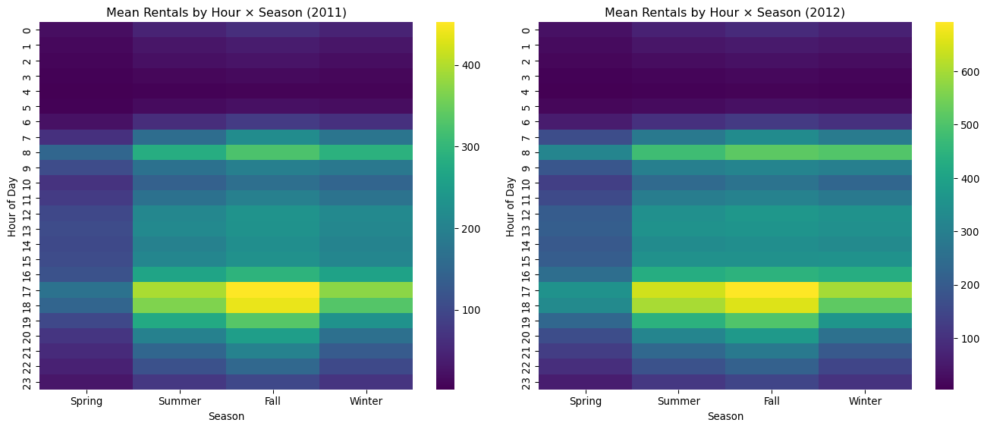
Insight | 2011 | 2012 | Interpretation
Peak hours | 8 AM, 5–6 PM | Same | Commuting-driven demand
Highest seasons | Summer & Fall | Same but stronger | Weather is the dominant factor
Overall demand | Moderate | Much higher | System growth/adoption
Winter usage | Low | Low | Weather constraints persist
The heatmaps show that bike-sharing demand follows clear and stable daily cycles, with strong peaks during morning and evening commuting hours. Summer and fall consistently display the highest usage, while winter remains the lowest. Demand is notably higher in 2012, indicating system growth and wider user adoption. These patterns highlight the importance of planning fleet allocation and operations around predictable peak periods.

How Weather Conditions Affect Bicycle Rental Demand

Impact of Weather Conditions
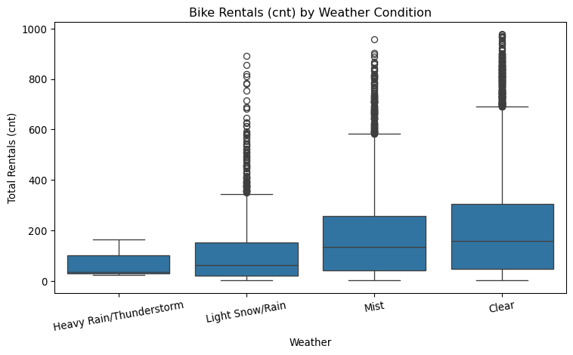
The boxplot clearly shows that bike rentals decrease as weather worsens:
Under clear weather, rentals are the highest and most variable. Mist and light snow/rain conditions show moderate but visibly lower usage. During heavy rain or thunderstorms, bike usage drops sharply, with very low median and narrow spread.
This confirms that adverse weather strongly discourages cycling, while clear conditions maximize ridership.

Effect of Environmental Factors on Bike Rental Demand
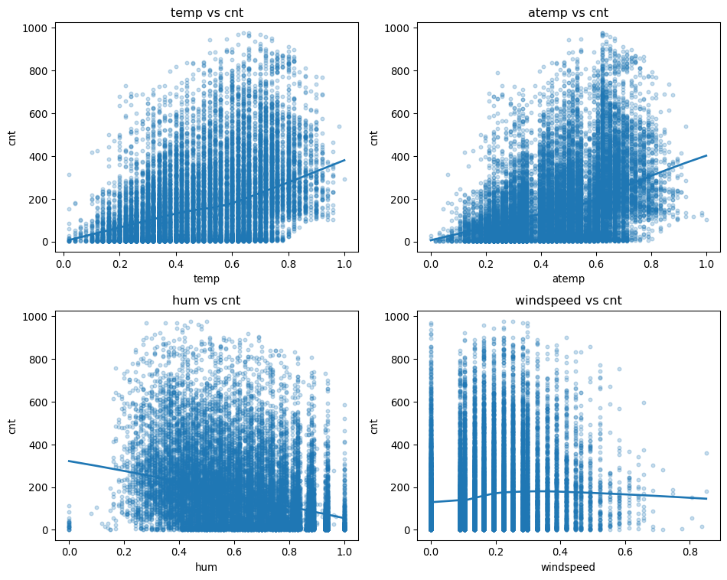
Variable | Relationship | Interpretation
Temperature (temp) | ++ Strong Positive | Higher temperatures increase bike usage, especially in comfortable ranges.
Feels-like temp (atemp) | + Positive | Pleasant perceived temperature encourages cycling.
Humidity (hum) | − Slight Negative | High humidity reduces usage due to discomfort or rain-related conditions.
Windspeed (windspeed) | − Weak Negative | Stronger winds make biking less appealing, though the effect is small.

Effect of Environmental Factors on Bike Rental Demand
To strengthen the understanding of how weather conditions shape bike rental behavior, it is helpful to use a modeling approach that can reveal the relative contribution of each climatic variable. The Random Forest Regressor offers this advantage by evaluating which features most effectively improve prediction accuracy across numerous decision trees. The resulting importance scores provide actionable insights, highlighting which environmental factors—such as humidity, perceived temperature, windspeed, or actual temperature
atemp 0.299042
hum 0.297526
windspeed 0.232331
temp 0.171101
dtype: float64
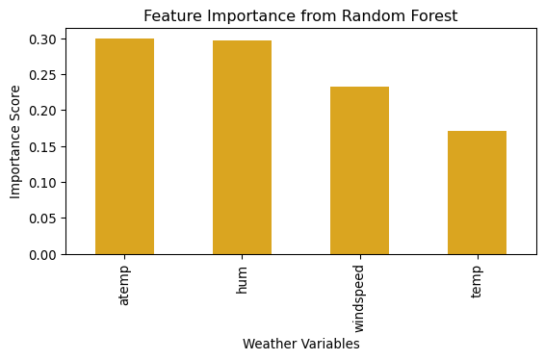

Preliminary Analysis
Before choosing a final prediction model, we first carried out an exploratory analysis to better understand how the variables behave and how they relate to bike rental demand. At this stage, the goal is not to build the strongest predictive model yet, but to identify patterns that will guide our modelling decisions.

Methods Used So Far

1. Exploratory Data Analysis (EDA)
We mainly used visual tools such as:
- Heatmaps to explore how demand changes across hours and seasons.
- Boxplots to compare distributions of rentals across weather conditions and seasons.
- Scatterplots and trend lines to observe relationships between environmental variables (temperature, humidity, windspeed) and demand.
- Distribution plots to study the shape and skewness of rental counts.
EDA helps us understand the structure of the data, detect patterns, confirm assumptions, and identify which variables are likely to be important later.
For example, strong hourly peaks and seasonal differences suggest temporal variables will play a key role.

Next Steps Toward Modelling
Although we explored the data visually, we have not yet selected the final model. However, based on our findings, we will consider:

Potential models to test:
- Multiple Linear Regression (simple, interpretable baseline)
- Random Forest Regression (can capture non-linear patterns seen in EDA)
These models are not final choices yet; they are candidates informed by what we learned through EDA.
So far, our analysis has focused on: - Understanding temporal and weather-related patterns - Identifying variables that seem important based on visual exploration - Preparing the data for modelling (cleaning, encoding, feature creation)
In the next stage, we will test and compare predictive models using the insights gained from EDA.

Appendix A: Description of Variables in hour.csv
A.1 Temporal Variables Variable Description instant Record index dteday Date yr Year (0 = 2011, 1 = 2012) mnth Month (1–12) hr Hour of the day (0–23) weekday Day of the week (0 = Sunday … 6 = Saturday) workingday 1 = Working day, 0 = Weekend or holiday holiday Indicates if the day is a holiday
A.2 Seasonal and Weather Category Variables Variable Description season Season (1 = Spring, 2 = Summer, 3 = Fall, 4 = Winter) weathersit Categorical weather situation Weather Categories Code Weather Description 1 Clear, few clouds, partly cloudy 2 Mist + cloudy / mist + broken clouds / mist + few clouds 3 Light snow; light rain + thunderstorm + scattered clouds; light rain + scattered clouds 4 Severe weather: heavy rain + ice pellets + thunderstorm + mist; snow + fog
A.3 Continuous Weather Variables Variable Description temp Normalized temperature (actual temp / 41°C) atemp Normalized “feels-like” temperature (feels-like temp / 50°C) hum Normalized humidity (humidity / 100) windspeed Normalized wind speed (windspeed / 67)
A.4 Demand Variables Variable Description casual Rentals by non-registered users registered Rentals by registered users cnt Total number of bike rentals (casual + registered)

