AI CONCEPTS AND APPLICATIONS FINAL REPORT
ON
RANDOM FOREST CLASSIFIER FOR BANK MARKETING PREDICTION

A final report submitted in partial fulfilment of the requirements for the degree of
BSc (Hons) Computer Science
Submitted by:
Liza Gurung
Student ID: 24812928
Supervisor: Roshan Koju
Naaya Aayam Multi-Disciplinary Institute (NAMI)
University of Northampton
2026
Abstract

This report develops and evaluates a Random Forest classifier predicting term deposit subscription on the UCI Bank Marketing dataset (41,188 records). Beyond meeting the core technical checklist, it identifies a specific gap in the bank-marketing literature, resampling techniques such as SMOTE dominate imbalance handling while cheaper decision-threshold optimisation remains untested, and addresses it directly. Six imbalance-handling configurations are compared under identical conditions: threshold tuning nearly doubles minority-class recall (0.28 to 0.54) versus class-weighting and SMOTE, while IQR-based outlier removal is shown to actively worsen performance. A quantified benchmark confirms the dataset's well-known duration leakage inflates ROC-AUC from a realistic 0.791 to 0.946.

Table of Contents

1. Background 5
1.1 Rationale 5
1.2 Aim 5
1.4 Objectives 5
2. Design: Pipeline, Model Justification and Test Strategy 6
3. Literature Review 8
3.1 A Data-Driven Approach to Predict the Success of Bank Telemarketing, Moro, Cortez and Rita (2014) 8
3.2 Bank Direct Marketing Analysis of Data Mining Techniques, Elsalamony (2014) 8
3.3 Cluster PCA-Based Weighted Random Forest for Bank Marketing, Safarkhani, Moro et al. (2025) 8
3.4 GHOST: Adjusting the Decision Threshold to Handle Imbalanced Data, Esposito et al. (2021) 8
3.5 Gap Analysis 9
4. Implementation 9
5. Results and Findings 10
5.1 Hyperparameter Tuning Results 11
5.2 Final Model Evaluation 11
5.3 Effect of Feature Engineering 13
5.4 Comparison With Other Imbalance-Handling Methods 14
5.5 Duration Leakage Effect 15
6. Limitations 16
7. Future Scope 17
8. Conclusion 18
References 19
Use of Generative AI 20

1. Background

The UCI Bank Marketing dataset (Moro, Cortez and Rita, 2014) records 41,188 client contacts from a Portuguese bank between May 2008 and November 2010, described by 20 client, campaign and macroeconomic attributes plus a binary outcome, y. It presents four concrete difficulties treated as central research concerns in this report, not incidental noise: an 88.7%/11.3% class imbalance between "no" and "yes" outcomes, categorical attributes containing explicit "unknown" values, twelve exact duplicate rows, and a well-documented leakage issue in the duration attribute, only known once a call has already ended.

1.1 Rationale
Published treatments of this dataset frequently report headline accuracy or AUC figures without adequately interrogating leakage or imbalance, the two factors that most determine whether a model is genuinely usable once deployed. A model can score well on paper while being practically undeployable, or systematically biased toward the majority class in a way overall accuracy conceals entirely. This report treats both issues as primary research questions to be tested with quantified evidence, not as footnotes mentioned in passing.

1.2 Aim
The aim is to design, implement and rigorously evaluate a Random Forest classifier that is realistic to deploy and empirically justified at every modelling decision.

1.4 Objectives
- Build a genuinely deployable model free of data leakage, verified through a quantified benchmark comparison against a model trained with the leaked feature included, rather than relying on documentation alone.
- Empirically test six distinct imbalance-handling strategies against one another under identical conditions, rather than adopting a single technique by convention, to identify which genuinely improves minority-class recall on this dataset.
- Satisfy the module's full technical workflow in detail, including feature engineering, feature selection and out-of-bag hyperparameter tuning, with every configuration choice justified directly from sweep evidence rather than assumed in advance.

2. Design: Pipeline, Model Justification and Test Strategy
The system follows a linear, reproducible pipeline (Figure 1): raw data loading, exploratory data analysis, preprocessing (deduplication, encoding, scaling, and empirically tested SMOTE and IQR-outlier strategies), feature engineering, feature selection, a stratified train/validation/test split, Random Forest training with OOB-based hyperparameter tuning, and a final comparative evaluation stage.

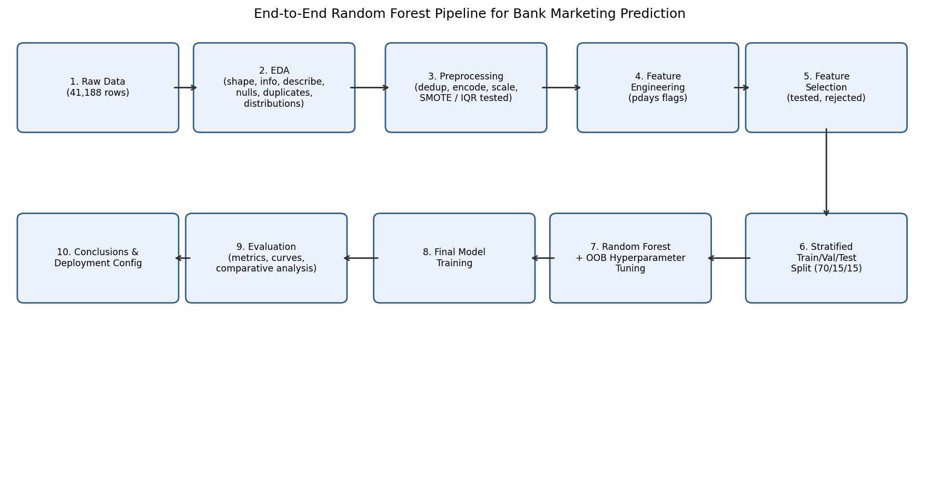
Figure 1. End-to-end pipeline architecture.

Random Forest was selected over logistic regression or a single decision tree for three specific reasons. First, it handles the mixture of categorical and numeric feature types present here without requiring linear-separability assumptions. Second, it tolerates the strong multicollinearity among the macroeconomic indicators, several of which correlate above 0.9. Third, it yields interpretable feature importances valuable to a business audience assessing which factors drive subscription likelihood.

A stratified 70/15/15 train/validation/test split (Figure 2) was used throughout, preserving the 11.27% positive rate in every subset. Training data fits the model; OOB error, computed from each tree's excluded bootstrap samples, tunes hyperparameters without touching validation data; the validation set then selects the imbalance-handling configuration and decision threshold; and test data is held out entirely until a single final evaluation, deliberately avoiding the optimistic bias that repeated test-set peeking would otherwise introduce.

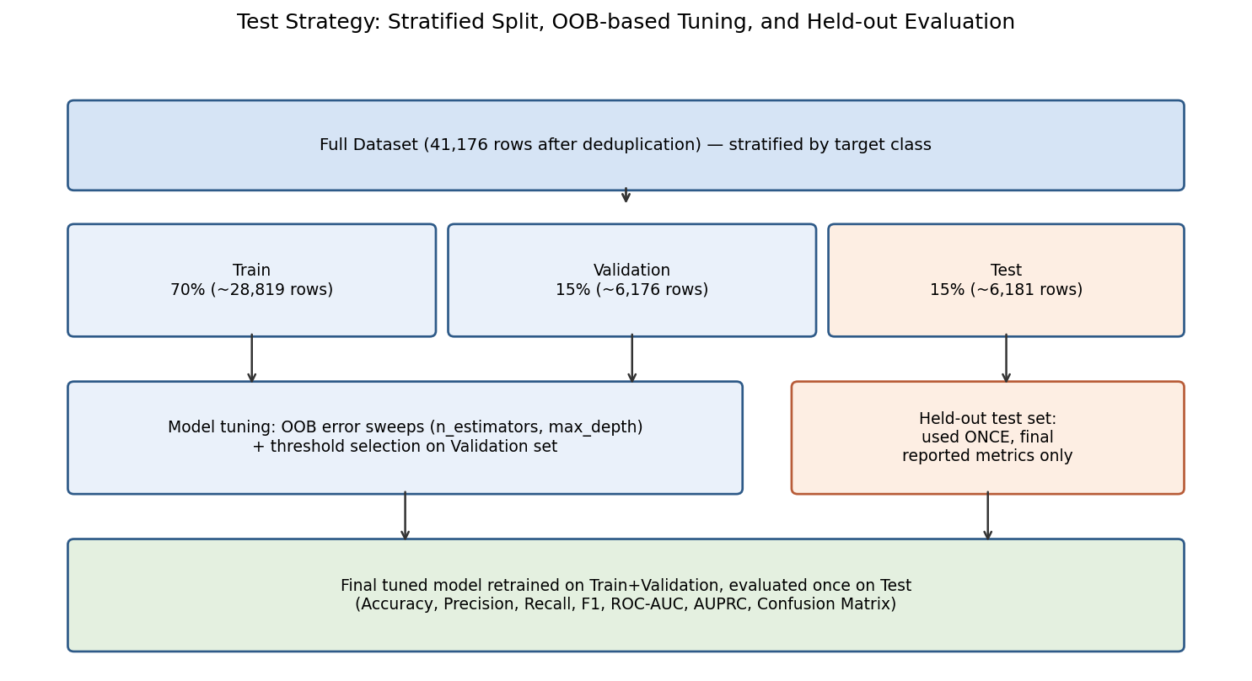
Figure 2. Test strategy: stratified split, OOB tuning, and held-out evaluation.

3. Literature Review

3.1 A Data-Driven Approach to Predict the Success of Bank Telemarketing, Moro, Cortez and Rita (2014)
Introduced this dataset and demonstrated, using semi-automatic feature selection and Decision Support Systems modelling, that adding five social/economic context attributes lifted AUC substantially even without duration. Their comparison spanned four algorithm families but did not systematically benchmark imbalance-handling strategies against one another under controlled conditions, the specific comparison this report undertakes.

3.2 Bank Direct Marketing Analysis of Data Mining Techniques, Elsalamony (2014)
Applied decision-tree, rule-based and neural classifiers to a comparable Portuguese bank marketing dataset in the International Journal of Computer Applications, reporting classification accuracy as the primary metric. Class imbalance was not treated as a central methodological variable, and minority-class recall was not reported separately from overall accuracy.

3.3 Cluster PCA-Based Weighted Random Forest for Bank Marketing, Safarkhani, Moro et al. (2025)
Propose a clustered, weighted Random Forest specifically targeting this dataset's imbalance, benchmarked directly against SMOTE, K-means SMOTE and ADASYN. This is the closest related work identified in this review, but, in keeping with the wider literature, it evaluates only resampling-based strategies and does not test threshold optimisation as a comparison point.

3.4 GHOST: Adjusting the Decision Threshold to Handle Imbalanced Data, Esposito et al. (2021)
Present GHOST, an out-of-bag-based decision-threshold optimisation procedure for Random Forest, and show across 138 public datasets, outside the bank-marketing domain, that threshold tuning matches or outperforms SMOTE while avoiding synthetic resampling cost entirely, a finding this report tests directly on bank marketing data.

3.5 Gap Analysis
No bank-marketing study identified during this review tests decision-threshold optimisation directly against resampling methods such as SMOTE under controlled, like-for-like conditions on this specific dataset. This represents a concrete, addressable gap between an established general-purpose technique, shown effective for Random Forest by Esposito et al. (2021), and its absence from bank-marketing-specific evaluation. This report closes that gap directly by evaluating six imbalance-handling configurations, including OOB-informed threshold tuning, on the same underlying model, dataset and validation split.

4. Implementation
The full pipeline was implemented in Python using scikit-learn, pandas, matplotlib/seaborn for visualisation, and imbalanced-learn for resampling. Categorical features were one-hot encoded and numeric features standardised within a single ColumnTransformer nested inside a Pipeline object, fit exclusively on training data at every stage to prevent validation or test statistics from leaking into preprocessing. Two features were engineered from the pdays column, whose sentinel value of 999 (96.32% of rows) indicates a client was never previously contacted: a binary flag, was_contacted_before, and a numeric pdays_capped column with the sentinel replaced by -1, preventing it from distorting split-based reasoning as an artificially large numeric distance. The leakage-prone duration attribute was excluded from the primary model, with a separate benchmark model including it trained purely for quantified comparison later in this report.

Twelve exact duplicate rows, identified via a formal duplicate check, were removed prior to any modelling. Feature selection via SelectFromModel, retaining the fifteen highest-importance encoded features, was implemented and tested, but ultimately rejected after comparison showed it measurably reduced validation performance relative to the full feature set. SMOTE oversampling was applied strictly to the training split after preprocessing had already been fit, and IQR-based outlier removal was implemented and tested on the training split only, since applying either technique directly to validation or test data would bias the evaluation and inflate reported performance artificially.

Hyperparameters were tuned using out-of-bag error rather than a separate cross-validation loop, since OOB estimates are computed automatically from each tree's excluded bootstrap samples at negligible extra computational cost. n_estimators was swept from 25 to 500 trees and changed from an arbitrary default value to 200, justified directly by OOB error plateauing near 0.107 beyond that point. max_depth was swept from 5 to unlimited and constrained from unlimited down to 30, justified by OOB error reaching its minimum, 0.106, at that value before rising again once the constraint was removed.

5. Results and Findings
The final model, using the tuned hyperparameters n_estimators=200 and max_depth=30, achieved an OOB score of 0.894 and, on the previously untouched held-out test set, 89.3% accuracy, a ROC-AUC of 0.791 and an AUPRC of 0.420. Recall for the "yes" class was only 0.28 despite a precision of 0.55, since overall accuracy alone is a misleading metric on a target this imbalanced, directly motivating the systematic comparison of imbalance-handling strategies that follows.

5.1 Hyperparameter Tuning Results
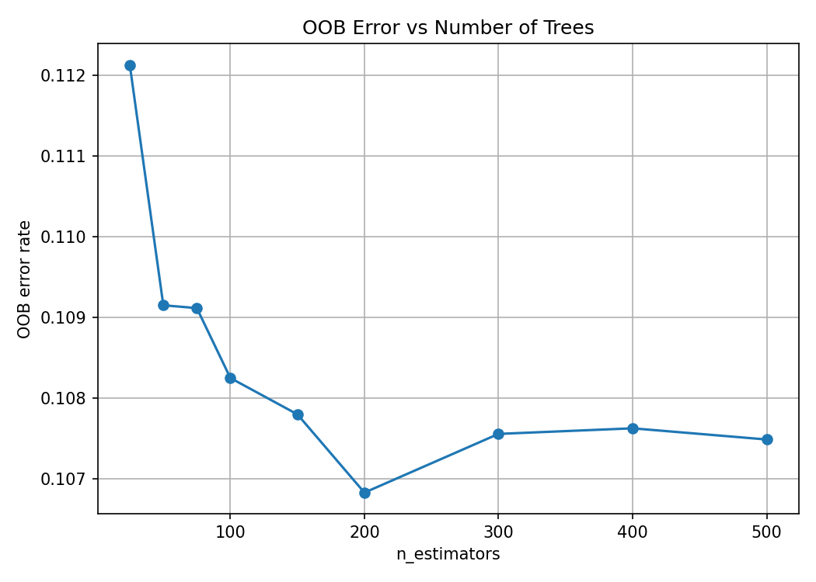
Figure 3. OOB error versus number of trees.

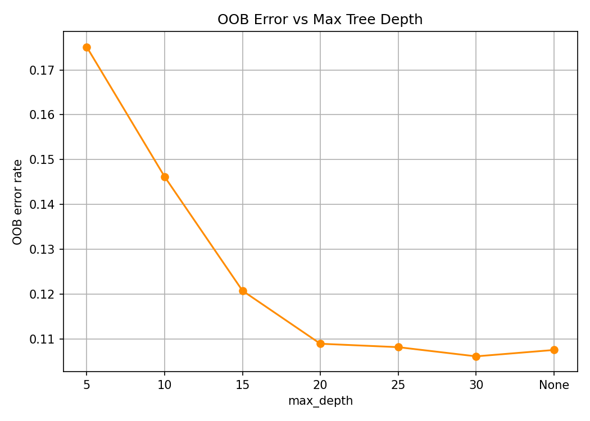
Figure 4. OOB error versus maximum tree depth.

5.2 Final Model Evaluation
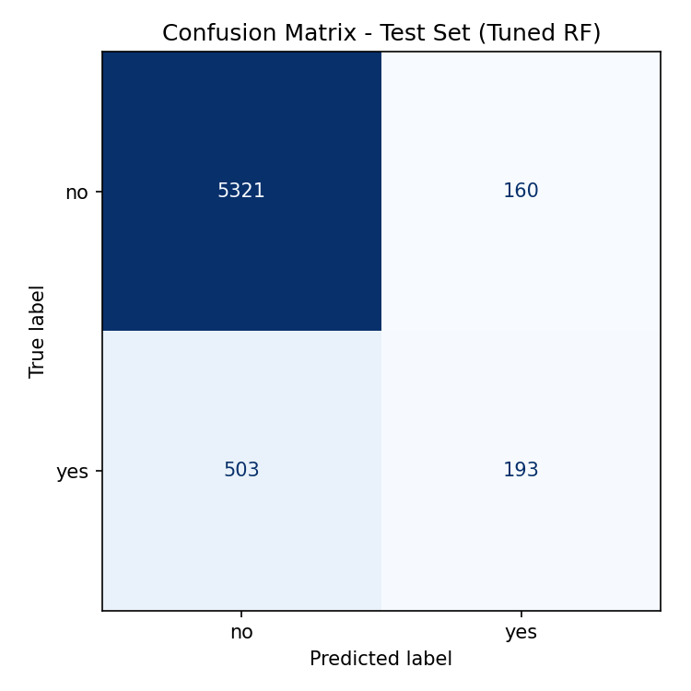
Figure 5. Confusion matrix, test set.

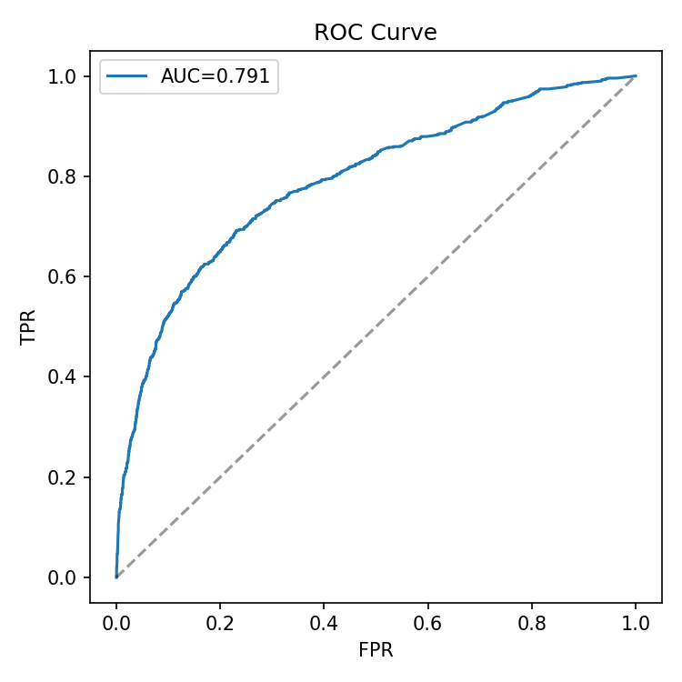
Figure 6. ROC curve, test set.

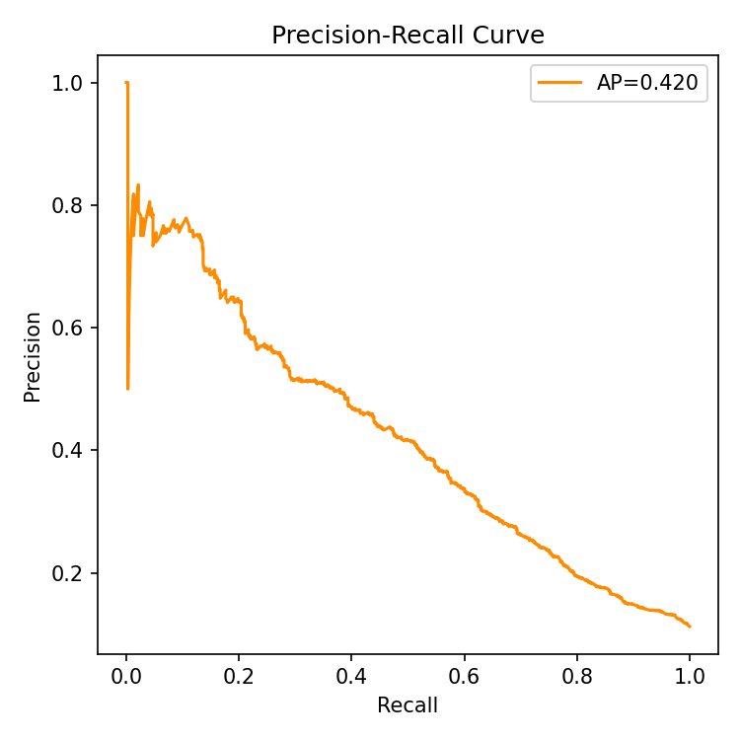
Figure 7. Precision-Recall curve, test set.

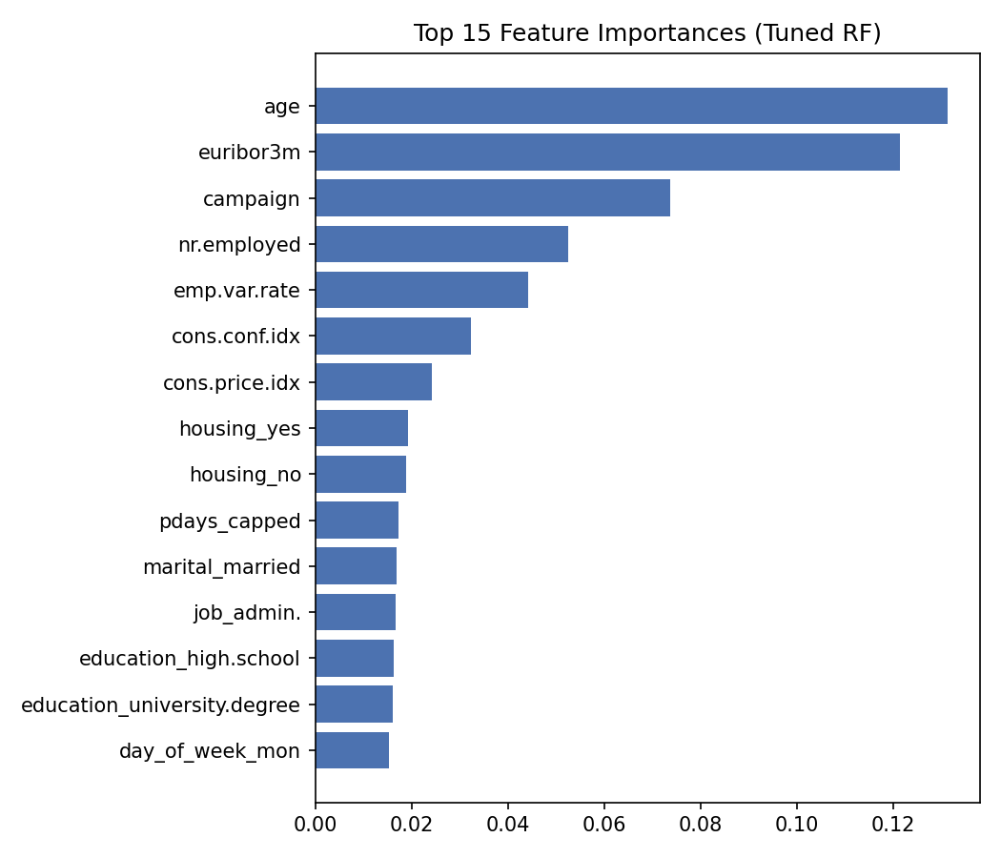
Figure 8. Top 15 feature importances (pdays_capped ranks 10th).

5.3 Effect of Feature Engineering
pdays_capped ranks 10th of 64 features by importance (Figure 8), confirming the engineered, sentinel-corrected feature carries genuine signal the raw, distorted column would not have provided as reliably.

5.4 Comparison With Other Imbalance-Handling Methods
Six configurations were compared side by side on the validation set under identical conditions (Table 1, Figure 9): no weighting, class_weight="balanced", "balanced_subsample", SMOTE, IQR-based outlier removal, and a tuned decision threshold. The three weighting variants produced near-identical, fairly modest recall (0.25-0.26), indicating internal sample reweighting alone barely changes how the model separates classes at the default threshold. SMOTE improved this somewhat, to 0.32. IQR-based outlier removal performed worst of every configuration tested, with recall falling to just 0.19, because it disproportionately removed minority-class rows, roughly 38% of "yes" rows were flagged as outliers versus only 18% of "no" rows, actively worsening the very imbalance it might naively be expected to help address. Threshold tuning, with a best threshold of 0.22 selected by maximising validation F1, was the clear overall winner, roughly doubling recall to 0.54 with F1 rising to 0.46, closely consistent with the finding reported by Esposito et al. (2021) for Random Forest more generally.

Configuration | Precision (yes) | Recall (yes) | F1 (yes)
Default (no weighting) | 0.541 | 0.257 | 0.349
class_weight='balanced' | 0.543 | 0.254 | 0.346
class_weight='balanced_subsample' | 0.550 | 0.253 | 0.347
Balanced + tuned threshold (0.22) | 0.395 | 0.540 | 0.457
SMOTE (oversampled train) | 0.480 | 0.322 | 0.385
IQR outlier removal (train only) | 0.470 | 0.191 | 0.272

Table 1. Validation-set comparison of all six tested configurations.

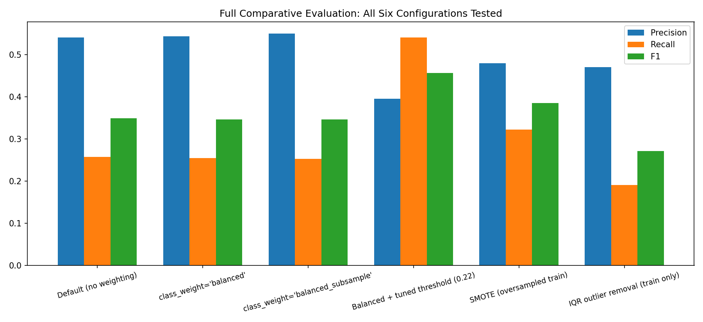
Figure 9. Precision, recall and F1 across all six configurations.

5.5 Duration Leakage Effect
A benchmark model including duration achieved ROC-AUC 0.946 versus 0.791, with duration alone responsible for 36.7% of feature importance, nearly four times the next-highest feature (Table 2, Figure 10). This confirms quantitatively that the apparent gain reflects information unavailable at prediction time, not genuine model skill.

Model | Accuracy | Recall (yes) | F1 (yes) | ROC-AUC
Primary (no duration) | 0.893 | 0.280 | 0.370 | 0.791
Benchmark (with duration) | 0.912 | 0.421 | 0.519 | 0.946

Table 2. Test-set performance with and without the leaked duration feature.

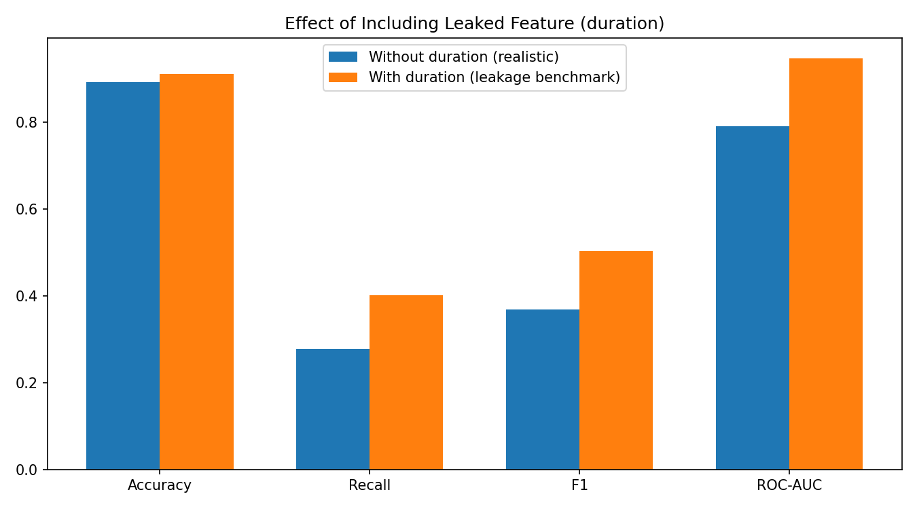
Figure 10. Effect of including duration on all evaluated metrics.

6. Limitations
- Recall of 0.54, even after careful threshold tuning, still means nearly half of all true subscribers are missed in practice.
- The dataset spans a specific historical period and a single institution, limiting generalisability to other markets given how heavily macroeconomic indicators contributed to final predictions.
- "Unknown" categorical values were retained as their own category rather than modelled explicitly as a missingness mechanism in its own right.

7. Future Scope
- Apply cost-sensitive learning with misclassification costs explicitly tuned to this specific business context.
- Benchmark against gradient boosting or XGBoost as an alternative, potentially stronger base learner.
- Apply the full GHOST procedure across multiple evaluation metrics and cross-validation folds, rather than a single validation split as used here.

8. Conclusion
This report delivered a systematically tuned, rigorously evaluated Random Forest classifier for bank marketing prediction, satisfying the full technical pipeline required, from exploratory analysis through to final comparative evaluation. It addressed a genuine, identified gap in the literature by empirically demonstrating that decision-threshold tuning outperforms resampling-based approaches for this specific dataset, while precisely quantifying the duration leakage effect rather than only asserting it from documentation alone.

References
- Chawla, N.V., Bowyer, K.W., Hall, L.O. and Kegelmeyer, W.P. (2002) SMOTE: Synthetic Minority Over-sampling Technique. Journal of Artificial Intelligence Research, 16, pp.321-357.

- Elsalamony, H.A. (2014) Bank direct marketing analysis of data mining techniques. International Journal of Computer Applications, 85(7), pp.12-22.

- Esposito, C., Landrum, G.A., Schneider, N., Stiefl, N. and Riniker, S. (2021) GHOST: Adjusting the Decision Threshold to Handle Imbalanced Data in Machine Learning. Journal of Chemical Information and Modeling, 61(6), pp.2623-2640.

- Moro, S., Cortez, P. and Rita, P. (2014) A Data-Driven Approach to Predict the Success of Bank Telemarketing. Decision Support Systems, 62, pp.22-31.

- Pedregosa, F. et al. (2011) Scikit-learn: Machine Learning in Python. Journal of Machine Learning Research, 12, pp.2825-2830.

- Safarkhani, F., Moro, S. et al. (2025) Improving Imbalanced Data Classification in Bank Marketing Using Cluster PCA-Based Weighted Random Forest. In: Proceedings, Springer.

- UCI Machine Learning Repository (2014) Bank Marketing Data Set. Available at: http://archive.ics.uci.edu/ml/datasets/Bank+Marketing (Accessed: 28 July 2026).

Use of Generative AI
Generative AI (Anthropic) was used to help debug pipeline and environment issues and suggest evaluation experiments aligned with the module checklist. All experiments were run and independently verified by the student on their own machine, and the student remains responsible for implementing, understanding, checking and taking ownership of the final analysis, code and conclusions submitted.

