LAB 1: LINUX, C++, AND GIT ENVIRONMENT SETUP
Li Zehao
Student ID: 24020036039
Abstract— This report documents the configuration, implementation, and verification of LAB1 in a WSL-based Ubuntu 20.04.3 LTS environment. The completed work includes shell file processing, Git identity configuration, C++ warmup exercises, implementation of the RandomVector class, a CMake library demonstration, and terminal evidence. The GitHub repository is organized by top-level laboratory folders so that LAB1, LAB2, and later labs remain separate. Figures 1–7 record the available execution evidence; the final LAB1 commit and push remain required before code submission.
Keywords— Ubuntu 20.04, WSL2, Linux shell, C++, Git, CMake, ROS1.

EXPERIMENT OBJECTIVES
LAB1 establishes the software environment required by the later robotics laboratories. The specific objectives are to operate a Linux shell, install and verify development tools, use Git for reproducible changes, compile and test C++ code, organize a multi-target CMake project, and record evidence that another student can follow.
Each result in this report is supported by a submitted text file, source file, terminal output, or embedded screenshot. The current Git screenshot is explicitly identified as a pre-commit state, so the report does not claim that LAB1 has already been uploaded to the remote repository.

ENVIRONMENT AND TOOLS

Target Operating System
The verified target distribution is Ubuntu 20.04.3 LTS (Focal Fossa), launched from Windows as the WSL distribution Ubuntu-20.04. The physical installation location is not relevant to reproducing the lab; the required evidence is the distribution name and Ubuntu release shown in Figure 1. A separate older WSL distribution is retained independently and is not used for the ROS1-based LAB2 workflow.
wsl -l -v
wsl -d Ubuntu-20.04 -- bash -lc "lsb_release -a"
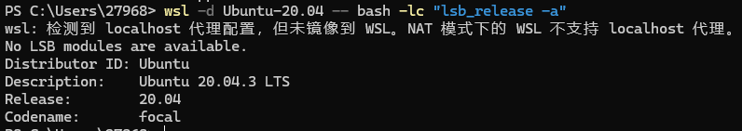
- Ubuntu release verification for the Ubuntu-20.04 WSL distribution.

Toolchain Verification
The required tools are Git, g++, CMake, wget, tar, fortune-mod, and lsb-release. The installed versions captured in Figure 2 are g++ 9.4.0, CMake 3.16.3, and Git 2.25.1. The Git configuration records the student's required name and GitHub noreply email.
sudo apt update
sudo apt install -y build-essential cmake git wget tar fortune-mod lsb-release
g++ --version | head -n 1
cmake --version | head -n 1
git --version
Tool | Expected evidence
Ubuntu | 20.04.3 LTS; codename focal
Compiler | g++ 9.4.0
CMake | CMake 3.16.3
Git | Git 2.25.1
Git identity | Li Zehao; 251839968+lizh-coder@users.noreply.github.com
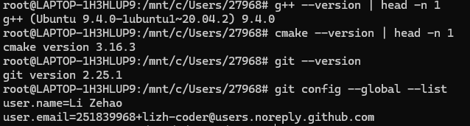
- Development-tool and Git-identity verification.

SHELL EXERCISES

Dante Statistics
The Dante text file was obtained with wget and inspected with standard shell utilities. The line and word counts were produced using wc, while blank lines were excluded with grep. The measured values were 19,567 lines, 97,676 words, and 14,338 non-blank lines. The command transcript is stored in exercise1.txt.
wc -l -w dante.txt
grep -c -v '^[[:space:]]*$' dante.txt
Measurement | Result
Total lines | 19,567
Total words | 97,676
Non-blank lines | 14,338
- Dante file-statistics command output.

Fortune Output
The fortune-mod package was installed and fortune was executed five times. The outputs were appended with the >> operator to fortunes.txt. This exercise verifies package installation, command execution, append redirection, and preservation of the generated evidence file.
sudo apt install -y fortune-mod
fortune >> fortunes.txt
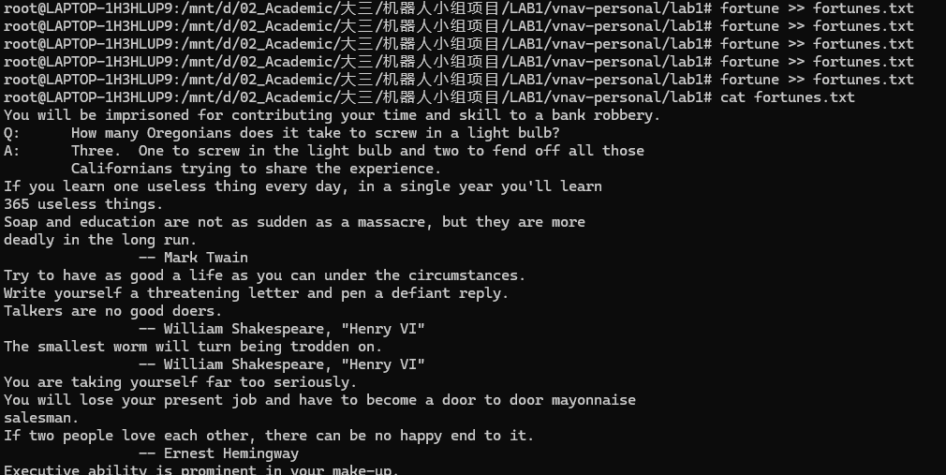
- Fortune command and saved-output verification.

C++ WARMUP
The required answers are recorded in cpp-warmup.txt. The file contains all ten responses requested in the exercise: two operator questions, four reference and pointer questions, and four numerical-type questions. Each answer states the output or final value and explains the relevant C++ rule.

Reproducibility
The response numbering in cpp-warmup.txt follows the exercise structure: Operators (1.1–1.2), References and Pointers (2.1–2.4), and Numbers (3.1–3.4).

RANDOMVECTOR IMPLEMENTATION

Implemented Methods
All TODO regions in the personal copy of random_vector.cpp were implemented. The constructor resizes the vector and fills it with uniformly scaled pseudo-random values. print displays the vector. mean computes the arithmetic average. max and min scan the vector with explicit comparisons. printHistogram counts values into the requested number of bins, handles an empty vector and equal extrema, clips the upper endpoint into the final bin, and prints a text histogram.

Build and Test
The supplied main program seeds the pseudo-random generator with 314159 and constructs a vector of 20 values. The captured Ubuntu execution produced Mean = 0.558804, Min = 0.0278694, and Max = 0.982655, followed by the five-bin text histogram in Figure 5. The original instructor file remains unchanged in vnav-codes; the completed personal copy is in vnav-personal/lab1/RandomVector/random_vector.cpp.
g++ -std=c++11 -Wall -pedantic -o random_vector main.cpp random_vector.cpp
./random_vector
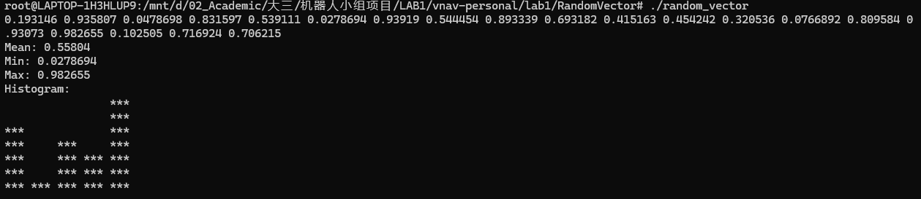
- RandomVector build and test output on Ubuntu 20.04.3.
The displayed numerical result is specific to the recorded Ubuntu C library random-number implementation. Re-running the same source on another platform may produce a different sequence even when the seed remains fixed.

CMAKE DEMONSTRATION

Project Structure
The CMake demonstration separates a small library from the executable that uses it. CMakeLists.txt declares the hello_world project, builds my_lib.cpp and my_lib.hpp into mylib, builds main.cpp into main, and links main against mylib. This demonstrates target-based organization instead of compiling every source file in one command.
cmake -S . -B build
cmake --build build
./build/main
The expected output is Hello world! followed by In library. The source files and the saved output are located in lab1/cmake_demo/.
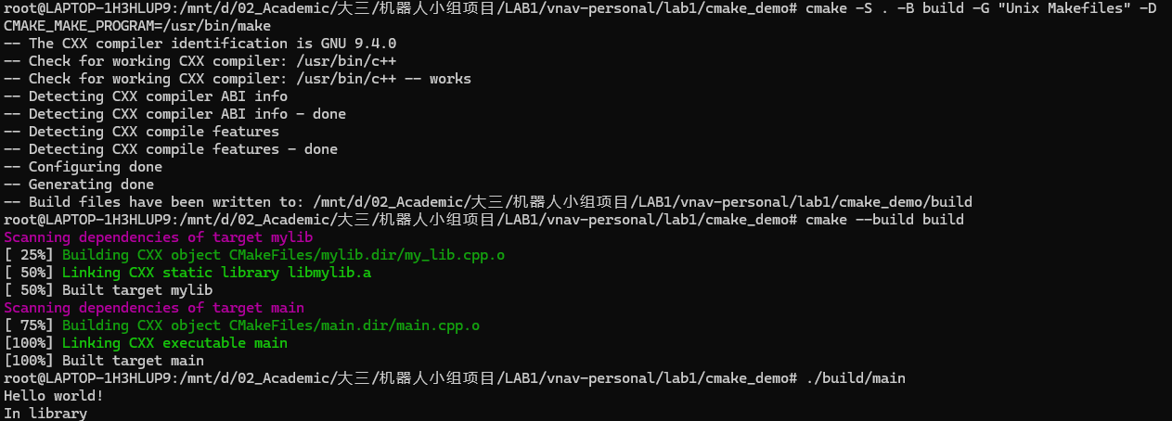
- CMake configuration, compilation, and program execution.

GIT WORKFLOW

Identity and Repository
Git was configured with the student's name and GitHub noreply email. The remote repository is https://github.com/lizh-coder/Robotics-Integration-Team-Project-I. It is intentionally organized with one top-level folder per laboratory, including LAB1, LAB2, and later labs. At the time Figure 7 was captured, .gitignore was staged and LAB1/ was still untracked; therefore the completed LAB1 files must be staged, committed, and pushed before submission.
git config --global user.name "Li Zehao"
git config --global user.email "251839968+lizh-coder@users.noreply.github.com"
git status
git log -1 --oneline
Git item | Recorded result
Author | Li Zehao
Email | 251839968+lizh-coder@users.noreply.github.com
Commit | 8e2e263 Initial commit (shown before LAB1 commit)
Remote | origin: github.com/lizh-coder/Robotics-Integration-Team-Project-I; LAB1 commit/push pending
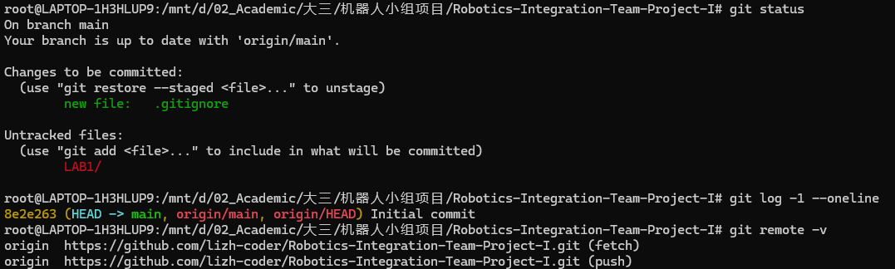
- Git remote and pre-commit working-tree status.

RESULTS AND COMPLETION STATUS
The shell, C++, and CMake implementation tasks are complete and are supported by Figures 1–6. The warmup answer file contains the full response set, and RandomVector has been compiled and executed. The only remaining submission action is Git synchronization: place the LAB1 deliverables under the repository's top-level LAB1/ folder, commit them on main, push to origin, and replace Figure 7 with the resulting clean working-tree screenshot.
Item | Status
Ubuntu 20.04.3 on WSL | Release verified; add wsl -l -v evidence only if WSL2 proof is required
Shell statistics and fortune | Completed; screenshots inserted
C++ warmup | Completed; all 10 answers recorded
RandomVector | Implemented and tested; screenshot inserted
CMake demo | Implemented and tested; screenshot inserted
Git remote commit and push | Pending: stage LAB1/, commit, push, then update Figure 7

SUBMISSION CHECKLIST
Student ID: 24020036039.
Figures 1–6 contain the available verification evidence. Figure 1 verifies Ubuntu 20.04.3 LTS; if the instructor specifically requires proof of WSL version 2, add the output of wsl -l -v to Figure 1.
Figure 7 records the pre-commit repository state. After committing and pushing LAB1/, replace it with a screenshot of git status, git log -1 --oneline, and git remote -v showing a clean main branch.
Remote repository: https://github.com/lizh-coder/Robotics-Integration-Team-Project-I. Required final Git action: commit and push the LAB1/ folder on branch main.

CONCLUSION
LAB1 established a reproducible Linux, C++, CMake, and Git workflow for subsequent robotics experiments. The direct evidence consists of the shell result files, the warmup answers, the RandomVector source and test output, the CMake targets, and the embedded screenshots. Once the LAB1 folder has been committed and pushed to the configured repository and Figure 7 has been updated to show that clean state, the report and code submission will be ready for final submission.

REFERENCES
- MIT VNAV, Lab 1: Linux, C++, and Git, https://vnav.mit.edu/labs_2023/lab1/.
- OUC V-Lab Course, vnav-codes repository, https://github.com/ouc-vlab-course/vnav-codes.
- IEEE, Preparation of Papers for IEEE Sponsored Conferences and Symposia, ieeeconf_A4.dot template.

