LAB 4: UAV CONTROL AND DRONE RACING
Li Zehao
Student ID: 24020036039
Repository: https://github.com/lizh-coder/Robotics-Integration-Team-Project-I
Team: 20
Abstract - This report documents the implementation and verification of the MIT VNAV LAB 4 drone-racing task. The system was executed in Ubuntu 20.04 and ROS Noetic under WSL2 with the Lab 4 TESSE/Unity simulator. The planner publishes gate poses, the trajectory node creates a yaw-continuous minimum-snap reference through twelve gates, and the geometric controller tracks it with racing safeguards. The verified full-course run crossed all twelve gate planes in order, recorded no collision objects, and reached the finish plane 20.818 s after the race start. Its peak speed was 7.139 m/s, RMS tracking error during the race was 0.084 m, and maximum height error was 0.062 m. The report also records the two individual trajectory-optimization deliverables.
Keywords - UAV, drone racing, minimum-snap trajectory, geometric control, ROS Noetic, TESSE, Unity, WSL2.

I. EXPERIMENT OBJECTIVES AND SCOPE
LAB 4 integrates gate waypoint publication, polynomial trajectory generation, geometric flight control, ROS communication, and the Unity racing simulator. The team task is to complete the supplied planner and trajectory-generation components, tune the Lab 3 controller for the racing course, and demonstrate a complete course run. The individual work derives the single-segment minimum-velocity solution and the constraint accounting for multi-segment minimum-snap trajectories.
TABLE I. LAB 4 SCOPE
Item | Completed implementation / evidence
Simulator | MIT VNAV LAB 4 Unity/TESSE racing scene with ROS bridge
Racing course | Twelve ordered gates and a terminal exit waypoint
Waypoint planning | Gate pose publication and Part 0 first-gate hover test
Trajectory | Yaw-continuous minimum-snap path with motion limits
Controller | Geometric tracking controller with racing safeguards
Recorded data | Ordered gate-plane crossings, tracking metrics, and collision check
External evidence | Complete Unity video and fastest-run rosbag referenced by rviz_drone_race.txt
II. EXPERIMENTAL ENVIRONMENT
The experiment was executed in Ubuntu 20.04 under WSL2 on Windows. ROS 1 Noetic, catkin tools, the TESSE ROS bridge, the Lab 4 Unity simulator, and the supplied MAV trajectory-generation dependencies were used. The simulator was launched through the WSL-compatible OpenGL wrapper developed for the legacy Unity build; ROS nodes then exchanged state and rotor commands through the bridge.
TABLE II. SOFTWARE ENVIRONMENT
Component | Verified configuration
Operating system | Ubuntu 20.04 under WSL2
ROS | ROS 1 Noetic with catkin tools
Workspace | /root/vnav_lab4_ws
Simulator | MIT VNAV LAB 4 Unity/TESSE build
Team packages | controller_pkg, planner_pkg, trajectory_generation_pkg
Visualisation | Unity course view and logged ROS state analysis
source /opt/ros/noetic/setup.bash
source ~/vnav_lab4_ws/devel/setup.bash
catkin build controller_pkg trajectory_generation planner_pkg
roslaunch trajectory_generation traj_following.launch
III. INDIVIDUAL DELIVERABLES
A. Single-segment trajectory optimization
The first individual deliverable solves the minimum-velocity problem from P(0) = 0 to P(1) = 1. The degree-one, degree-two, and degree-three parameterizations all give the same unconstrained optimum P(t) = t with J = 1. With the additional terminal constraint P'(1) = -2, the degree-two optimum is P(t) = 4t - 3t^2 with J = 4, while the degree-three optimum is P(t) = t/4 + 9t^2/2 - 15t^3/4 with J = 17/8.
B. Multi-segment trajectory optimization
The second individual deliverable derives the constraint count for minimum snap and for a general r-th-derivative objective. Minimum snap uses seventh-degree polynomials, giving 8k coefficients over k segments. The 2k waypoint endpoint constraints, 6(k - 1) interior free-derivative constraints, and 6 fixed start/end derivative constraints total 8k. Generalizing gives degree 2r - 1 and 2rk constraints.
minimum snap: 2k + 6(k - 1) + 6 = 8k; general case: 2k + 2(r - 1)(k - 1) + 2(r - 1) = 2rk
IV. TEAM IMPLEMENTATION
A. Gate waypoint publication
The planner reads the fixed Lab 4 gate poses and orientations and publishes them in /desired_traj_vertices. Part 0 was implemented as a separate first-gate hover test in simple_traj_planner.cpp. The full-race launch uses traj_vertices_publisher.cpp, which supplies the ordered twelve-gate sequence to the trajectory-generation node.
V = {v_0, v_1, ..., v_12}; v_i = [p_i, psi_i] for each gate position p_i and gate yaw psi_i
B. Minimum-snap trajectory generation and following
trajectory_generation_node.cpp waits for measured vehicle state before planning, unwraps gate yaw, and fits a minimum-snap polynomial through the twelve gate planes. Gate direction is used to set a continuous pass-through velocity. The node samples the polynomial at 100 Hz and limits horizontal speed, acceleration, vertical motion, and yaw rate. A virtual trajectory clock slows only when tracking error becomes large, and it prevents gate progress from advancing before the vehicle is close enough to the active gate plane.
max speed = 8.0 m/s, max acceleration = 8.5 m/s^2, gate speed = 5.6 m/s, max yaw rate = 1.8 rad/s
TABLE III. RELEVANT ROS INTERFACES
Interface | Role
/current_state | Measured vehicle position, velocity, and attitude
/desired_traj_vertices | Ordered gate positions and orientations
/desired_state | Sampled position, velocity, acceleration, and yaw reference
/rotor_speed_cmds | Controller rotor-speed command returned through the bridge
C. Geometric controller and racing safeguards
The controller receives current and desired state, computes translational force from position, velocity, and acceleration terms, then converts desired attitude and rate errors into rotor-speed commands. The racing configuration uses the simulator inertia, critically damped attitude gains, a 0.82 rad commanded tilt limit, and a 3.0 rad/s rate limit. Until the full trajectory arrives, the controller holds the measured initial pose so the trajectory follower does not produce unintended motion before the planner starts the race.
F_d = m(a_d - k_x e_x - k_v e_v + g e_3), M = J(-k_R e_R - k_omega e_omega) + omega x J omega
The rate and tilt safeguards preserve control authority while preventing the growing bank oscillation observed during earlier high-speed trials. Position and attitude commands are limited consistently with the trajectory timing, so the vehicle accelerates through gates without requiring an unbounded camera or body-rate response.
D. Runtime architecture and execution sequence
The race is organized as four cooperating processes. The Unity executable advances vehicle dynamics and renders the course. tesse_ros_bridge converts simulator messages to ROS state topics and returns rotor commands. trajectory_generation publishes the desired state and controller_pkg closes the feedback loop. planner_pkg is launched last; it publishes the gate waypoints and begins the full race only after the simulator, bridge, and trajectory follower are ready.
TABLE IV. RUNTIME EXECUTION SEQUENCE
Process | Purpose during verification
Unity LAB 4 simulator | Runs the racing scene, vehicle dynamics, and cameras
TESSE ROS bridge | Publishes state and accepts rotor-speed commands
Trajectory generation plus controller | Publishes the limited reference and closes the flight-control loop
Planner and rosbag recorder | Starts gate publication and records the two required ROS topics
The process order is Unity simulator, ROS bridge, trajectory follower, and waypoint publisher. The Part 0 first-gate hover test is performed before the full race. For a recorded full-course run, rosbag records /current_state and /desired_state before planner_pkg is launched.
V. VERIFICATION METHOD
A. Acceptance criteria
A valid racing result requires more than a generated polynomial. The vehicle must launch without colliding, cross every gate plane in the published order, complete the course, and settle after the final gate. The checks below combine simulator video with independent ROS logging so that the execution sequence, geometric path, tracking quality, and terminal state are all observable.
TABLE V. FLIGHT VERIFICATION CRITERIA
Criterion | Evidence used in this report
Safe start | Measured-pose hold until the complete route is available
All gates in order | Interpolated actual crossing through each of 12 gate planes
Collision-free flight | Empty collision_objects field in the verification log
Bounded tracking | RMS and maximum state-error analysis
Stable finish | Final five-second tilt and speed measurements
B. Logged-data analysis
The verified run was logged from /current_state and /desired_state. Its gate crossings are evaluated by interpolating the actual state through each gate plane, rather than relying on a proximity-only test. Time is measured from the first racing desired state to the final gate-plane crossing. Position error, height error, speed, tilt, gate offsets, and collision messages are retained in the machine-readable verification record.
RMSE = sqrt((1/N) sum_{k=1}^{N} ||p_k - p_{d,k}||^2); finish time = t(final gate plane) - t(race start)
VI. EXPERIMENTAL RESULTS
A. Unity race-course evidence
Figure 1 is a frame from the recorded Lab 4 Unity race. The quadrotor, active gate, and following gate are visible while the vehicle is in motion. This evidence is paired with the complete recording because a single frame cannot demonstrate all twelve gate crossings or the final stop.
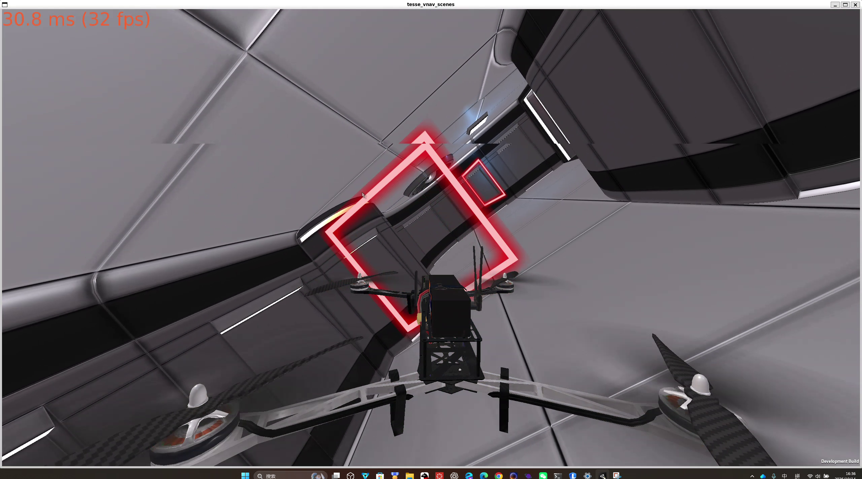
Fig. 1. Unity simulator evidence during the recorded Lab 4 drone-racing run.
B. Horizontal gate sequence
Figure 2 plots the recorded world-frame flight path. The numbered white markers are independently interpolated actual gate-plane crossings. The curve passes the twelve markers in the required order, beginning at the start marker near the first gate and ending at the stop marker beyond the final gate. The maximum measured horizontal gate-plane offset was 0.099 m.
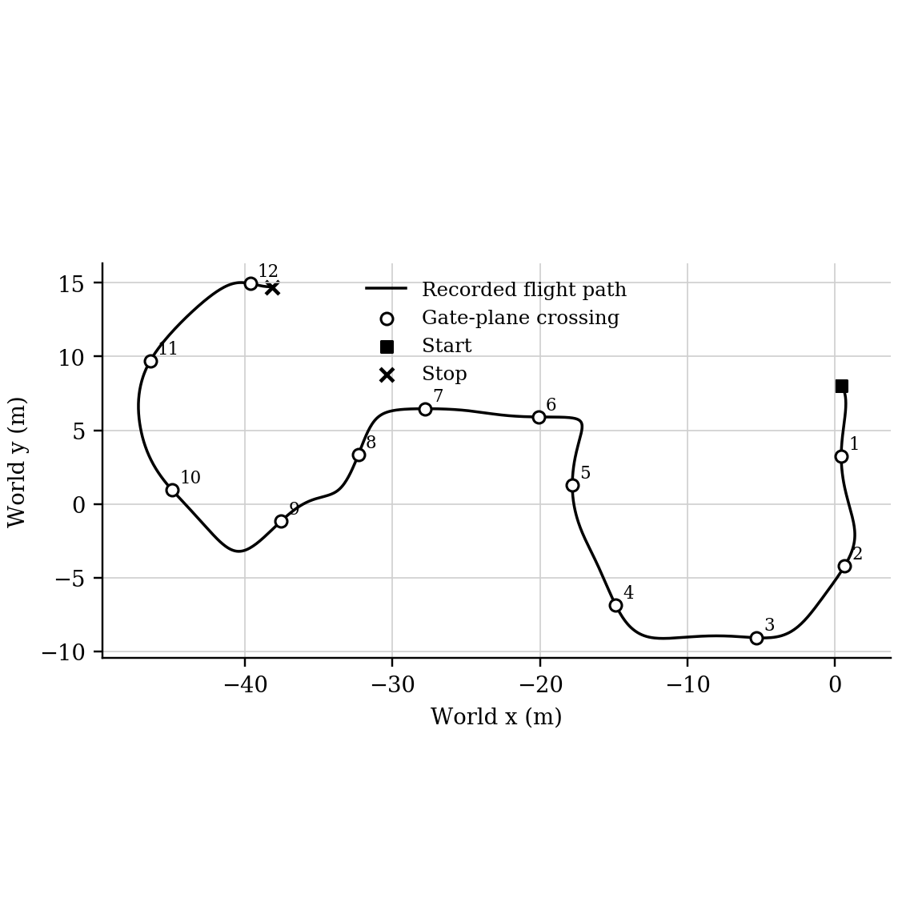
Fig. 2. Recorded horizontal path with the twelve actual gate-plane crossings in sequence.
C. Position tracking and motion limits
Figure 3 shows altitude and the logged 3D tracking and height errors. The maximum 3D tracking error was 0.253 m and the RMS tracking error during the racing interval was 0.084 m. The maximum height error was 0.062 m. The height response returns to the terminal value after the last gate rather than continuing to climb or descend.
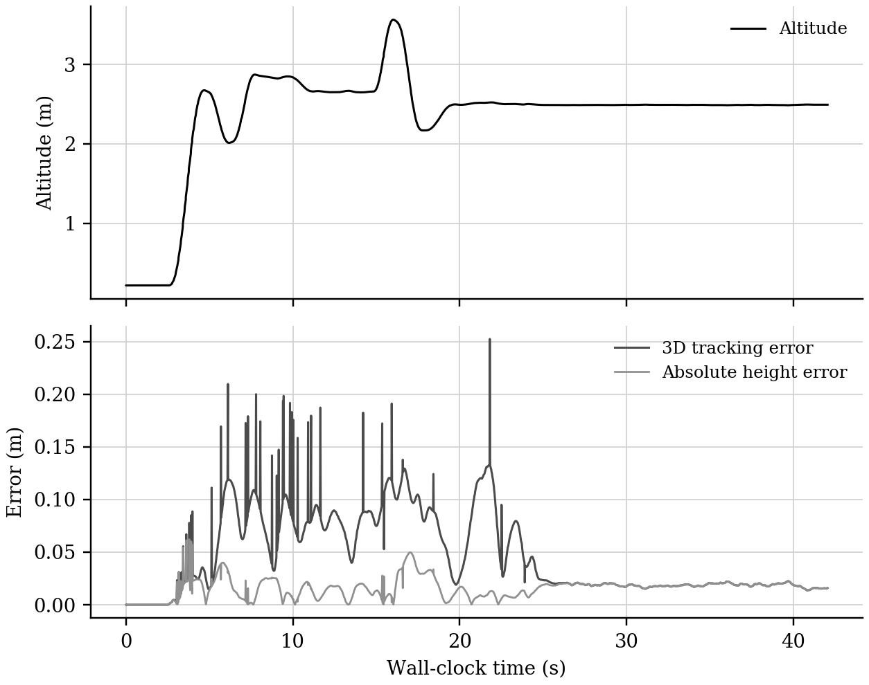
Fig. 3. Recorded altitude, three-dimensional tracking error, and height error.
Figure 4 shows the bounded tilt and speed profiles. The run reached 7.139 m/s and completed the final gate plane at 20.818 s from the race start. Tilt returns to zero and speed falls below 0.022 m/s during the final five seconds, confirming a stable terminal stop rather than residual motion after the course.
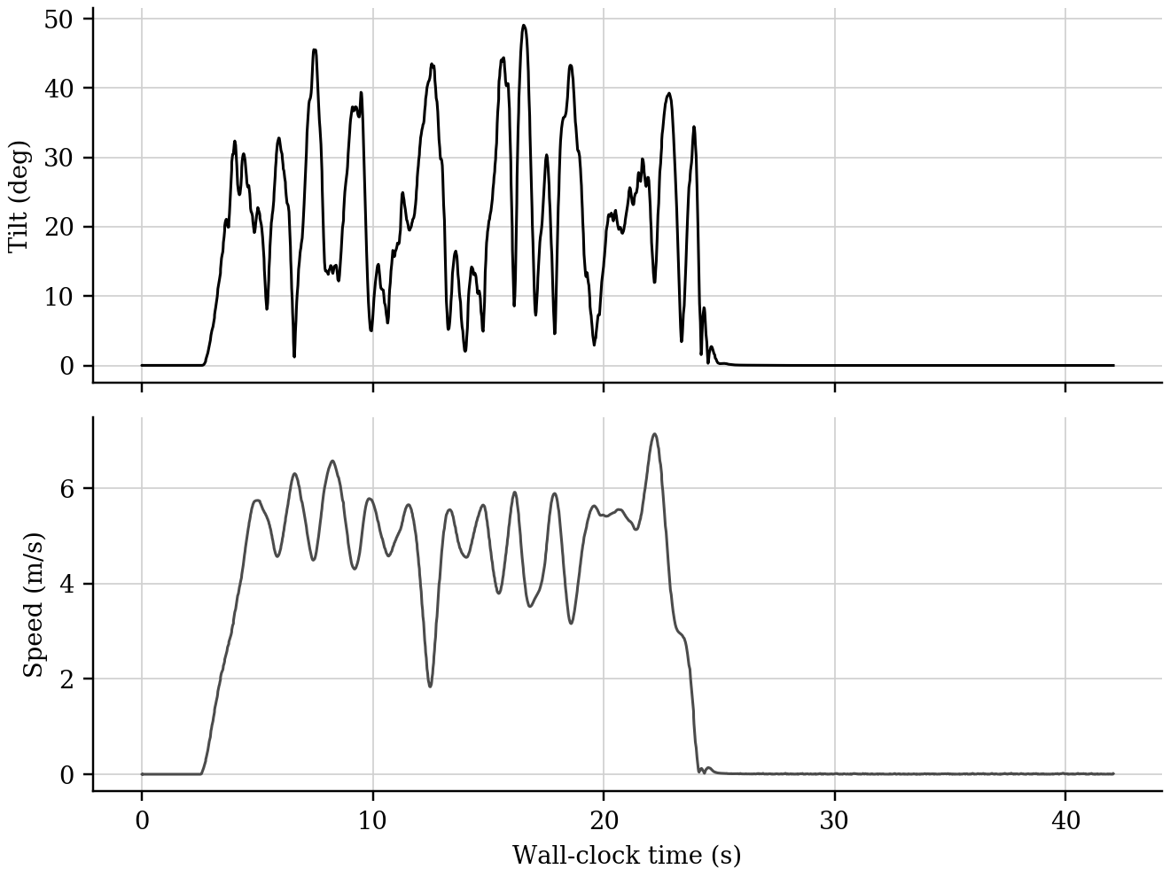
Fig. 4. Recorded tilt and speed profiles for the verified race.
D. Terminal Unity observation
Figure 5 is a later Unity frame from the same recording. It provides visual evidence of continued controlled flight near the end of the course. The complete video and recorded topic data are the time-continuous evidence; the still image is included to make the simulator state immediately reviewable inside the report.
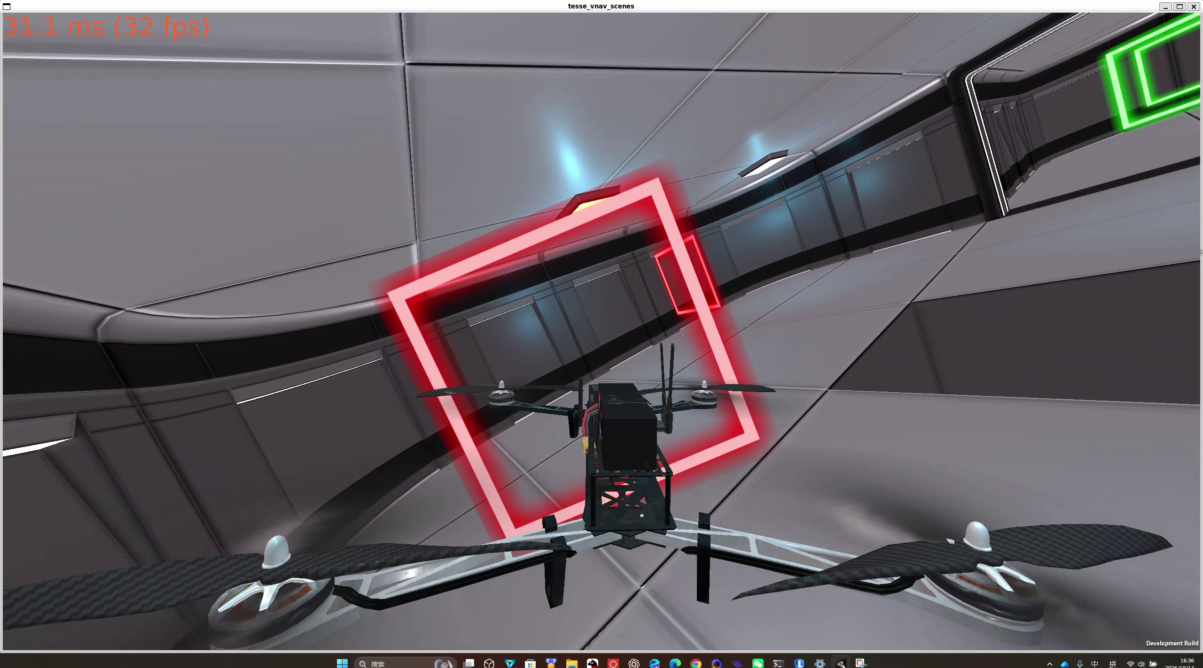
Fig. 5. Unity simulator observation from the recorded late-course flight segment.
E. Quantitative summary
TABLE VI. VERIFIED RACING METRICS
Metric | Measured value
Finish-plane time from race start | 20.818 s
Gate traversal | 12 / 12 gate planes crossed in order
Collision objects | None
Peak speed | 7.139 m/s
RMS / maximum tracking error | 0.084 m / 0.253 m during racing
Maximum height error | 0.062 m
Maximum tilt / final 5 s speed | 49.08 degrees / 0.022 m/s
F. Recorded video and rosbag evidence
The complete Unity recording and the fastest complete-run rosbag are the required external evidence for the team deliverable. Their publicly viewable Google Drive or Dropbox URLs are maintained in rviz_drone_race.txt in the repository. The rosbag is required to include /current_state and /desired_state, matching the topics used for the quantitative verification in this report.
VII. DISCUSSION
The initial Lab 4 difficulty was not only obtaining a high nominal speed, but maintaining stability while following a curved, three-dimensional, gate-constrained path. Starting the control loop before a trajectory existed caused an unintended motion command, so the controller was changed to hold the measured pose until planner_pkg publishes the complete route. Continuous gate velocities, acceleration-aware segment timing, and the virtual trajectory clock then allowed faster motion without requiring the controller to catch an infeasible reference.
The final configuration separates path limits from control safeguards. Trajectory limits of 8.0 m/s and 8.5 m/s^2 define the reference, while the 0.82 rad tilt and 3.0 rad/s rate limits protect the geometric controller. This combination produced a 20.818 s complete run with no reported collision object, 12 ordered gate-plane crossings, and a stable terminal state. The highest actual tilt was 49.08 degrees, which is a brief physical transient rather than a growing oscillation.
The evidence has complementary roles. Unity video shows the visible race progression, the planar gate-crossing analysis proves ordered traversal, the ROS log quantifies tracking and stability, and the rosbag makes the state and reference replayable. Taken together, these records distinguish a complete controlled flight from a path that is only mathematically generated or visually staged.
VIII. CONCLUSION
The LAB 4 planner, trajectory-generation node, and geometric controller were integrated and tested in the ROS/TESSE racing environment. The final implementation completes the twelve-gate course in 20.818 s from race start, crosses every gate plane in order, reports no collision object, and settles after the finish. The reported speed, tracking-error, height-error, and terminal-state metrics show that the faster trajectory remains controlled. The individual deliverables provide the required trajectory-optimization derivations, while the source, runtime record, video, and rosbag make the team result reproducible.
IX. SUBMISSION PACKAGE REQUIREMENTS
The repository uses the required lab4 folder and separates individual deliverables, the complete racing workspace, and runtime evidence. This report describes the implementation and metrics; the source directory contains the planner, trajectory generator, controller, RViz configuration, and required dependencies. The external video and rosbag URLs are kept in the specifically required rviz_drone_race.txt file.
TABLE VII. REQUIRED LAB 4 SUBMISSION ARTEFACTS
Artefact | Required location and purpose
Individual deliverables | lab4/01_Individual_Deliverables/ - two typeset trajectory-optimization PDFs
Racing source and runtime record | lab4/02_Team_Racing_Source_Code/ and lab4/03_Runtime_Evidence/ - executable source and verified metrics
Video and rosbag links | lab4/rviz_drone_race.txt - public links required by the VNAV handout
This report | lab4/01_Individual_Deliverables/ - implementation, evidence, and quantitative results
REFERENCES
[1] MIT VNAV Lab 4 Exercises, https://vnav.mit.edu/labs_2023/lab4/exercises.html
[2] MIT-SPARK, VNAV-labs release VNAV2021, https://github.com/MIT-SPARK/VNAV-labs/releases/tag/VNAV2021
[3] C. Richter, A. Bry, and N. Roy, Polynomial Trajectory Planning for Aggressive Quadrotor Flight in Dense Indoor Environments, ISRR, 2013.
[4] T. Lee, M. Leok, and N. H. McClamroch, Geometric Tracking Control of a Quadrotor UAV on SE(3), 49th IEEE CDC, 2010.
[5] ROS Noetic documentation, mav_trajectory_generation documentation, and the accompanying Lab 4 individual deliverables.

