LAB 2: ROS INSTALLATION AND USE
Li Zehao
Student ID: 24020036039
Abstract - This report documents the installation and use of ROS 1 Noetic for the MIT VNAV Lab 2 two-drone exercise. The work reuses the supplied two_drones_pkg skeleton, builds a catkin workspace under Ubuntu 20.04 on WSL2, publishes the world-to-drone transforms, queries relative transforms with tf2, and visualizes the trajectories in RViz. The dynamic implementation was verified at 50 Hz, and the required homogeneous-transform and quaternion derivations are included. Runtime screenshots remain marked as placeholders for insertion from the student's own terminal and RViz session.
Keywords - ROS 1, ROS Noetic, WSL2, tf2, RViz, catkin, homogeneous transforms, quadrotor

1. EXPERIMENT OBJECTIVES AND REUSE
The objective of LAB2 is to use ROS 1 to organize a package, compile a catkin workspace, publish coordinate transforms, query transforms with tf2, and visualize a two-drone scene. The experiment follows the MIT VNAV Lab 2 exercises. The existing LAB1 repository already contained the official two_drones_pkg skeleton, so a copy was made under LAB2/lab2/two_drones_pkg. This preserved the earlier submission while allowing the LAB2 implementation to be completed independently.
The completed work includes the 50 Hz world-to-av1 and world-to-av2 transform publisher, the lookupTransform call used by the trajectory publisher, explicit geometry_msgs, tf2_geometry_msgs, and visualization_msgs dependencies, and the ROS launch and RViz configuration. The course-provided quadrotor.dae is referenced by the two mesh markers. On this WSLg host, RViz must be launched with software OpenGL rendering because the D3D12 backend loads the mesh but renders it blank.
TABLE I. EXPERIMENT SCOPE
Item | Implementation status
ROS installation | ROS Noetic verified in Ubuntu 20.04 WSL2
Workspace | catkin workspace /root/vnav_ws built successfully
Package | two_drones_pkg found with rospack
Transform publisher | Implemented and verified at 50 Hz
Transform listener | lookupTransform implemented for three trails
Screenshots | Evidence captured and embedded in this report
Student information | Li Zehao; Student ID: 24020036039

2. EXPERIMENTAL ENVIRONMENT
The experiment was performed in Ubuntu 20.04.3 LTS running under WSL2 on Windows. ROS 1 Noetic, catkin, tf2, RViz, and the required message packages are installed. The source package is stored on the D: drive and copied into the Ubuntu workspace at /root/vnav_ws/src/two_drones_pkg.
TABLE II. SOFTWARE ENVIRONMENT
Component | Verified configuration
Operating system | Ubuntu 20.04.3 LTS on WSL2
ROS distribution | Noetic
Build system | catkin build
Visualization | RViz 1.14.26
Workspace | /root/vnav_ws
Package path | /root/vnav_ws/src/two_drones_pkg
Rendering setting | LIBGL_ALWAYS_SOFTWARE=true for RViz on this host

wsl -d Ubuntu-20.04
source /opt/ros/noetic/setup.bash
source /root/vnav_ws/devel/setup.bash
rosversion -d
rospack find two_drones_pkg
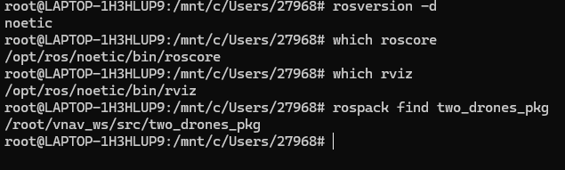
Fig. 1. ROS and package environment verification.

3. DELIVERABLE 1: NODES, TOPICS, AND LAUNCH
The launch file two_drones.launch has one static argument. With static:=true, two static_transform_publisher nodes provide the initial frame arrangement. With the default static:=false, frames_publisher_node publishes the dynamic transforms. In both modes plots_publisher_node publishes a MarkerArray on /visuals and RViz subscribes to /visuals, /tf, and /tf_static.
TABLE III. ROS NODES AND CONNECTIONS
Node | Role | Relevant interface
/frames_publisher_node | Dynamic transform publisher | /tf, 50 Hz per transform
/av1broadcaster | Static world to av1 transform | /tf_static, static mode
/av2broadcaster | Static world to av2 transform | /tf_static, static mode
/plots_publisher_node | MarkerArray and trajectory publisher | publishes /visuals; listens through tf2
/rviz | Visualization | subscribes to /visuals and TF
/rosout | ROS logging | system logging topic

The static mode is first used to verify package discovery, frame names, and the RViz configuration. The dynamic mode is then used for the actual motion and trajectory experiment.
# Terminal 1
source /opt/ros/noetic/setup.bash
roscore
# Terminal 2: static verification
source /opt/ros/noetic/setup.bash
source /root/vnav_ws/devel/setup.bash
roslaunch two_drones_pkg two_drones.launch static:=true
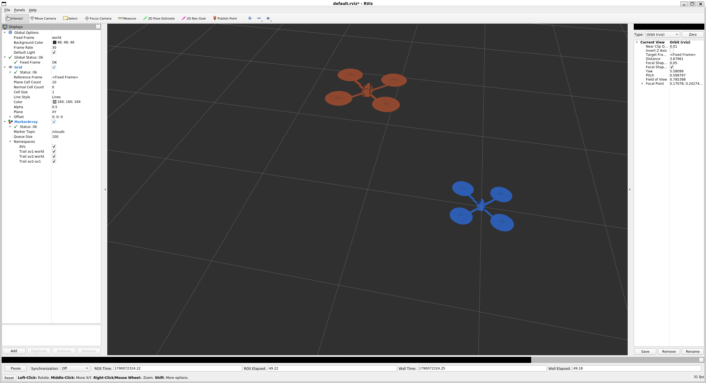
Fig. 2. Static launch and RViz verification.
rosnode list
rostopic list
rosnode info /plots_publisher_node
rostopic info /visuals
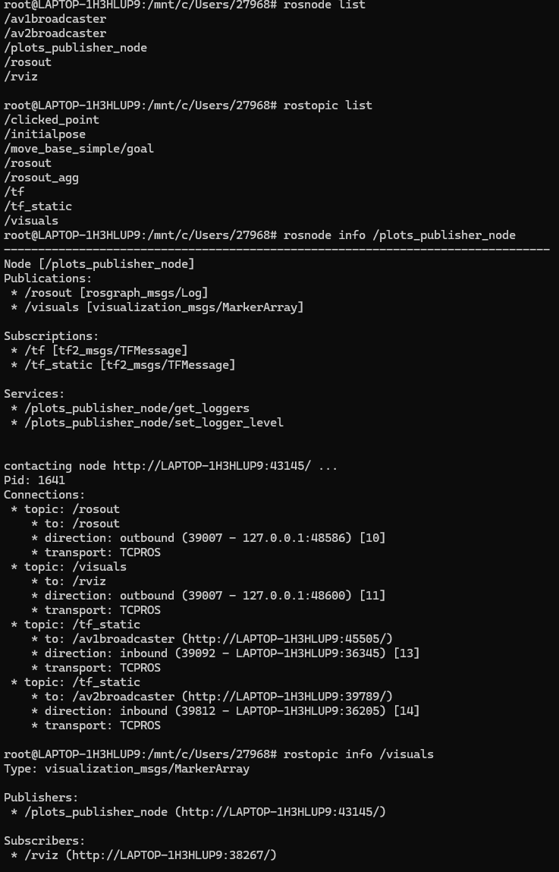
Fig. 3. Node and topic inspection.

4. DELIVERABLE 2: PUBLISHING COORDINATE TRANSFORMS
The dynamic publisher creates a 50 Hz timer. If t denotes the elapsed time since startup, the two drone origins are prescribed by the exercise as follows:
o₁ʷ(t) = [ cos(t), sin(t), 0 ]ᵀ
o₂ʷ(t) = [ sin(t), 0, cos(2t) ]ᵀ
For AV1, the yaw is t. The body y axis is therefore tangent to [cos(t), sin(t), 0], because its tangent direction is [-sin(t), cos(t), 0]. The z axis remains parallel to the world z axis. AV2 uses the identity rotation because only its position is needed for the requested trajectory derivations.
roslaunch two_drones_pkg two_drones.launch
rosrun tf tf_echo world av1
rosrun tf tf_echo world av2
rostopic hz /tf
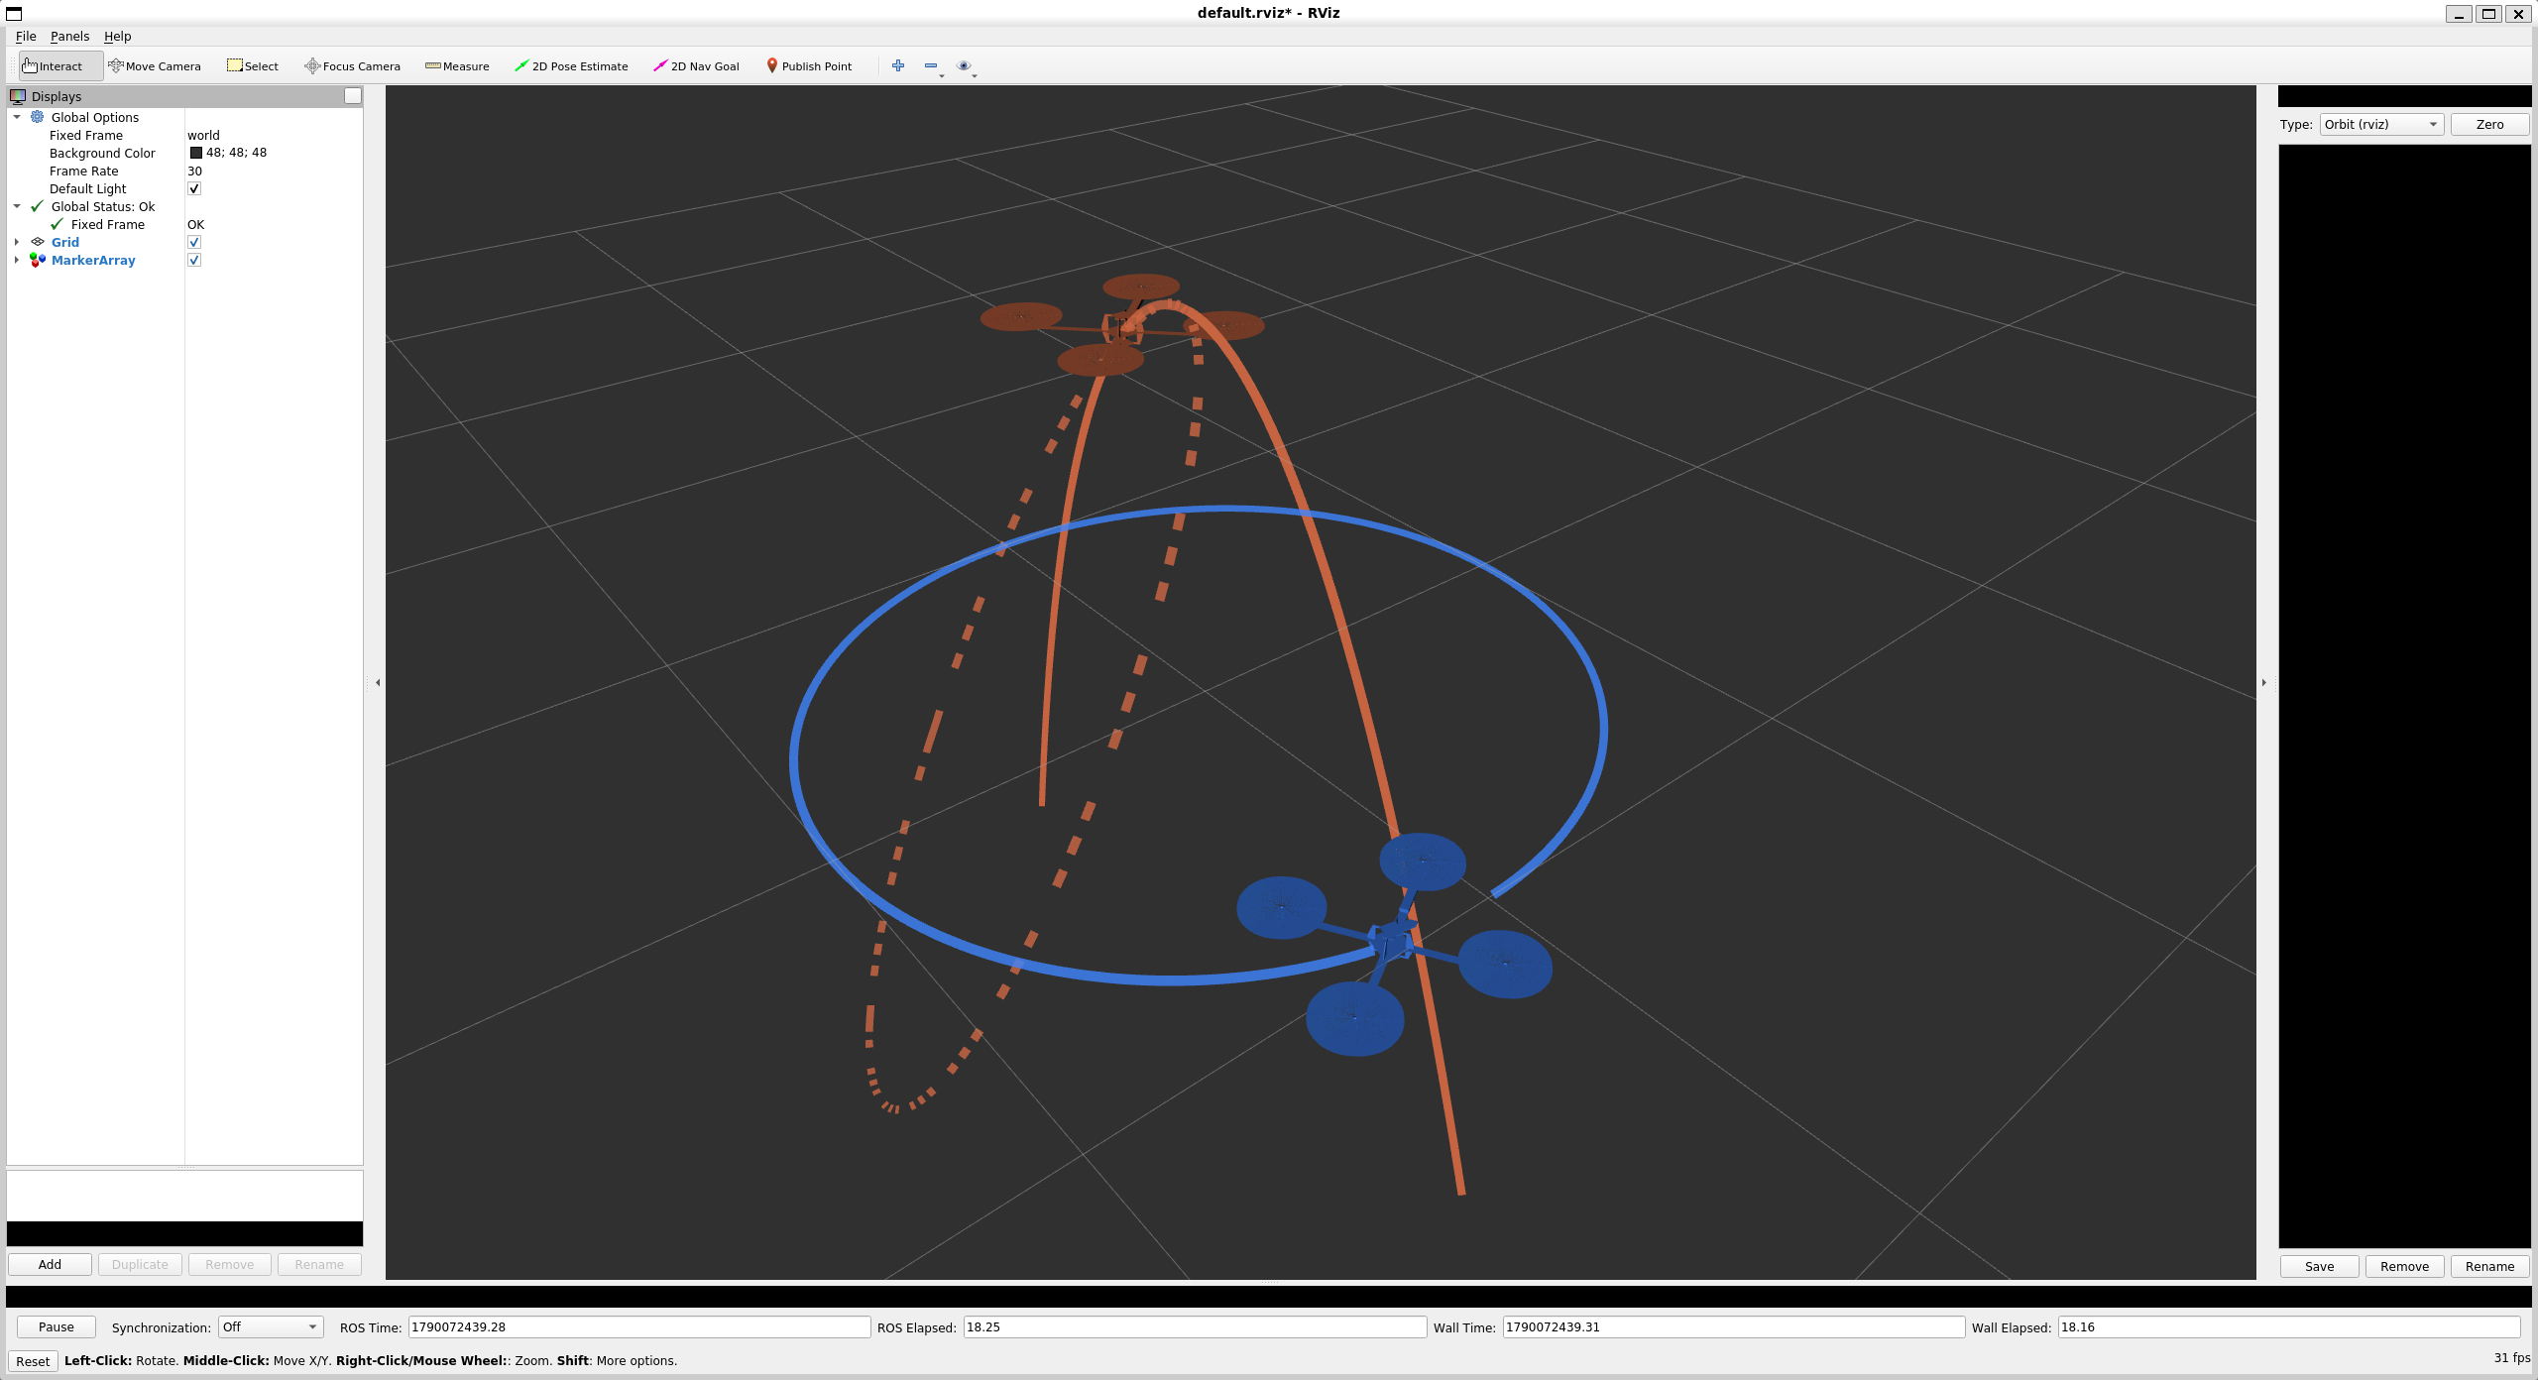
Fig. 4. Dynamic motion in RViz.
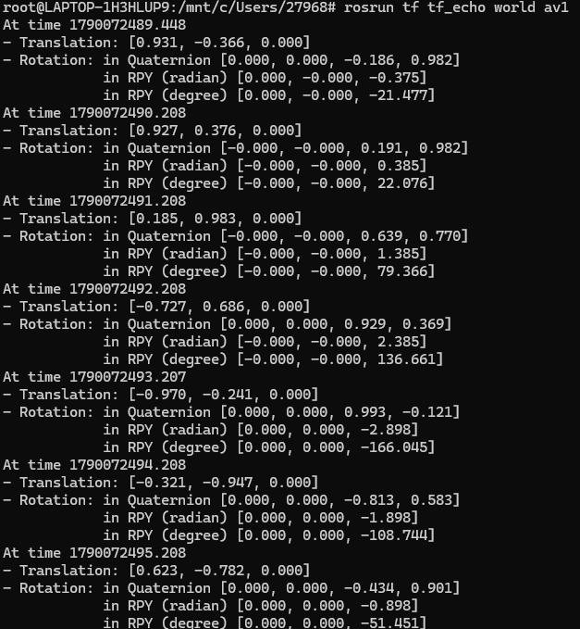
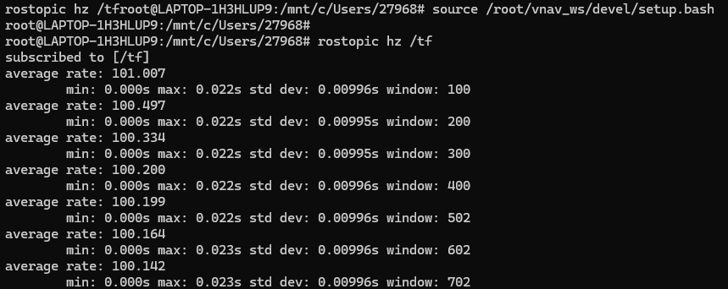
Fig. 5. Dynamic TF evidence: changing world-to-av1 transform and /tf publication rate.

5. DELIVERABLE 3: QUERYING RELATIVE TRANSFORMS
The trajectory publisher receives a reference frame and a destination frame for each trail. The latest available transform is obtained with:
transform = parent->tf_buffer.lookupTransform(
ref_frame, dest_frame, ros::Time(0));
The first trail queries world to av1 and is shown in blue. The second queries world to av2 and is shown in orange. The third queries av1 to av2 and is drawn as an orange dashed curve. When RViz Fixed Frame is changed from world to av1, AV1 becomes stationary and the relative AV2 curve is shown in the moving AV1 frame.
TABLE IV. TRAJECTORY MARKERS
Namespace | Lookup call | Expected appearance
Trail av1-world | lookupTransform(world, av1, 0) | Blue solid circular trail
Trail av2-world | lookupTransform(world, av2, 0) | Orange solid x-z trail
Trail av2-av1 | lookupTransform(av1, av2, 0) | Orange dashed relative trail

# In RViz, change Global Options -> Fixed Frame to av1
rosrun tf tf_echo av1 av2
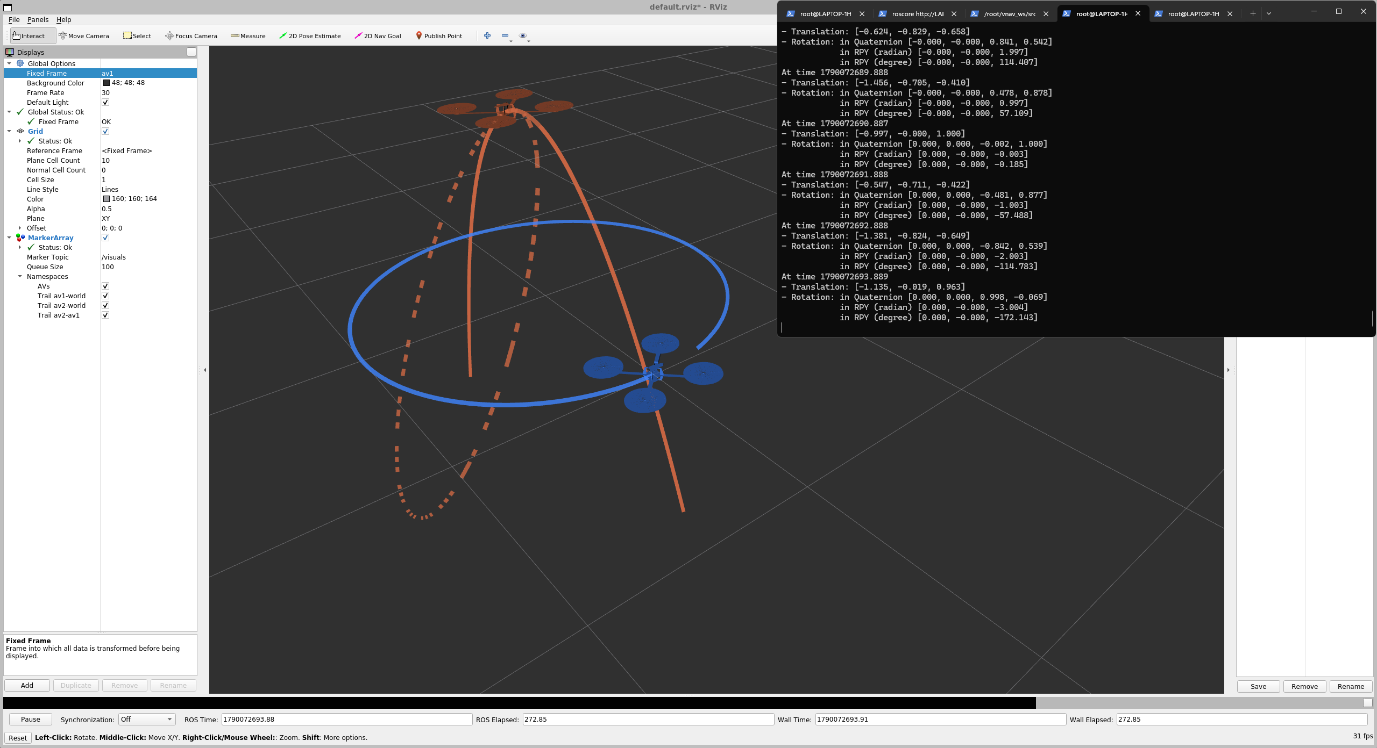
Fig. 6. AV2 relative to AV1 with Fixed Frame set to av1.

6. DELIVERABLE 4: HOMOGENEOUS TRANSFORMS AND TRAJECTORY DERIVATIONS

6.1 AV2 in the world frame
Let x = sin(t). Then cos(2t) = 1 - 2 sin²(t), so the AV2 path satisfies:
y = 0, z = 1 - 2x²
The path is a parabolic arc in the world x-z plane.

6.2 Relative homogeneous transform
Let ʷT₁ and ʷT₂ map coordinates from AV1 and AV2 to the world frame. With AV1 yaw equal to t and AV2 rotation equal to I:
¹T₂ = (ʷT₁)⁻¹ ʷT₂, o₂¹ = Rz(-t) (o₂ʷ - o₁ʷ)
o₂¹(t) = [ -1 + 0.5 sin(2t), -0.5 + 0.5 cos(2t), cos(2t) ]ᵀ

6.3 Plane and ellipse
The relative coordinates satisfy z = 2y + 1, so the trajectory lies on the plane z - 2y = 1. Choose the center p = [-1, -0.5, 0]ᵀ and the right-handed orthonormal basis:
xₚ = [1,0,0]ᵀ, yₚ = [0,1/√5,2/√5]ᵀ, zₚ = [0,-2/√5,1/√5]ᵀ
o₂ᵖ(t) = [ 0.5 sin(2t), (√5/2) cos(2t), 0 ]ᵀ
Therefore the trajectory is an ellipse in the plane z - 2y = 1. Its semiaxes are 0.5 and √5/2, with the longer semiaxis along yₚ.
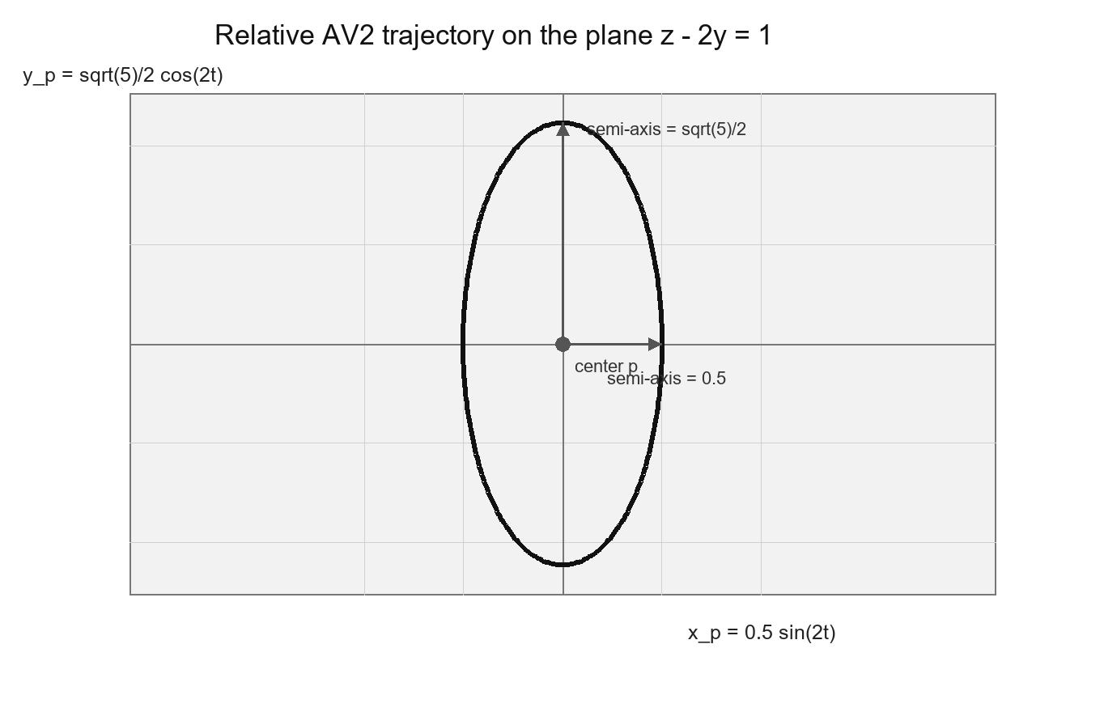
Fig. 7. Relative AV2 trajectory in the centered p frame; the ellipse lies on z - 2y = 1.

7. DELIVERABLE 5: QUATERNION LINEAR MAPS
Use q = [q₁,q₂,q₃,q₄]ᵀ with the first three entries as the imaginary part and q₄ as the scalar part. Quaternion multiplication can be written in two linear forms:
qₐ ⊗ qᵦ = Ω₁(qₐ) qᵦ = Ω₂(qᵦ) qₐ
Ω₁(q) = [ q₄ -q₃ q₂ q₁ ] Ω₂(q) = [ q₄ q₃ -q₂ q₁ ]
[ q₃ q₄ -q₁ q₂ ] [ -q₃ q₄ q₁ q₂ ]
[ -q₂ q₁ q₄ q₃ ] [ q₂ -q₁ q₄ q₃ ]
[ -q₁ -q₂ -q₃ q₄ ] [ -q₁ -q₂ -q₃ q₄ ]
For a unit quaternion q, both left and right multiplication preserve the quaternion norm because quaternion norms are multiplicative. Hence ||Ω₁(q)x|| = ||x|| and ||Ω₂(q)x|| = ||x|| for every x in R⁴, which proves Ωᵢ(q)ᵀΩᵢ(q) = Ωᵢ(q)Ωᵢ(q)ᵀ = I₄. The fourth column of both displayed matrices is q, so Ωᵢ(q)e₄ = q. Multiplying by Ωᵢ(q)ᵀ gives Ωᵢ(q)ᵀq = e₄, where e₄ = [0,0,0,1]ᵀ.
For arbitrary x, y, and z, Ω₁(x)Ω₂(y)z = x ⊗ (z ⊗ y) while Ω₂(y)Ω₁(x)z = (x ⊗ z) ⊗ y. Associativity proves Ω₁(x)Ω₂(y) = Ω₂(y)Ω₁(x). Since Ω₂(y)ᵀ = Ω₂(conj(y)), replacing y by conj(y) proves Ω₁(x)Ω₂(y)ᵀ = Ω₂(y)ᵀΩ₁(x).

8. OPTIONAL DELIVERABLE 6: INTRINSIC AND EXTRINSIC ROTATIONS
For column vectors and active rotations, extrinsic rotations about fixed world axes multiply on the left, giving R_ext = R₂R₁R₀. Intrinsic rotations about the current body axes multiply on the right. If the intrinsic sequence is applied in reverse order, the accumulated expression is also R₂R₁R₀, so both descriptions produce the same final orientation. The required numerical substitution is:
R₀ = Rx(90°), R₁ = Ry(180°), R₂ = Rx(-30°)
R₂R₁R₀ = [ -1 0 0 ; 0 -1/2 -√3/2 ; 0 -√3/2 1/2 ]
Thus the extrinsic sequence and the reversed intrinsic sequence have exactly the same final orientation. This completes the optional deliverable without requiring an additional ROS screenshot.

9. COMPLETE OPERATION AND SCREENSHOT PROCEDURE
The following sequence produces the evidence required for the final report. Run each command in a separate Ubuntu terminal unless the command is explicitly marked as a continuation in the same terminal.
1. Enter Ubuntu from PowerShell with: wsl -d Ubuntu-20.04.
2. In Terminal 1 run source /opt/ros/noetic/setup.bash and roscore. Capture the terminal only if the instructor requests ROS master evidence.
3. In Terminal 2 run source /opt/ros/noetic/setup.bash, source /root/vnav_ws/devel/setup.bash, rosversion -d, which roscore, which rviz, and rospack find two_drones_pkg. Capture Fig. 1.
4. Run roslaunch two_drones_pkg two_drones.launch static:=true. Wait for RViz. Confirm Fixed Frame = world, MarkerArray status OK, and AVs checked. Capture Fig. 2.
5. In Terminal 3 run rosnode list, rostopic list, rosnode info /plots_publisher_node, and rostopic info /visuals. Capture Fig. 3.
6. Stop only the launch with Ctrl+C. Keep roscore running.
7. Run roslaunch two_drones_pkg two_drones.launch. Wait 5 to 10 seconds so the three trails become visible. Capture Fig. 4.
8. In Terminal 3 run rosrun tf tf_echo world av1 and rostopic hz /tf. Wait until translation values change and the frequency stabilizes. Capture Fig. 5.
9. In RViz change Global Options -> Fixed Frame from world to av1. Keep MarkerArray and all four namespaces enabled. Run rosrun tf tf_echo av1 av2 in Terminal 3. Capture Fig. 6.
10. The captured screenshots are embedded in Figs. 1 through 6. Fig. 7 is the analytic relative-trajectory plot generated from the derived expression.
11. Before submission, confirm that the document title, author name, student ID, figures, and all mathematical deliverables are present.
TABLE V. FINAL SUBMISSION CHECKLIST
Evidence | Status before student insertion
ROS Noetic and package path | Verified in Fig. 1
Static nodes and topics | Verified in Figs. 2 and 3
Dynamic AV1 and AV2 motion | Verified in Fig. 4
Changing TF values and frequency | Verified in Fig. 5
Relative AV2-to-AV1 view | Verified in Fig. 6
Math derivations | Deliverables 4-6 completed
Author information | Li Zehao; 24020036039

10. CONCLUSION
LAB2 established a working ROS 1 Noetic environment and used it to publish, query, and visualize the two-drone coordinate frames. The implementation satisfies the required node, topic, launch, transform, and tf2 lookup functions. The analytic results show that the AV2 trajectory is a parabola in the world frame and an ellipse on the plane z - 2y = 1 when expressed relative to AV1. The remaining report work is limited to inserting the student's screenshots and completing the identifying information and any instructor-required explicit matrix expansion.

REFERENCES
[1] MIT VNAV Lab 2 Exercises, https://vnav.mit.edu/labs_2023/lab2/exercises.html
[2] MIT-SPARK, VNAV-labs, https://github.com/MIT-SPARK/VNAV-labs
[3] ROS Noetic documentation and tf2 tutorials, https://wiki.ros.org/tf2
[4] LAB2 course slides, LAB2/Lab2.pdf

