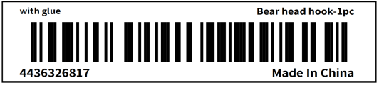

**Name: Apex CE Specialists GmbH**

**Address:Grafenberger Allee 277,40237 Düsseldorf,DE**

**Email: Info@apex-ce.com**

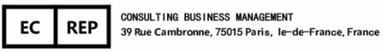

**Manufacturer: Shenzhenshixingchenkejimaoyi Co., Ltd.**

**Manufacturer Address: 101, Building 12, Xianglong Garden, Bantian Street, Longgang District, Shenzhen City,**

**Guangdong Province,China**

**Manufacturer Email: isa@sparkx.top**

**Batch Code:4436326817**

