number | structure | λ_{abs[nm]} | λ_{em [nm]} | ε [M⁻¹ cm⁻¹]
1 | 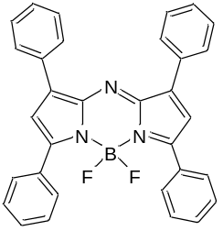 | 640  in CHCl₃ | 688  in CHCl₃ | 79000
2 | 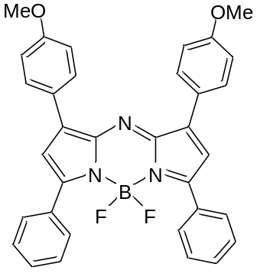 | 664 nm | 672 nm | 78000
3 | 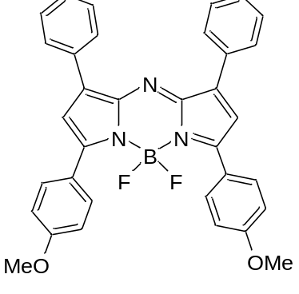 | 688 | 715 | 85000
4 | 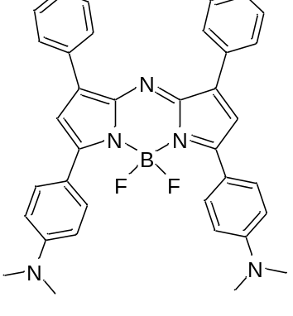 | 799 | 823 | 87000
5 | 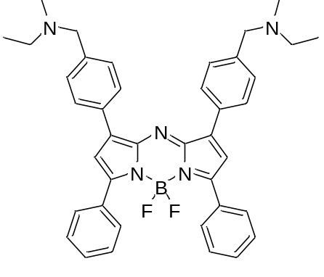 | 654 | 683 | 71600
6 | 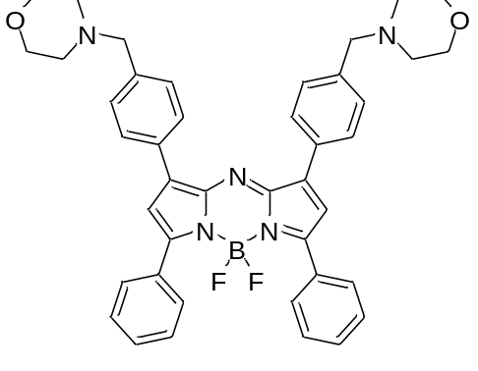 | 655 | 683 | 87600
7 | 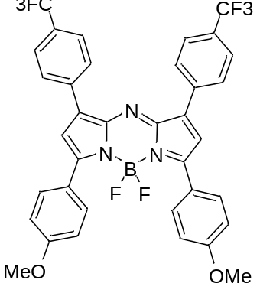 | 704 | 741
8 | 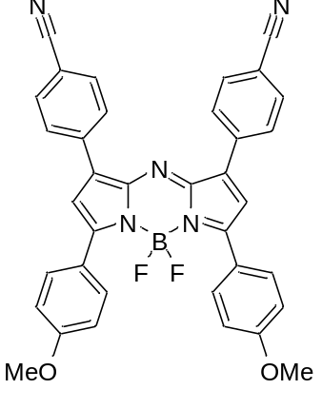 | 716 | 755
9 | 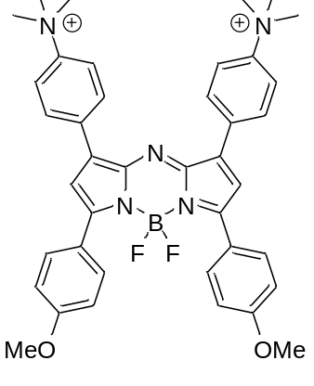 | 712 | 752
10 | 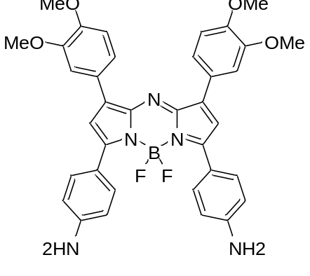 | 750 | 815 | 48000
11 | 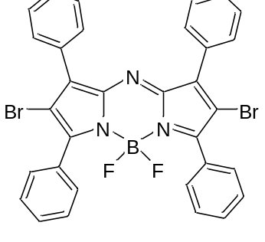 | 650 | 673 | 79000
12 | 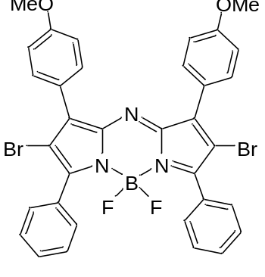 | 679 | 714 | 75000
13 | 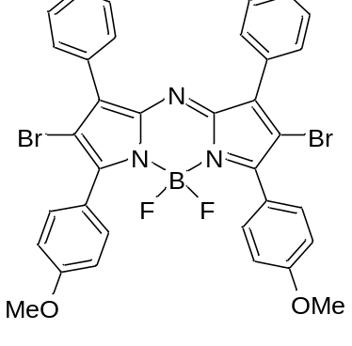 | 653 | 679 | 80000
14 | 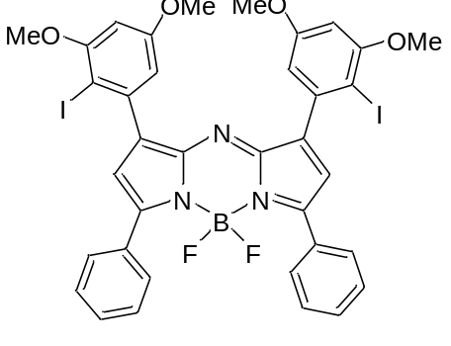 | 658 | 690 | 83000
15 | 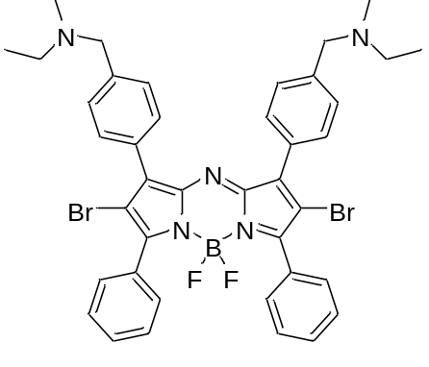 | 684 | 728 | 70800
16 | 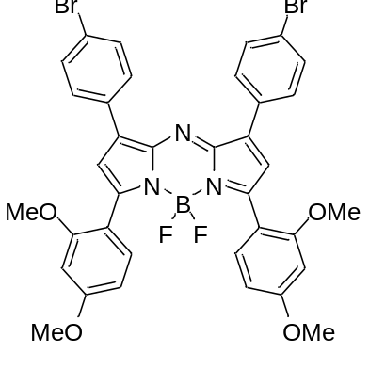 | 692 | 738 | 66200
17 | 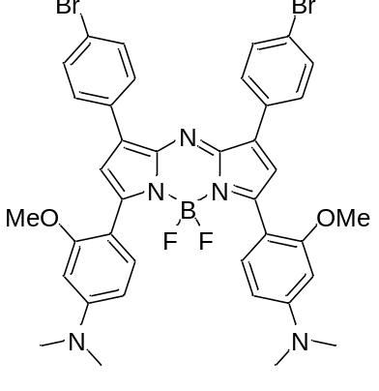 | 798 | 830 | 68610
18 | 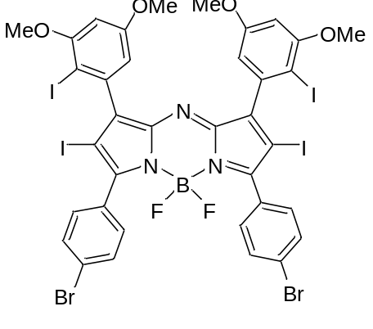 | 666 | 694 | 69900
19 | 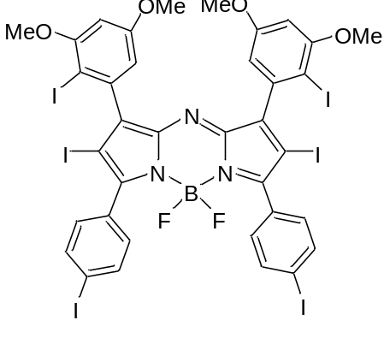 | 676 | 712
20 | 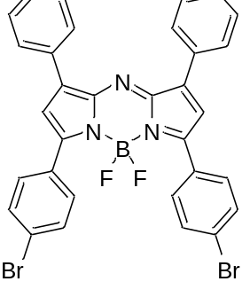 | 658 | 690 | 66000
21 | 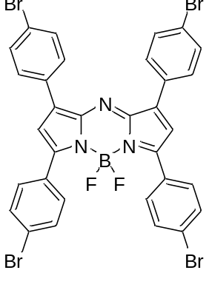 | 667 | 699 | 60700
22 | 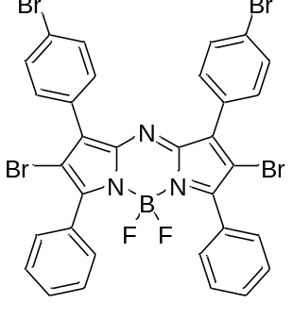 | 651 | 685 | 45900
23 | 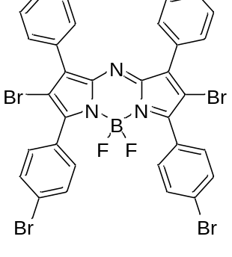 | 651 | 685 | 59300
24 | 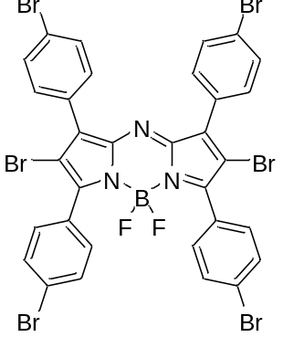 | 657 | 685 | 39100
25 | 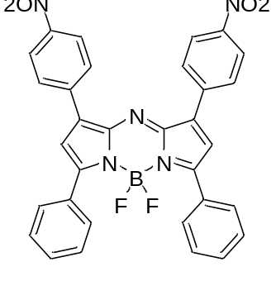 | 662  ACN | 696 | 78000
26 | 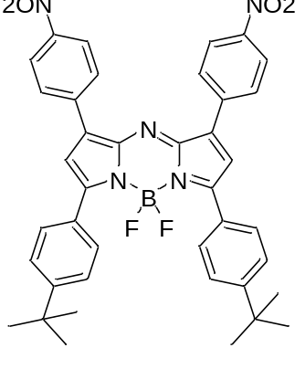 | 681  ACN | 715 | 70000
27 | 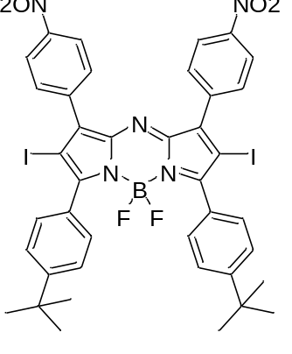 | 672  ACN | 732 | 50000
28 | 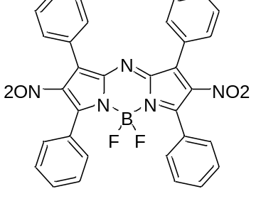 | 620 | 664 | 45400
29 | 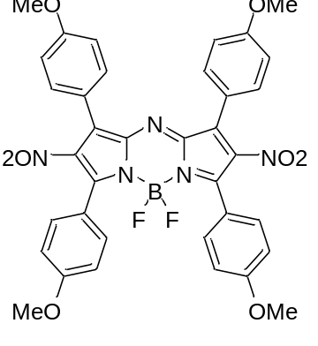 | 692 | 723 | 46400
30 | 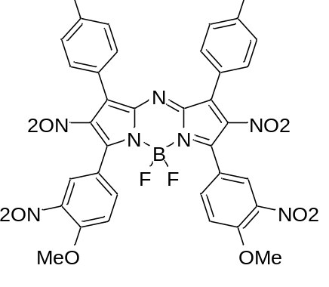 | 654 | 699 | 45100
31 | 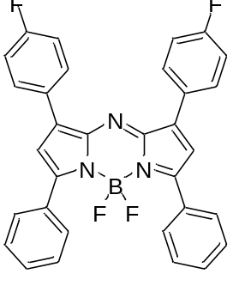 | 650 | 674 | 80000
32 | 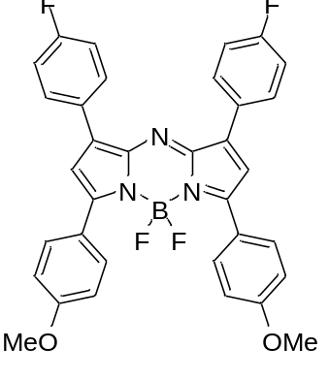 | 688 | 715 | 86000
33 | 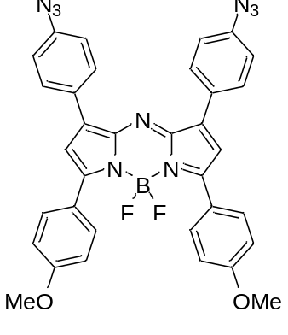 | 710 | 754 | 67000
34 | 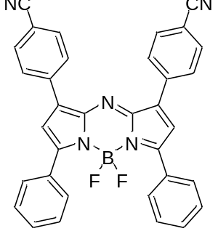 | 667 | 711
35 | 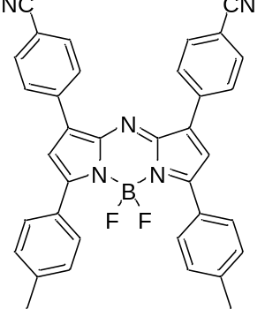 | 685  THF | 733
36 | 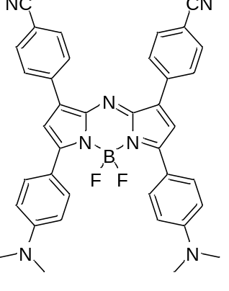 | 855  THF
37 | 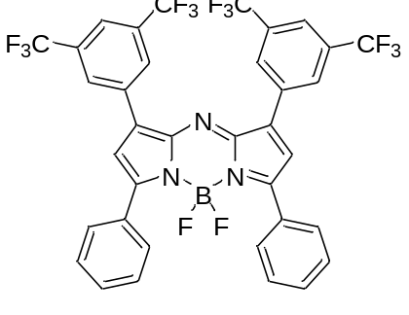 | 656 | 685 | 81430
38 | 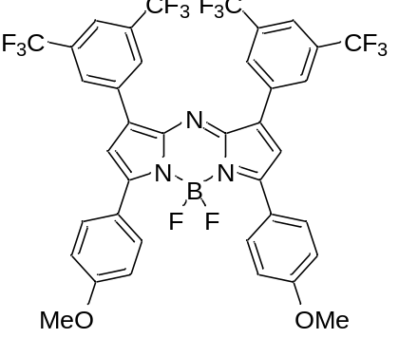 | 706 | 739 | 83040
39 | 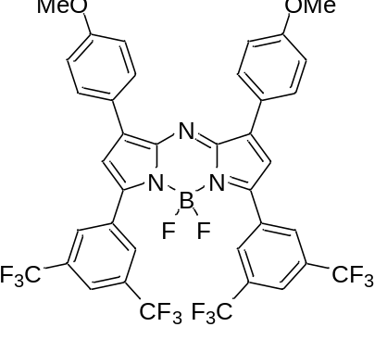 | 774 | 722 | 13260
40 | 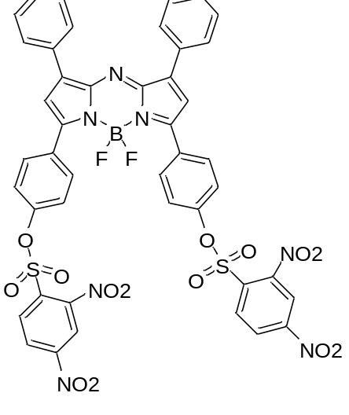 | 654  THF | 682 | 82280
41 | 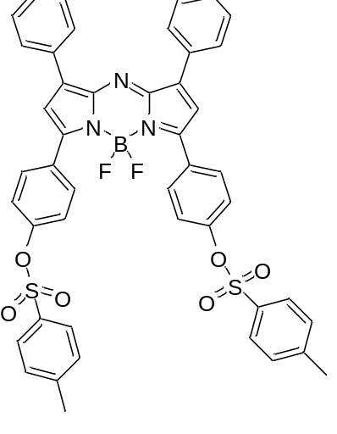 | 658  THF | 686 | 74746
42 | 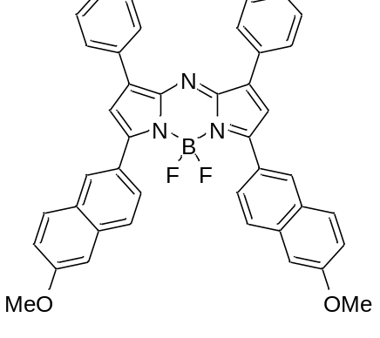 | 706 | 733 | 89000
43 | 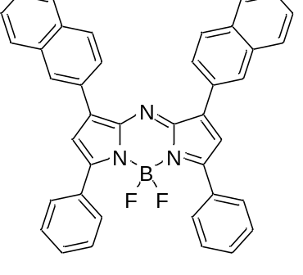 | 650 | 681
44 | 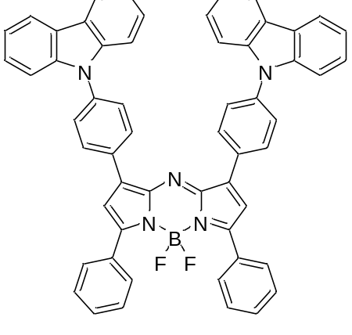 | 606 | 774
45 | 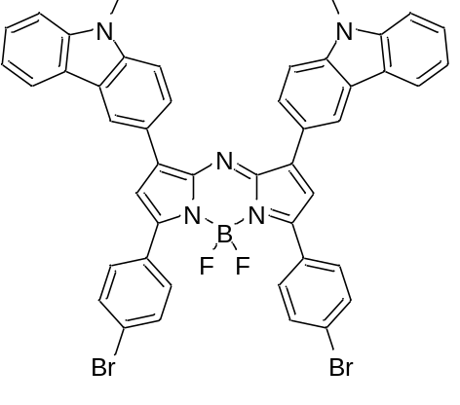 | 653 | 815 | 37000
46 | 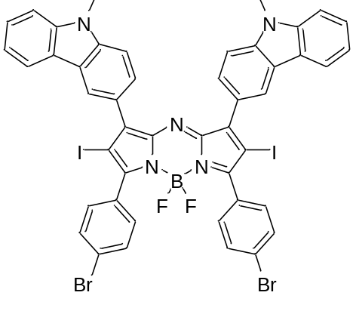 | 649 | 830 | 41000
47 | 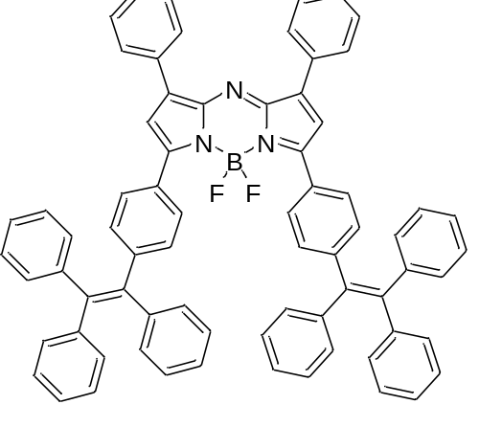 | 708 | 754 | 77500
48 | 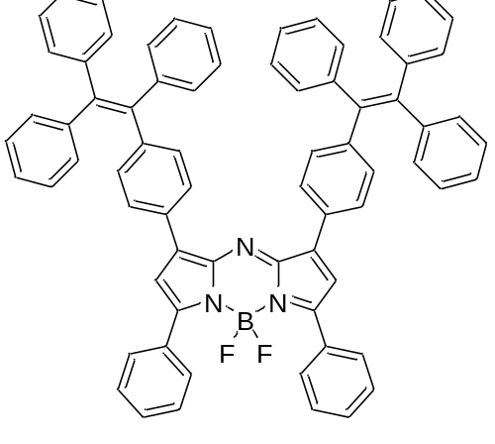 | 682 | 730 | 77100
49 | 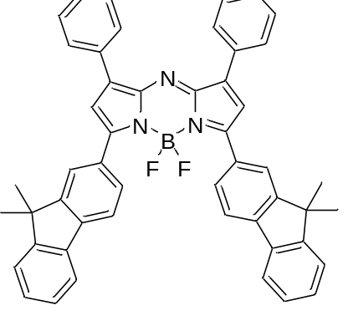 | 708 | 742 | 92400
50 | 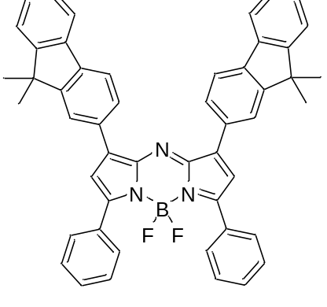 | 677 | 713 | 86700
51 | 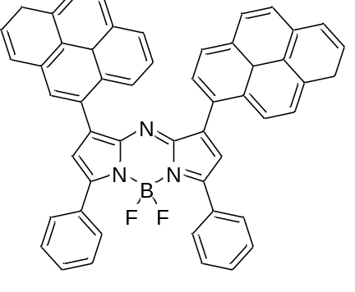 | 670 | 763
52 | 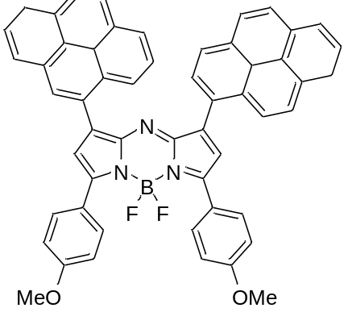 | 700 | 744
53 | 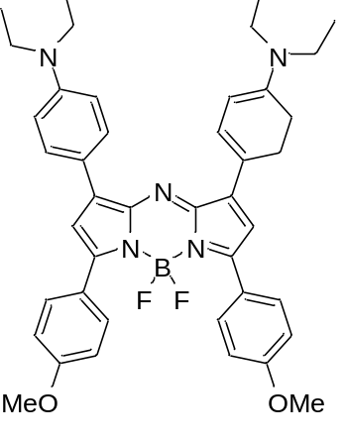 | 689 | 960 | 40000
54 | 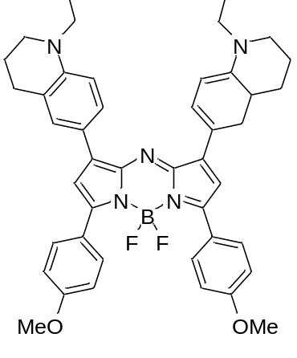 | 830 | 1030 | 26000
55 | 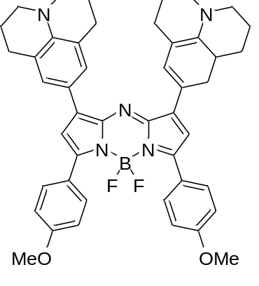 | 910 | 1060 | 170000
56 | 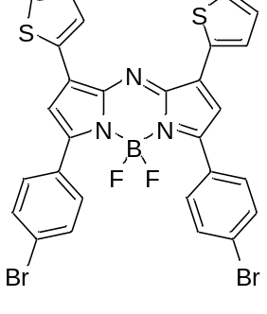 | 694 | 729 | 82000
57 | 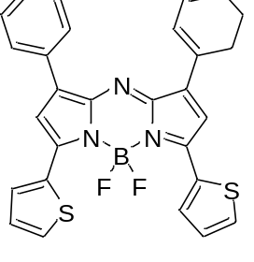 | 710 | 732 | 108600
58 | 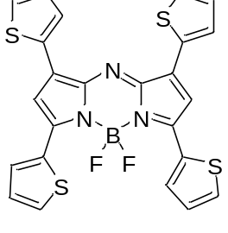 | 733  ACN | 757 | 110000
59 | 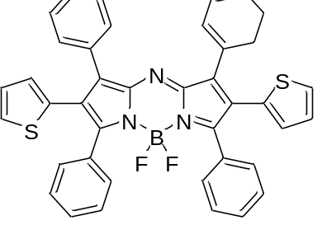 | 650 |  | 40000
60 | 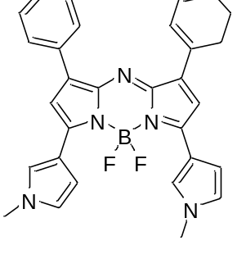 | 721 | 751 | 115000
61 | 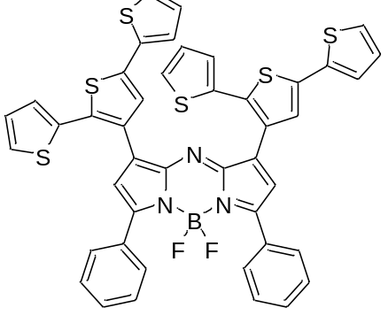 | 665 |  | 15100
62 | 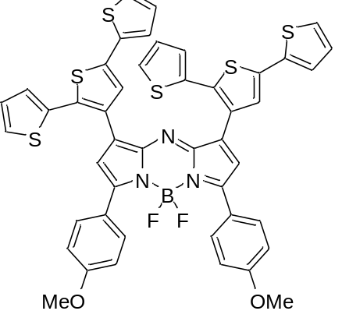 | 706 | 734 | 40300
63 | 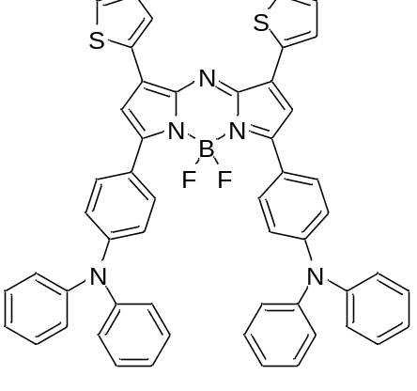 | 818 | 896 | 15236
64 | 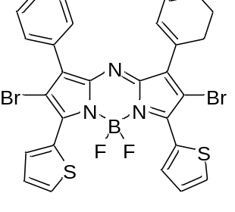 | 726 | 752 | 108000
65 | 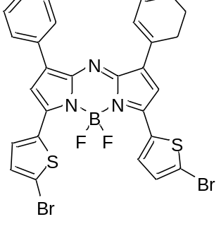 | 727 | 751 | 111000
66 | 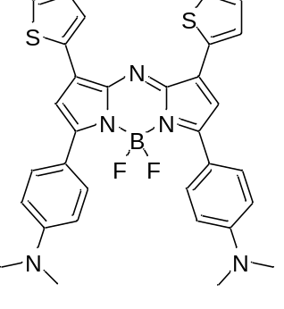 | 824
67 | 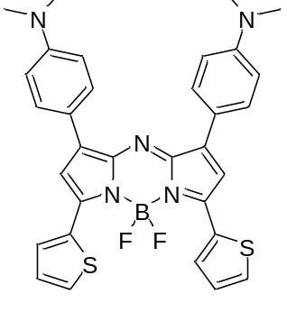 | 790
68 | 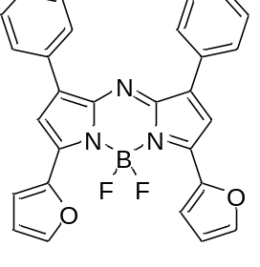 | 721 | 730 | 133900
69 | 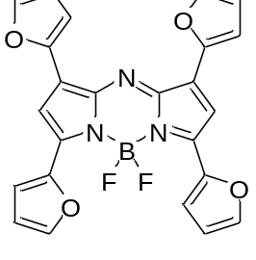 | 751 | 758 | 130700
70 | 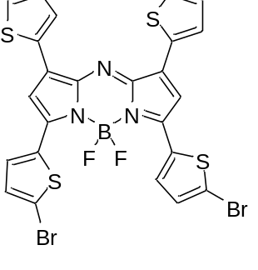 | 756 |  | 120000
71 | 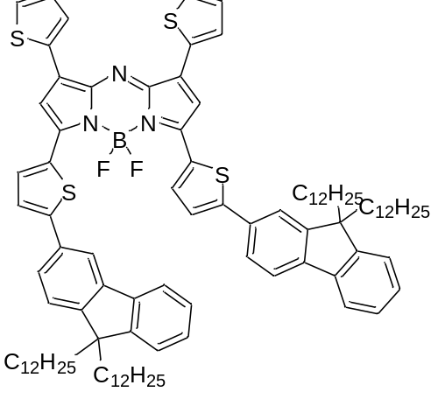 | 864 |  | 48000
72 | 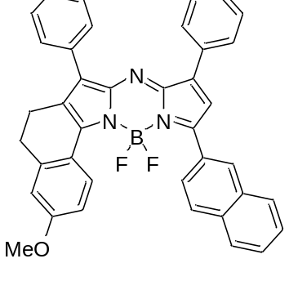 | 715 | 730 | 141000
73 | 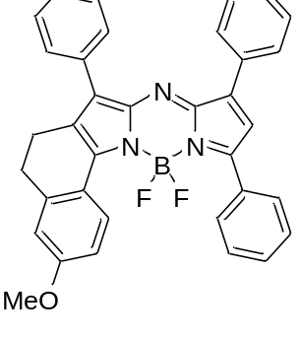 | 688 | 710 | 108000
74 | 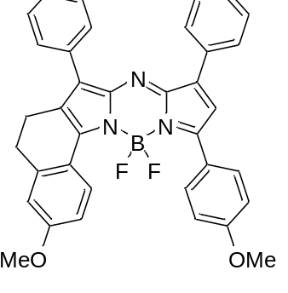 | 708 | 732 | 96200
75 | 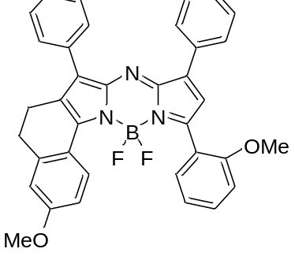 | 678 | 713 | 83900
76 | 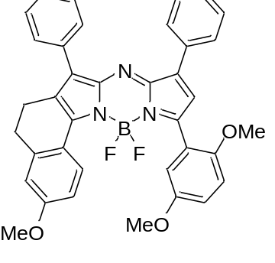 | 707 | 735 | 66500
77 | 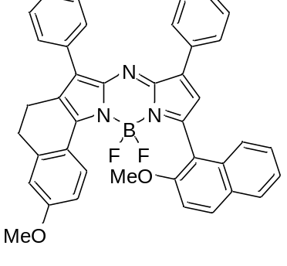 | 668 | 692 | 113000
78 | 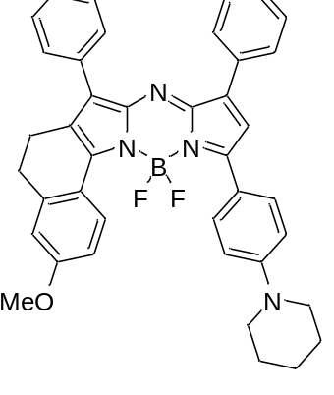 | 774 | 815 | 70300
79 | 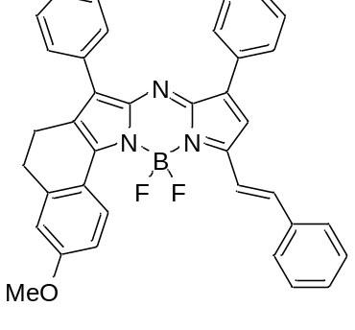 | 731 | 749 | 166000
80 | 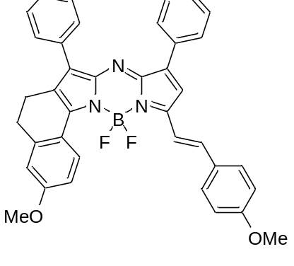 | 746 | 780 | 166000
81 | 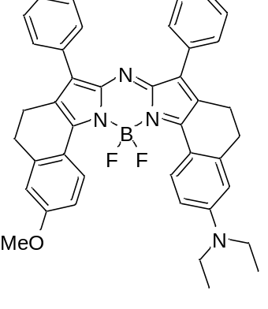 | 796 | 813 | 172000
82 | 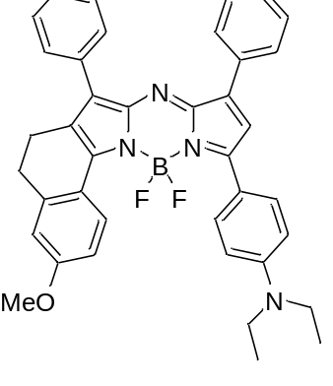 | 789 | 822 | 135000
83 | 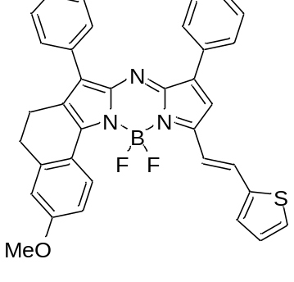 | 760 |  | 155000
84 |  | 762 | 778 | 155000
85 | 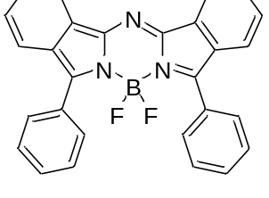 | 715 | 736 | 87100
86 | 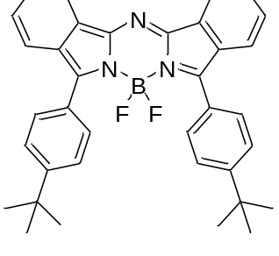 | 724 | 749 | 85100
87 | 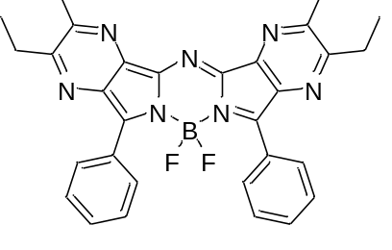 | 685 | 721
88 | 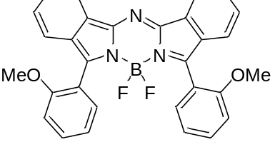 | 681 | 723 | 79000
89 | 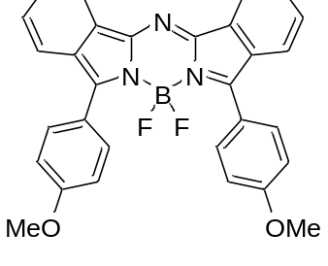 | 729 | 769 | 91100
90 | 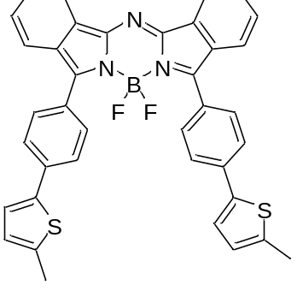 | 793 | 841 | 95000
91 | 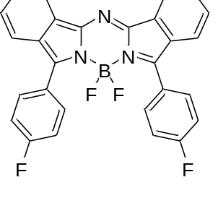 | 713 | 724
92 | 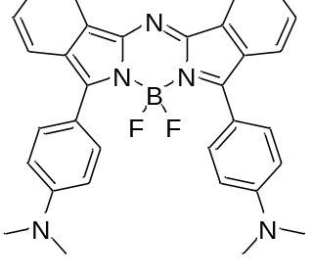 | 794 | 830
93 | 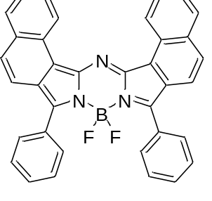 | 737 | 753
94 | 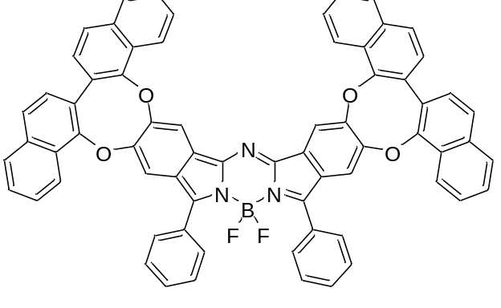 | 722 | 754 | 109647
95 | 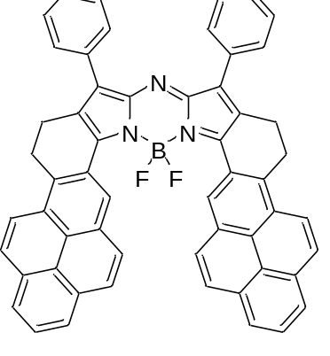 | 746 | 762
96 | 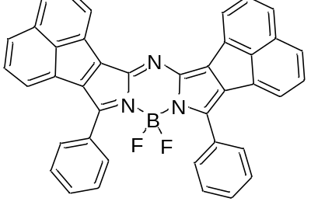 | 673 | 774
97 | 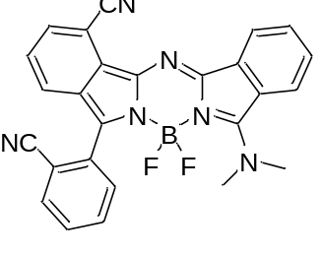 | 591 | 654 | 25820
98 | 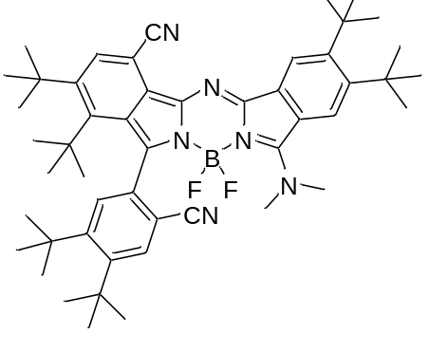 | 599 | 674 | 40090
99 | 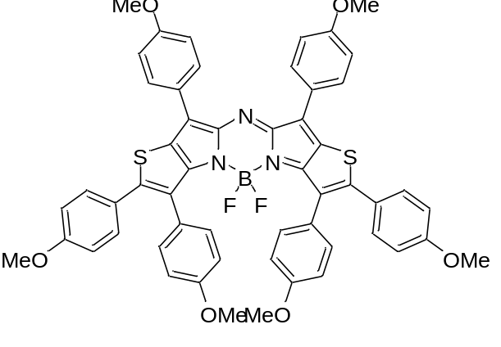 | 784 | 816
100 | 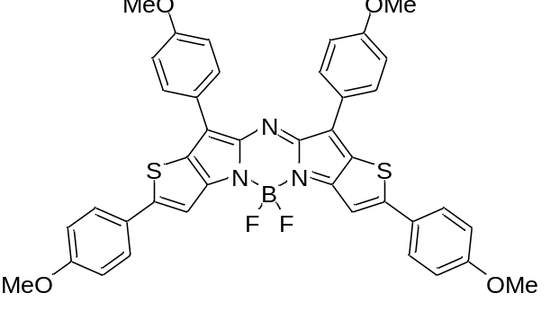 | 788 | 814

