number | structure | λ_{abs[nm]} | λ_{em [nm]} |  [M⁻¹ cm⁻¹]
1 | 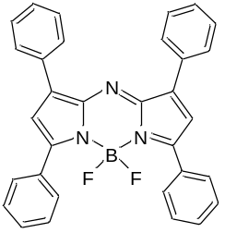 | 640  in CHCl₃ | 688  in CHCl₃ | 79000
2 | 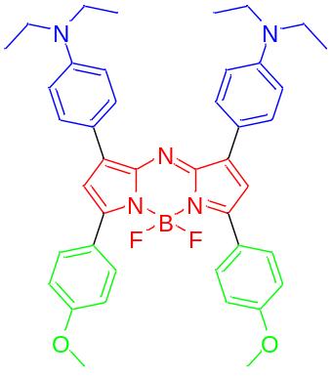 | PBS (pH=7.4) + 20% DMSO  799 | 960 | 40000
3 | 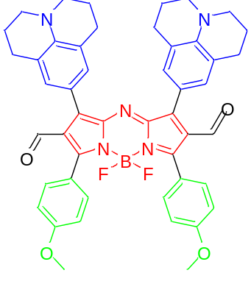 | 1020
4 | 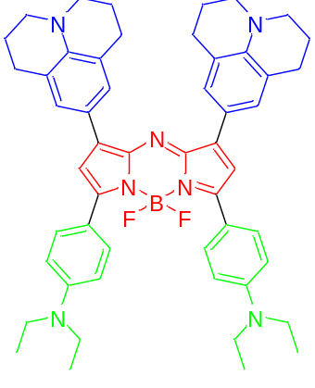 | DMSO  853 | 1028 | 135000
5 | 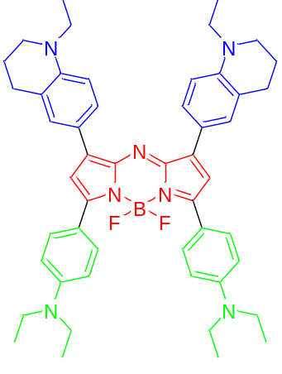 | DMSO  859 | 998
6 | 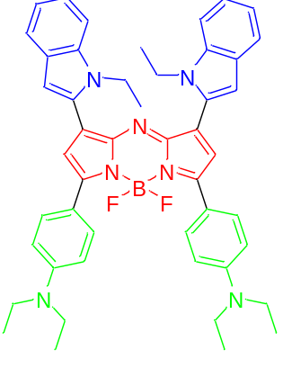 | DMSO  880 | 980
7 | 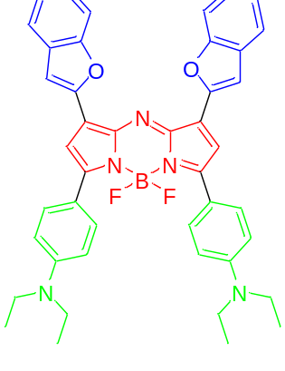 | DMSO  913 | 1030
8 | 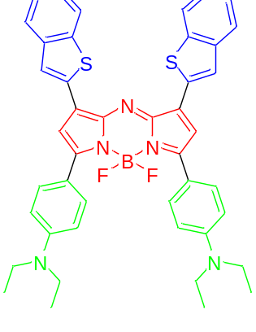 | DMSO  910 | 1028
9 | 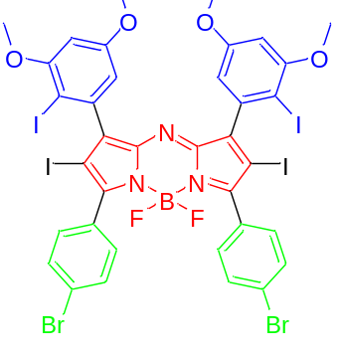 | DMSO  666 | 694 | 69900
10 | 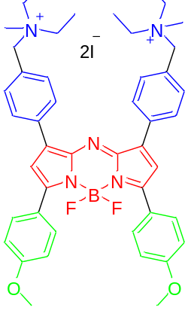 | CHCl₃  702 | 732 | 69000
11 | 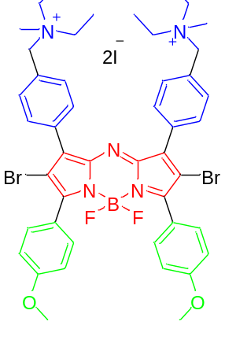 | CHCl₃  681 | 722 | 64000
12 | 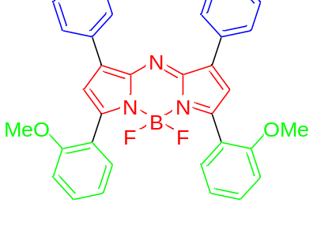 | Toluene  640 | 688 | 73850
13 | 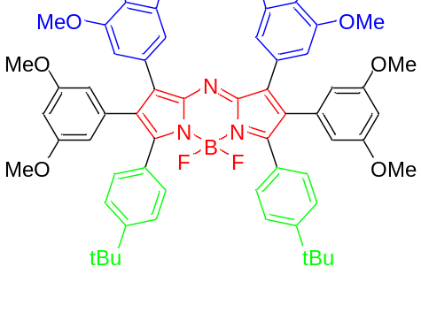 | Toluene  674 | 721 | 95500
14 | 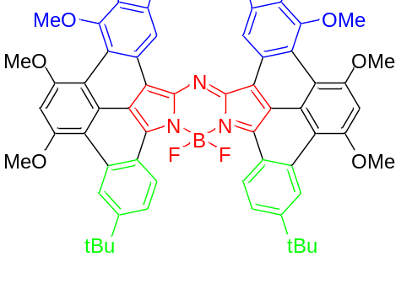 | Toluene  878 | 907 | 260100
15 | 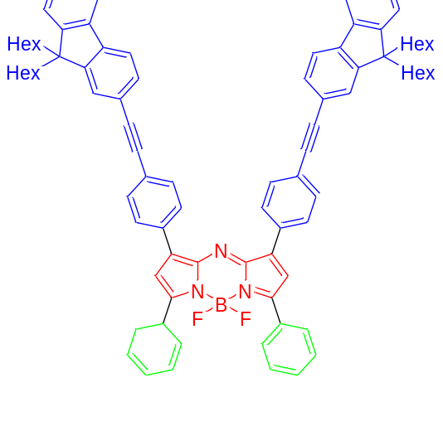 | 675 | 711 | 86000
16 | 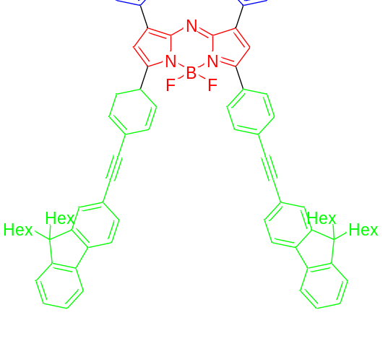 | CHCl₃  694 | 741 | 100000
17 | 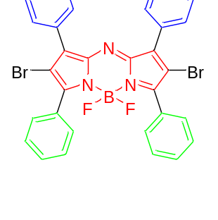 | Toluene  654 | 691 | 81000
18 | 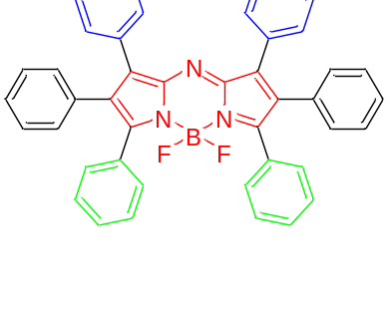 | Toluene  656 | 695 | 83000
19 | 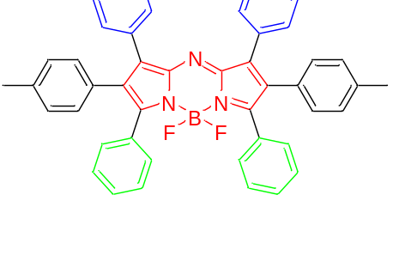 | Toluene  656 | 709 | 50000
20 | 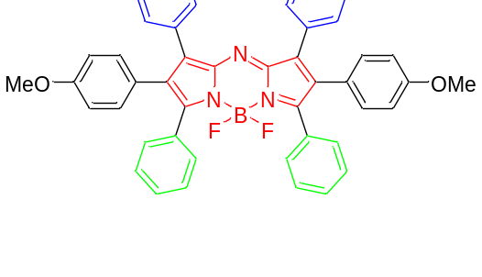 | Toluene  653 | 692 | 31000
21 | 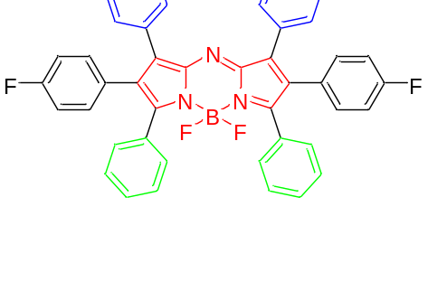 | Toluene  654 | 750 | 55000
22 | 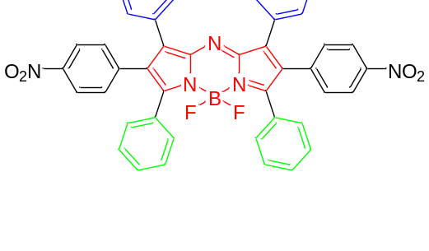 | Toluene  654 | 688 | 76000
23 | 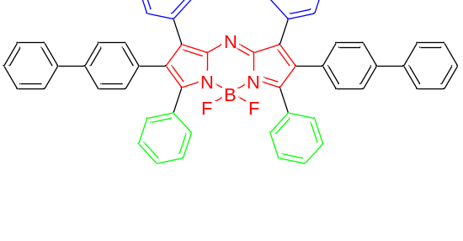 | Toluene  656 | 716 | 70000
24 | 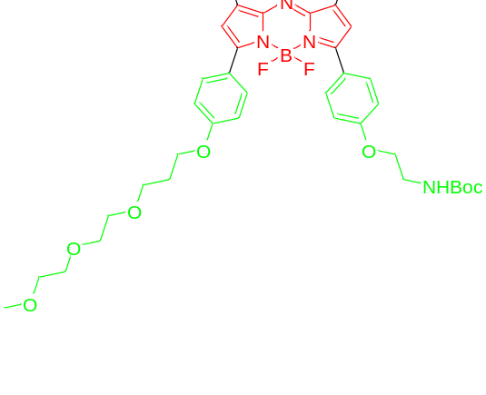 | Ethanol  688 | 714 | 95000
25 | 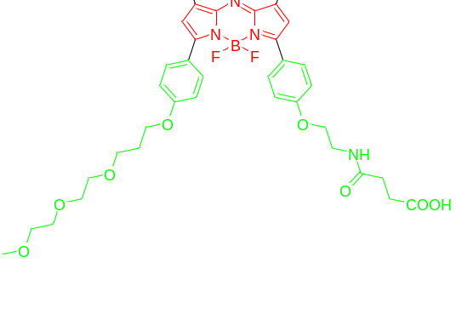 | Ethanol  691 | 714 | 85500
26 | 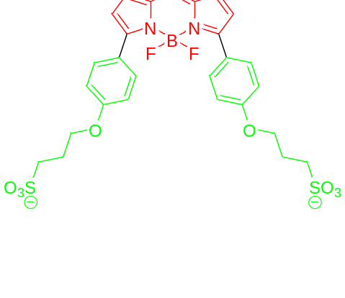 | CHCl₃  694 | 726 | 51000
27 | 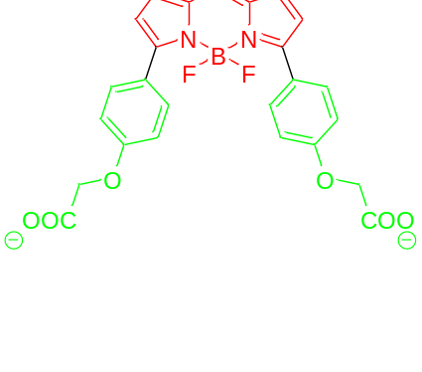 | CHCl₃  681 | 711 | 89000
28 | 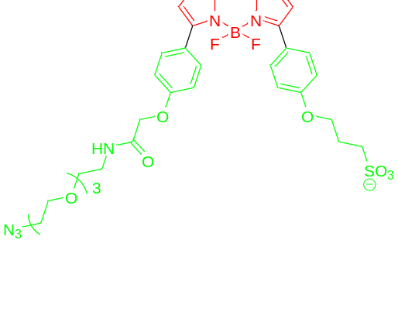 | Buffer  689 | 719 | 74000
29 | 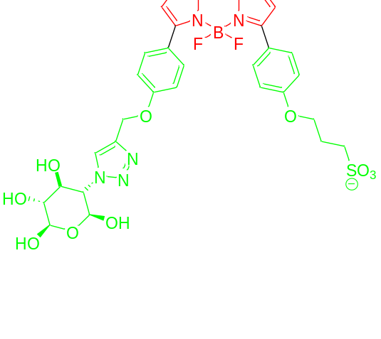 | Buffer  688 | 722 | 69000
30 | 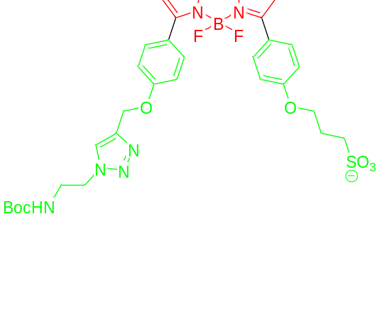 | Buffer  692 | 721 | 65000
31 | 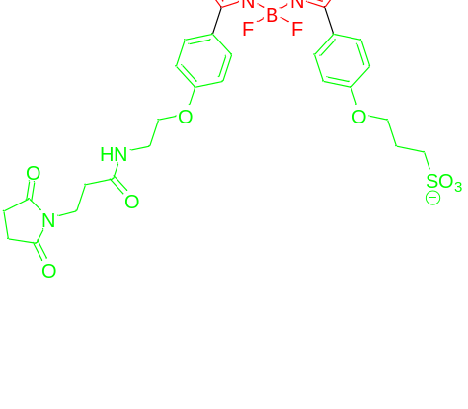 | MeOH  691 | 716 | 82000
32 | 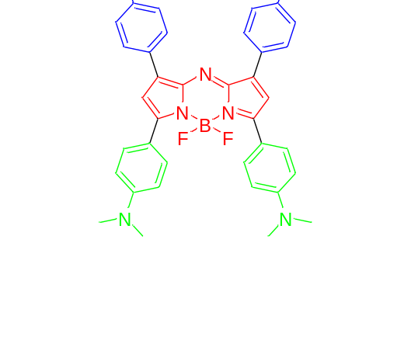 | Buffer  786 |  | 50000
33 | 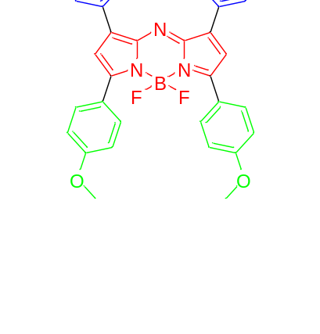 | CHCl₃  702 | 735 | 69000
34 | 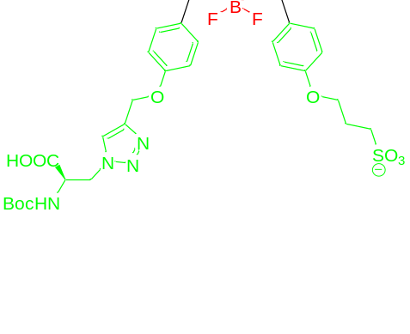 | Buffer  688 | 722 | 66000
35 | 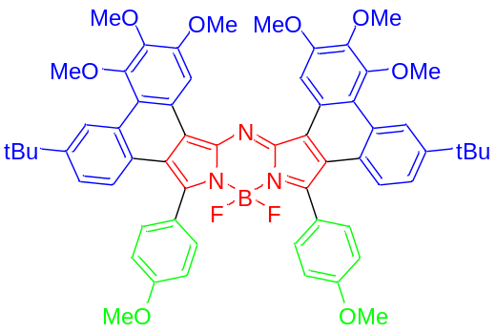 | In Toluene  745 | 771 | 124700
36 | 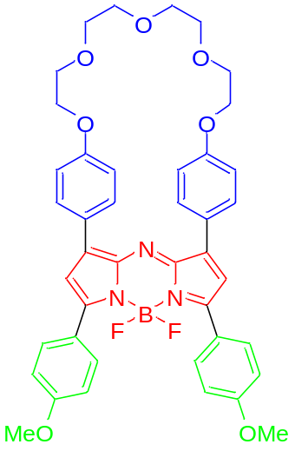 | 686 | 752 | 82200
37 | 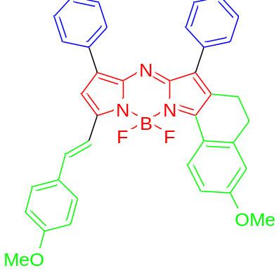 | 746 | 780 | 153000
38 | 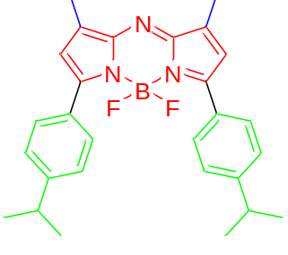 | in DMSO  774 | 822 | N.A
39 | 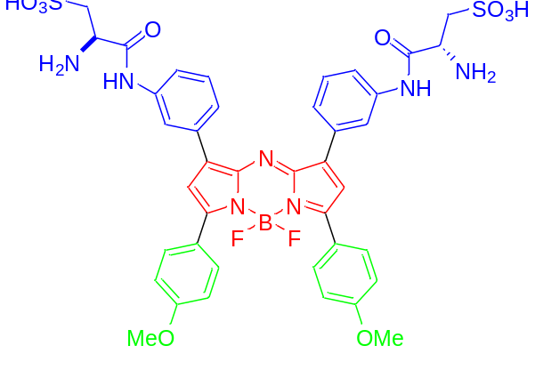 | in DMSO  703 | 730 | 61200
40 | 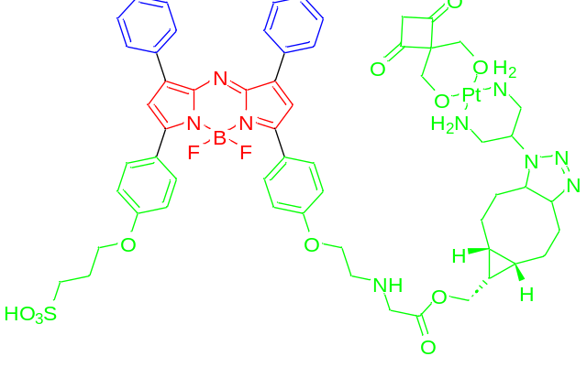 | In H₂O  695 | 720 | 64000
41 | 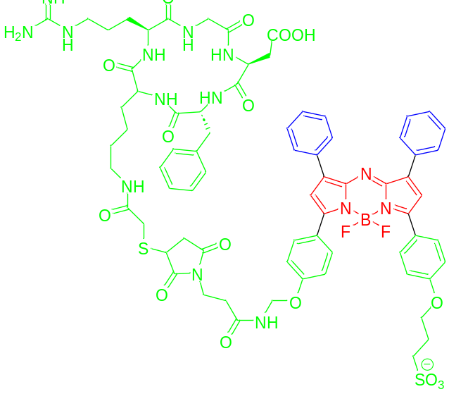 | In MeOH  691 | 716 | N.A
42 | 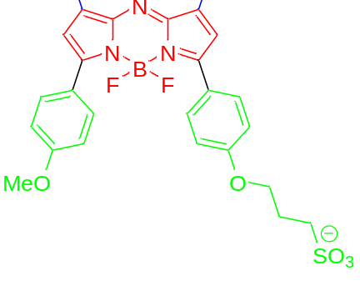 | In PBS  651 | 691 | N.A
43 | 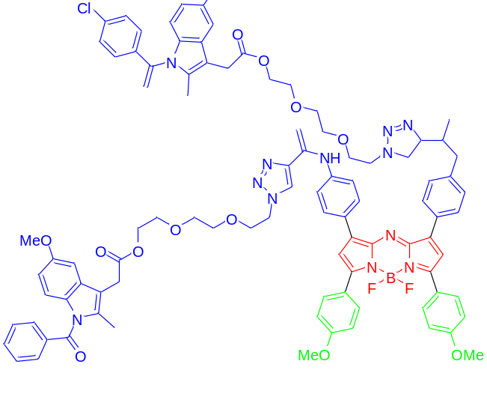 | in DMSO  704 | 734 | 25000
44 | 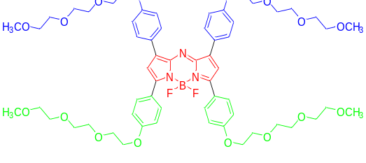 | 690 |  | 81000
45 | 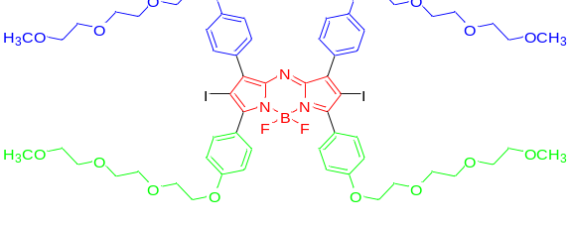 | 670 |  | 39000
46 | 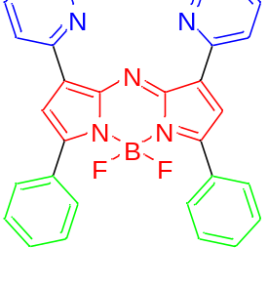 | MeCN  655 | 682
47 | 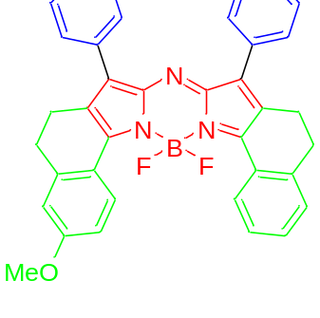 | CHCl3  723 | 734 | 157000
48 | 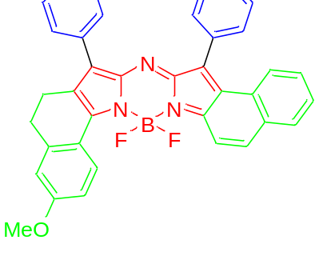 | CHCl3  715 | 730 | 141000
49 | 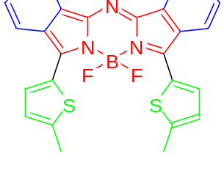 | 793 | 841 | 95000
50 | 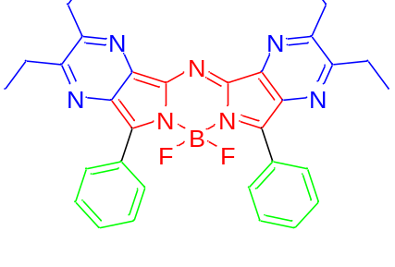 | 685 | 721
51 | 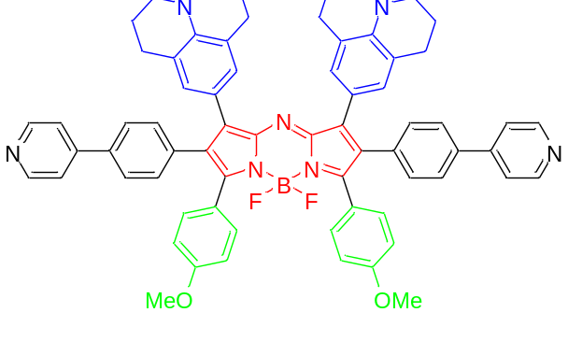 | 820 | 1002
52 | 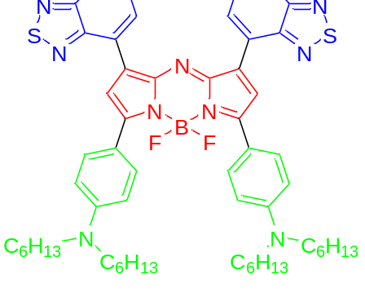 | 甲苯895 | 975 | 78000
53 | 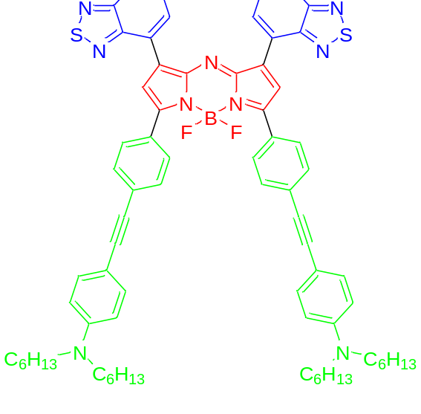 | 甲苯782 | 975 | 50500
54 | 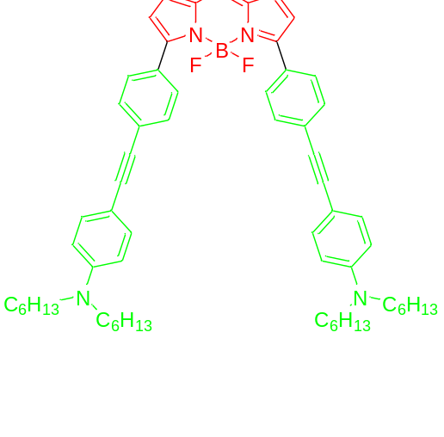 | 甲苯  740 | 826 | 57000
55 | 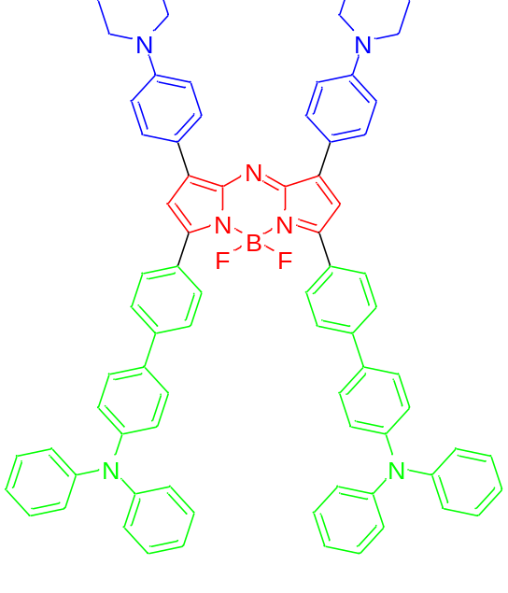 | in DMSO  860 | 1045
56 | 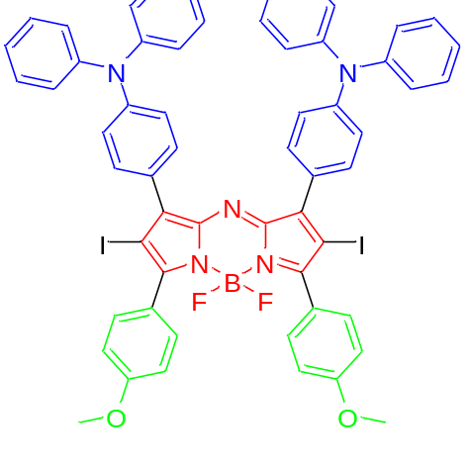 | 675 | 965
57 | 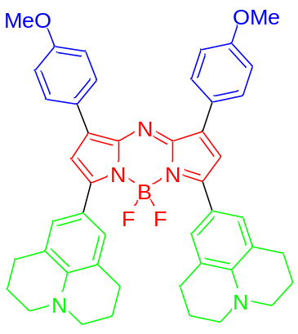 | 890  in DMSO | 982  in DMSO | 71000
58 | 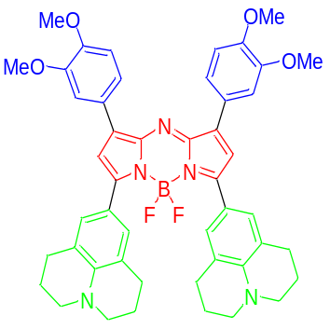 | 891  in DMSO | 984  in DMSO | 68000
59 | 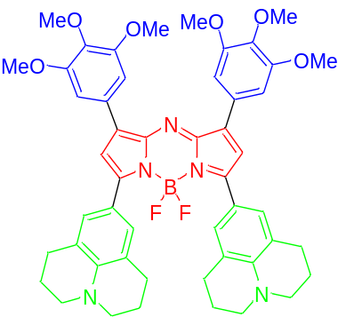 | 904  in DMSO | 993  in DMSO | 70000
60 | 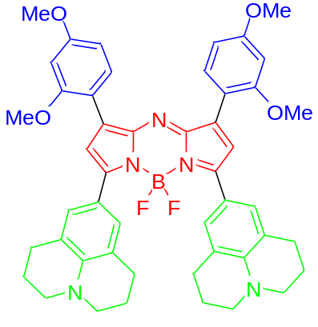 | 873  in DMSO | 959  in DMSO | 66000
61 | 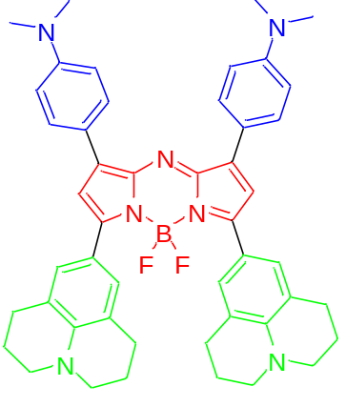 | 878  in DMSO | 956  in DMSO | 78000
62 | 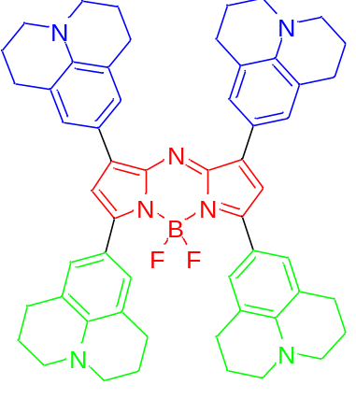 | 889  in DMSO | 941  in DMSO | 83000
63 | 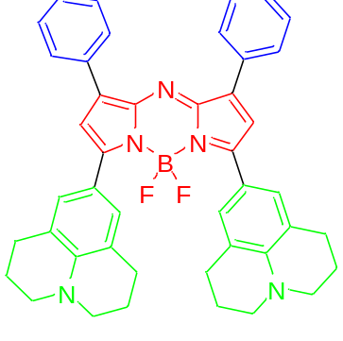 | 911  in DMSO | 1003  in DMSO | 60000
64 | 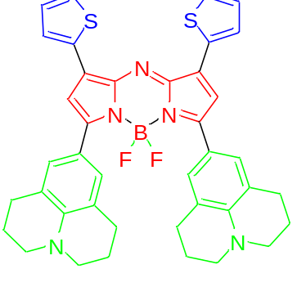 | 932  in DMSO | 1028  in DMSO | 62000
65 | 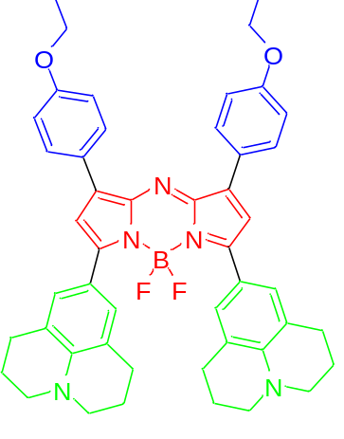 | 889  in DMSO | 977  in DMSO | 60000
66 | 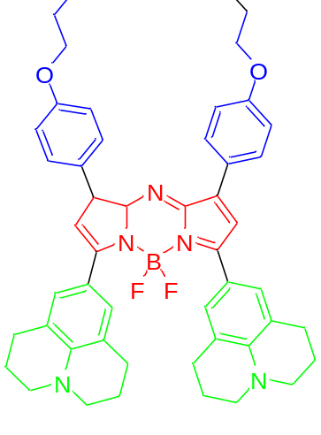 | 889  in DMSO | 979  in DMSO | 60000
67 | 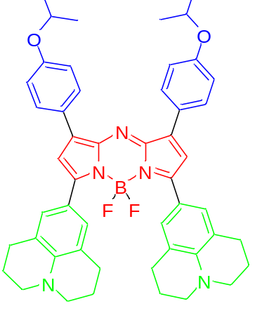 | 889  in DMSO | 977  in DMSO | 64000
68 | 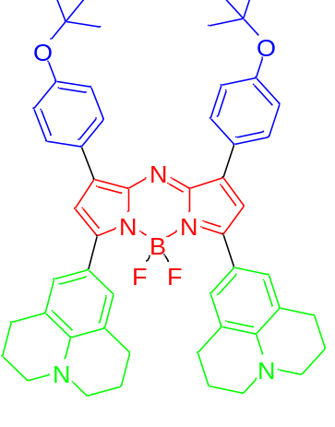 | 896  in DMSO | 991  in DMSO | 62000
69 | 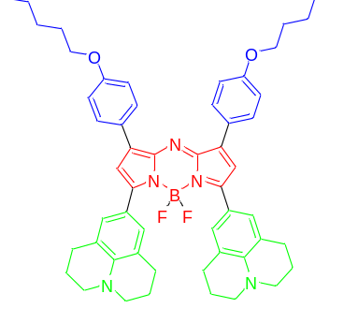 | 889  in DMSO | 979  in DMSO | 68000
70 | 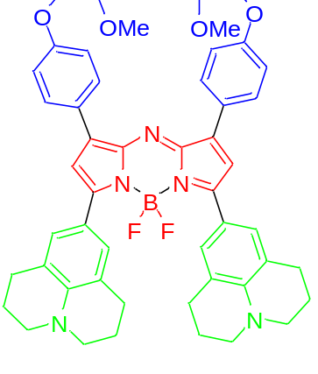 | 891  in DMSO | 979  in DMSO | 60000
71 | 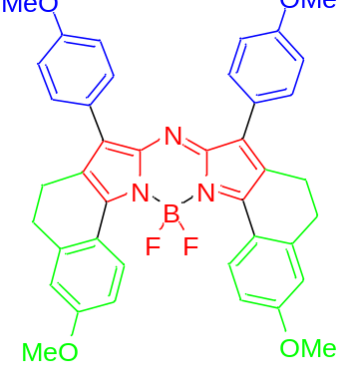 | 736  in CHCl₃ | 748  in CHCl₃ | 157000
72 | 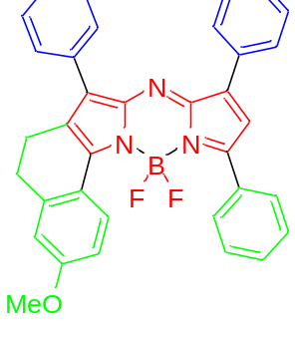 | 688  in CHCl₃ | 710  in CHCl₃ | 108000
73 | 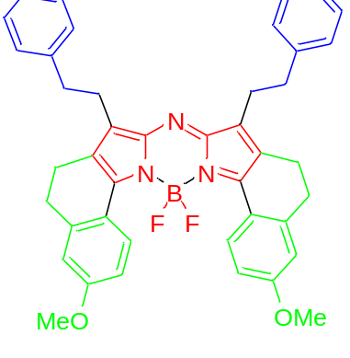 | 721  in CHCl₃ | 732  in CHCl₃ | 162000
74 | 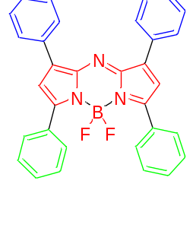 | 658  in CHCl₃ | 680  in CHCl₃
75 | 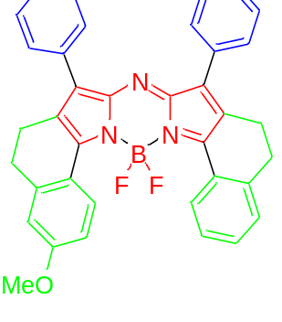 | 723  in CHCl₃ | 734  in CHCl₃ | 157000
76 | 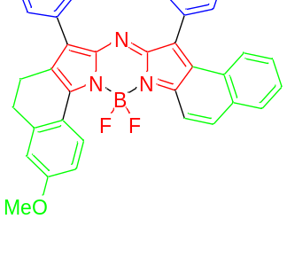 | 715  in CHCl₃ | 730  in CHCl₃ | 141000
77 | 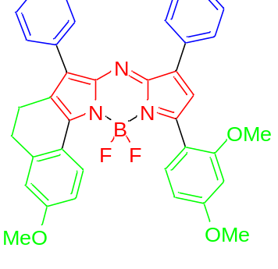 | 707  in CHCl₃ | 735  in CHCl₃ | 78000
78 | 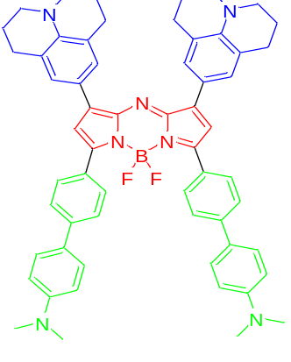 | 900 | 1020 | 28000
79 | 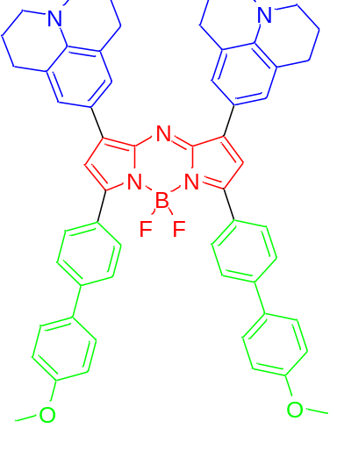 | 910 | 1030 | 30000
80 | 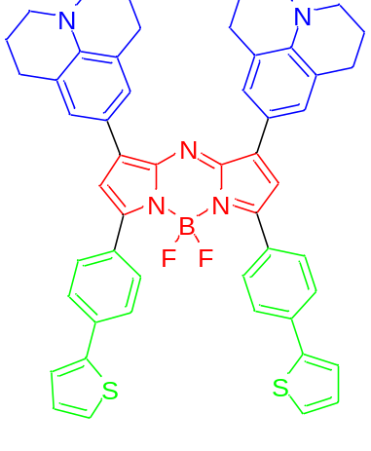 | 910 | 1040 | 24000
81 | 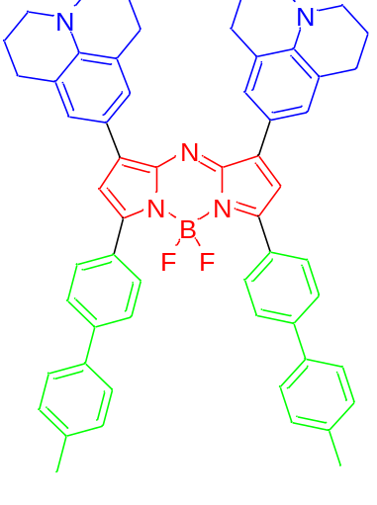 | 900 | 1030 | 28000
82 | 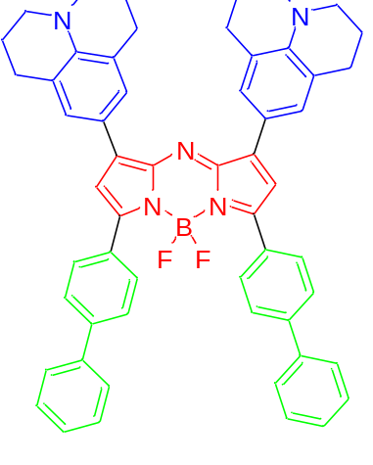 | 940 | 1040 | 20000
83 | 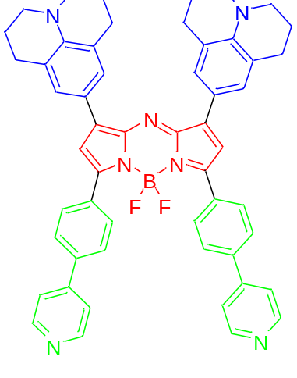 | 920 | 1060 | 25000
84 | 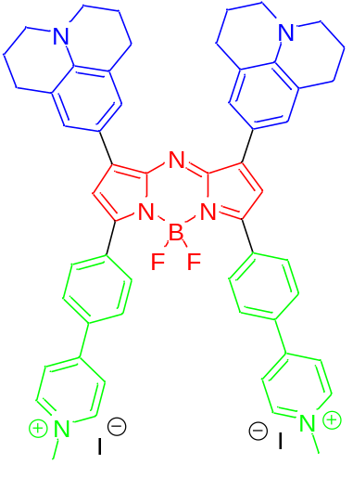 | 1010 | 1180 | 20000
85 | 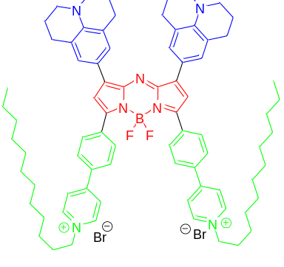 | 1000 | 1180 | 22000
86 | 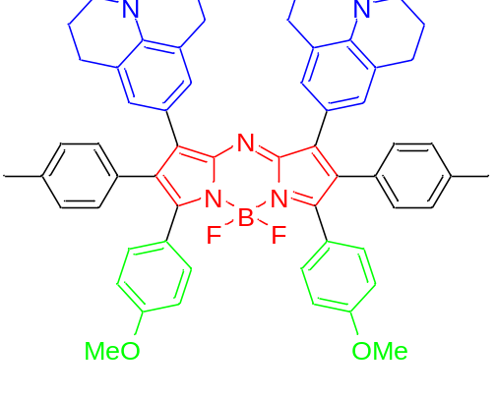 | 896 | 1023 | 15700
87 | 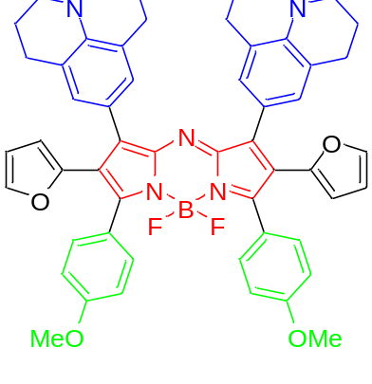 | 904 | 1036 | 12500
88 | 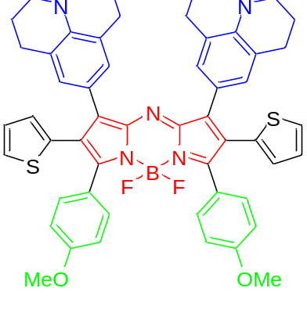 | 902 | 1027 | 23800
89 | 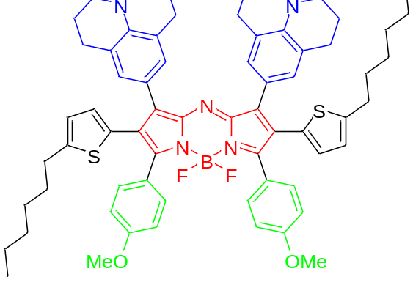 | 904 | 1038 | 24500
90 | 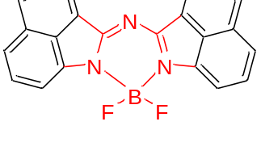 | 539 | 541 | 48000
92 | 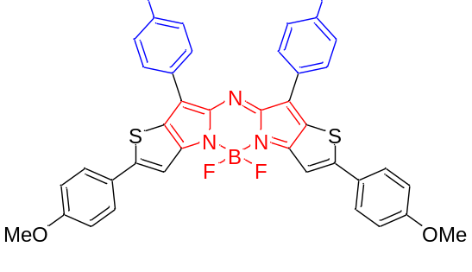 | 788 | 814 | 170000
93 | 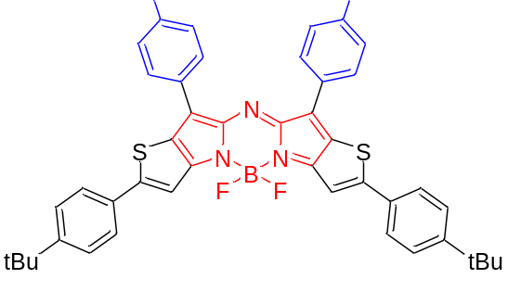 | 767 | 793 | 223900
94 | 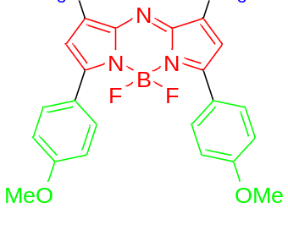 | 648 | 678 | 81000
95 | 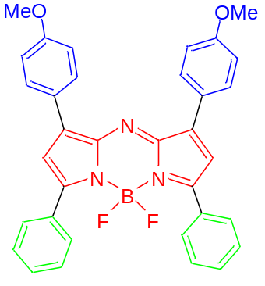 | 664 nm | 672 nm | 78000
96 | 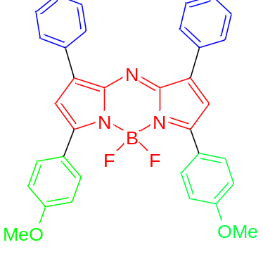 | 688 | 715 | 85000
97 | 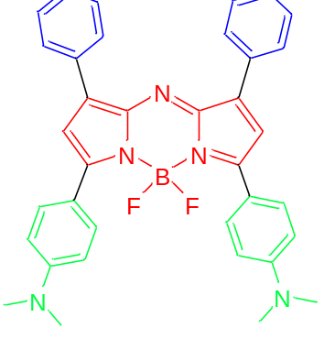 | 799 | 823 | 87000
98 | 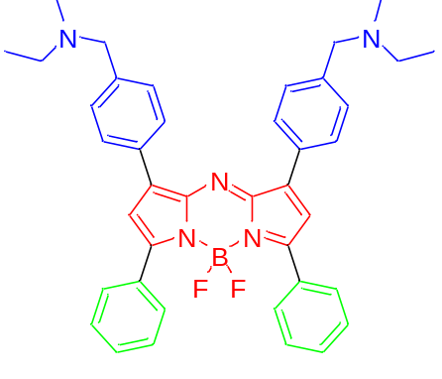 | 654 | 683 | 71600
99 | 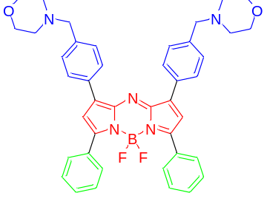 | 655 | 683 | 87600
100 | 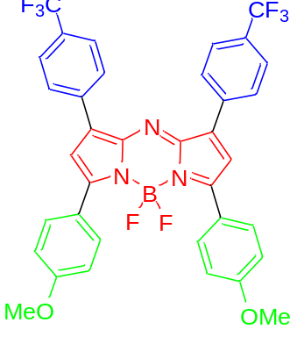 | 704 | 741
101 | 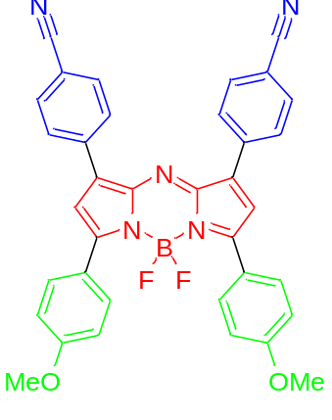 | 716 | 755
102 | 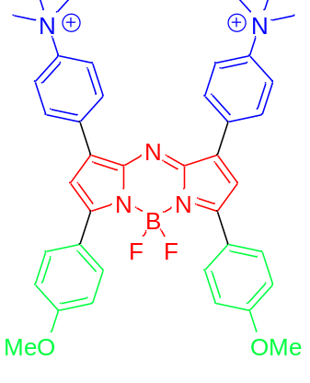 | 712 | 752
103 | 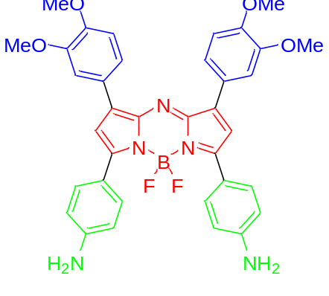 | 750 | 815 | 48000
104 | 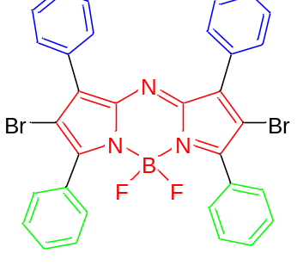 | 650 | 673 | 79000
105 | 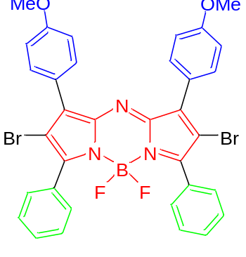 | 679 | 714 | 75000
106 | 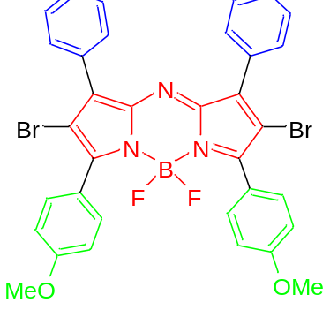 | 653 | 679 | 80000
107 | 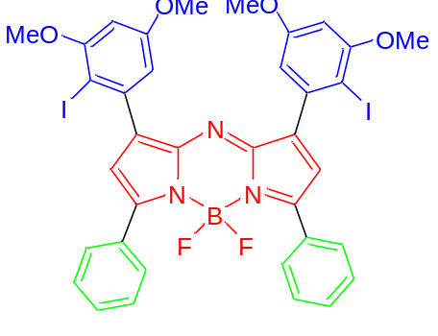 | 658 | 690 | 83000
108 | 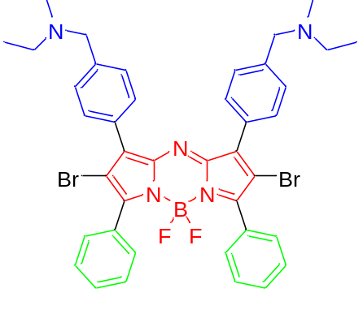 | 684 | 728 | 70800
109 | 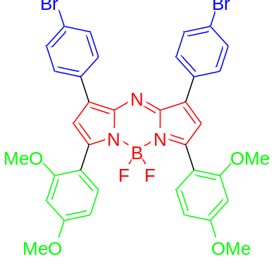 | 692 | 738 | 66200
110 | 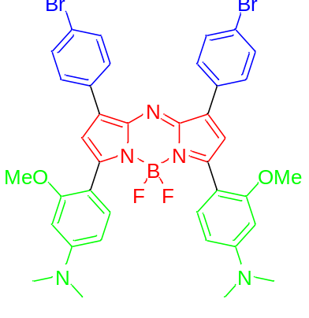 | 798 | 830 | 68610
111 | 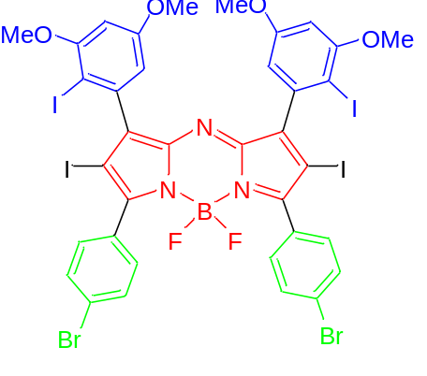 | 666 | 694 | 69900
112 | 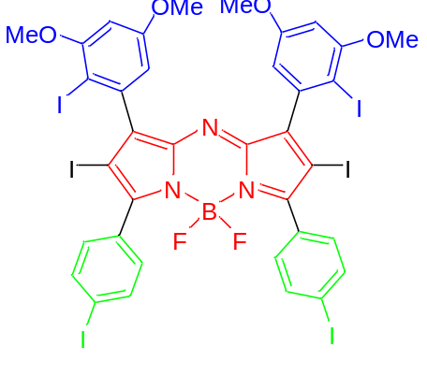 | 676 | 712
113 | 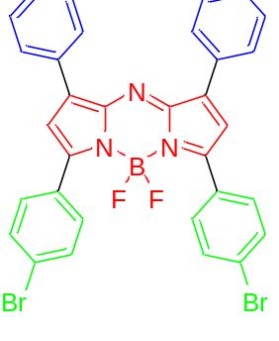 | 658 | 690 | 66000
114 | 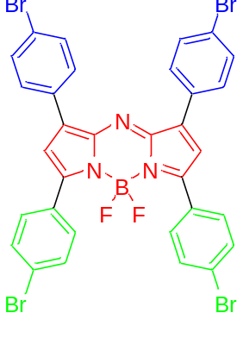 | 667 | 699 | 60700
115 | 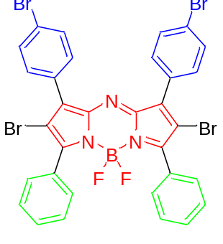 | 651 | 685 | 45900
116 | 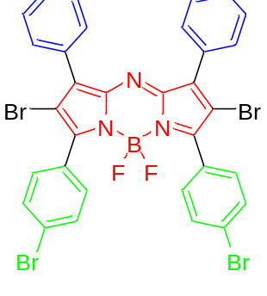 | 651 | 685 | 59300
117 | 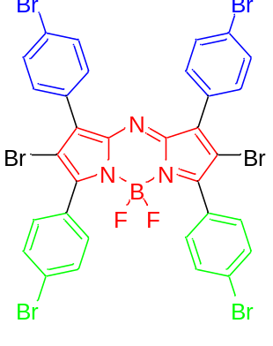 | 657 | 685 | 39100
118 | 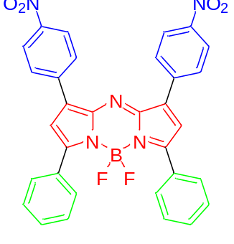 | 662  ACN | 696 | 78000
119 | 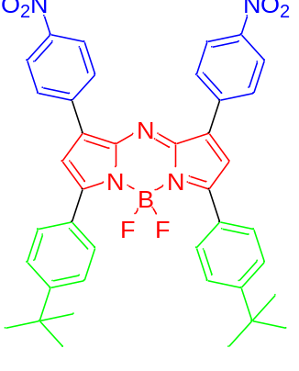 | 681  ACN | 715 | 70000
120 | 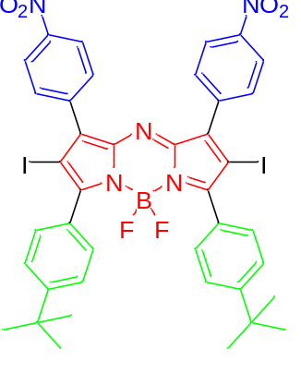 | 672  ACN | 732 | 50000
121 | 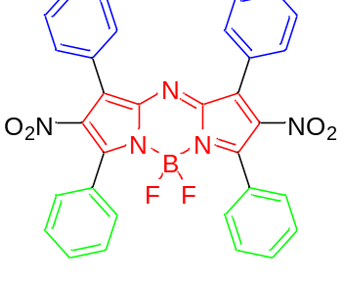 | 620 | 664 | 45400
122 | 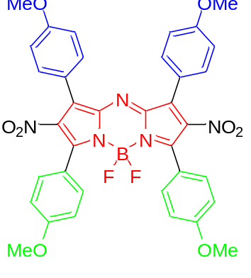 | 692 | 723 | 46400
123 | 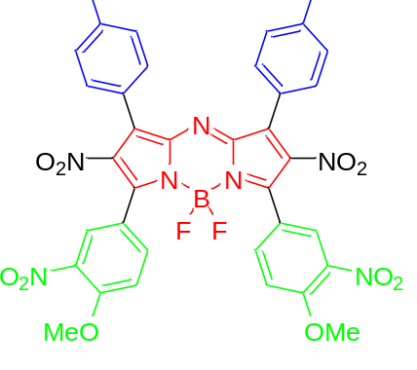 | 654 | 699 | 45100
124 | 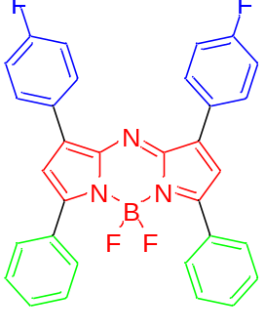 | 650 | 674 | 80000
125 | 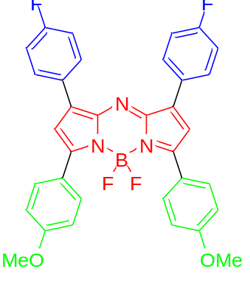 | 688 | 715 | 86000
126 | 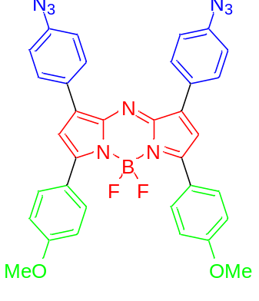 | 710 | 754 | 67000
127 | 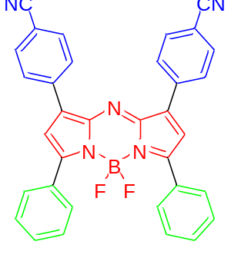 | 667 | 711
128 | 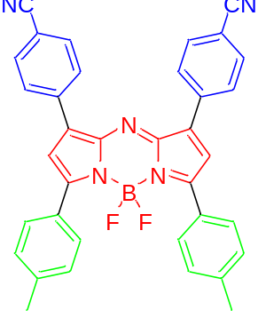 | 685  THF | 733
129 | 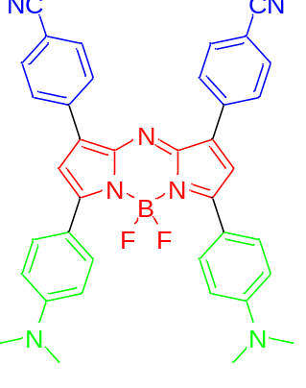 | 855  THF
130 | 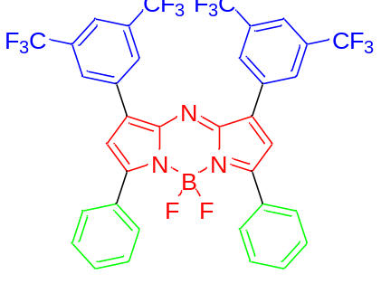 | 656 | 685 | 81430
131 | 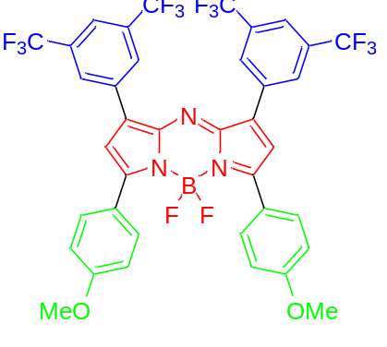 | 706 | 739 | 83040
132 | 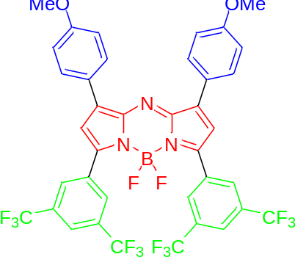 | 774 | 722 | 13260
133 | 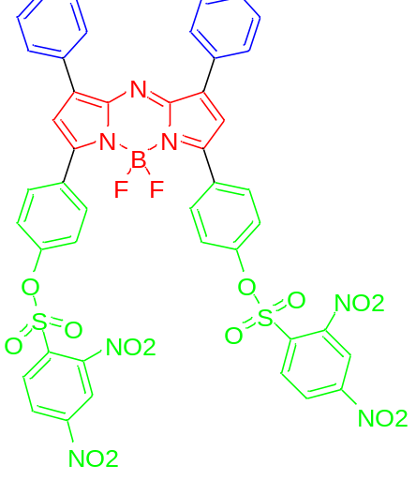 | 654  THF | 682 | 82280
134 | 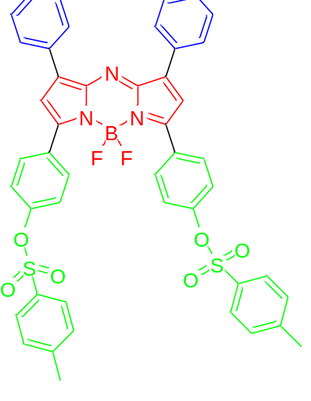 | 658  THF | 686 | 74746
135 | 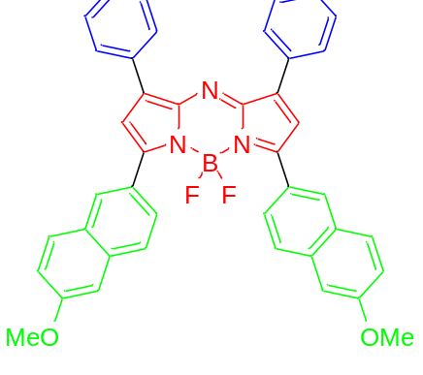 | 706 | 733 | 89000
136 | 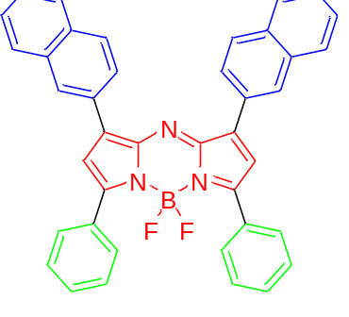 | 650 | 681
137 | 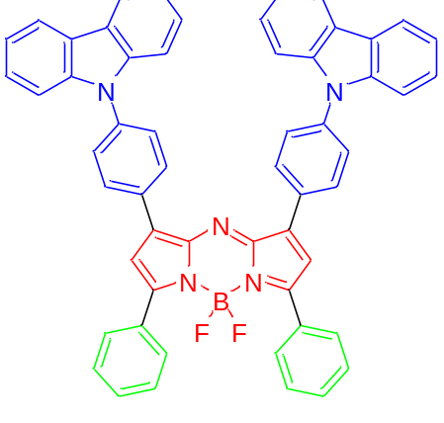 | 606 | 774
138 | 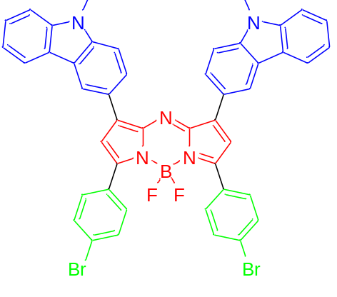 | 653 | 815 | 37000
139 | 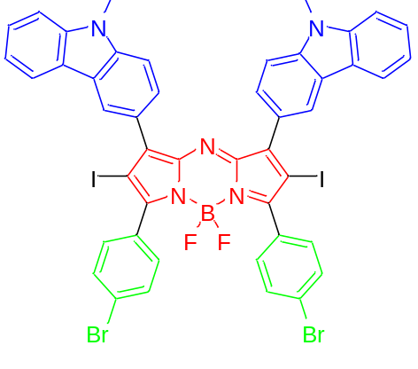 | 649 | 830 | 41000
140 | 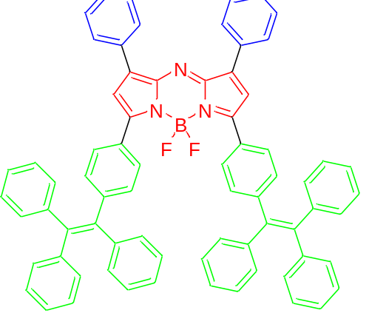 | 708 | 754 | 77500
141 | 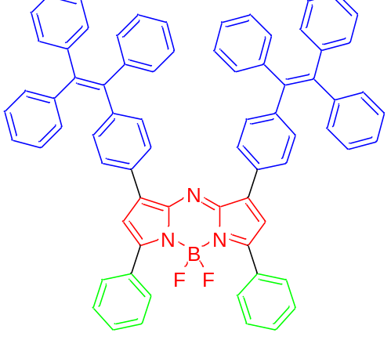 | 682 | 730 | 77100
142 | 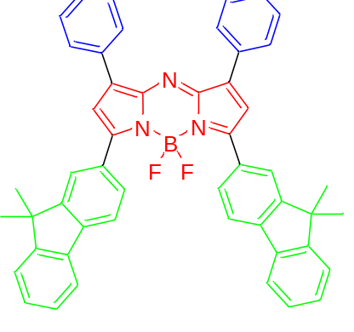 | 708 | 742 | 92400
143 | 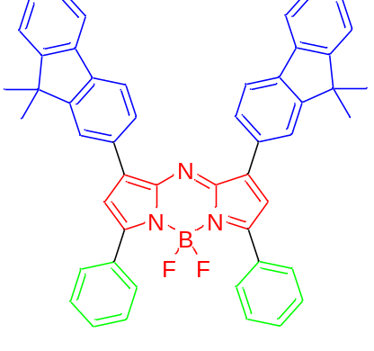 | 677 | 713 | 86700
144 | 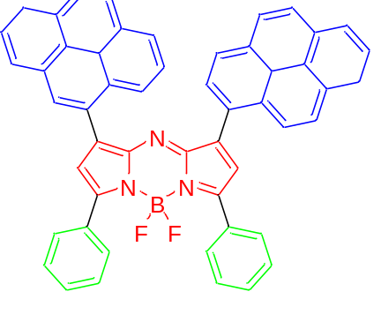 | 670 | 763
145 | 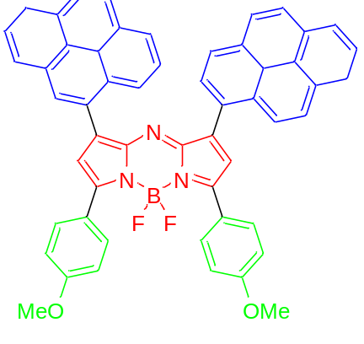 | 700 | 744
146 | 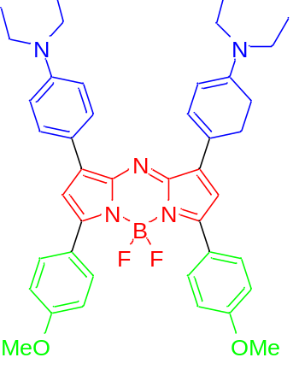 | 689 | 960 | 40000
147 | 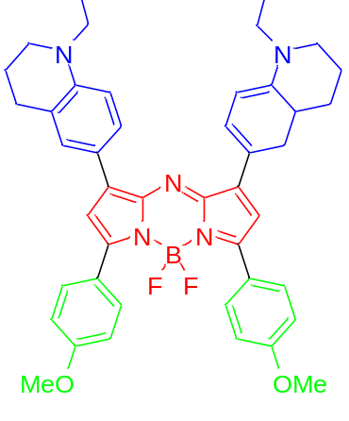 | 830 | 1030 | 26000
148 | 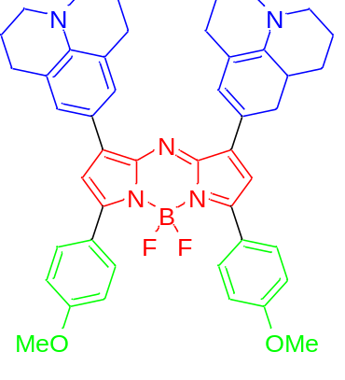 | 910 | 1060 | 170000
149 | 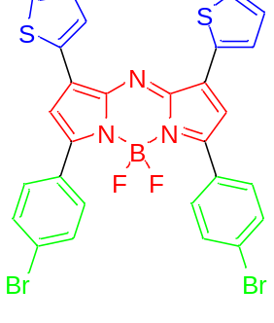 | 694 | 729 | 82000
150 | 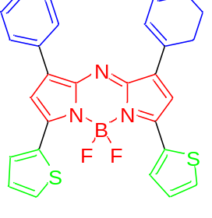 | 710 | 732 | 108600
151 | 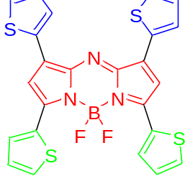 | 733  ACN | 757 | 110000
152 | 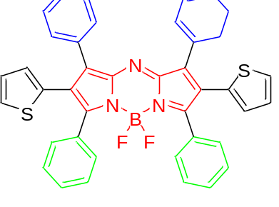 | 650 |  | 40000
153 | 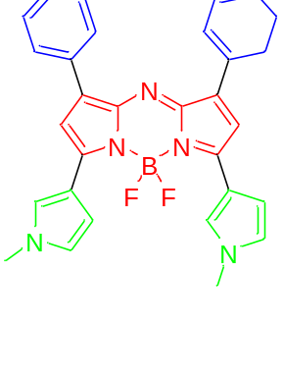 | 721 | 751 | 115000
154 | 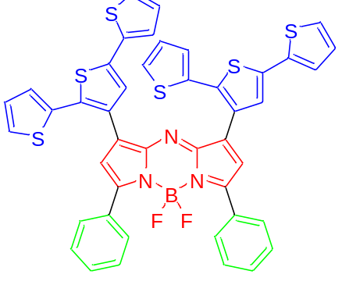 | 665 |  | 15100
155 | 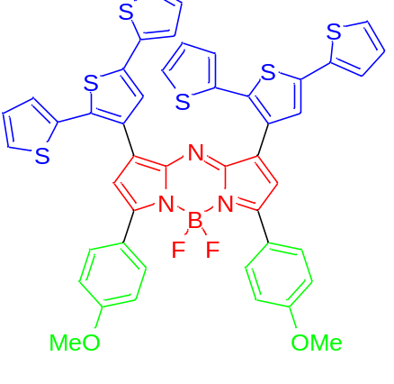 | 706 | 734 | 40300
156 | 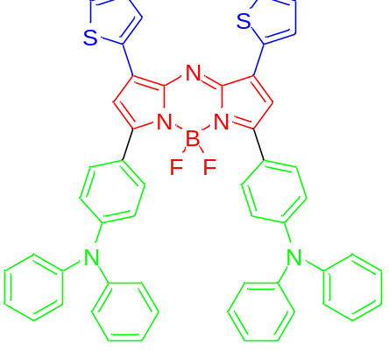 | 818 | 896 | 15236
157 | 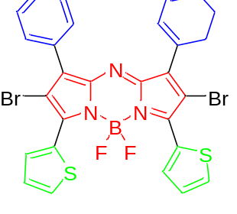 | 726 | 752 | 108000
158 | 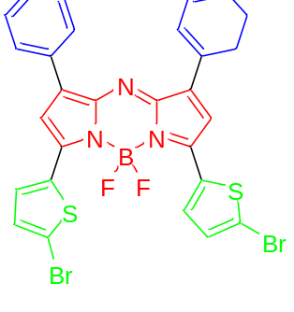 | 727 | 751 | 111000
159 | 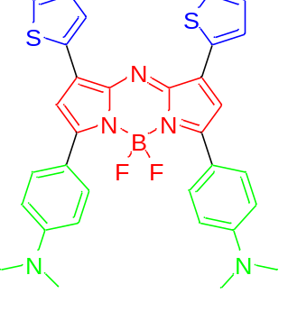 | 824
160 | 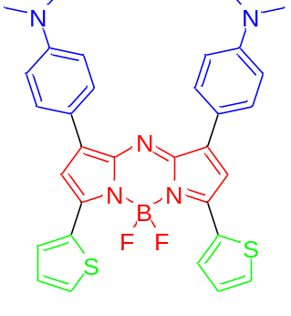 | 790
161 | 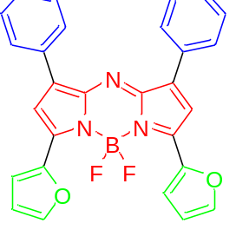 | 721 | 730 | 133900
162 | 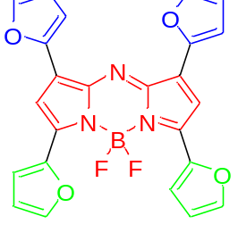 | 751 | 758 | 130700
163 | 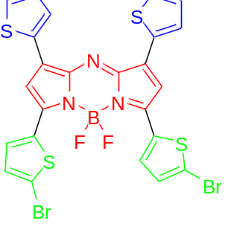 | 756 |  | 120000
164 | 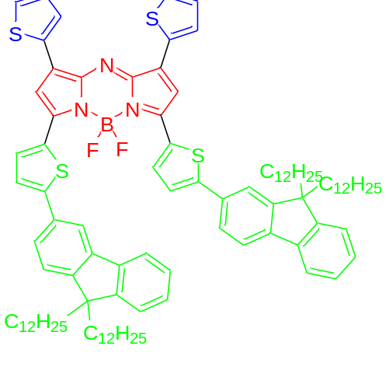 | 864 |  | 48000
165 | 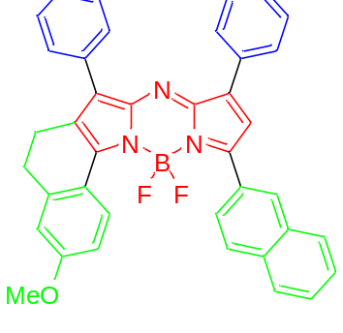 | 715 | 730 | 141000
166 | 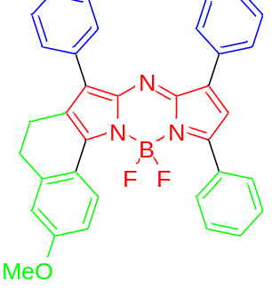 | 688 | 710 | 108000
167 | 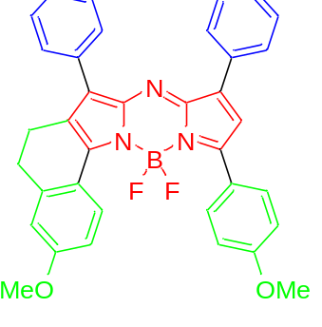 | 708 | 732 | 96200
168 | 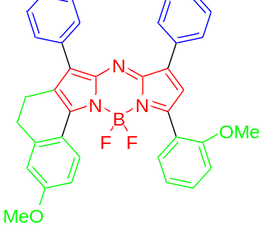 | 678 | 713 | 83900
169 | 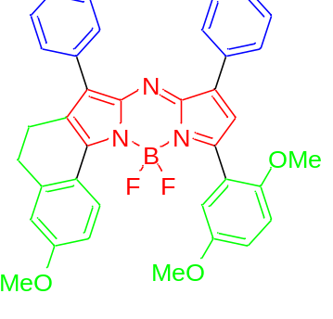 | 707 | 735 | 66500
170 | 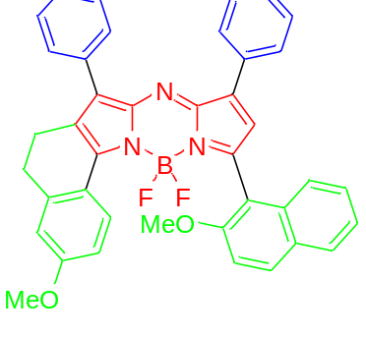 | 668 | 692 | 113000
171 | 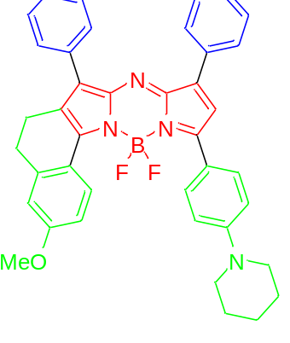 | 774 | 815 | 70300
172 | 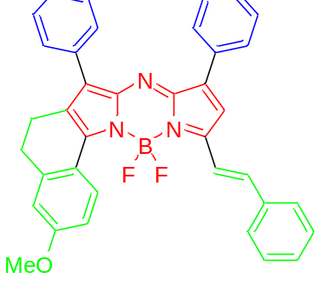 | 731 | 749 | 166000
173 | 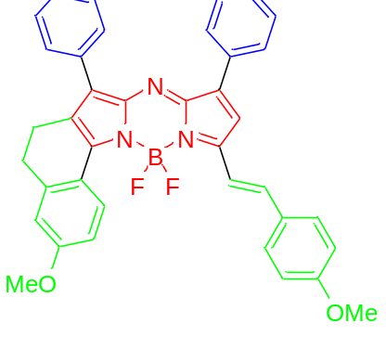 | 746 | 780 | 166000
174 | 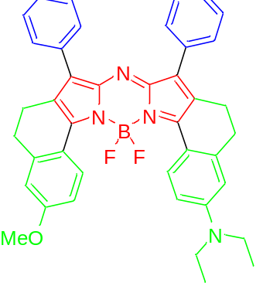 | 796 | 813 | 172000
175 | 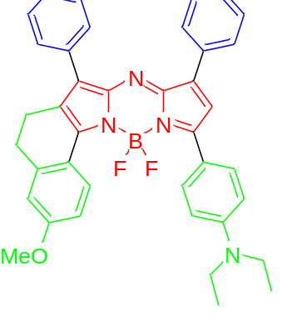 | 789 | 822 | 135000
176 | 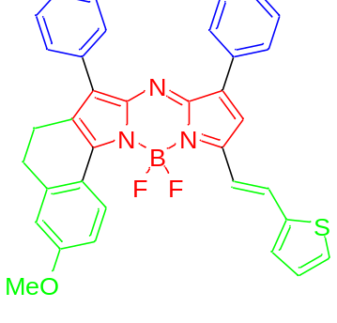 | 760 |  | 155000
177 | 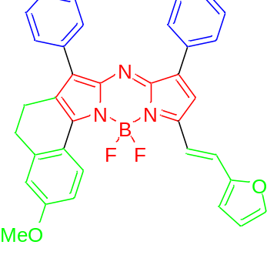 | 762 | 778 | 155000
178 | 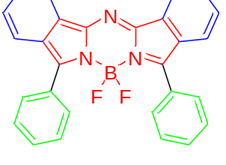 | 715 | 736 | 87100
179 | 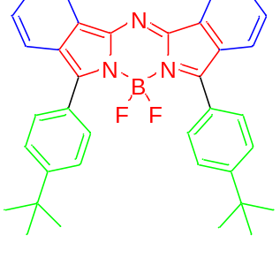 | 724 | 749 | 85100
180 | 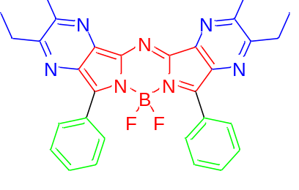 | 685 | 721
181 | 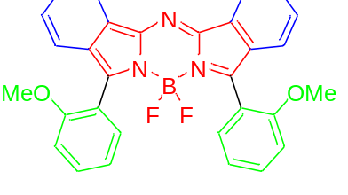 | 681 | 723 | 79000
182 | 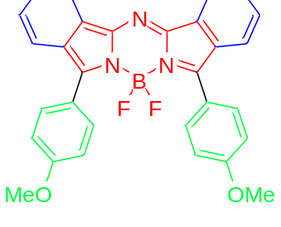 | 729 | 769 | 91100
183 | 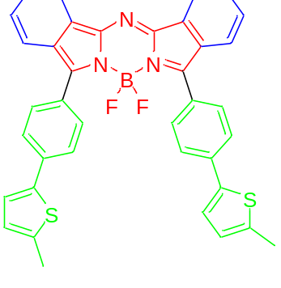 | 793 | 841 | 95000
184 | 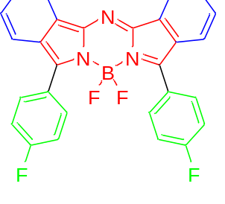 | 713 | 724
185 | 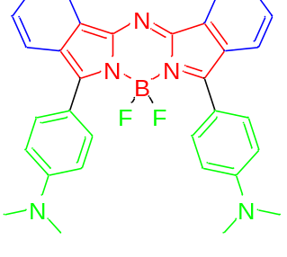 | 794 | 830
186 | 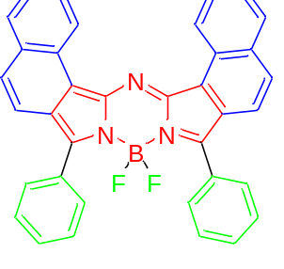 | 737 | 753
187 | 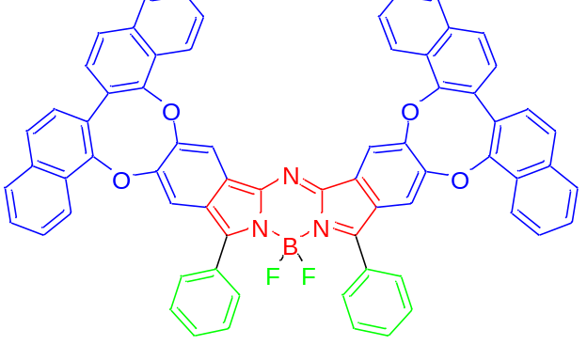 | 722 | 754 | 109647
188 | 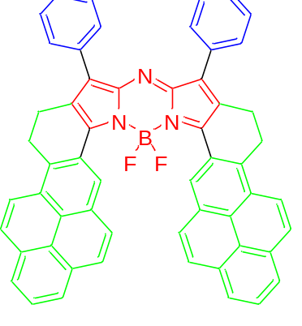 | 746 | 762
189 | 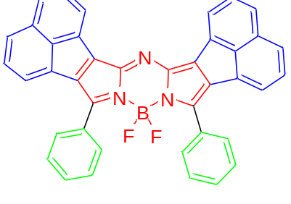 | 673 | 774
190 | 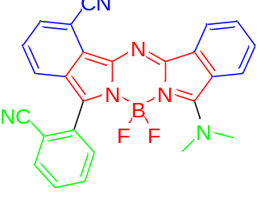 | 591 | 654 | 25820
191 | 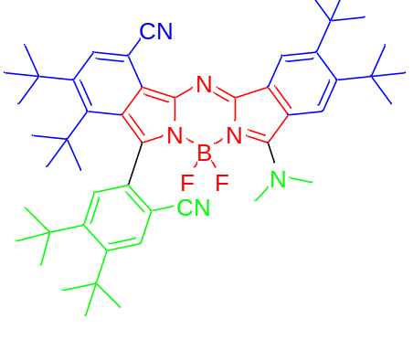 | 599 | 674 | 40090
192 | 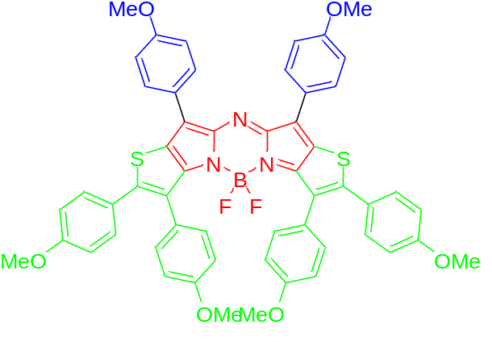 | 784 | 816
193 | 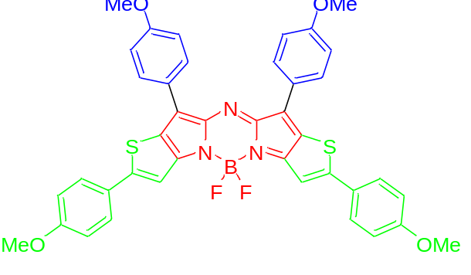 | 788 | 814
194 | 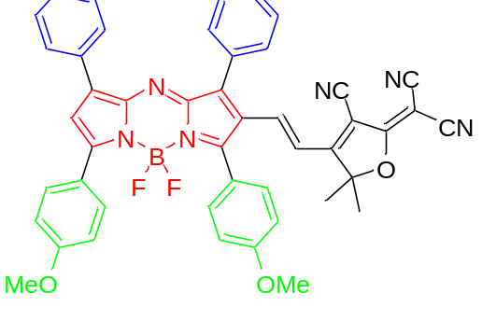 | 700
195 | 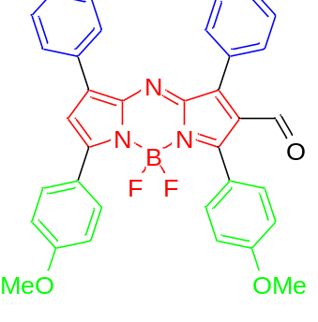 | 643 | 670
196 | 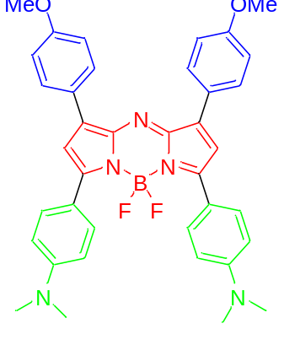 | 792
197 | 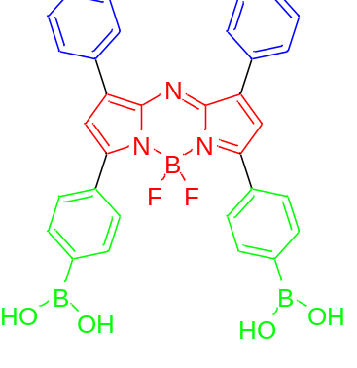 | 655 | 682
198 | 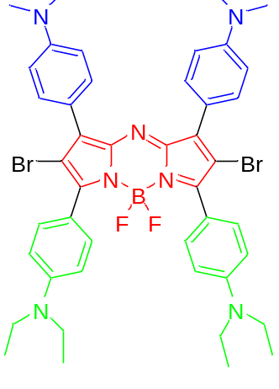 | 848

