这是word1111

Microsoft Office for the Pharmaceutical and Healthcare Industries

It is likely that you and your colleagues are currently using a version of Microsoft Office at work or at home. It also is likely that many of you make use of only a small proportion of the features available, since it has become well known that most of us learn the minimum amount of features necessary to do our jobs. Accordingly, when Microsoft planned the 2003 release of Microsoft Office System our strategy was not to simply add a bunch of new features that the IT staff would find exciting but most professionals would never use. Instead, the product teams spent time talking with industry leaders to learn how Microsoft Office can truly alleviate the pains that plague professionals in various industries. The healthcare and pharmaceutical industries were specifically targeted so that the 2003 release of Microsoft Office System would be a platform that enables professionals to improve productivity, build integrated applications, foster collaboration, and be innovative.



C:\Users\SwedenLi\AppData\LocalLow\Temp\Microsoft\OPC\DDT.e69p3ut5afdqe1bvsz2t0gleb.tmp

There are several common complaints in the healthcare and pharmaceutical industries that the Microsoft Office can address. First, the cost of healthcare and drug development has skyrocketed. Everyone is asked to “do more with less,” which translates into seeing more patients each day, applying for more grants, writing more standard operating procedures (SOPs), processing more claims, and recruiting more patients for clinical trials. Packing more work into the day can mean working longer hours, but it also requires all of us to become more efficient in what we do and look for ways to better manage our time.

Another common complaint voiced by healthcare and pharmaceutical professionals is the high turnover among some staff. Healthcare workers are spending too much time engaged in activities that are not direct patient care. A HIMSS survey published in May 2003 indicated that technology would have a “great deal” of impact on staffing shortages. High rates of staff turnover are noted within the pharmaceutical industry among clinical research associates, and of course, this adds to the overall costs of running clinical trials. Electronic methods to store information and communicate with other professionals can not only make it easier to train new staff, but they also may lead to less attrition in the first place.

Difficulty with finding, storing, and communicating information is a third complaint voiced by healthcare and pharmaceutical professionals. The average hospital has more than 200 information systems such as admissions, radiology, pathology, pharmacy, and surgery that typically do not communicate with each other. Most of the software used to facilitate clinical trials is not integrated. Claims processing often involves re-keying data over and over. Professionals too often rely on their own hard-drives for storing critical documents, and sensitive information is passed back and forth via e-mail with the hope that it somehow remains secure.

Finally, there is mounting pressures for healthcare and pharmaceutical companies to comply with regulations such as those presented by HIPAA, 21 CFR Part 11, and JCAHO. In some cases, such regulations require complete overhauls of processes and systems. Yet at the same time, quality patient care must be maintained.

As a result, healthcare and pharmaceutical professionals bear the following burdens: doing more with less, picking up the slack that result from high staff turnover, navigating between disconnected systems, and complying with the plethora of governmental and agency regulations. These are some heavy burdens, which can result in long work days, feelings of disconnectedness, citations from regulatory bodies, and most importantly, reduced quality of care for patients. There is no panacea that can magically ease all the burdens and

Created by Bonnie Dansky Cotton Created on 5/23/2005 12:22:00 PM

- 1 -

Microsoft Office for the Pharmaceutical and Healthcare Industries

improve patient care. However, it is these issues that the product managers had in mind when designing the new Microsoft Office System.

The 2003 release of Microsoft Office is a system, rather than simply a conglomeration of features. It is now a platform to enable higher rates of productivity, collaboration between teams and across organizations, connections to back-end systems, the use of third-party software add-ons, and building internal applications. Although there still was attention paid to personal productivity, the Microsoft product managers took a new approach: the applications in the 2003 release of the Microsoft Office System were designed to easily interact with one another, other Microsoft applications, and even many of your legacy systems. This means that the Microsoft Office System will not only assist you in improving personal productivity, but it can revolutionize how team members collaborate and how your organization does business. “Revolutionize” is a strong word, but it is appropriate, since the changes in the 2003 release of the Microsoft Office System are far-reaching and forward-thinking.

This paper will be organized in four main sections: personal impact, business information, effective teaming, and process management, which includes security and compliance with industry regulations. Saving time and increasing each professional’s ability to make significant contributions, given the increasingly demanding business environment will be discussed first, and this discussion does involve highlighting some new features in Outlook and Word. Although you just read above how the Microsoft Office System is a “system” and not “simply a conglomeration of features,” there are several new features that are worth describing.

How the Microsoft Office System is a platform will become apparent in the sections about business information and effective teaming, which are followed by an in-depth discussion of Information Rights Management. The final section builds on all of the previous ones by presenting how the Microsoft Office System can help improve your organization’s ability to respond to the demands of a market that is frequently changing and has ever-increasing numbers of regulations.

**Personal Impact: Save Time and Increase Personal Productivity**

**Microsoft Office Outlook 2003**

The advances of technology have afforded healthcare and pharmaceutical workers with the ability to receive information from an abundance of sources, anywhere, anytime. Now, information can pour in from e-mail messages, cellular telephone calls, pagers, and personal digital assistants (PDAs). This is how we do business today.

Yet, this wealth of easily accessible information can at times feel burdensome, so it is imperative that we find efficient ways to plow through it all. The average information worker (which all of us are), spends up to 30% of time each day reading e-mail messages, and many of us end up with hundreds or thousands of messages in our Inboxes. Finding efficiencies with managing e-mail is critical to staying up-to-date and on top of our work.

***All E-Mail Accounts in One Location with a New Viewing Pane***

Created by Bonnie Dansky Cotton Created on 5/23/2005 12:22:00 PM

- 2 -

Microsoft Office for the Pharmaceutical and Healthcare Industries

Since many healthcare and pharmaceutical professionals can get buried under a mountain of e-mail each day, the 2003 release of Outlook was designed to increase personal productivity and save time by enabling professionals to view all e-mail accounts in one view, sort mail by threaded conversation, assign follow-up flags with a single click, glance at incoming mail message alerts and grasp critical information, and view multiple calendars at the same time. Let’s start with viewing email from multiple accounts. This means that e-mail from any account – MSN, Hotmail, other personal or other professional accounts -- can be viewed in place. You no longer need to open multiple e-mail applications in order to view your messages. Additionally, the default viewing pane is on the right side (rather than at the bottom of the page) and is large enough that clicking to open a message is rarely necessary. Attachments can be easily accessed directly from the reading pane.

***View Threaded Conversations***

Back and forth “threads” of e-mail messages can be viewed by conversation. So when several people are collaborating on a manuscript, grant application, or New Drug Application (NDA), all messages that pertain to the topic can be grouped together. Grouping also can be accomplished by creating “virtual” search folders, where new messages that arrive on a particular topic are available in a virtual subfolder, as well as in the Inbox.

***Follow-Up with Quick Flags***

Quick flags are available to assist with finding messages that require follow-up. The flags are easier to see than before, they come in a variety of colors, and flagged messages are automatically placed in a single “For Follow-Up” virtual folder, no matter where the messages actually reside (i.e., in the Inbox or other subfolders). With a single click a message can be flagged, and with another click all messages that require follow-up can be viewed. The image below depicts the new reading pane and quick flags.

Created by Bonnie Dansky Cotton Created on 5/23/2005 12:22:00 PM

- 3 -

crosoft Office for the Pharmaceutical and Healthcare Industries

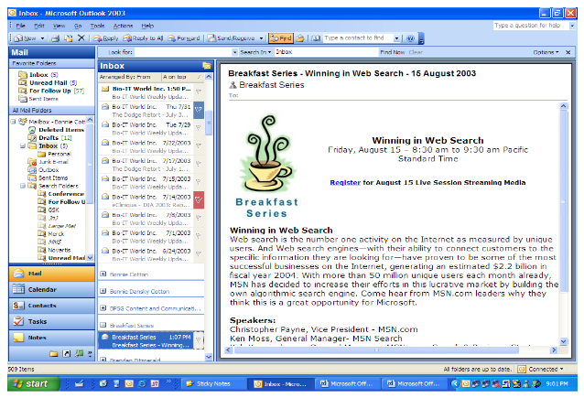

***Shared Calendars***

Scheduling appointments with colleagues or for several practitioners at the same time can be accomplished by selecting to “Open a Shared Calendar” and choosing names. For instance, a scheduling manager in a physician’s office can view the calendars for all of the physicians in the practice at the same time in one view. This way, he can effortlessly identify a time for an office meeting or provide appointment options to patients without having to toggle between multiple calendars. All of these new features in Outlook were designed to enable the busy healthcare or pharmaceutical professional to work more efficiently and increase productivity.

Created by Bonnie Dansky Cotton Created on 5/23/2005 12:22:00 PM

- 4 -

crosoft Office for the Pharmaceutical and Healthcare Industries

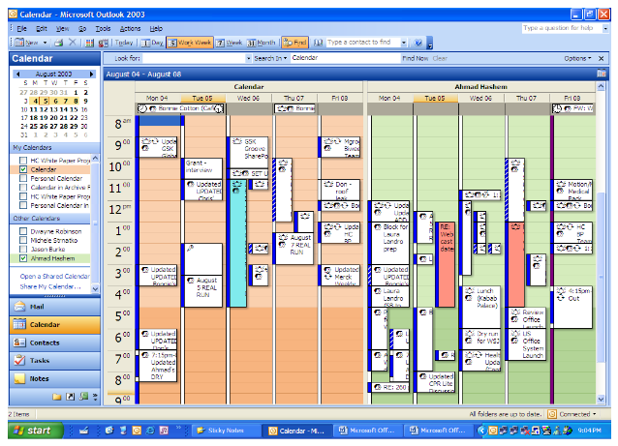

**Microsoft Office Word 2003**

Personal productivity also can be increased with other applications in the Microsoft Office System. The new features in Microsoft ® Office Word 2003 are specifically geared toward professionals such as the scientist or healthcare practitioner. First of all, the view in Word has been updated to reflect the finding that people read more comfortably when the number of characters in a line is between 50 and 70 – similar to how text is presented in a book or journal article. Consequently, the vast amount of reading that healthcare professionals do can be accomplished more quickly and comfortably.

***Research Pane***

The Research Pane is an addition to Microsoft Office that healthcare and pharmaceutical professionals will find particularly helpful. Here is where you will begin to see how the Microsoft Office System is a platform for providing professionals with the tools necessary to do their jobs more efficiently. With the Research Pane, research can be conducted from within a Word 2003 document by simply holding the Alt key and clicking on a word in the document. It is no longer necessary to open a browser or new window to search for information.

If a scientist is writing a paper on a topic such as cardiomyopathy, she can conduct literature searches on the Web from within her manuscript, as well as access a medical dictionary. Since translation of foreign language text can be accomplished with a single click

Created by Bonnie Dansky Cotton Created on 5/23/2005 12:22:00 PM

- 5 -



©2006 Microsoft Corporation. All rights reserved. This presentation is for informational p