The financial system channels funds to investment projects that make the economy more productive.

**金融市场**

**Financial market**: A collection of people and firms that buy and sell securities or currencies.

**Security**: Claim on some future flow of income, such as a stock or bond. **Stock**: Ownership share in a corporation. **Bond**: Security that promises predetermined payments at certain points in time at face value. Before that, the owner may receive coupon payments.

**金融市场的经济职能**：

**1.Matching** savers and investors. 2.**Risk sharing**: diversify the distribution of wealth among many assets.

**Asymmetric Information:** The problem that one side of an economic transaction knows more than the other. **Adverse Selection:** The problem that the people or firms who are most eager to make a transaction are the least desirable to parties on the other side of the transaction. **Moral Hazard:** The risk that one party to a transaction takes actions that harm another party.

**银行：**

**Financial institution**: Firm that helps channel funds from savers to investors. **Bank**: Financial institution that accepts deposits and makes private loans.

**银行的职能**：Reducing adverse selection; Reducing moral hazard; Investment and financing; Making private loans.

**Federal reserve system** is the c**entral bank** of the United State. A central bank controls an economy’s **money supply**, which has strong effects on the financial system and the economy.

**What’s money**: The medium of exchange; The unit of Account; Store of value.

Types of money: Commodity money; Fiat money; E-money; Stored-value money.

**中央银行的职能**：Clearing payments; Monetary policy; Lending; Bank regulation.

**Fed控制货币供给的方式**：Open market operations; Adjusting the reserve requirement ratio; Adjusting the Fed’s loan rate.

**[案例] Fed应对911的策略：**

1. The Fed adjusted the rules governing payments. Normally, the Fed charges overdraft fees to banks with negative balances in their Fed accounts. **These fees were suspended** from 9.11 to 9.21. This policy encouraged banks to keep making payments even if incoming funds were delayed, pushing their balances negative.
2. Starting on September 11, the Fed i**ncreased the money supply** to match money demand. This action kept interest rates stable.
3. It **pushed short-term rates** from 3.5 percent to 3 percent, which is accomplished by increasing the money supply.

**经济增长：**Increases in productivity and living standards; growth in real GDP.

Financial markets and banks benefit the economy as a whole. When funds flow to good investment projects, the economy becomes more productive and living standards rise.

**Saving and growth**: Economic growth depends on saving rates. The more people save, the more funds are available for investment. With high saving, companies can build factories and implement new technologies. The produce more, leading to higher profits and higher wages for workers; When real GDP rises, an economy produces more goods and services, and the people in the economy can consume more. Therefore, a high level of economic growth causes living standards to rise.

**[案例] 苏联计划经济的问题：**

1. Planners put too many resources into prestige sectors of the economy that symbolized economic development. These sectors were mainly in heave industry. The Soviets built too many factories to produce steel and too few to produce consumer goods.
2. Soviet planners overemphasized short-term increases in productivity. They were too hasty in trying to reach Western output. Planners neglected investments that were important for the long term.
3. A related problem was that factory managers were evaluated based on annual production quotas. Managers focused on meeting current quotas rather than increasing long-run productivity.
4. The power of government bureaucrats reduced efficiency. Plant managers were rewarded for following orders, not for thinking of innovative ways to raise output.

资产价格和利**率**

Future value: $1 today = $ in n years. Present value: $1 in n years = $ today.

**经典资产价格理论：**

* **The price of an asset equals the present value of expected income from the asset.**
* Rational expectations: Expected income is the best possible forecast based on all public information.
* The interest rate in the present value formula is the safe interest rate plus a risk premium: .

现值和利率的关系：

* **bond price** =  (where C is an annual coupon payment, F is face value).
* **stock price** = (E: earning per share)

两种利率：

* **Safe interest rate** (): Interest rate that savers can receive for sure.
* **Risk Premium** (): Payment on an asset that compensates the owner for taking on risk.

资产价格改变的原因：Changes in interest rates affect the prices of both stocks and bonds. An asset price is the present value of expected income from the asset. A higher interest rate reduces asset prices because it reduces the present value of any income flow. (The change in the interest rate has larger effects on prices of long-term bonds than on prices of short-term bonds.)

**[案例] The Fed and the Stock Market**

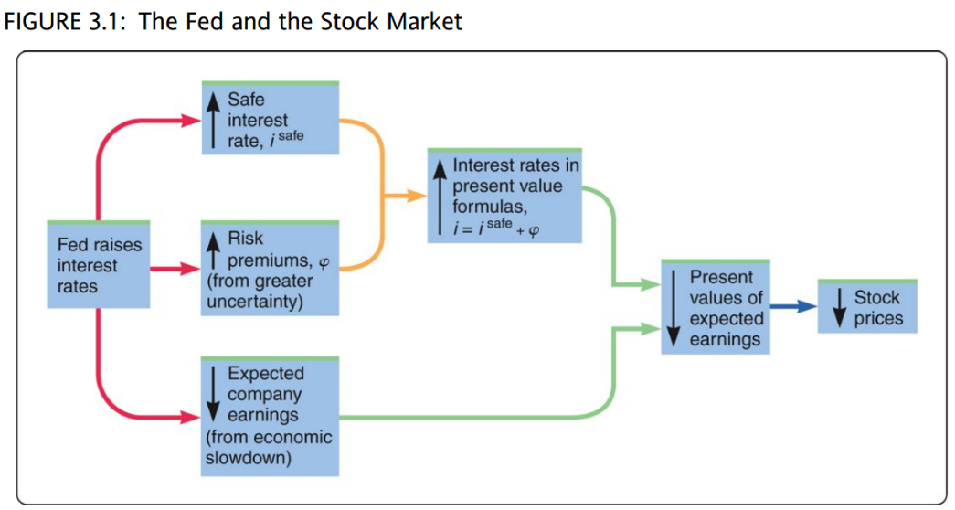

* One rate determined by the Fed is the economy’s safe interest rate. A higher safe rate reduces the present value of companies’ earnings;
* Higher rates also reduce spending by consumers and firms. The economy slows, reducing expected earnings for many companies.
* Some economists think there is a third effect: higher risk premiums. A slower economy not only reduces expected earnings but also raises uncertainty, because it is hard to predict the effects of the slowdown. Higher risk premiums raise the interest rates that determine present values.

**Asset-price bubble**: Rapid rise in asset prices that is not justified by changes in interest rates or expected asset income. When a bubble occurs, an asset price rises simply because people expect it to rise.

**P/E ratio** (price-earnings): A company’s stock price divided by earnings per share over the recent past. Some think high P/E ratios are evidence of bubbles.

**Asset-price crash**: Large and rapid fall in asset prices.

**Crash prevention:**

* Margin requirements: Limits on the use of credit to purchase stocks.
* Circuit breaker: Requirement that a securities exchange shut down temporarily if prices drop by a specified percentage.

衡量利率和资产回报的指标：

**Yield to maturity:** interest rate that makes the present value of payments from a bond equal to its price. . (p: price; C: an annual coupon payment; F: face value;T: maturity; **i: yield to maturity.**)

**Rate of return:** return on a security as a percentage of its initial price.  (P_0: initial price; P_1: the price after you hold it for a year; X: a coupon payment C, or a dividend D.)

Returns on stocks and bonds.

名义利率和实际利率：

**Nominal interest rate (i)**: interest rate offered by a bank account or bond.

**Real interest rate (r):** ( is inflation rate.)

Ex ante real interest rate: . (事前实际利率)

Ex post real interest rate: . (事后实际利率)

Inflation rate: percentage change in the aggregate price level over a period of time.

**可贷资产理论**

**Real interest rates** are determined by the **supply and demand for loans.**

demand for loans = Investment

supply for loans = saving + capital inflows – capital outflows = saving + net capital inflows.

真实利率对供给和需求的影响：

**Effect on loan demand:** ↑real interest rate → ↓investment → ↓quantity of loans demand.

**Effect on supply:**

* ↑real interest rate → ↑saving
* ↑real interest rate → ↑capital inflows and ↓capital outflows → ↑net capital inflows.

So, ↑real interest rate → ↑saving and ↑net capital inflows → ↑quantity of loans supplied.

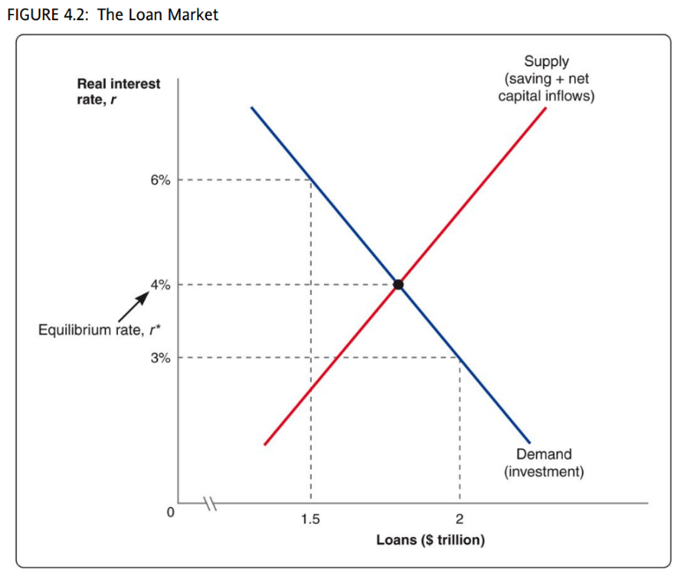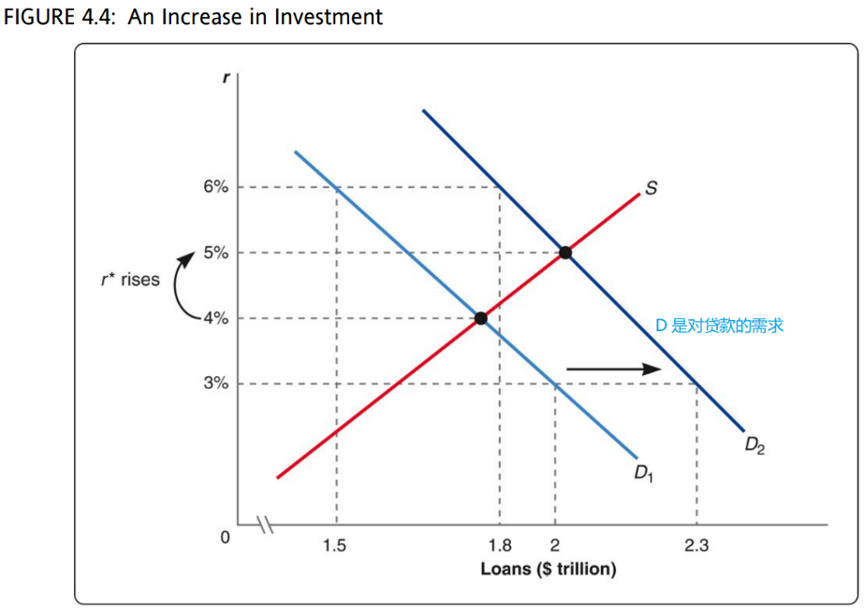

[FIGURE 4.2]

* The demand curve shows how investment falls as the real interest rate raises.
* The supply curve shows that a higher interest rate raises the sum of saving and net capital inflows and therefore raises the quantity of loans demanded.

**可贷资产理论下利率的决定因素：**

**shifts in investment** (FIGURE 4.4), **shifts in saving** (FIGURE 4.5)**, shifts in net capital inflows** (FIGURE 4.6)**.**

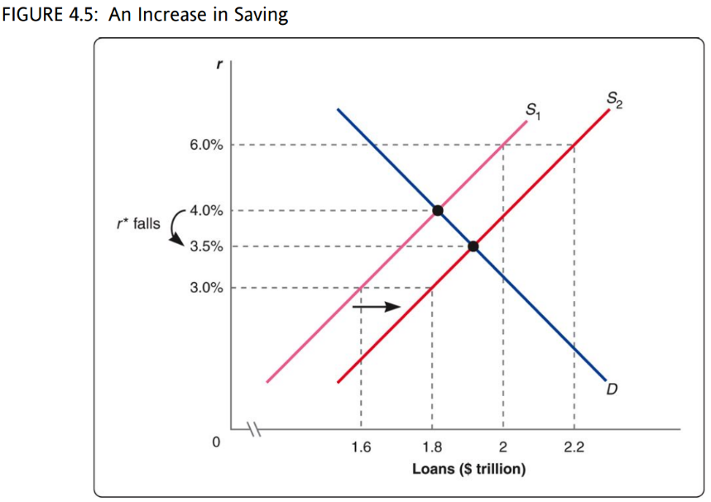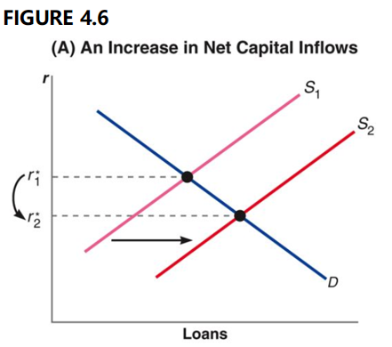

[FIGURE 4.4] Generally， any event that encourages investment shifts the demand curve for loans to the right, raising the equilibrium interest rate. Any event that makes investment less attractive does the reverse.

[FIGURE 4.5] Suppose people save more at a given interest rate, this change will **raise the sum of saving and net capital inflows** at a given interest rate, shifting the supply curve for loans to the right.

Saving = private saving + public saving (私人存款是个人和公司存款，公共存款是政府存款)

Public saving = tax revenue – government spending (budget surplus 表示为正，budget deficit 表示为负)

[FIGURE 4.6] shows what happens if net capital inflows rise for a given interest rate. The effects are similar to those of higher saving. The sum of **saving and net capital inflows rises**, shifting the supply curve for loans to the right, reducing the equilibrium interest rate.

Capital flight (资本外逃): Sudden decrease in net capital inflows that occurs when foreign savers lose confidence in an economy.

**外国利率变化的影响**：Interest rates in different countries are connected: they tend to move in the same direction. An event that r**aises the interest rate** in one country, such as a higher budget deficit, **reduces net capital inflows** to other countries. The **supply of loans falls** in the other countries, so their **interest rates rise** too.

Nominal interest rates (名义利率): . (Fisher equation)

**流动性偏好理论：**

The **nominal interest rate** is determined by the **supply and demand for money**. (The key simplifying assumption is that only two kinds of assets exist, money and bonds. Bonds pay interest but money does not.)

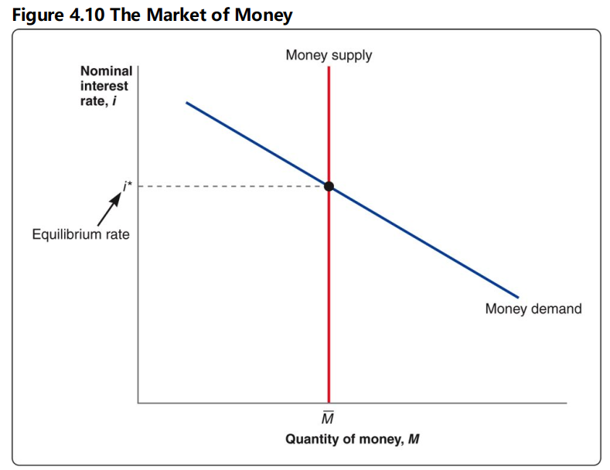

[FIGURE 4.10] (持有money是为了方便购买，持有bonds是为了获取利息，所以) A higher interest rate reduces the quantity of money demanded. (The money supply is fixed at a level chosen by the Fed, regardless of the interest rate. )

**流动性偏好理论下改变名义利率的因素**：**Shifts in money supply** (decisions by the central bank), **Shifts in money demand** (Changes in aggregate spending, Changes in transaction technologies.).

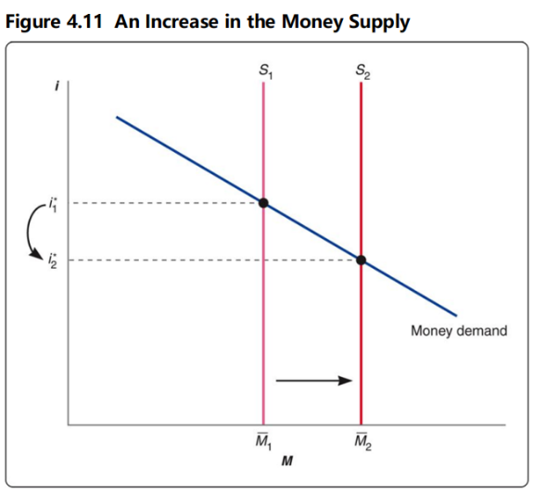

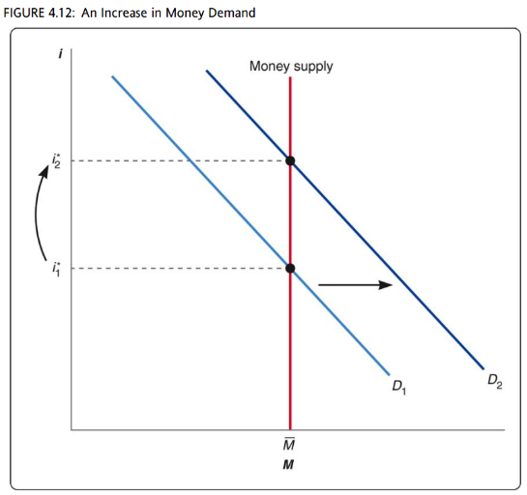[FIGURE 4.11] When money supply increases, the money supply curve shifts to the right, reducing the equilibrium nominal interest rate.

[FIGURE 4.12] When money demand increases, the demand curve shifts to right, raising the equilibrium interest rate.

**利率的期限结构：**Relationships among interest rates on bonds with different maturities.

Factors that explain differences among interest rates: Maturity, Default risk, Liquidity, Taxation.

* The 2-year rate is the average of the current 1-year rate and the 1-year rate in the following year: ;
* The n-period interest rate is the average of one-period rates in the current period and the next n-1 periods: .

**Accounting for risk:** . ( is the term premium for an n-period bond, that is extra return on a long-term bond that compensates for its riskiness; E means expected.)

**Yield curve (收益曲线):** The term structure of interest rates can be summarized in a graph called the yield curve, which shows **interest rates on bonds of various maturities** at a given point in time.

The shape of the curve depends on **expectations about future interest rates**. (Inverted yield curve: downward-sloping yield curve signifying that short-term interest rates exceed long-term rates.)

**[案例]Inverted Yield Curve**

An inverted curve occurs only if short-term interest rates are expected to fall by a large amount. Why might this expectation arise?

Historically, most inverted yield curves have been caused by the Fed’s monetary policy – specifically, by efforts to reduce inflation. To fight inflation, the Fed **slows the growth of the money supply.** This action **raises short-term interest rates**, as we can see with the liquidity preference theory. Higher interest rates **reduce economic growth** temporarily, and slower growth **reduces inflation**. In such an episode, short-term interest rates rise temporarily. People expect the central bank to end its policy in the future, reducing short-term rates. In fact, these rates are likely to fall by more than they have risen, ending up lower than they were before the central bank acted. The reason is that inflation will probably fall, reducing nominal interest rates through the Fisher equation. The expected decrease in rates may be large enough to invert the yield curve.

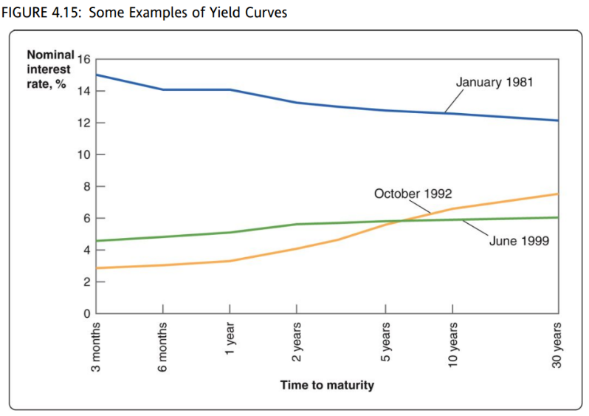

In Figure 4.15, we saw that the yield curve for Treasury securities was inverted in 1981. At that time inflation had been running near 10 percent, and the Federal Reserve was determined to reduce it. The Fed slowed money growth, raising the 3-month Treasury bill rate to 15 percent. The yield curve inverted because people expected large decreases in inflation and interest rates. Expectations turned out to be correct: the 3-month T-bill rate fell to 8 percent in 1983 and 6 percent in 1986.

Another inverted yield curve occurred at the end of 2000. The Fed was worried that inflation might rise, because output had been growing at an unusually rapid pace. The Fed raised short-term interest rates to contain inflation, and the yield curve mildly inverted.

**[案例] The Paradox of Japanese Interest rate**

Low bond ratings usually produce high interest rates, but Japan is an exception. Why hasn’t default risk produces higher rates?

Part of the answer is the **inflation rate**. In much of the 2000s, Japanese inflation was negative; over 2002–2006, it hovered around −1 percent. So the real interest rate on government debt, i − π, was about 1.4% − (−1%) = 2.4%. **A real rate of 2.4 percent is not unusually low.**

Still, one might expect default risk to push the real rate higher. In Japan, the effect of default risk has been offset by **two factors that push interest rates down**. Both are part of the loanable funds theory of interest rates.

The first factor is **high saving.** Over 2002–2006, private saving in Japan averaged 26 percent of GDP, compared to 15 percent in the United States. As a result, total saving was high despite government budget deficits. High saving raises the supply of loans, reducing the real interest rate.

The other factor is **investment**. Japan’s slump eroded confidence in the economy, reducing firms’ desire to invest. Low investment means a low demand for loans, which also reduces the real interest rate.

**Securities and Stock**

债券(Bonds): Bonds are long-term debt securities that are issued by government agencies or corporations. The issuer of a bond is obligated to pay interest payments periodically and the par value at maturity. (treasury and federal agency bonds, municipal bonds, corporate bonds.)

Stock index quotations: Down Jones Industrial Average; Standard & Poor’s 500; Wilshire 5000 Equity Index; New York Stock Exchange Index; Nasdaq Composite Index.

Stock valuation methods: Price-Earning method; Dividend discount model; Free cash flow model.

影响股价的因素：Economic factors; Market-related factors; Firm-specific factors.

汇率：

Purchasing power parity: theory of exchange rates based on the idea that a currency purchases the same quantities of goods and services in different countries; implies that real exchange rates are constant over time.

Supply of dollars = imports + capital outflows. (购买外国商品和服务是**进口，**购买外国资产是**资本流出**)

Demand for dollars = exports + capital inflows. (外国人购买本国商品和服务是**出口**，购买本国资产是**资本流入**)

**supply of dollars = demand for dollars** → imports + capital outflows = exports + capital inflows. → exports – imports = capital outflows – capital inflows → net exports = net capital outflows. (NX = NCO)

真实汇率的影响：A rise in real exchange rate means that U.S. goods become more expensive compared with foreign goods. 外国商品变得更受欢迎，所以进口增加，出口减少。**↑ɛ → ↓exports, ↑imports → net exports.**

**影响真实汇率的因素：**

**1. Shift in net capital outflows** (**Figure 6.7**): When NCO rises, the vertical curve shifts to the right, reducing the equilibrium exchange rate. (R rise in capital outflows means Americans buy more foreign assets. To do so, they must first trade dollars for foreign currency. The supply of dollars rises, pushing down the price of the dollar.) 包括**Changes in interest rates**: if rates rise in U.S., U.S. assets will become more attractive. **Changes in confidence**; **Changes in expected exchange rates. 2. Shifts in net exports (Figure 6.8):** net exports rise for each real exchange rate, shifting the NX curve to the right, and the equilibrium real exchange rate rises. (To buy more U.S. goods, foreigners need more dollars, and higher demand for the dollar pushes up its price.) 包括 **Foreign recessions; Changes in commodity prices.**

