**WEB DEVELOPMENT I PROJECT**

**Project Information**

Project Name: AIRS'R'US Airline Reservation System

Team Name: Zulu

Team Members: LI Zhi, FENG Xiaoli, BAO Qingjun,

Last Update Date: 2023-10-16

Develop language: html CSS PHP

Front-end Framework: JQuery Bootstrap

Database: MySQLi

Develop IDE: VS Code

**Project/Website Design Purpose**

In the fast-paced world of modern travel, a world famous airline company AIRS'R'US having a seamless and efficient Airline Reservation System is crucial. Our purpose in designing this system is to create a user-friendly platform that simplifies the complexities of flight bookings, ensuring a hassle-free experience for travelers.

**Timeline**

* 2023 Oct. 16 – Website Architecture Design, Product Requirement Document
* 2023 Oct. 18 – Wireframe UI Design, Database Identify Entities and Schema, ER-Diagram
* 2023 Oct. 23 – UI Responsive design, Database Schema and Normalize
* 2023 Oct. 27 – PHP programming, Testing
* 2022 Nov. 3 – Website final version and Presentation

Project Requirements Description 3

Project Function Flow Chart 4

Website Map 5

Update Record 6

Website Development Features 7

UI Wireframe Design 8

Database Design Purpose 9

Database ER Diagram 10

Database Schema Design 11

Database SQL Statements 13

Project github link: 13

### Project Requirements Description

1. USER REGISTRATION & LOGIN

* Allow users to register and login
* Registered users can manage and modify their profile

1. SEARCH

* Provider search functionality to allow users to find flights, the flights items will be listed.
* Flight search should have departure and arrival airport, departure time and arrival time, and number of guests.
* Switch the date to return the flights list.

1. FILTER

* Allow users to filter flight search results by Stops, Airlines
* Filtered flights interaction can sort result by Earliest departure, Earliest arrival, Shortest trip, Lowest price

1. INTERACTION

* Provide users ability to book and checkout a flight.
* Each book flight should have a booking number, each person on the flight should have a name and a seat (note that no 2 users can have the same seat on the same flight).

1. ADMIN

* Admin should be able to manage users, airports, flights and user bookings

1. CHECKOUT

* Confirm with the user the flight selected the passengers and the seat selection

1. NOTES

* Direct flights only.
* Time zones do not need to be managed. You control airports, plane(s), seating.

1. Contact and Footer

* Customer Support and Contact Information
* Links to important pages like Privacy Policy, Terms of Service
* Copyright information and social media icons.

### Project Function Flow Chart

### Website Map

### Update Record

|  |  |  |  |
| --- | --- | --- | --- |
| Version | Action | Task | Date |
| 01.00.00 | Create | Documents |  |
|  | Create | 3 html pages |  |
|  | Domain | aibao.me |  |
|  | Create | Database Tables |  |
|  | Create | UI CSS renew |  |
|  | Create | PHP Register/Login |  |
|  | Create | PHP query |  |
|  | Create | PHP SESSION |  |

### Website Development Features

* PHP Language Object-Oriented programming thinking
* Pushed on github

### UI Wireframe Design

**Main Menu**

**Registration / Login**

**User Profile / Editor**

**User Admin**

**Search Flights**

**Book Flights / Orders Cart**

### Database Design Purpose

Designing the database system for an Airline Reservation System involves creating a structure that can efficiently store, retrieve, and manage various data entities such as users, flights, airports, bookings, and more.

* Users: Store user information such as user ID, name, email, password (hashed), and other relevant details.
* Flights: Include flight ID, airline name, departure and arrival airports, departure and arrival times, price, and seat availability.
* Airports: Store airport ID, airport name, location, and any other necessary details.
* Bookings: Record booking ID, user ID (foreign key referencing Users table), flight ID (foreign key referencing Flights table), booking date, and other booking-related information.

### Database ER Diagram

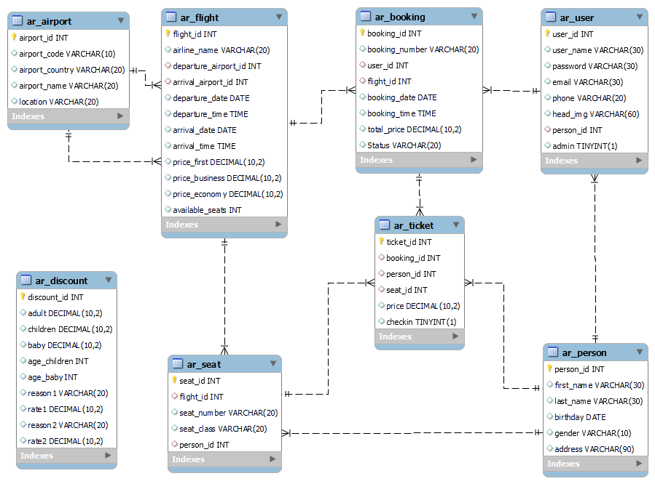

### Database Schema Design

**User Table: ar_user**

|  |  |  |  |
| --- | --- | --- | --- |
| **Field** | **Data Type** | **Key** | **Description** |
| UserID | INT | PK | Unique identifier for the user. |
| UserName | VARCHAR |  | User's registration name. |
| Email | VARCHAR |  | User's email address. |
| PasswordHash | VARCHAR |  | Hashed password for user authentication. |
| Phone | VARCHAR |  | User's phone number. |
| PersonID | INT | FK | References Person(PersonID) |
| Admin | BOOLEAN |  | Administer or not: false / true |

**Person Table: ar_person**

|  |  |  |  |
| --- | --- | --- | --- |
| **Field** | **Data Type** | **Key** | **Description** |
| PersonID | INT | PK | Unique identifier for the person. |
| FName | VARCHAR |  | Person's first name |
| LName | VARCHAR |  | Person's last name |
| Birthday | DATE |  | Date of birth |
| Address | VARCHAR |  | Person's address. |
| Gender | VARCHAR |  | Person's gender |

**Flight Table: ar_flight**

|  |  |  |  |
| --- | --- | --- | --- |
| **Field** | **Data Type** | **Key** | **Description** |
| FlightID | INT | PK | Unique identifier for the flight. |
| AirlineName | VARCHAR |  | Name of the airline operating the flight. |
| DepartureAirportID | INT | FK | References Airport(AirportID): Departure airport for the flight. |
| ArrivalAirportID | INT | FK | References Airport(AirportID): Arrival airport for the flight. |
| DepartureDate | DATE |  | Date of the flight's departure. |
| DepartureTime | TIME |  | Time of the flight's departure. |
| ArrivalDate | DATE |  | Date of the flight's arrival. |
| ArrivalTime | TIME |  | Time of the flight's arrival. |
| PriceFirst | DECIMAL |  | First Class Ticket price for the flight. |
| PriceBusiness | DECIMAL |  | Business Ticket price for the flight. |
| PriceEconomy | DECIMAL |  | Economy Ticket price for the flight. |
| AvailableSeats | INT |  | Number of available seats on the flight. |

**Flight Table: ar_seat**

|  |  |  |  |
| --- | --- | --- | --- |
| **Field** | **Data Type** | **Key** | **Description** |
| SeatID | INT | PK | Unique identifier for the seat. |
| FlightID | INT | FK | Unique identifier for the flight |
| SeatNumber | VARCHAR |  | Number of this seat |
| SeatClass | VARCHAR |  | Class of seat: “First Class” / “Business” / “Economy” |
| PersonID | INT | FK | References Person(PersonID): the person who take this seat |

**Airport Table: ar_airport**

|  |  |  |  |
| --- | --- | --- | --- |
| **Field** | **Data Type** | **Key** | **Description** |
| AirportID | INT | PK | Unique identifier for the airport. |
| AirportCode | VARCHAR |  | IATA code |
| AirportCountry | VARCHAR |  | Country of the airport. |
| AirportName | VARCHAR |  | Name of the airport. |
| Location | VARCHAR |  | Location or city where the airport is located. |

**Booking Table: ar_booking**

|  |  |  |  |
| --- | --- | --- | --- |
| **Field** | **Data Type** | **Key** | **Description** |
| BookingID | INT | PK | Unique identifier for the booking order. |
| BookingNumber | VARCHAR |  | Unique number for the booking order. |
| UserID | INT | FK | References User(UserID): ID of the booking user. |
| FlightID | INT | FK | References Flight(FlightID): ID of the booked flight. |
| BookingDate | DATETIME |  | Date and time when the booking was made. |
| TotalPrice | DECIMAL |  | Total price paid for the booking. |
| Status | VARCHAR |  | Booking status (e.g., Confirmed, Pending, Cancelled, etc.). |

**Ticket Table: ar_ticket**

|  |  |  |  |
| --- | --- | --- | --- |
| **Field** | **Data Type** | **Key** | **Description** |
| TicketID | INT | PK | Unique identifier for the ticket. |
| BookingID | INT | FK | References Booking(BookingID): ID of the booking order. |
| PersonID | INT | FK | References Person(PersonID): the person who take this seat |
| SeatID | INT | FK | References Seat(SeatID): The Seat Person selected |
| Price | DECIMAL |  | Price paid for the ticket. |
| Checkin | BOOLEAN |  | The ticket check-in information: false / true |

**Discount Table: ar_discount**

|  |  |  |  |
| --- | --- | --- | --- |
| **Field** | **Data Type** | **Key** | **Description** |
| DiscountID | INT | PK | Unique identifier for the ticket price discount. |
| Adult | DECIMAL |  | Discount for the Adult person / normal price |
| Children | DECIMAL |  | Discount for the Children person |
| Baby | DECIMAL |  | Discount for the Baby person |
| AgeChildren | INT |  | The age rules for the Children |
| AgeBaby | INT |  | The age rules for the Baby |
| Reason1 | VARCHAR |  | Reason 1 for discount |
| Rate1 | DECIMAL |  | Reason 1 discount rate |
| Reason2 | VARCHAR |  | Reason 2 for discount |
| Rate2 | DECIMAL |  | Reason 2 discount rate |

### Database SQL Statements

### Project github link:

https://github.com/polluxbao/vanibao-bookstore