安卓图表引擎AChartEngine的使用效果分析
条形图 | static android.content.Intent | getBarChartIntent(android.content.Context context,XYMultipleSeriesDataset dataset, XYMultipleSeriesRenderer renderer,BarChart.Type type)
条形图 | static android.content.Intent | getBarChartIntent(android.content.Context context,XYMultipleSeriesDataset dataset, XYMultipleSeriesRenderer renderer,BarChart.Type type, java.lang.String activityTitle)
条形图 | static GraphicalView | getBarChartView(android.content.Context context,XYMultipleSeriesDataset dataset, XYMultipleSeriesRenderer renderer,BarChart.Type type)
气泡图 | static android.content.Intent | getBubbleChartIntent(android.content.Context context,XYMultipleSeriesDataset dataset, XYMultipleSeriesRenderer renderer)
气泡图 | static android.content.Intent | getBubbleChartIntent(android.content.Context context,XYMultipleSeriesDataset dataset, XYMultipleSeriesRenderer renderer, java.lang.String activityTitle)
气泡图 | static GraphicalView | getBubbleChartView(android.content.Context context,XYMultipleSeriesDataset dataset, XYMultipleSeriesRenderer renderer)
组合图 | static android.content.Intent | getCombinedXYChartIntent(android.content.Context context,XYMultipleSeriesDataset dataset, XYMultipleSeriesRenderer renderer, java.lang.String[] types, java.lang.String activityTitle)
组合图 | static GraphicalView | getCombinedXYChartView(android.content.Context context,XYMultipleSeriesDataset dataset, XYMultipleSeriesRenderer renderer, java.lang.String[] types)
立方折线图 | static GraphicalView | getCubeLineChartView(android.content.Context context,XYMultipleSeriesDataset dataset, XYMultipleSeriesRenderer renderer, float smoothness)
立方折线图 | static android.content.Intent | getCubicLineChartIntent(android.content.Context context,XYMultipleSeriesDataset dataset, XYMultipleSeriesRenderer renderer, float smoothness)
立方折线图 | static android.content.Intent | getCubicLineChartIntent(android.content.Context context,XYMultipleSeriesDataset dataset, XYMultipleSeriesRenderer renderer, float smoothness, java.lang.String activityTitle)
拨号盘 | static android.content.Intent | getDialChartIntent(android.content.Context context,CategorySeries dataset, DialRenderer renderer, java.lang.String activityTitle)
拨号盘 | static GraphicalView | getDialChartView(android.content.Context context, CategorySeries dataset,DialRenderer renderer)
圆环图 | static android.content.Intent | getDoughnutChartIntent(android.content.Context context,MultipleCategorySeries dataset, DefaultRenderer renderer, java.lang.String activityTitle)
圆环图 | static GraphicalView | getDoughnutChartView(android.content.Context context,MultipleCategorySeries dataset, DefaultRenderer renderer)
圆环图 | static android.content.Intent | getLineChartIntent(android.content.Context context,XYMultipleSeriesDataset dataset, XYMultipleSeriesRenderer renderer)
折线图 | static android.content.Intent | getLineChartIntent(android.content.Context context,XYMultipleSeriesDataset dataset, XYMultipleSeriesRenderer renderer, java.lang.String activityTitle)
折线图 | static GraphicalView | getLineChartView(android.content.Context context,XYMultipleSeriesDataset dataset, XYMultipleSeriesRenderer renderer)
饼图 | static android.content.Intent | getPieChartIntent(android.content.Context context, CategorySeries dataset,DefaultRenderer renderer, java.lang.String activityTitle)
饼图 | static GraphicalView | getPieChartView(android.content.Context context, CategorySeries dataset,DefaultRenderer renderer)
范围条形图 | static android.content.Intent | getRangeBarChartIntent(android.content.Context context,XYMultipleSeriesDataset dataset, XYMultipleSeriesRenderer renderer,BarChart.Type type, java.lang.String activityTitle)
范围条形图 | static GraphicalView | getRangeBarChartView(android.content.Context context,XYMultipleSeriesDataset dataset, XYMultipleSeriesRenderer renderer,BarChart.Type type)
散点图 | static android.content.Intent | getScatterChartIntent(android.content.Context context,XYMultipleSeriesDataset dataset, XYMultipleSeriesRenderer renderer)
散点图 | static android.content.Intent | getScatterChartIntent(android.content.Context context,XYMultipleSeriesDataset dataset, XYMultipleSeriesRenderer renderer, java.lang.String activityTitle)
散点图 | static GraphicalView | getScatterChartView(android.content.Context context,XYMultipleSeriesDataset dataset, XYMultipleSeriesRenderer renderer)
时间图 | static android.content.Intent | getTimeChartIntent(android.content.Context context,XYMultipleSeriesDataset dataset, XYMultipleSeriesRenderer renderer, java.lang.String format)
时间图 | static android.content.Intent | getTimeChartIntent(android.content.Context context,XYMultipleSeriesDataset dataset, XYMultipleSeriesRenderer renderer, java.lang.String format, java.lang.String activityTitle)
时间图 | static GraphicalView | getTimeChartView(android.content.Context context,XYMultipleSeriesDataset dataset, XYMultipleSeriesRenderer renderer, java.lang.String format)

效果展示：
AChartEngine 是一个安卓系统上制作图表的框架,目前它支持如下的图表类型:
- line chart (折线图)
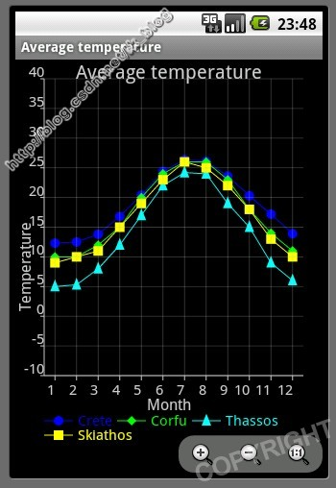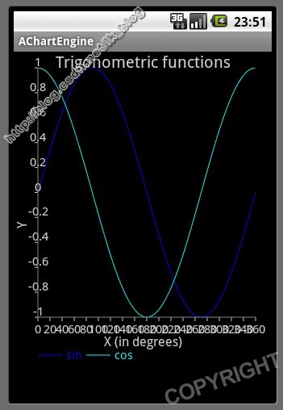
- area chart (面积图；分区图，对比图)
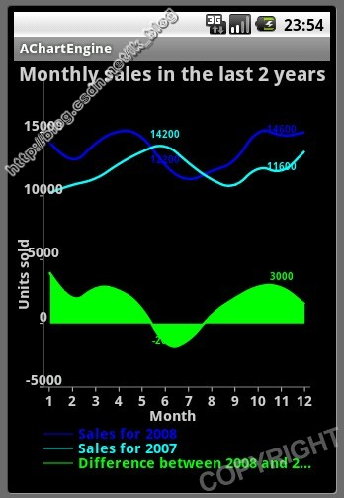
- scatter chart ( 散点图)
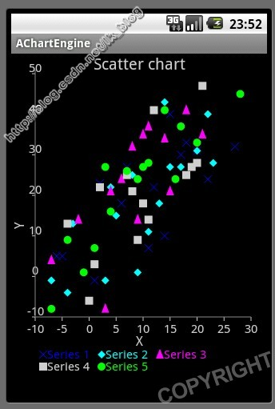
- time chart (时间图；进度表)
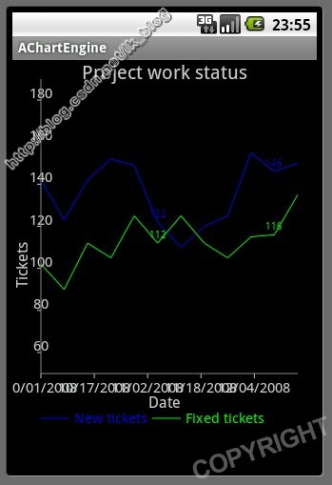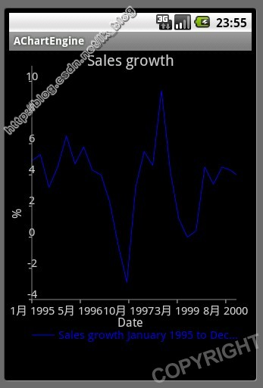
- bar chart (条形图;柱状图)
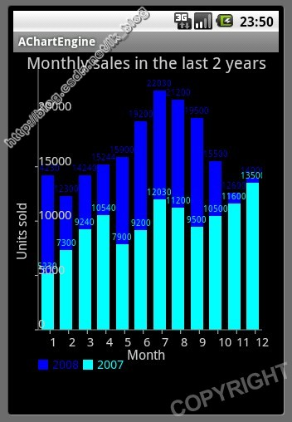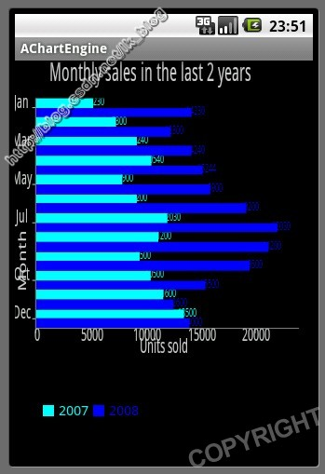
- pie chart ( 饼图)
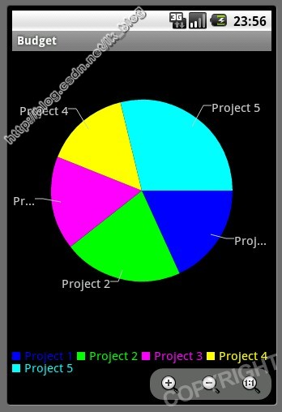
- bubble chart (气泡图)
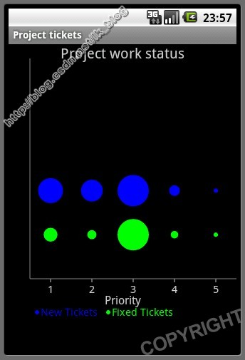
- doughnut chart (圆环图)
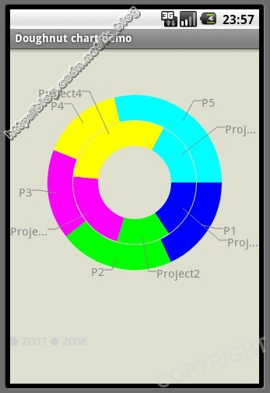
- range (high-low) bar chart (范围条形图)

- dial chart / gauge (拨号盘/压力表)
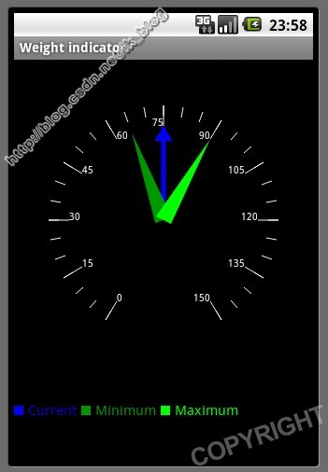
- combined (any combination of line, cubic line, scatter, bar, range bar, bubble) chart(组合图)
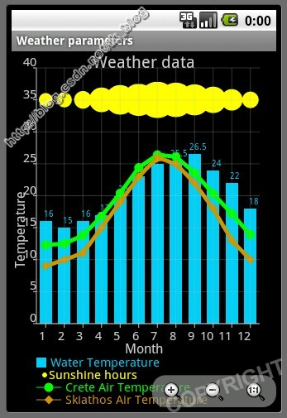
- cubic line chart (立方折线图)
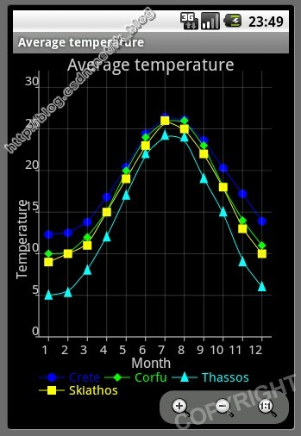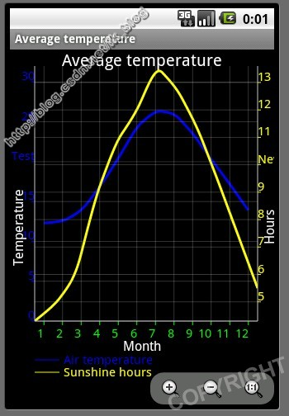
参考：
http://blog.csdn.net/lk_blog/article/details/7645509
使用总结：
有坐标轴的图表，坐标轴外侧背景不能设置为透明色。
无坐标轴的图表，如饼状图环状图等，所展示内容个数不宜过多，否则显示效果拥挤。

自己使用的一些代码效果：
private View getLineChart(ArrayList<Parcelable> arrayList) {
XYMultipleSeriesDataset dataset = new XYMultipleSeriesDataset();
{
{// 第一条线
CategorySeries series = new CategorySeries("指标得分 (单位：分)");
for (Parcelable parcel : arrayList) {
CityInfo info = (CityInfo) parcel;
series.add(info.getIndicatorScore());
}
dataset.addSeries(series.toXYSeries());
}
{// 第二条线
CategorySeries series = new CategorySeries("平均得分 (单位：分)");
for (Parcelable parcel : arrayList) {
CityInfo info = (CityInfo) parcel;
series.add(info.getAverageScore());
}
dataset.addSeries(series.toXYSeries());
}
}
XYMultipleSeriesRenderer renderer = new XYMultipleSeriesRenderer();
{
renderer.setXAxisMax(20);
renderer.setYAxisMax(100);
renderer.setXAxisMin(0);
renderer.setYAxisMin(0);
renderer.setBarSpacing(2);
renderer.setChartTitle("有道理");
renderer.setLegendHeight(20);

renderer.setYTitle("得分");
renderer.setXTitle("城市名称");

int count = 1;
for (Parcelable parcel : arrayList) {
CityInfo information = (CityInfo) parcel;
renderer.addXTextLabel(count, information.getName());
count++;
}
{//第一条线的绘制颜色等信息
XYSeriesRenderer srenderer = new XYSeriesRenderer();
srenderer.setColor(Color.BLUE);
srenderer.setPointStyle(PointStyle.DIAMOND);
renderer.addSeriesRenderer(srenderer);
}
{//第二条线的绘制颜色等信息
XYSeriesRenderer srenderer = new XYSeriesRenderer();
srenderer.setColor(Color.RED);
srenderer.setPointStyle(PointStyle.CIRCLE);
renderer.addSeriesRenderer(srenderer);
}
System.err.println("============================= "
+ renderer.getSeriesRendererCount());
}
renderer.setBackgroundColor(Color.TRANSPARENT);
return ChartFactory.getLineChartView(getThis(), dataset, renderer);
}

代码所得结果是:
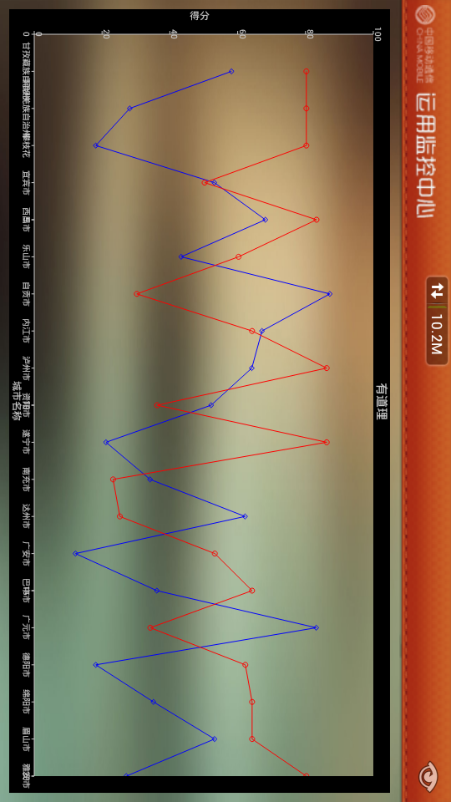
如图，外框无法透明。

