RESUME
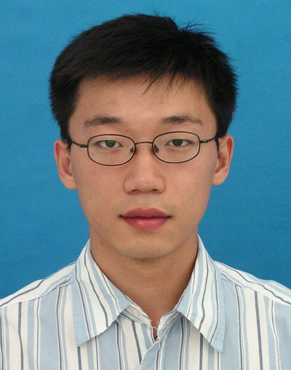
李 腾
基本情况：
性别：男 年龄：28 户口：北京 学历：本科 工作经验： 6年
联系电话： 18611607955 Email：liteng69@gmail.com
教育背景及成绩：
- 2001年9月 - 2005年7月 北京航空航天大学 本科
专业名称： 管理科学与工程
- PMP（项目管理师），2009年通过美国项目管理协会（PMI）资格认证。
- 等级考试：托福 成绩：620
- 等级考试：托业 成绩：745

自我评价：
- 4年世界500强外企渠道销售管理工作经验，现担任华北地区建材产品销售主管。
- 熟悉新销售渠道开发、代理商关系开发维护等工作。对招商，推广，促销等商务活动的组织开展具有丰富的经验。
- 熟悉代理商管理工作，包含培训、业绩考核、市场秩序维护等工作。
- 熟悉零售专卖店的市场开发，曾牵头在全国范围内开设48家专卖店。
- 善于团队管理，带领华北区各地销售人员完成公司既定目标，获得公司A级评价。

工作经验：
2007年11月 – 现在 公司名称：LG Hausys Trading Co.,Ltd.
部门：装饰材华北营业
职位：区域销售经理
工作职责和业绩：
- 负责华北地区的LG装饰材料产品的销售，曾经负责过的产品包括PVC地板和墙纸，完成公司任务指标120%，内部评价等级为A.
- 开发并维护渠道代理商，工程代理商。期间开发代理商7个，均成为各区域主要销售力量。在天津，石家庄等地均设有办事处。
- 对LG产品进行市场宣传推广等各种活动，包括产品发布会，媒体广告，交流论坛等。
- 发展LG零售市场，在职期间共策划并执行开设地板专卖店48家，壁纸专店12家，分布全国。

2005年7月 – 2007年10月 公司名称：北京四维图新导航信息技术有限公司
部门：产品企划部
职位：项目经理
2年项目管理经历，积累了丰富的对应客户的经验,接洽过NOKIA,神达,NISSAN等高端客户。作为项目经理曾全程负责过对应神达公司两个版次产品的出品。
RESUME
Li Teng
Personal Info：
Gender：Male Age：28 Hukou：Beijing Highest Education：Bachelor
Work experience： 6 years
Mobile Phone： 18611607955 Email：liteng69@gmail.com
Education And Certificates：
- 2001. 9 - 2005 . 7 Beihang University School of Economics and Management
Major :Management Science and Engineering
- PMP（Project Management Professional），Project Management Institute(PMI) certified.
- Grade Exam: TOEFL Scores：620
- Grade Exam: TOEIC Scores：745

Self Assessment：
- 4 years sales management experience in top 500 enterprises, currently serves as director of product sales in North China.
- Familiar with the new product market development, dealer relations development and maintenance work. With experience of investment, promotion, marketing and other business activities.
- As a manufacturer’s representative has a wealth of experience in coordinating the first party, including hotels, hospitals, schools.Had approached Vanke, Huayuan and other top domestic real estate and signed strategic cooperation agreements.
- Familiar with the market development of the retail store.Has opened 48 stores across the country as a leader.
- Be good at team management, achieved stated objectives as a team leader, and acquired A-level evaluation in LG Group.
Work Experience：
2007．11 – now Company Name: LG Hausys Trading Co.,Ltd.
Department : Decorative Materials business in North China
Job Title : Regional Sales Manager
Achievements：
- Responsible for LG decoration materials sales in North China, has been responsible over the products including PVC flooring and wallpaper, had completed business target 120%, internal evaluation rating of A.
- Develop and maintain channel agents, project agents. Has developed 7 agents independently, which has became the region's main sales force.
- Execute The LG product marketing and promotion activities, including product launches, media advertising, communication forums.
- Develop LG retail market, has planned and executed the opening of 48 floor stores and 12 wallpaper stores all over the country.

2005.7 – 2007.10 Company Name: China NavInfo Co.Ltd.
Department: Product Planning Department
Job Title:Project Manager
2 years project management experience and be adept at dealing with customers.Have cooperated with global companies including NOKIA、MITAC and NISSAN.

