# ISCC2024 WriteUp

Whooops+李卓航+925798691@qq.com

### Misc FunZip

### 解题思路

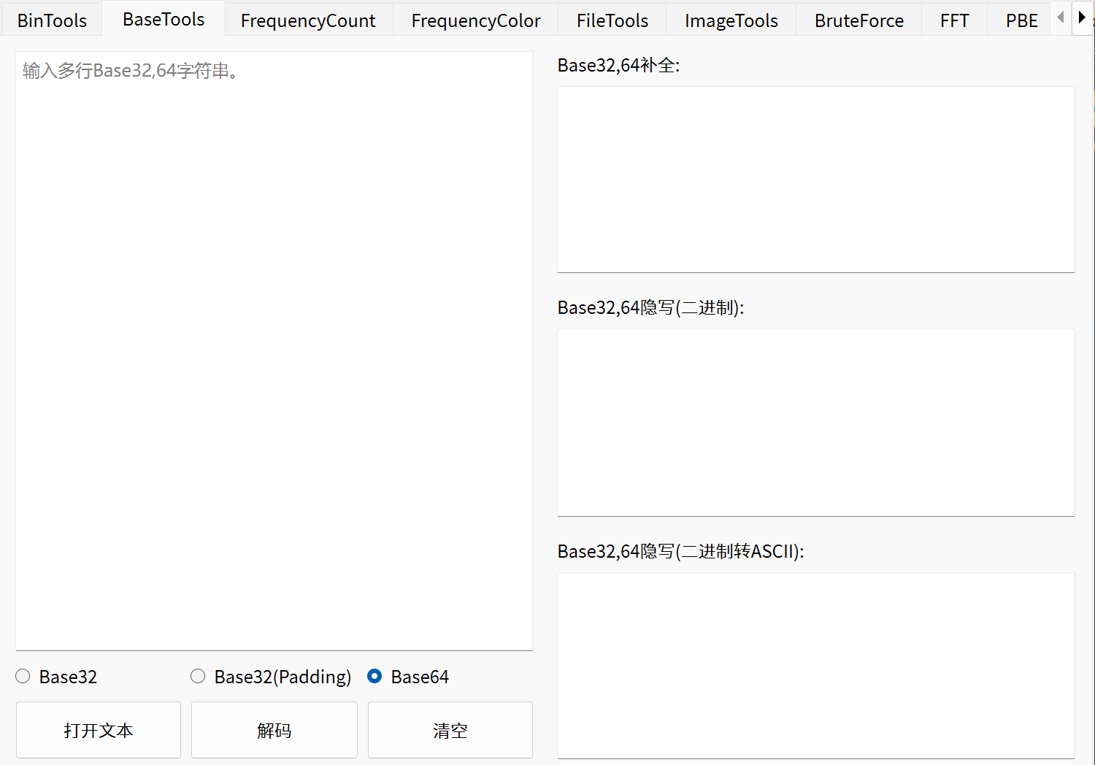1. base64隐写用PuzzleSolver一把梭