# ISCC2024 WriteUp

AkyOI+李承达+3433778745@qq.com

### Reverse Badcode

### 解题思路（必须包含文字说明+截图）

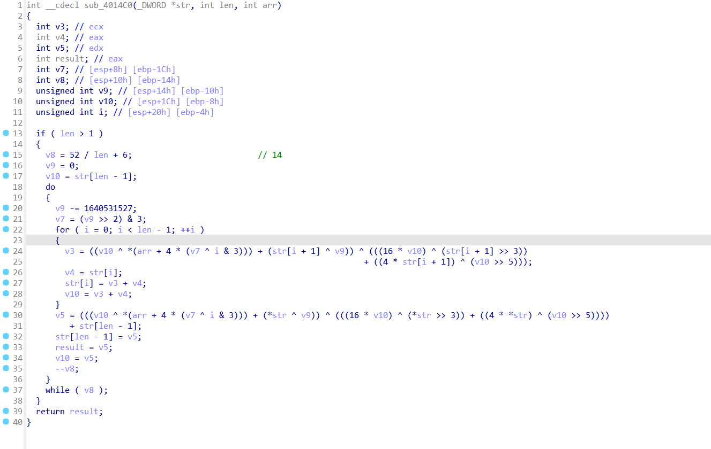

发现是XXTEA

之后按照程序的逻辑直接写脚本

### Exp（如有，请粘贴完整代码，不允许截图！）

from Crypto.Util.number import *

def changebyte(z, y, x, k, p, e):

return ((((z >> 5) ^ (y << 2)) + ((y >> 3) ^ (z << 4))) ^ ((x ^ y) + (k[(p & 3) ^ e] ^ z)))

def fun1(v, k):

value = 0x61C88647

n = len(v)

r = 6 + 52 // n

x = 0

z = v[n - 1]

for i in range(r):

x = (x - value) & 0xFFFFFFFF

e = (x >> 2) & 3

for p in range(n - 1):

y = v[p + 1]

v[p] = (v[p] + changebyte(z, y, x, k, p, e)) & 0xFFFFFFFF

z = v[p]

p += 1

y = v[0]

v[n - 1] = (v[n - 1] + changebyte(z, y, x, k, p, e)) & 0xFFFFFFFF

z = v[n - 1]

return v

def func2(v, k):

value = 0x61C88647

n = len(v)

r = 6 + 52 // n

x = (0 - r * value) & 0xFFFFFFFF

y = v[0]

for i in range(r):

e = (x >> 2) & 3

for p in range(n - 1, 0, -1):

z = v[p - 1]

v[p] = (v[p] - changebyte(z, y, x, k, p, e)) & 0xFFFFFFFF

y = v[p]

p -= 1

z = v[n - 1]

v[0] = (v[0] - changebyte(z, y, x, k, p, e)) & 0xFFFFFFFF

y = v[0]

x = (x + value) & 0xFFFFFFFF

return v

p = [0x154470BD,0xCBAC1CA8,0x7AFCD5E2,0x4F666267,0x5A76A6AE, 0x88FEB27D]

kkk = [0x12345678, 0x9ABCDEF0, 0xFEDCBA98, 0x76543210]

ddd = func2(p, kkk)

flag=[]

v16='674094872038771148666737'

for i in range(len(p)):

x=long_to_bytes(ddd[i])

for j in range(3,-1,-1):

flag.append(x[j])

for i in range(len(flag)):

flag[i]^=ord(v16[i])-0x30

if i%2:

flag[i]-=2

else:

flag[i]+=3

print(bytes(flag))