# ISCC2024 WriteUp 提交模板

AkyOI+李承达+3433778745@qq.com

### Reverse CrypticConundrum

### 解题思路（必须包含文字说明+截图）

发现有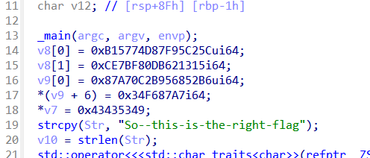UPX的壳, upx -d +文件名 直接脱壳

之后按照逻辑直接写脚本

### Exp（如有，请粘贴完整代码，不允许截图！）

#include <iostream>

#include <vector>

#include <algorithm>

int main() {

std::vector<unsigned char> cmp = {0x5C, 0xC2, 0x95, 0x7F, 0xD8, 0x74, 0x57, 0xB1, 0x15, 0x13, 0x62, 0xDB, 0x80, 0xBF, 0xE7, 0x0C, 0xB6, 0x52, 0x68, 0x95, 0x2B, 0x0C, 0xA7, 0x87, 0xF6, 0x34};

std::string key2 = "ISCC";

int i;

for (i = 0; i < cmp.size(); i++) {

cmp[i] -= 10;

cmp[i] &= 0xff;

}

for (i = 0; i < cmp.size() - 1; i++) {

cmp[i] += cmp[i + 1];

cmp[i] &= 0xff;

}

for (i = 0; i < cmp.size() - 1; i++) {

cmp[i] ^= key2[2];

}

for (i = 0; i < cmp.size(); i += 2) {

cmp[i] ^= key2[i % 4];

}

for (i = 0; i < cmp.size() / 2; i++) {

unsigned char temp = cmp[i];

cmp[i] = cmp[cmp.size() - i - 1];

cmp[cmp.size() - i - 1] = temp;

}

for (i = 0; i < cmp.size() / 2; i++) {

unsigned char temp = cmp[i];

cmp[i] = cmp[cmp.size() - i - 1];

cmp[cmp.size() - i - 1] = temp;

}

for (i = 0; i < cmp.size(); i++) {

cmp[i] += key2[i % 4];

cmp[i] &= 0xff;

}

for (auto &byte : cmp) {

std::cout << byte;

}

std::cout << std::endl;

return 0;

}