# ISCC2024 WriteUp 提交模板

AkyOI+李承达+3433778745@qq.com

### Reverse DLLCode

### 解题思路（必须包含文字说明+截图）

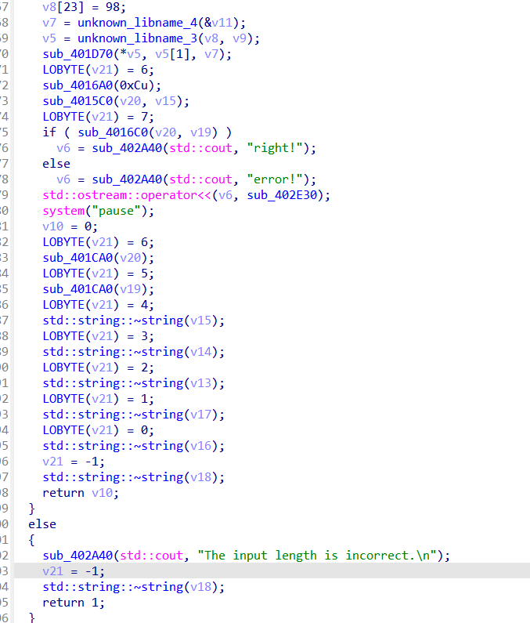

仔细审代码，然后理清每个函数的作用，根据逻辑就可以写出来解密的脚本。

### Exp（如有，请粘贴完整代码，不允许截图！）

#include <iostream>

#include <vector>

#include <string>

int main() {

std::vector<int> key1 = {73, 83, 67, 67};

std::vector<int> v4 = {2, 0, 3, 1, 6, 4, 7, 5, 10, 8, 11, 9};

std::vector<int> enc = {0x0, 0x10, 56, 20, 17, 61, 50, 43, 27, 0, 20, 124, 67, 120, 83, 68, 70, 74, 63, 103, 116, 125, 117, 98};

std::vector<int> enc2(enc.begin(), enc.begin() + 12);

std::vector<int> enc1_2(enc.begin() + 12, enc.end());

std::vector<int> flag(24, 0);

for (int i = 0; i < 12; ++i) {

flag[2 * i + 1] = enc1_2[v4[i]];

}

for (int i = 0; i < enc2.size(); ++i) {

enc2[i] ^= key1[i & 3];

}

for (int i = 0; i < 12; ++i) {

flag[2 * i] = enc2[i];

}

for (int i = 0; i < flag.size(); ++i) {

std::cout << static_cast<char>(flag[i]);

}

return 0;

}