Nebu1ea 韩磊 [1504895347@qq.com](mailto:1504895347@qq.com)

Misc:Number_is_the_key

解题思路：

excel打开，根据单元格格式上色，即把加粗显示的格子涂黑，并修改列宽和行高以便观看，即可出现的二维码。可以用脚本代替手工。

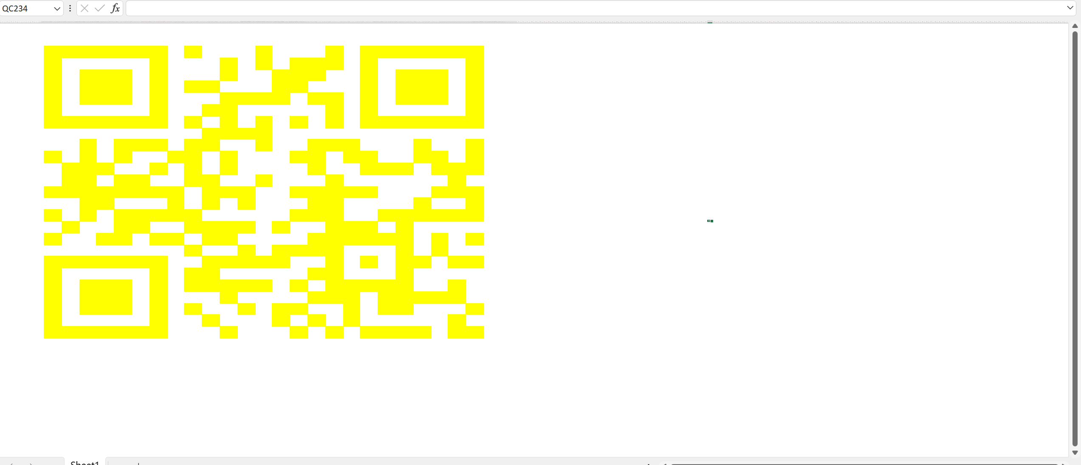

Exp:

from openpyxl import load_workbook

from openpyxl.styles import PatternFill

w1 = load_workbook('./attachment-1.xlsx')

w2 = w1.active

bold_cells = []

for r in w2.iter_rows():

    for c in r:

        if c.font.bold:

            bold_cells.append(c.coordinate)

highlight_style = PatternFill(start_color="FFFF00", end_color="FFFF00", fill_type="solid")

for i in bold_cells:

    w2[i].fill = highlight_style

w1.save('atta.xlsx')