**单周期CPU设计**

李卓 pb19000064

**实验目的**

理解CPU的结构和工作原理

掌握单周期CPU的设计和调试方法

熟练掌握数据通路和控制器的设计和描述方法

**实验原理**

设计实现单周期RISC-V CPU，可执行以下10条指令

* + add, addi, sub, auipc, lw, sw, beq, blt, jal, jalr

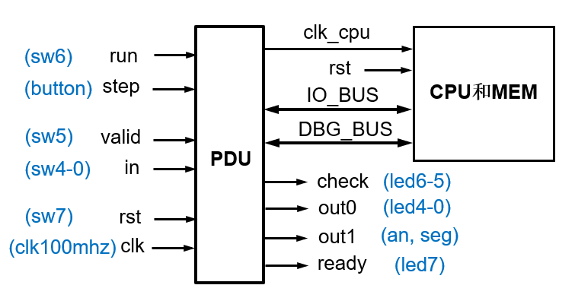

单周期CPU数据通路

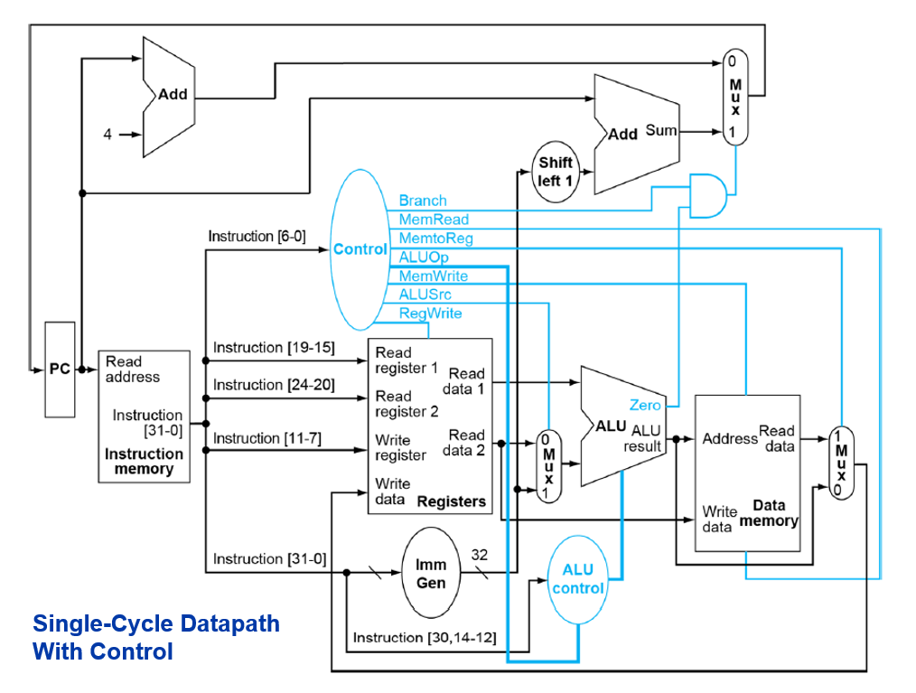

该通路只能实现原有的六条指令，对于新加的四条指令(auipc, blt, jalr sum),需要修改通路。

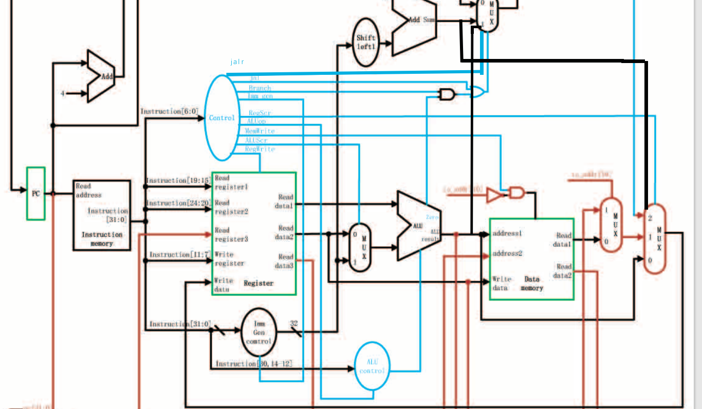

sub：不需特殊处理

auipc：

连接regscr的mux 和pc_adder。执行时pc_adder将pc和立即数相加，RegSrc=11，mux选择pc adder 的结果sum

blt:

根据funct3位判断blt指令。alu_control向alu发送操作符LT:101，alu将两数相减 最高位为一则说明小于，zero置为1，其他与beq指令完全相同

jalr：

control unit增加控制信号 jalr。连接alu的结果与pc_mux。执行时，jalr为1，pc_mux输入为3，选择alu相加的结果写入pc。RegSrc=10, 原pc+4的结果写入寄存器中

io_bus信号

CPU运行时访问开关(sw)、指示灯(led)和数码管(an, seg）

* + io_addr：I/O外设的地址
  + io_din：CPU接收来自输入缓冲寄存器（IBR）的sw输入数据
  + io_dout：CPU向led和seg输出的数据
  + io_we：CPU向led和seg输出时的使能信号，利用该信号将io_dout存入输出缓冲寄存器（OBR），再经数码管显示电路将其显示在数码管（an，seg）

debug_bus信号

调试时将存储器和寄存器堆内容，以及CPU数据通路状态信息导出显示

* + m_rf_addr：存储器(MEM)或寄存器堆(RF)的调试读口地址
  + rf_data：从RF读取的数据
  + m_data：从MEM读取的数据
  + pc：PC的内容

pdu 运行方式：

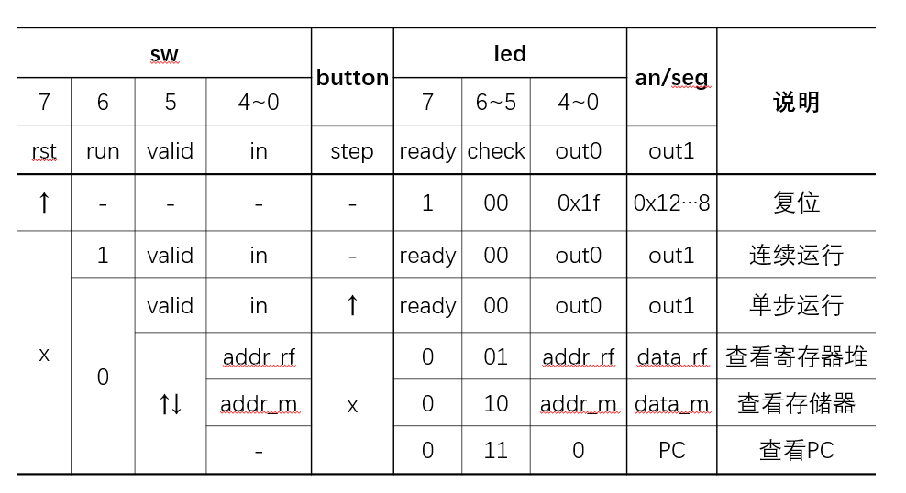

**实验过程**

源文件结构：

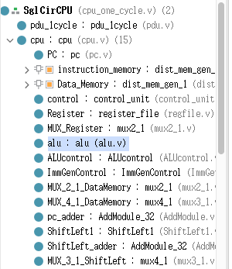

各个模块定义如下图  
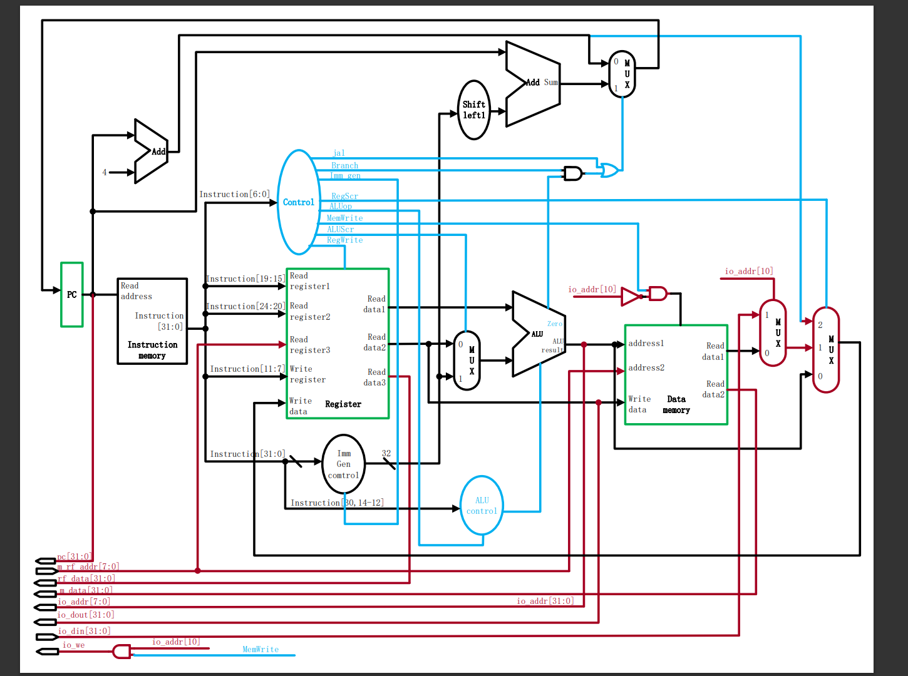

电路

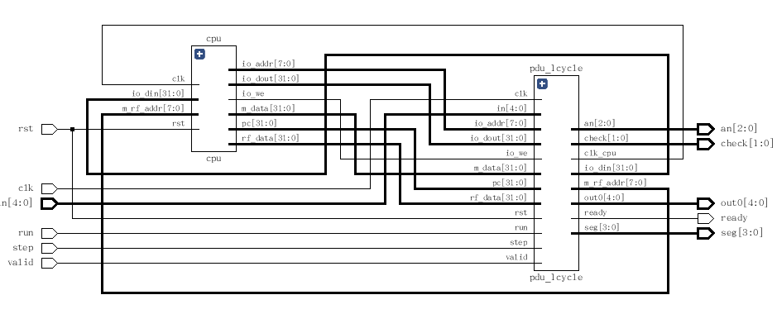

下载测试

***FibFrMem.s***

***FibFrMem_IM.coe***

***FibFrMem_DM.coe***

***FibFrMem.bit***

由Mem生成fib数列, 分别为 汇编源文件，指令段coe，数据段coe，下载结果

***FibFrIO.bit***

由IO生成fib数列 的下载结果, 指令段coe用老师给的

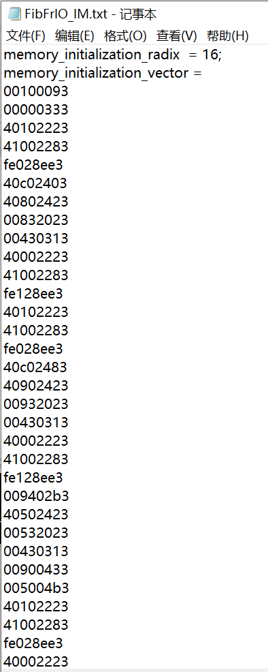

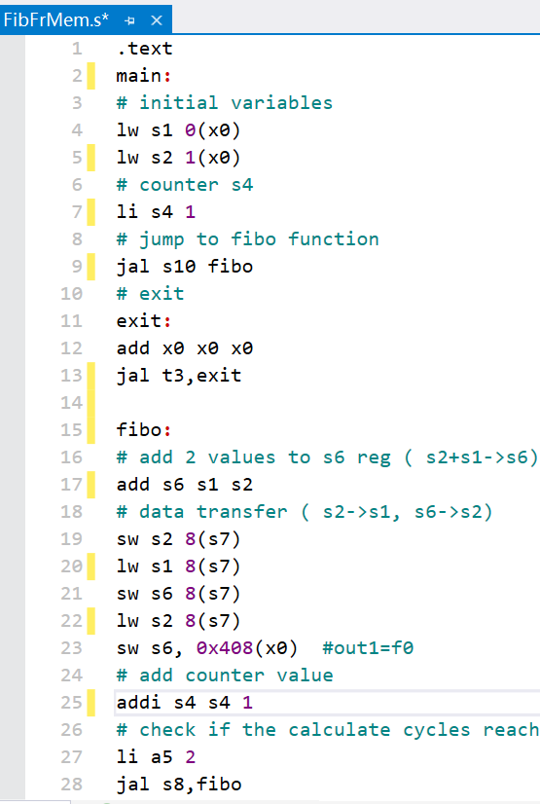

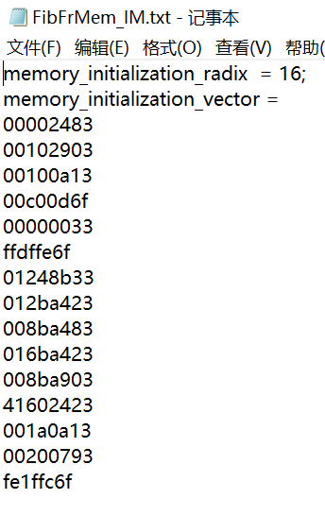

仿真测试：

***test1.s***

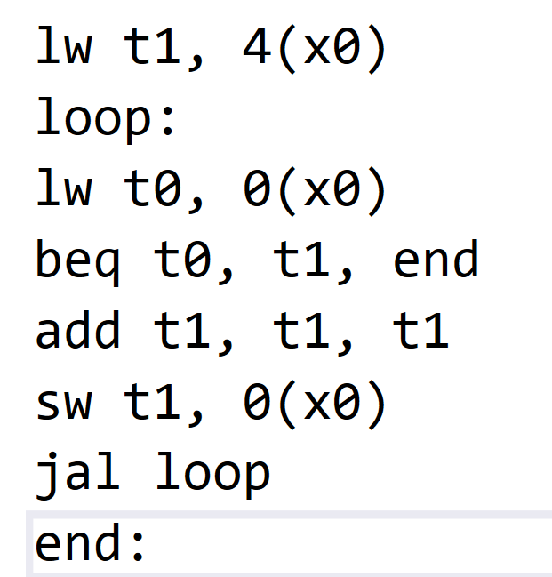

生成的波形图 ***wave1.pdf***

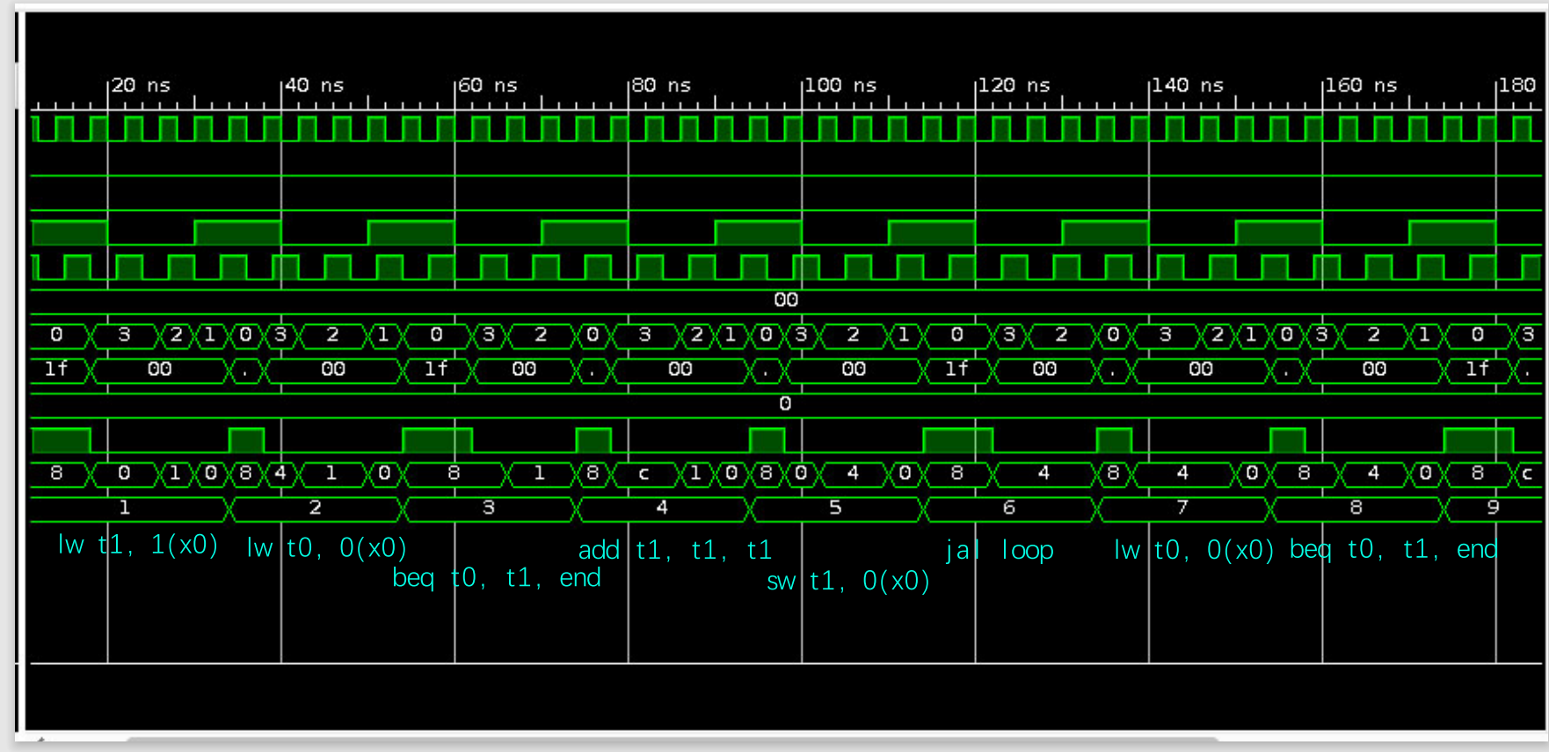

***test2.s***

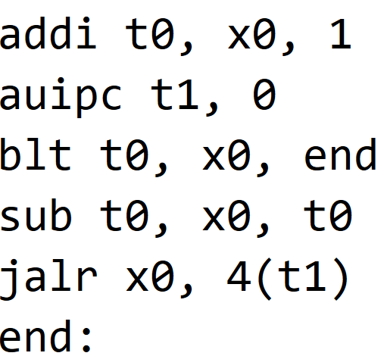

生成的波形图 ***wave2.pdf***

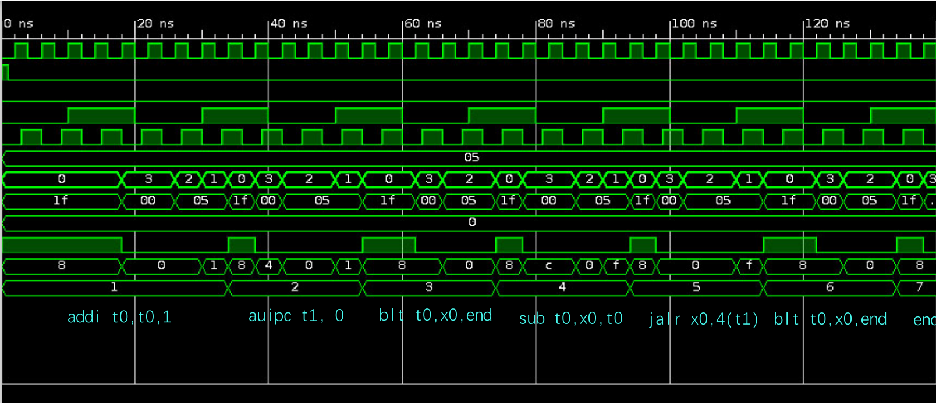

**实验代码**

SglCirCpu.v

*module SglCirCPU(*

*input run, //sw6*

*input step, //button*

*input valid,//sw5*

*input [4:0]in,//sw4-0*

*input rst, //sw7*

*input clk, //clk100mhz*

*output [1:0]check, //led6-5*

*output [4:0] out0, //led4-0*

*output [2:0] an, //8个数码管*

*output [3:0] seg,*

*output ready //led7*

*);*

*wire clk_cpu,io_we;*

*wire[7:0]io_addr,m_rf_addr;*

*wire[31:0]io_dout,io_din,rf_data,m_data,pc;*

*pdu_1cycle pdu_1cycle(*

*.clk(clk),*

*.rst(rst),*

*//选择CPU工作方式;*

*.run(run),*

*.step(step),*

*.clk_cpu(clk_cpu),*

*//输入switch的端口*

*.valid(valid),*

*.in(in),*

*//输出led和seg的端口*

*.check(check), //led6-5:查看类型*

*.out0(out0), //led4-0*

*.an(an), //8个数码管*

*.seg(seg),*

*.ready(ready), //led7*

*//IO_BUS*

*.io_addr(io_addr),*

*.io_dout(io_dout),*

*.io_we(io_we),*

*.io_din(io_din),*

*//Debug_BUS*

*.m_rf_addr(m_rf_addr),*

*.rf_data(rf_data),*

*.m_data(m_data),*

*.pc(pc)*

*);*

*cpu cpu (*

*.clk(clk_cpu),*

*.rst(rst),*

*//IO_BUS*

*.io_addr(io_addr), //led和seg的地址*

*.io_dout(io_dout), //输出led和seg的数据*

*.io_we(io_we), //输出led和seg数据时的使能信号*

*.io_din(io_din), //来自sw的输入数据*

*//Debug_BUS*

*.m_rf_addr(m_rf_addr), //存储器(MEM)或寄存器堆(RF)的调试读口地址*

*.rf_data(rf_data), //从RF读取的数据*

*.m_data(m_data), //从MEM读取的数据*

*.pc(pc) //PC的内容*

*);*

*endmodule*

pdu.v

*module pdu_1cycle(*

*input clk,*

*input rst,*

*//选择CPU工作方式;*

*input run,*

*input step,*

*output clk_cpu,*

*//输入switch的端口*

*input valid,*

*input [4:0] in,*

*//输出led和seg的端口*

*output [1:0] check, //led6-5:查看类型*

*output [4:0] out0, //led4-0*

*output [2:0] an, //8个数码管*

*output [3:0] seg,*

*output ready, //led7*

*//IO_BUS*

*input [7:0] io_addr,*

*input [31:0] io_dout,*

*input io_we,*

*output [31:0] io_din,*

*//Debug_BUS*

*output [7:0] m_rf_addr,*

*input [31:0] rf_data,*

*input [31:0] m_data,*

*input [31:0] pc*

*);*

*reg [4:0] in_r; //同步外部输入用*

*reg run_r, step_r, step_2r, valid_r, valid_2r;*

*wire step_p, valid_pn; //取边沿信号*

*reg clk_cpu_r; //寄存器输出CPU时钟*

*reg [4:0] out0_r; //输出外设端口*

*reg [31:0] out1_r;*

*reg ready_r;*

*reg [19:0] cnt; //刷新计数器，刷新频率约为95Hz*

*reg [1:0] check_r; //查看信息类型, 00-运行结果，01-寄存器堆，10-存储器，11-PC*

*reg [7:0] io_din_a; //_a表示为满足组合always描述要求定义的，下同*

*reg ready_a;*

*reg [4:0] out0_a;*

*reg [31:0] out1_a;*

*reg [3:0] seg_a;*

*assign clk_cpu = clk_cpu_r;*

*assign io_din = io_din_a;*

*assign check = check_r;*

*assign out0 = out0_a;*

*assign ready = ready_a;*

*assign seg = seg_a;*

*assign an = cnt[19:17];*

*assign step_p = step_r & ~step_2r; //取上升沿*

*assign valid_pn = valid_r ^ valid_2r; //取上升沿或下降沿*

*assign m_rf_addr = {{3{1'b0}}, in_r};*

*//同步输入信号*

*always @(posedge clk) begin*

*run_r <= run;*

*step_r <= step;*

*step_2r <= step_r;*

*valid_r <= valid;*

*valid_2r <= valid_r;*

*in_r <= in;*

*end*

*//CPU工作方式*

*always @(posedge clk, posedge rst) begin*

*if(rst)*

*clk_cpu_r <= 0;*

*else if (run_r)*

*clk_cpu_r <= ~clk_cpu_r;*

*else*

*clk_cpu_r <= step_p;*

*end*

*//读外设端口*

*always @* begin*

*case (io_addr)*

*8'h0c: io_din_a = {{27{1'b0}}, in_r};*

*8'h10: io_din_a = {{31{1'b0}}, valid_r};*

*default: io_din_a = 32'h0000_0000;*

*endcase*

*end*

*//写外设端口*

*always @(posedge clk, posedge rst) begin*

*if (rst) begin*

*out0_r <= 5'h1f;*

*out1_r <= 32'h1234_5678;*

*ready_r <= 1'b1;*

*end*

*else if (io_we)*

*case (io_addr)*

*8'h00: out0_r <= io_dout[4:0];*

*8'h04: ready_r <= io_dout[0];*

*8'h08: out1_r <= io_dout;*

*default: ;*

*endcase*

*end*

*//LED和数码管查看类型*

*always @(posedge clk, posedge rst) begin*

*if(rst)*

*check_r <= 2'b00;*

*else if(run_r)*

*check_r <= 2'b00;*

*else if (step_p)*

*check_r <= 2'b00;*

*else if (valid_pn)*

*check_r <= check - 2'b01;*

*end*

*//LED和数码管显示内容*

*always @* begin*

*ready_a = 1'b0;*

*case (check_r)*

*2'b00: begin*

*out0_a = out0_r;*

*out1_a = out1_r;*

*ready_a = ready_r;*

*end*

*2'b01: begin*

*out0_a = in_r;*

*out1_a = rf_data;*

*end*

*2'b10: begin*

*out0_a = in_r;*

*out1_a = m_data;*

*end*

*2'b11: begin*

*out0_a = 5'b00000;*

*out1_a = pc;*

*end*

*endcase*

*end*

*//扫描数码管*

*always @(posedge clk, posedge rst) begin*

*if (rst) cnt <= 20'h0_0000;*

*else cnt <= cnt + 20'h0_0001;*

*end*

*always @* begin*

*case (an)*

*3'd0: seg_a = out1_a[3:0];*

*3'd1: seg_a = out1_a[7:4];*

*3'd2: seg_a = out1_a[11:8];*

*3'd3: seg_a = out1_a[15:12];*

*3'd4: seg_a = out1_a[19:16];*

*3'd5: seg_a = out1_a[23:20];*

*3'd6: seg_a = out1_a[27:24];*

*3'd7: seg_a = out1_a[31:28];*

*default: ;*

*endcase*

*end*

*endmodule*

cpu.v

*module cpu (*

*input clk,*

*input rst,*

*//IO_BUS*

*output [7:0] io_addr, //led和seg的地址*

*output [31:0] io_dout, //输出led和seg的数据*

*output io_we, //输出led和seg数据时的使能信号*

*input [31:0] io_din, //来自sw的输入数据*

*//Debug_BUS*

*input [7:0] m_rf_addr, //存储器(MEM)或寄存器堆(RF)的调试读口地址*

*output [31:0] rf_data, //从RF读取的数据*

*output [31:0] m_data, //从MEM读取的数据*

*output [31:0] pc //PC的内容*

*);*

*wire [31:0] PC_in, PC_out, PC_plus_4_new,PC_plus_4, PC_NotJump, WriteData, MemData, MDR; // PC_plus_4=PC+4； PC_out 当前地址 PC_in 下一个指令*

*wire zf, RegWrite, ALUSrc, PC_en, RegDst, Jump, Branch, MemRead, MemtoReg, MemWrite,ALU_zero;*

*wire [31:0] ReadData1_Data_Memory,ShiftLeft_Output,ShiftLeft_plus_pc,MUX_3_1_out_DataMemory,MUXout_DataMemory;*

*wire [31:0] INS,ImmgenControl_Output,JumpAddr, BranchAddr, ALU_result, ReadData1, ReadData2, ALUsrcB, Imm,ReadData3; // INS 指令 wire [4:0] WriteReg; wire [2:0] ALUop;*

*wire[1:0]ALUop;*

*wire[2:0]ALUfunc;*

*wire jal,jalr;*

*wire Imm_gen;*

*wire [1:0]RegSrc;*

*assign PC_plus_4_new = pc + 32'd4;*

*// wire MemWrite;*

*// wire ALUSrc;*

*// wire RegWrite;*

*assign io_we = MemWrite&&(~ALU_result[10]);*

*pc PC(*

*.input_data(PC_in),*

*.en(1),*

*.rst(rst),*

*.clk(clk),*

*.output_data(pc)*

*);*

*dist_mem_gen_0 instruction_memory(*

*.a(pc[9:2]),*

*.spo(INS)*

*);*

*dist_mem_gen_1 Data_Memory(*

*.a(ALU_result[9:2]),*

*.d(ReadData2),*

*.dpra(m_rf_addr[7:0]), //second address*

*.dpo(m_data[31:0]), //ReadData2*

*.clk(clk),*

*.we(MemWrite&&(~ALU_result[10])),*

*.spo(ReadData1_Data_Memory) //ReadData1*

*);*

*assign io_dout = ReadData2;*

*control_unit control(*

*.instruction(INS[6:0]), // aka. op code*

*.jal(jal),*

*.jalr(jalr),*

*.Branch(Branch),*

*// .Imm_gen(Imm_gen),*

*.RegSrc(RegSrc),*

*.MemWrite(MemWrite),*

*.ALUSrc(ALUSrc),*

*.RegWrite(RegWrite),*

*.ALUop(ALUop)*

*);*

*register_file Register(*

*.clk(clk),*

*.ra0(INS[19:15]),*

*.rd0(ReadData1),*

*.ra1(INS[24:20]),*

*.rd1(ReadData2),*

*.wa(INS[11:7]),*

*.we(RegWrite),*

*.wd(MUX_3_1_out_DataMemory),//here comes the bug 15:52*

*.ra2(m_rf_addr[7:0]),*

*.rd_debug(rf_data[31:0])*

*);*

*mux2_1 MUX_Register(*

*.a(ReadData2),*

*.b(ImmgenControl_Output),*

*.sel(ALUSrc),*

*.o(ALUsrcB)*

*);*

*alu alu(*

*.a(ReadData1),*

*.b(ALUsrcB),*

*.f(ALUfunc),*

*.y_r(ALU_result),*

*.z_r(ALU_zero)*

*);*

*ALUcontrol ALUcontrol(*

*.funct3(INS[14:12]),*

*.ALUop(ALUop),*

*.ALUout(ALUfunc)*

*);*

*ImmGenControl ImmGenControl(*

*.instruction(INS),*

*.immediate(ImmgenControl_Output)*

*);*

*mux2_1 MUX_2_1_DataMemory(*

*.a(ReadData1_Data_Memory),*

*.b(io_din[31:0]),*

*.sel(ALU_result[10]),*

*.o(MUXout_DataMemory)*

*);*

*assign io_addr[7:0] = ALU_result[7:0];*

*mux4_1 MUX_4_1_DataMemory(*

*.d(ShiftLeft_plus_pc),//3*

*.c(PC_plus_4), // 2?*

*.b(MUXout_DataMemory), //1?*

*.a(ALU_result), // 0?*

*.sel(RegSrc),*

*.o(MUX_3_1_out_DataMemory)*

*); // may cause a bug here*

*AddModule_32 pc_adder(*

*.a(32'd4),*

*.b(pc), //两操作数*

*.y_r(PC_plus_4) //运算结果*

*);*

*ShiftLeft1 ShiftLeft1(*

*.immediate(ImmgenControl_Output),*

*.immediate_out(ShiftLeft_Output)*

*);*

*AddModule_32 ShiftLeft_adder(*

*.clk(clk),*

*.a(ShiftLeft_Output),*

*.b(pc), //两操作数*

*.y_r(ShiftLeft_plus_pc) //运算结果*

*);*

*mux4_1 MUX_3_1_ShiftLeft(*

*.a(PC_plus_4_new),*

*.b(ShiftLeft_plus_pc),*

*.c(ALU_result),*

*.d(32'b0),*

*.sel({jalr,{jal||(Branch && ALU_zero)}}), // notice the logic computing here may cause a bug. remember to check out*

*.o(PC_in)*

*);*

*endmodule*

control_unit.v register_file.v

*module control_unit(*

*input [6:0] instruction, // aka. op code*

*// output reg jal, Branch, reg Imm_gen, reg [1:0]RegSrc, reg MemWrite, reg ALUSrc,reg RegWrite,*

*// remove imm_gen*

*output reg jalr,jal, Branch, reg [1:0]RegSrc, reg MemWrite, reg ALUSrc,reg RegWrite,*

*output reg [1:0] ALUop*

*);*

*always@(*)*

*case (instruction)*

*7'b0110011://add sub*

*begin*

*jalr=0;*

*jal=0;*

*Branch=0;*

*RegSrc=2'b00;*

*ALUop=2'b00;*

*MemWrite=0;*

*ALUSrc=0;*

*RegWrite=1;*

*end*

*7'b0010011://addi*

*begin*

*jalr=0;*

*jal=0;*

*Branch=0;*

*RegSrc=2'b00;*

*ALUop=2'b00;*

*MemWrite=0;*

*ALUSrc=1;*

*RegWrite=1;*

*end*

*7'b1101111://jal*

*begin*

*jalr=0;*

*jal=1;*

*Branch=0;*

*RegSrc=2'b10;*

*ALUop=2'b00;*

*MemWrite=0;*

*ALUSrc=0;*

*RegWrite=1;*

*end*

*7'b1100011://beq blt*

*begin*

*jalr=0;*

*jal=0;*

*Branch=1;*

*RegSrc=2'b00;*

*ALUop=2'b01;*

*MemWrite=0;*

*ALUSrc=0;*

*RegWrite=0;*

*end*

*7'b0000011://lw*

*begin*

*jalr=0;*

*jal=0;*

*Branch=0;*

*RegSrc=2'b01;*

*ALUop=2'b00;*

*MemWrite=0;*

*ALUSrc=1;*

*RegWrite=1;*

*end*

*7'b0100011://sw*

*begin*

*jalr=0;*

*jal=0;*

*Branch=0;*

*RegSrc=2'b00;*

*ALUop=2'b00;*

*MemWrite=1;*

*ALUSrc=1;*

*RegWrite=0;*

*end*

*7'b0010111://auipc*

*begin*

*jalr=0;*

*jal=0;*

*Branch=0;*

*RegSrc=2'b11;*

*ALUop=2'b00;*

*MemWrite=0;*

*ALUSrc=0;*

*RegWrite=1;*

*end*

*7'b1100111://jalr*

*begin*

*jalr=1;*

*jal=0;*

*Branch=0;*

*RegSrc=2'b10;*

*ALUop=2'b00;*

*MemWrite=0;*

*ALUSrc=1;*

*RegWrite=1;*

*end*

*default: ;*

*endcase*

*endmodule*

*module register_file #(parameter WIDTH = 32)(*

*input clk,*

*input [4:0]ra0,*

*output[WIDTH-1:0]rd0,*

*input[4:0]ra1,*

*output[WIDTH-1:0]rd1,*

*input[4:0]wa,*

*input we,*

*input[WIDTH-1:0]wd,*

*input[7:0]ra2,// didn't connect anything*

*output[WIDTH-1:0]rd_debug*

*);*

*// reg [3:0] regfile[0:7];*

*reg [WIDTH-1:0] regfile[31:0];*

*assign rd0 = regfile[ra0],*

*rd1 = regfile[ra1];*

*assign rd_debug = regfile[ra2];*

*always @ (posedge clk) begin*

*if (we) begin*

*if(wa == 0)begin*

*regfile[wa]<=0;*

*end*

*else begin*

*regfile[wa] <= wd;*

*end*

*end*

*end*

*endmodule*