In this project, “FM090 Leave Application Form” has been implemented. And four MS office software have been used, which are SharePoint, Power Automate, Power Apps and Forms.

SharePoint, be used to create site “Bowen Created”, lists: “Department”, “Staff”, “Leave Application Form” (“ApplicationForm”, “Manager” and “Position” used for testing), and page “Employee Information Form”.

1. Create Site
2. Create List: Setting -> Add an app
3. Create columns: List setting -> Create column

Lookup, Single line of text, Data and Time, and Choice have been used

1. View: Edit current view, create view, Group by Department
2. Add new items
3. Change Classic experience: List Setting -> Advanced Setting -> List experience
4. Change List name and navigation: List Setting
5. Get List Item Entity Type Full Name: Site URL_api/web/lists/GetByTitle(‘ListName’)/
6. Create .html: List setting -> RSS setting, RSS Feed

Site “Bowen Created”:

<https://cablexau.sharepoint.com/sites/BowenCreated2>

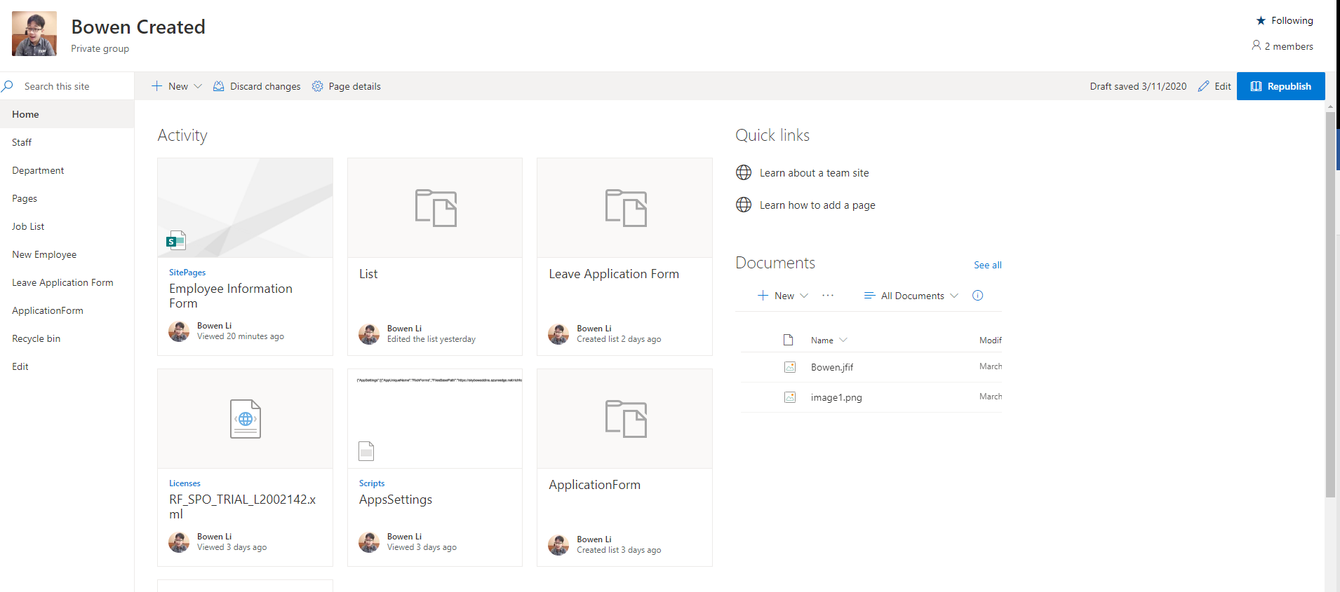

Staff:

<https://cablexau.sharepoint.com/sites/BowenCreated2/Lists/List/Department.aspx>

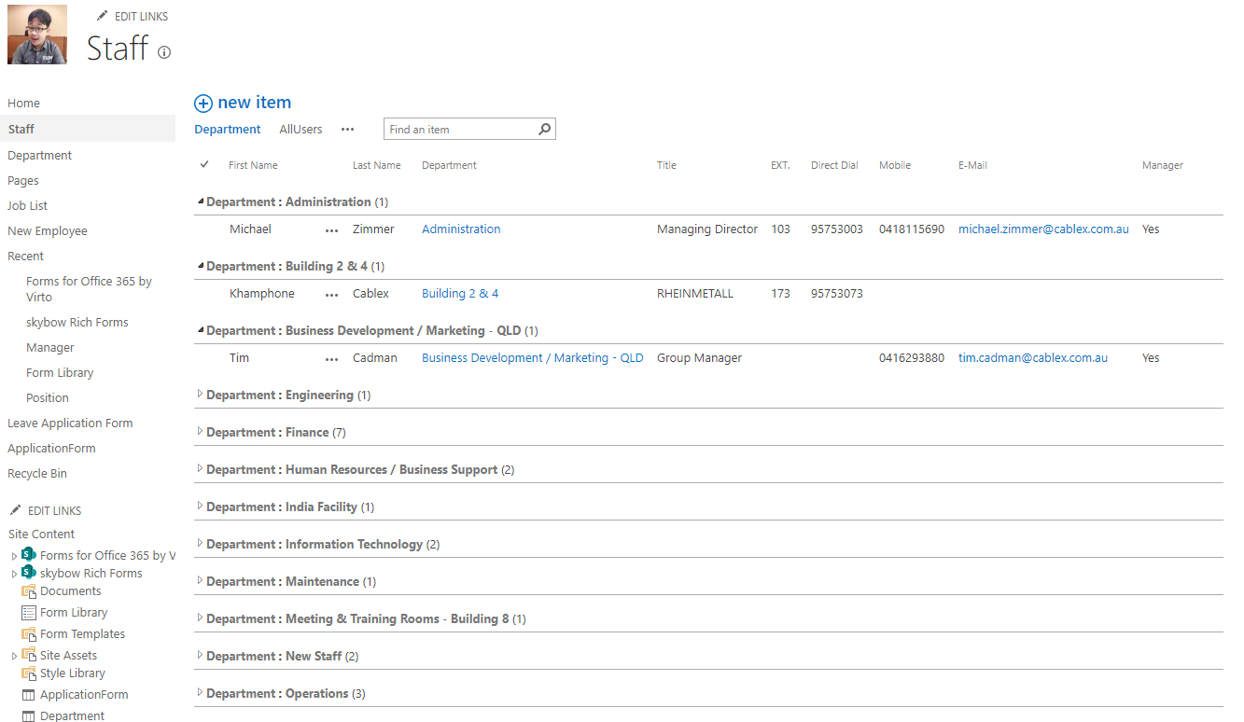

Department:

<https://cablexau.sharepoint.com/sites/BowenCreated2/Lists/Department/AllItems.aspx>

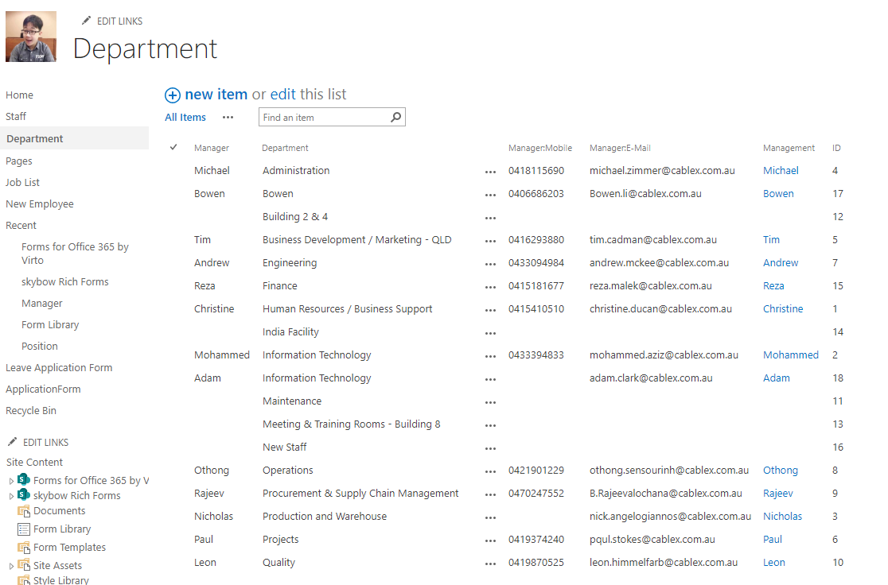

Leave Application Form:

<https://cablexau.sharepoint.com/sites/BowenCreated2/Lists/Leave%20Application%20Form/AllItems.aspx?viewpath=%2Fsites%2FBowenCreated2%2FLists%2FLeave%20Application%20Form%2FAllItems.aspx>

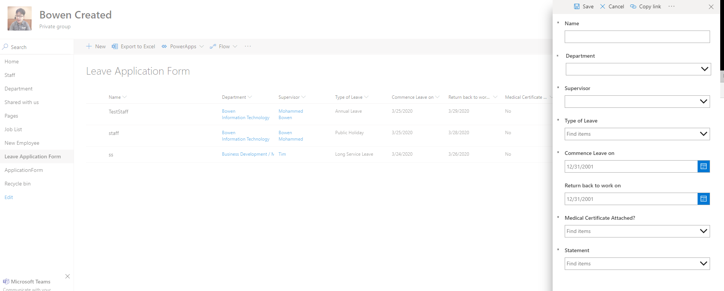

New Employee:

<https://cablexau.sharepoint.com/sites/BowenCreated2/SitePages/EmployeeInformationForm.aspx>

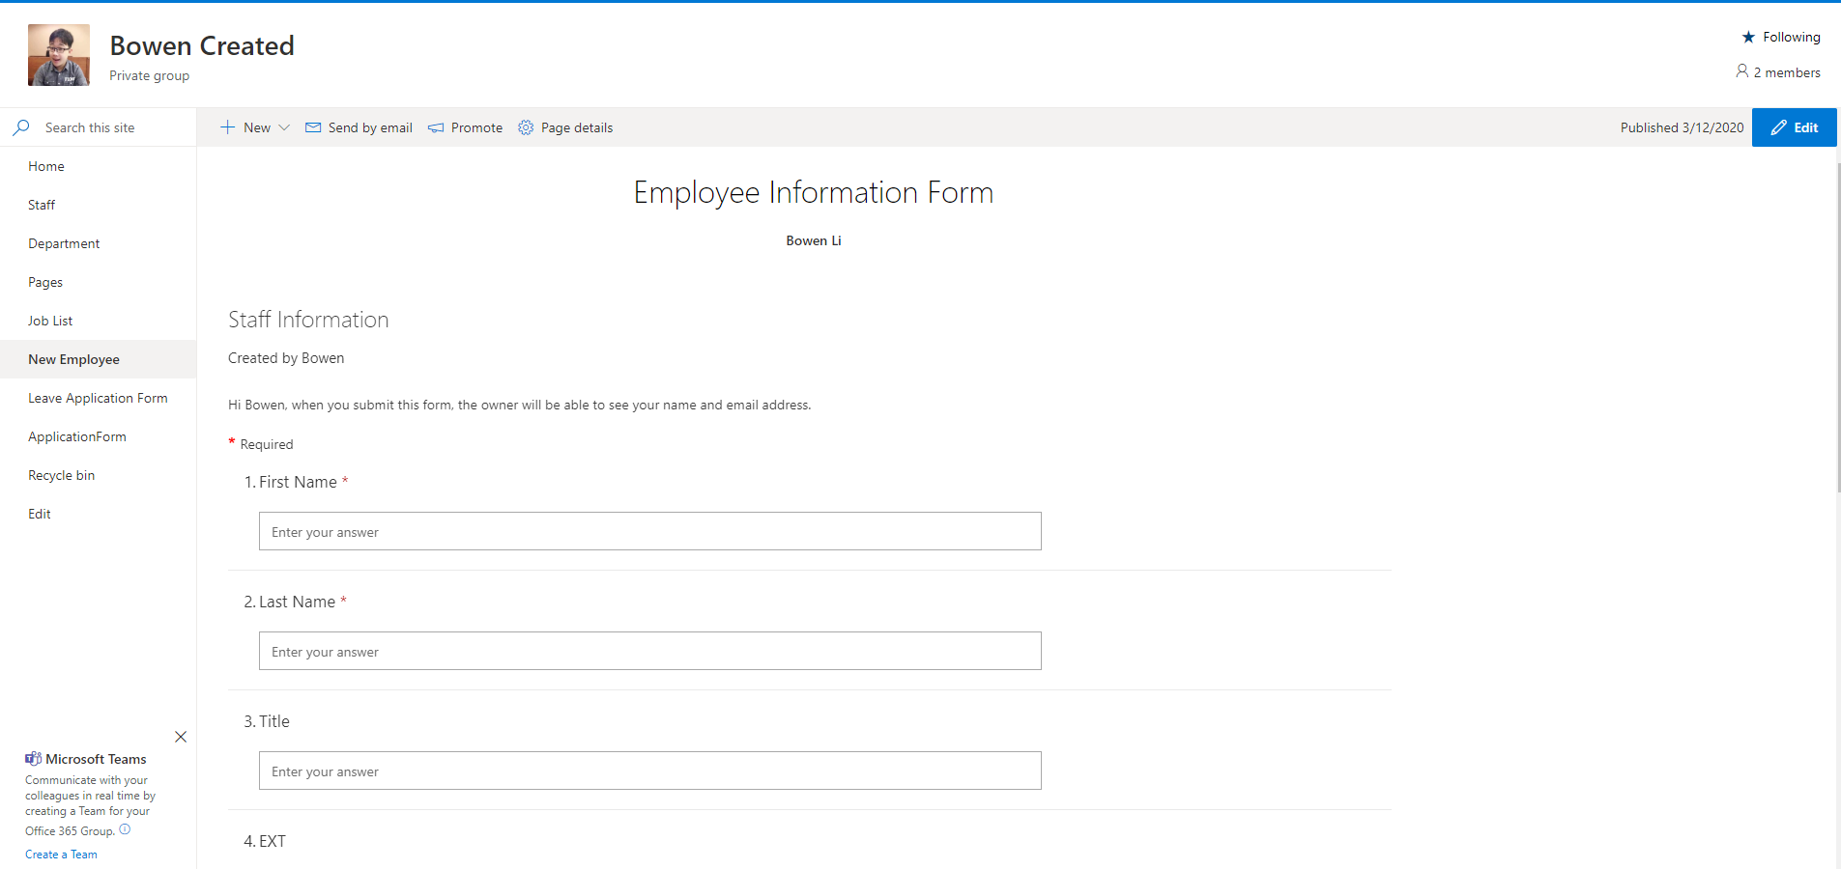

Power Automate, be used to create automated flows include “Leave Application Form”, “New Staff Application Form” and “Start approval when a new staff is added”.

1. Power Automate Flows: Create From templates or start from blank
2. New Staff Application Form flow

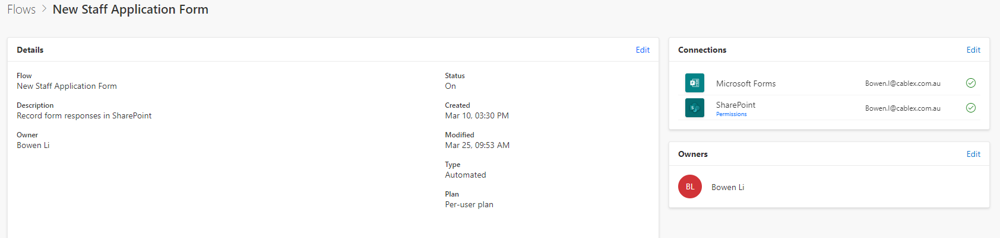 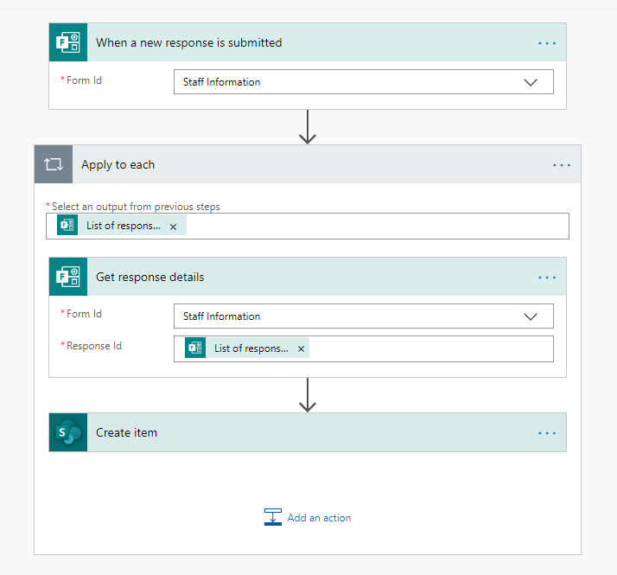

1. Start approval when a new staff is add

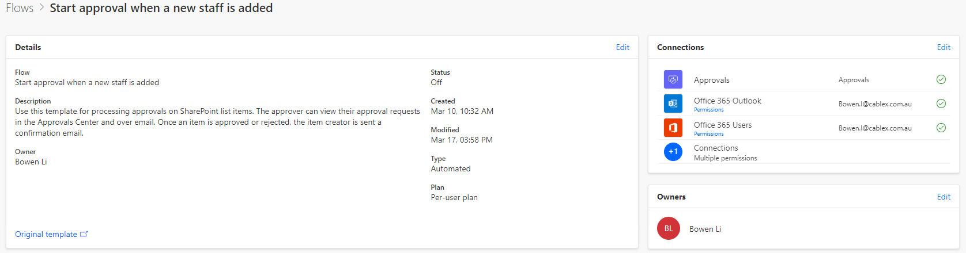 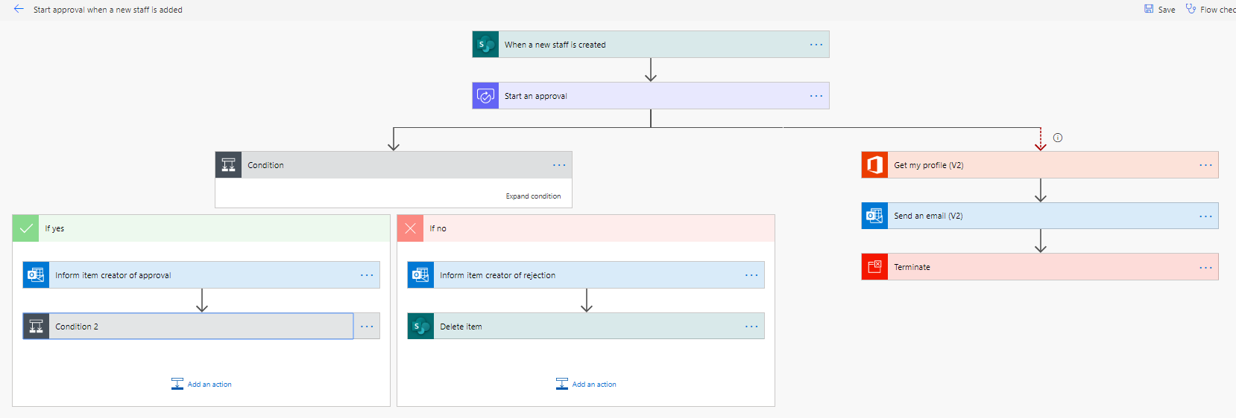

1. Leave Application Form

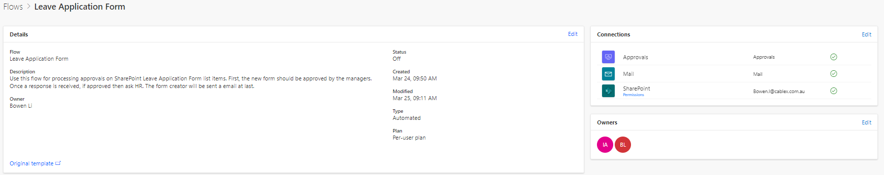

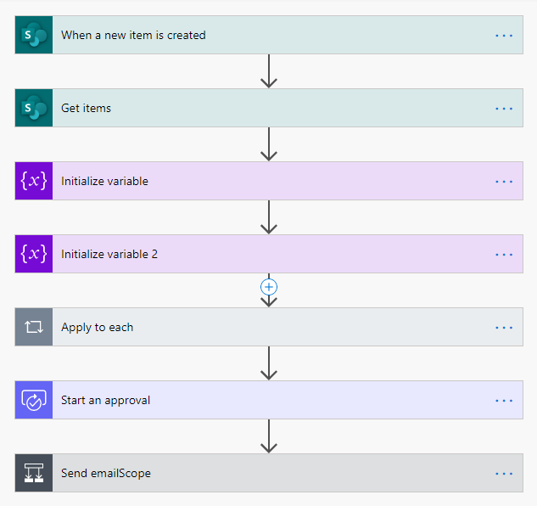 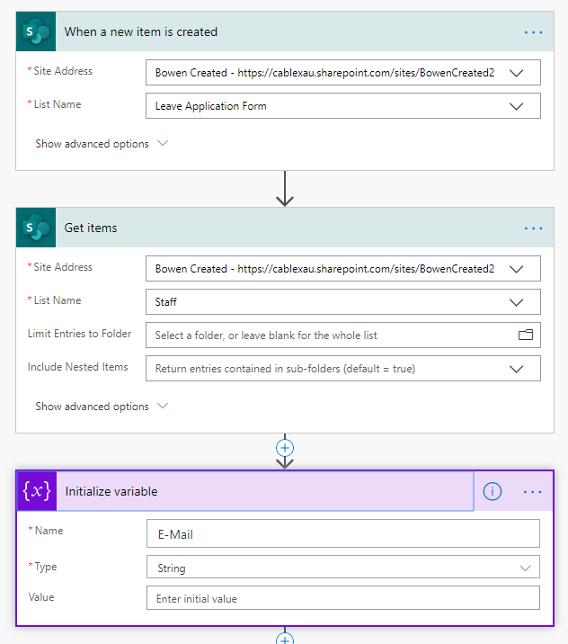 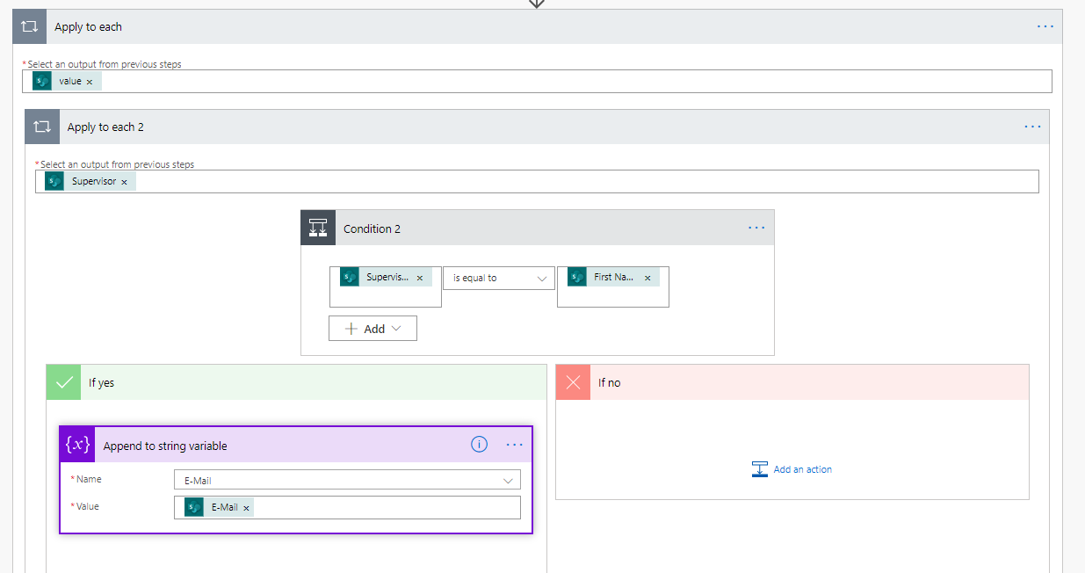 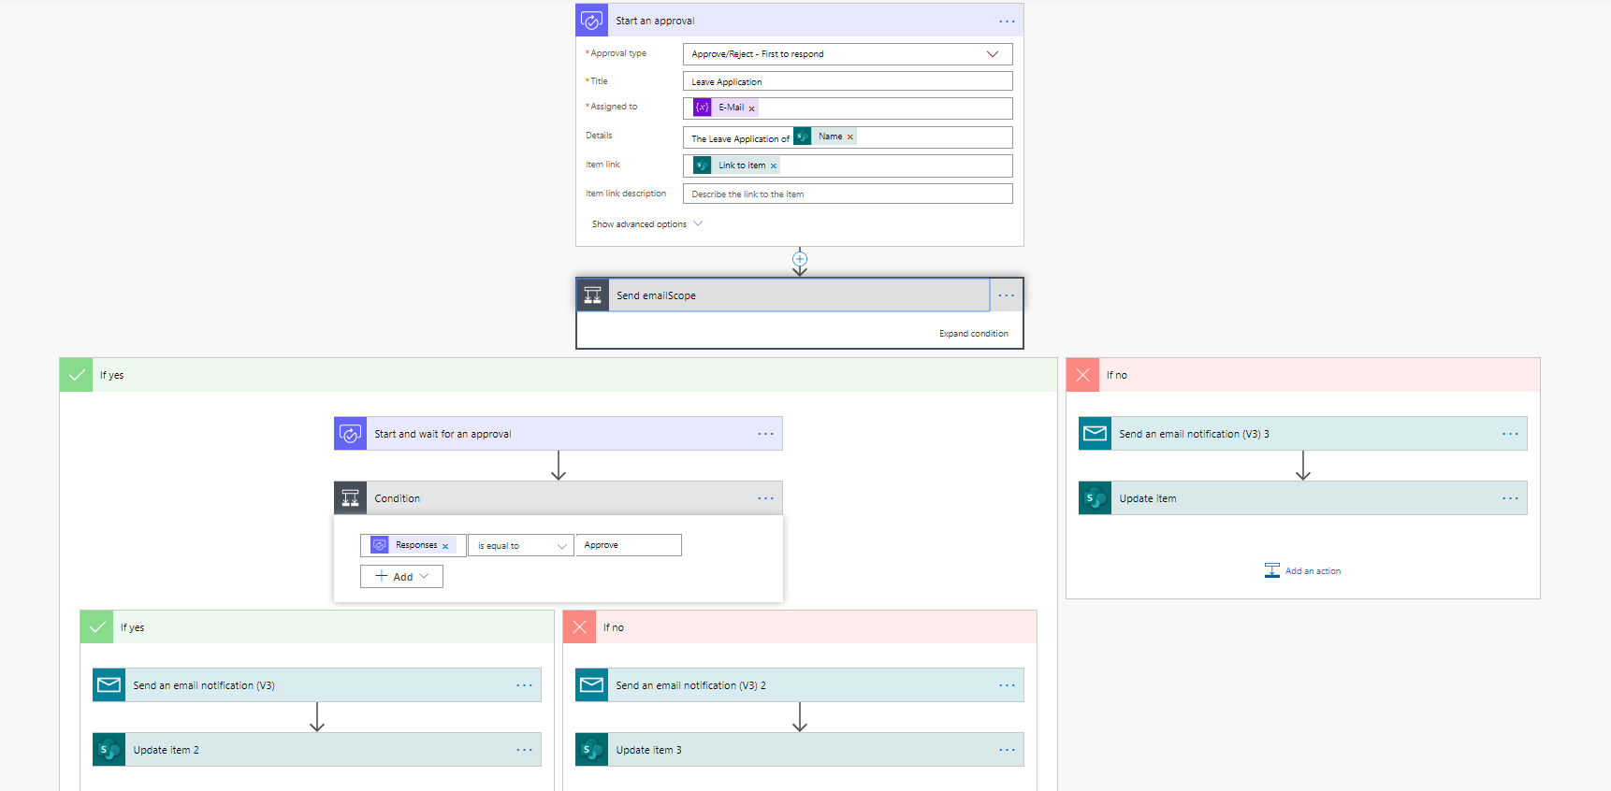

Power Apps, be used to create forms for the SharePoint list “Leave Application Form” (“ApplicationForm” be used for testing).

Power Apps Functions:

Filter, Choices, GroupBy, Distinct…

Need time to read documents and examples.

<https://docs.microsoft.com/en-us/powerapps/maker/canvas-apps/dependent-drop-down-lists>

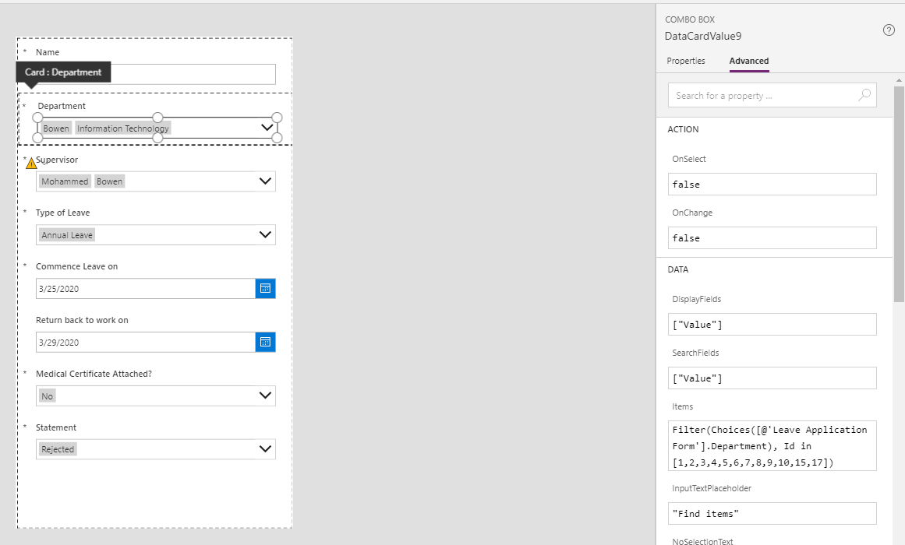 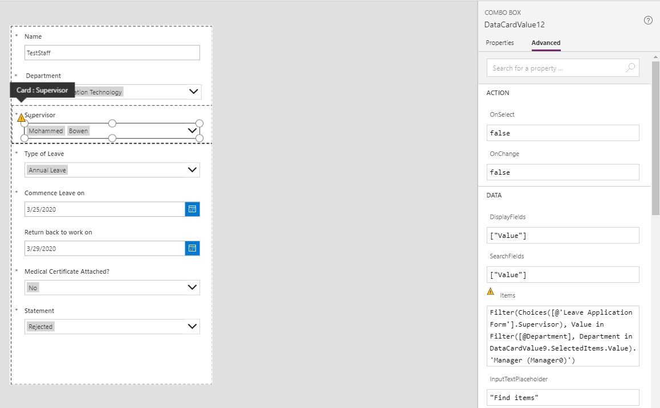

MS Office Forms, be used to create a user-friendly interface form for the SharePoint list “Staff”.

MS Office Forms vs. Power Apps

|  |  |  |
| --- | --- | --- |
|  | MS Office Forms | Power Apps |
| Advantages | Easy to build, use Automate post data.  Easy to learn and understand. | More functions.  Could get data from SharePoint lists. |
| Disadvantages | Cannot connect lists directly.  Single structure and few data types. | Long time to learn.  Need Programming. |