Task 1
The purpose of this task is to analyze the existing security configuration of the dvdrental database. The goal is to understand how access to data is currently managed, what roles and permissions exist, and whether the system is secure or potentially vulnerable.
By exploring documentation and system tables, I understood that PostgreSQL keeps metadata in system catalogs, mainly located in the pg_catalog schema. I identified relevant tables such as pg_roles, pg_class, and pg_policies based on their names and purpose, and used them to analyze different aspects of database security.

After running the query on pg_roles, I noticed that most roles in the database start with the prefix pg_, which suggests that they are system-defined roles. Additionally, these roles do not have login permissions, and I did not create them manually. Based on this, I concluded that they are automatically created by PostgreSQL for internal use and management purposes. The only actual user with login access is the postgres role. In the query result, the symbol [v] represents a true value, meaning that the corresponding privilege is enabled. What stood out to me is that this role has all major privileges enabled, including superuser rights, the ability to create other roles, and permission to create databases. From my understanding, this means that the entire database is essentially controlled by a single account. All other roles do not have these capabilities, which indicates that they cannot be used to connect to the database.

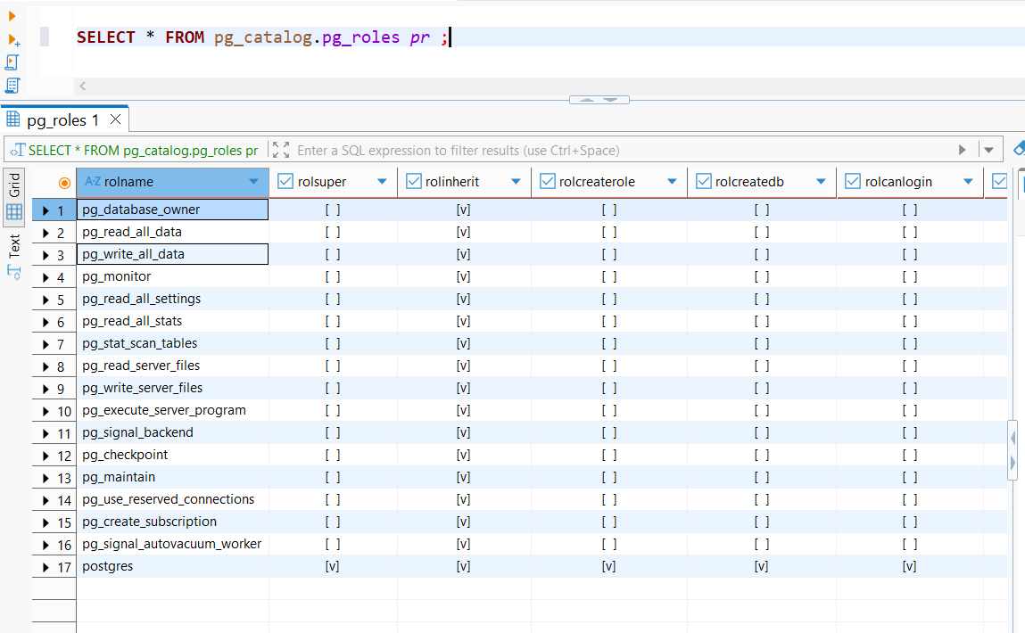
Therefore:
- There is only one active user - postgres
- This user has full administrative privileges
- No other custom roles or limited users are defined
From this, I understand that there is no separation of responsibilities in the system. Everything depends on one powerful account, which could be risky if misused or compromised.

Initially, I queried the pg_auth_members table directly to observe role relationships. However, I noticed that the results contained only internal identifiers, which were not meaningful on their own. To better understand the relationships, I joined this table with pg_roles to retrieve the actual role names. This allowed me to clearly see which roles are members of other roles.
Although role memberships were not explicitly mentioned in the task requirements, I decided to analyze them because they are directly related to how permissions are managed in PostgreSQL. Roles can inherit permissions from other roles, so understanding these relationships is important for evaluating the overall access control structure.
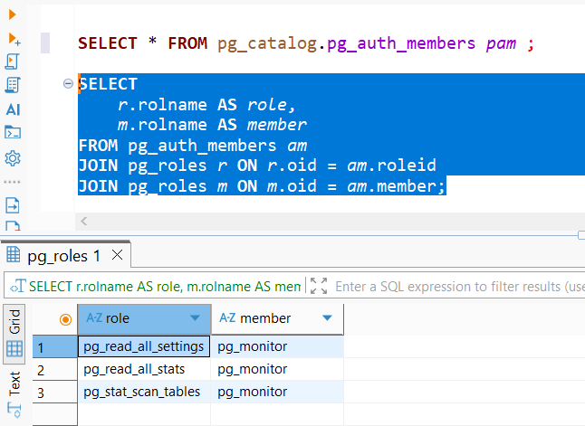
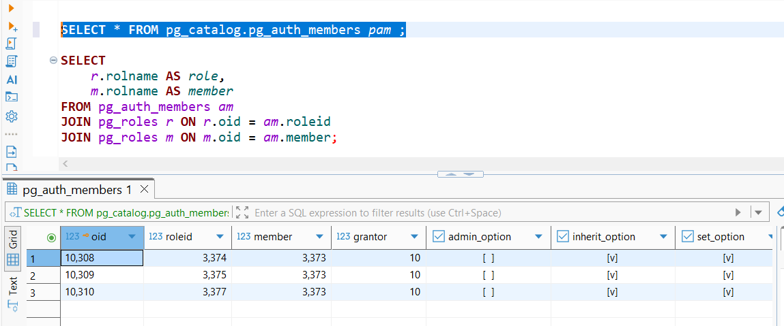

When analyzing role memberships using pg_auth_members, I found that only system-defined relationships exist. For example, the pg_monitor role inherits certain read-related roles.
However, there are no custom role relationships that would normally be used in an application environment, such as grouping users into roles like “manager” or “customer”.

This suggests that:
- Only default PostgreSQL role relationships are present
- No custom role hierarchy has been created
- Permissions are not being managed through role grouping
In my opinion, this indicates that role-based access control has not been implemented. Instead of organizing permissions through roles, everything seems to rely on direct access by the main user.

Initially, I explored the table-level privileges by running a general query on information_schema.role_table_grants using SELECT *. This allowed me to see the full structure of the data, including columns such as grantor, schema name, and catalog. However, I noticed that this output contained more information than necessary for the purpose of this task and made it harder to focus on the relevant details.
For this reason, I refined the query by selecting only the most important columns, such as grantee, table_name, and privilege_type, and filtering the results to include only the public schema. This made the output clearer and easier to interpret, allowing me to directly observe which user has which permissions on each table.
I chose to use information_schema because it provides a structured and user-friendly way to access information about database objects and permissions.
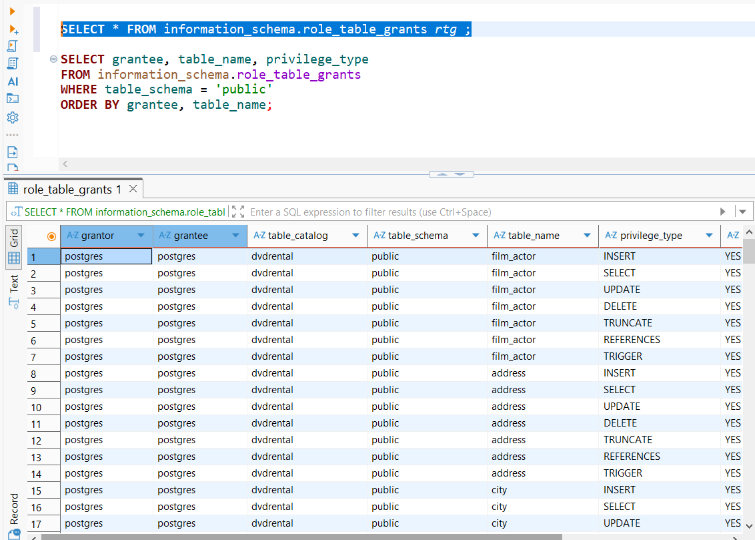

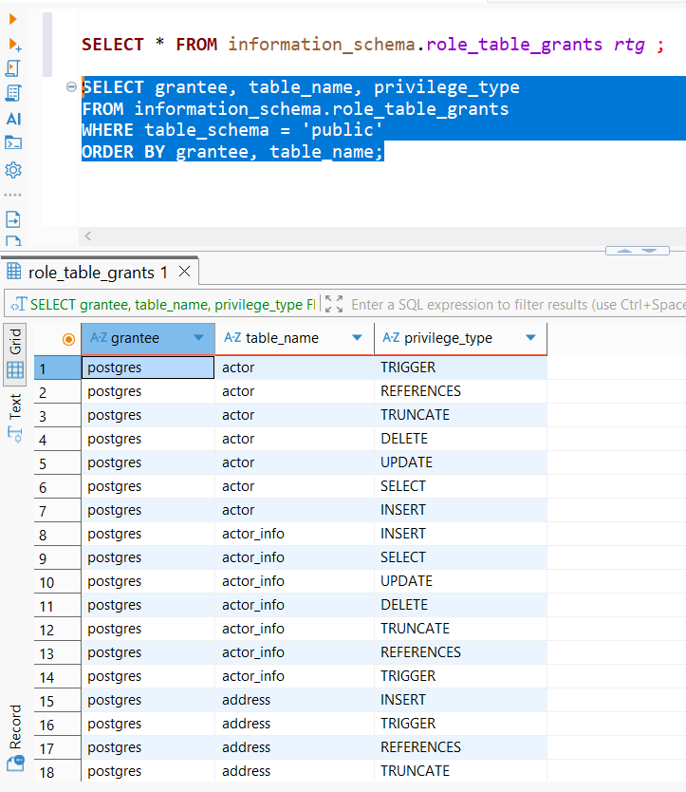
After checking table-level permissions, I noticed that all privileges are assigned exclusively to the postgres user.
This includes full access such as: SELECT / INSERT / UPDATE / DELETE
No other users or roles have any permissions on the tables.
From this, I understood that there is no defined control over who can access or modify data. Everything is handled by a single user, without any restrictions or differentiation between types of access.
This lead to the conclusion that, there is no concept of limited or read-only users and that the all operations are centralized under one account.

To understand whether row-level security is used in the database, I started by exploring the pg_class table. At first, I ran a general query:
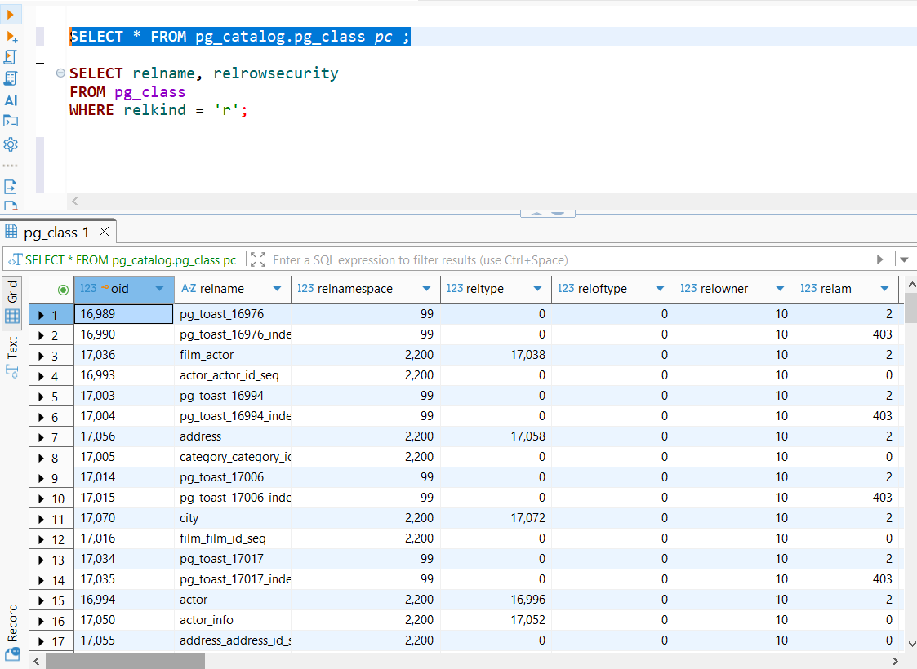
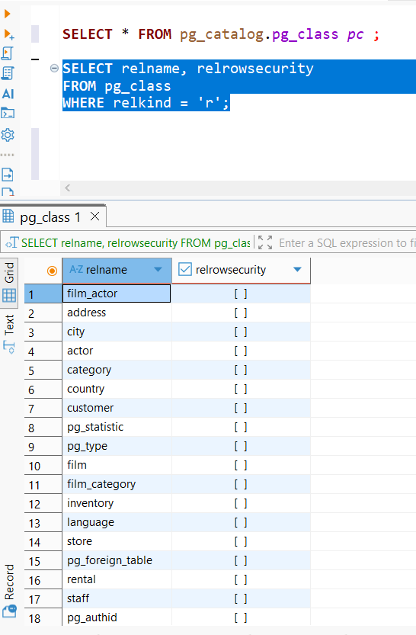
This gave me a large amount of information about different database objects, including tables, indexes, and internal system objects. After looking through the columns, I noticed that pg_class contains a column called relrowsecurity, which indicates whether row-level security is enabled. Based on this, I refined my query to focus only on relevant data. I added the condition relkind = 'r' because I learned that this value represents ordinary tables, and I wanted to exclude other types of objects such as indexes or system structures.
From the results, I saw that all tables have relrowsecurity set to false. So, no table has row level security enabled and that this applies to all main tables like customer, rental, and payment.
This means that if a user has access to a table, they automatically have access to all rows within it. There is no filtering or restriction based on user identity or ownership of the data. Therefore, no matter who accesses the table, they see everything.
From this, I can say that row-level security is not being used in this database. While this might be acceptable in simple cases, in a real-world application it would be important to limit access so that users can only see their own data.
And additionally, when I checked the pg_policies table, it returned no results. At first, I wasn’t sure what to expect, but after understanding that this table stores row-level security rules, it became clear that no such rules have been defined.

This reinforces the idea that the database currently has very minimal security configuration.
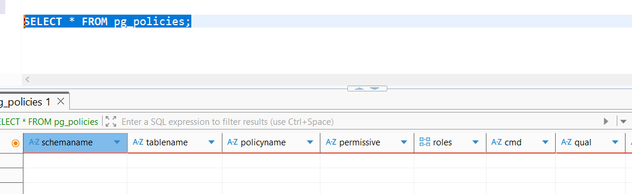

Finally, I checked the database-level settings. To better understand, I decided to examine how connections to the database are managed. At first, I explored the pg_database table using a general query to see what kind of information it contains. This helped me notice that it stores configuration details for each database, including connection limits. Since connection control can affect both performance and security, I focused specifically on the datconnlimit column. I then refined the query to check the connection limit for the dvdrental database, as this seemed most relevant for evaluating how access to the database is regulated.
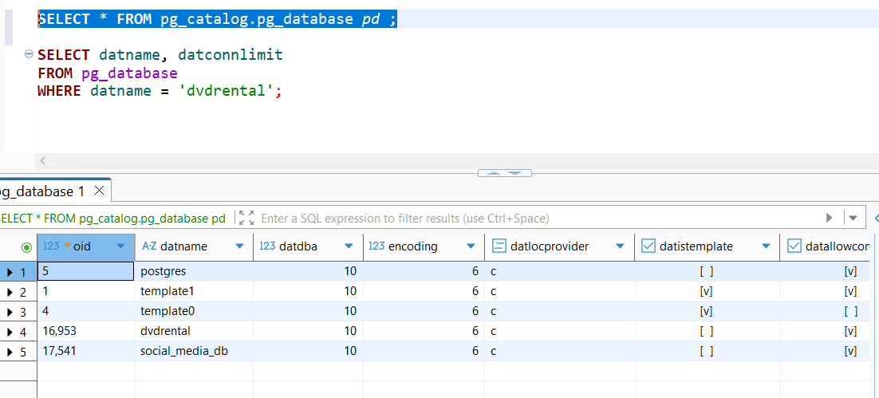
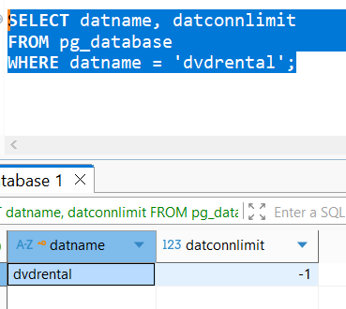
The result showed that the connection limit is set to -1, which means there is no restriction on how many connections can be made to the database.
From my understanding, this could lead to potential issues such as:
- Too many users connecting at once
- Performance degradation
- Possible denial-of-service situations
So even at the database level, there is no control over resource usage.

After going through all these steps, I can say that the database is functional but not well-secured. My approach was based on exploring system catalogs and trying to understand what each one represents and why it is relevant.
Overall, I observed that:
- The system relies entirely on a single superuser
- There is no structured access control
- No role hierarchy or grouping exists
- Data access is not restricted at either table or row level
- There are no limits on database connections
From my perspective, this helped me understand how important it is to properly design access control, especially in systems where multiple users interact with data.
Based on these observations, I would suggest several improvements. First, it would be important to create separate roles for different types of users (for example, admin, staff, and customer) instead of relying only on the postgres superuser. Then, permissions should be assigned to these roles rather than directly to users, which would make access control more organized and easier to manage. In addition, implementing row-level security would allow restricting users so they can only access their own data, especially in tables like customer, rental, and payment. Finally, setting reasonable connection limits could help prevent potential overload or misuse of the database. Overall, these changes would make the system more realistic and safer to operate.

