Task 4
1. How can one restrict access to certain columns of a database table?
From my understanding, access to specific columns in a table can be restricted by using column-level privileges in SQL. Instead of giving permission to the entire table, PostgreSQL allows us to grant access only to selected columns using the GRANT statement.
For example, a user might be allowed to see general information like names, but not sensitive data such as payment details. This helps improve data security by limiting what each user can access.
Example:
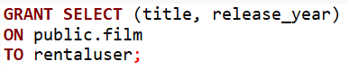
With this query, the rentaluser can only view the title and release_year columns from the film table, but not other columns like language_id or rental_rate and others.
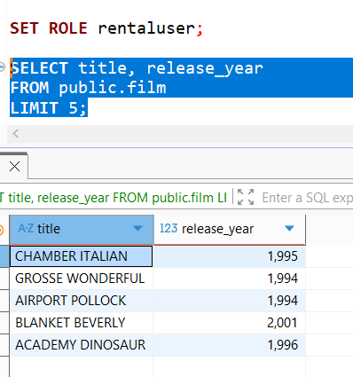

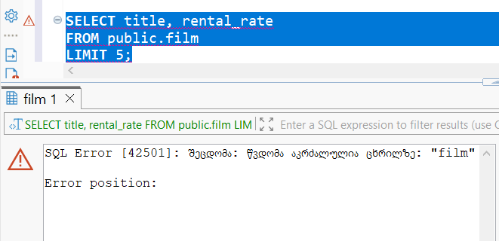
We see that the data on title and release_year is indeed returned but wen we try selecting other column as well we see that it will result in an error for restricted columns.
In a real company, for example in a customer support system, employees might only need access to customer names and IDs, but not their payment information or personal details. Column-level restriction ensures that sensitive data is protected and only accessible to authorized roles.
While working on the tasks, I realized that giving full table access is often unnecessary and even risky. By restricting access at the column level, the database becomes more secure and better organized. This approach follows the principle of giving users only the permissions they actually need.

2. What is the difference between user identification and user authentication?
Identification is the process of declaring who the user is. In PostgreSQL, this happens when a user provides a username while attempting to connect to the database. At this stage, the system only knows the claimed identity, but it does not yet verify it.
Authentication, on the other hand, is the process of verifying that the user is actually who they claim to be. This is typically done by checking credentials such as a password. Only after successful authentication does PostgreSQL allow the user to access the database.
When logging into an online banking system, entering your username is the identification step. Entering the correct password (or a code sent to your phone) is the authentication step. Even if someone knows your username, they cannot access your account without successfully authenticating.
CREATE ROLE rentaluser
WITH LOGIN
PASSWORD 'rentalpassword';
rentaluser is identification (the username) and 'rentalpassword' is used for authentication, especially in PostgreSQL which requires users to authenticate using a password.

3. What are the recommended authentication protocols for PostgreSQL?
PostgreSQL supports several authentication methods, but some are considered more secure and are therefore recommended in modern systems.
The most recommended authentication protocols are:
- SCRAM-SHA-256
This is the most secure and preferred method. It uses strong hashing and protects passwords from being exposed, even if the communication is intercepted. PostgreSQL uses it by default in newer versions, making it the best and easier choice for production systems.
- MD5 (deprecated but still used)
This method hashes passwords using MD5. While it is more secure than plain text passwords, it is now considered outdated and less secure compared to SCRAM-SHA-256. It is only recommended for compatibility with older systems.
- Peer authentication
This method is commonly used for local connections. It verifies the operating system user instead of requiring a password. It is secure in controlled environments but not suitable for remote access.
- Certificate-based authentication (SSL)
This method uses SSL certificates to authenticate users. It is very secure and often used in enterprise environments where encrypted connections and strong identity verifications are required.

PostgreSQL requires users to authenticate using a password so it is configured to use SCRAM-SHA-256, so password is stored securely using strong hashing.
In a real-world application, such as an online streaming or rental platform, secure authentication is critical to protect user accounts and sensitive data. Using strong authentication methods helps prevent unauthorized access, data breaches, and credential theft.

4. What is proxy authentication in PostgreSQL and what is it for? Why does it make the previously discussed role-based access control easier to implement?
Proxy authentication in PostgreSQL is when one user connects to the database, but then acts as another role using SET ROLE. So basically, the system lets a user “switch” into another role that has specific permissions.
At first this was a bit confusing to me, but the idea is actually simple: instead of giving every user a lot of direct permissions, we create roles with permissions, and then allow users to temporarily use those roles.
For example, a user might log in as rentaluser, but then switch to another role like rental (a group role) to perform certain actions.
In our task, we created a group role: CREATE ROLE rental NOLOGIN; Then we added the user to that role using GRANT rental TO rentaluser; And gave permissions to the role instead of the user: GRANT INSERT, UPDATE ON public.rental TO rental; So now, when rentaluser connects, they can use: SET ROLE rental; and perform INSERT or UPDATE operations through that role.
In real systems, there can be many users (employees, customers, admins), and managing permissions individually would be very messy. For example: A company might have roles like admin, manager, employee, so instead of assigning permissions to each person, they assign them to roles and then users just “inherit” permissions by switching to those roles.
Why this makes role-based access control easier? - From my understanding, proxy authentication makes everything much more organized:
- You don’t need to assign permissions to every single user
- You define permissions once (in roles) and reuse them
- It’s easier to update access (just change the role, not all users)
- And it reduces mistakes, because permissions are centralized

