The Experiment Report of Machine Learning



December 14, 2017

Grade:

Graduate

Student ID：

201721045374

Supervisor:

Qingyao Wu

Author:

Di Liu

**SUBJECT:**SOFTWARE ENGINEERING

**SCHOOL:** SCHOOL OF SOFTWARE ENGINEERING

Logistic Regression, Linear **Classification** and Stochastic Gradient Descent

Abstract

We implemented a Logistic regression and a Linear classification algorithm ,which get very low loss in the LIBSVM a9a data set. More than that ,We used four type of

optimization methods, which can help us update the parameters.

# **INTRODUCTION**

In statistics, logistic regression, or logit regression, or logit In statistics, logistic regression, or logit regression, or logit model is a regression model where the dependent variable (DV) is categorical. This article covers the case of a binary dependent variable—that is, where the output can take only two values, "0" and "1", which represent outcomes such as pass/fail, win/lose, alive/dead or healthy/sick. Cases where the dependent variable has more than two outcome categories may be analysed in multinomial logistic regression, or, if the multiple categories are ordered, in ordinal logistic regression. In the terminology of economics, logistic regression is an example of a qualitative response/discrete choice model.

Logistic regression was developed by statistician David Cox in 1958. The binary logistic model is used to estimate the probability of a binary response based on one or more predictor (or independent) variables (features). It allows one to say that the presence of a risk factor increases the odds of a given outcome by a specific factor.

# **METHODS AND THEORY**

**2.1** **logistic function**

The sigmoid function aka logistic function, is often used as the thresholding function, which is continuous and differentiable.

Given a data set *D* of n n statistical units, we assume that the model’s parameter as ***W***.So, it can also be written as :

So,the probability function can be written as :

That is same to:

We used the Likelihood function to evaluate the parameters in data set *D*:

Then,

The is a penalty for model parameters to prevent overfitting.

The Gradient of J(W) is as follow:

So, we can update the parameter as follow：

**2.2** **svm (support vector machine)**:

Not like the single perceptron machine, support vector machine thought that the hyperplane is based on the support vector. It use hinge loss to calculate the gradient:

The loss function is:

And the update equation of parameter is:

**2.3 NAG**

As it’s well known to us all, Momentum strategy is on the basis of SGD strategy. It consider that the update of parameter is not only depends on the gradient of this moment, but also depends on the gradient of last moment

It’s update equation is as follows:

NAG(Nesterov Accelerated Gradient) make some progress on the momentum algorithm.

It looks a little longer than momentum strategy. So, this strategy can decides the update step ,and convergence faster.

# **Experiment**

So, to get the “correct” ,We used the batch Gradient Descent Algorithm. The Loss function is as follow:

And the gradient function is as bellow:

So,We update our linear regression as follow:

The is the training loss and validation vs iterations:

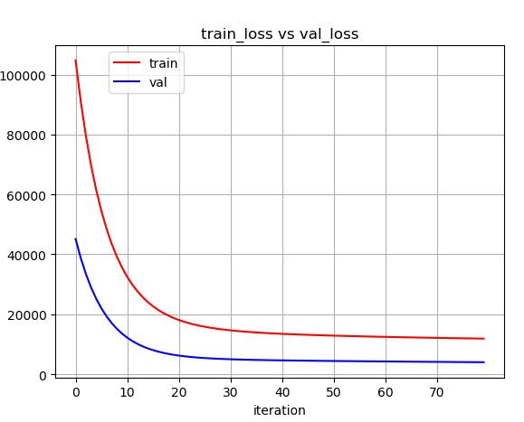

What’s more ,we also conducted a Linear Classification algorithm. The loss function is as follows:

In my experiment,we set the initial value of as normal distribution and the learning rate is 0.01.We conduct the regression experiment in the LIBSVM set and separate the traning data set and the vilification as 32561 :16281.

The is the training loss and validation vs iterations:

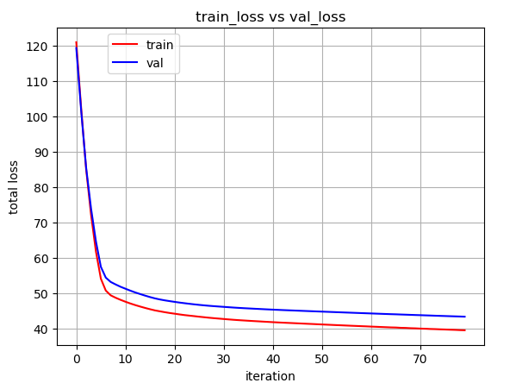

# **conclusion**

We performed logistic regression and linear classification algorithms and got good results. Linear model operation is very simple and convenient, has a wide range of applications in the CS and financial fields.