Lindsay Sheppard

Sociology 565: Demography

Demography Exercise 1: Russian Population Statistics

**Overview**

Stock and flow models are used in many fields to describe the relationship between stocks, or quantities measured at one specific time, and flows, or variables that are measured over intervals of time (Stock and flow, n.d.). Using insightmaker.com, a model examined how one stock, *population*, may be affected by the variables *birth rate, death rate,* and *net migration rate* over time in the Russian Federation (Russia). The Central Intelligence Agency’s (CIA) World Factbook website provided demographic data from July 2018 for each of these variables and was used to generate insight (Figure 1) into Russia’s future population trends (CIA, 2019).

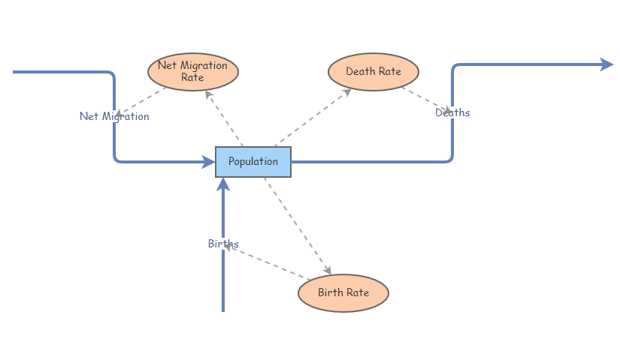

**Figure 1**: Stock and flow model created using insightmaker.com

To build a system dynamic stock and flow model, a stock titled “population” was created; all other variables connect into “population” using flows (blue arrows) and links (dotted arrows). The two main flows into the stock ‘population’ are the variables *birth rate*, which contains a flow rate equal to the population value multiplied by the birth rate, and *net migration rate,* whose flow rate is the population value multiplied by the net migration value. The flow out of population is attributed to the variable *death rate,* which has a flow rate equal to the population value multiplied by the death rate value.

**Population**

Population data is shown in Figure 2 (CIA, 2019). The initial value of 142,122,776 people (July 2018 estimate) was input into the model (Figure 3); despite Russia being the world’s largest country by landmass, it has a relatively small population compared to other countries. As a quick comparison, the United States, which is approximately half the size of Russia, reported a July 2018 population estimate of 329,256,465 persons (CIA, 2019).

There are several reasons for Russia’s lower population density. Because Russia is so large, much of its northern land is uninhabitable by humans (Yegorov, 2018). Other cited issues are that Russians have faced population decline for reasons relating to World War II, and global trends in general dictate that more countries are experiencing lower birth rates, with Russia no exception (Yegorov, 2018).

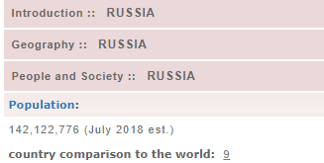

**Figure 2**: Population value (CIA, 2019)

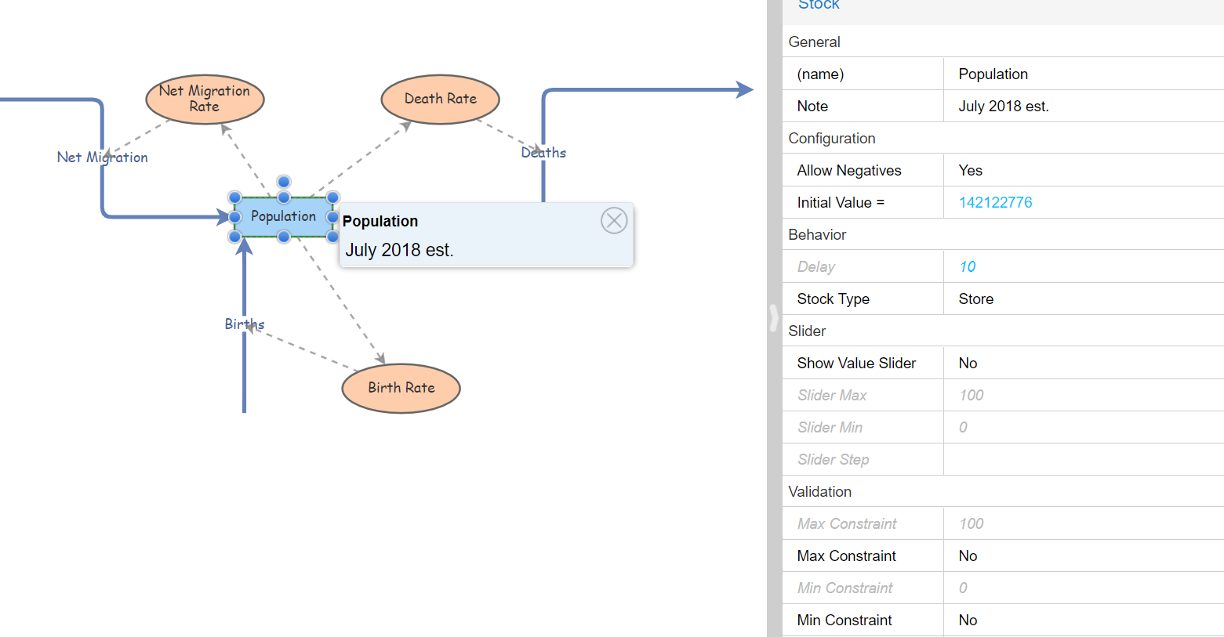

**Figure 3**: Population input

Figure 4 demonstrates that if left unchanged, Russia would face population decline over the next 100 years due to lower birth rates (Figures 5-7), higher death rates (Figures 8-10), and net migration (Figures 11-13), without consideration for other aforementioned population-lowering variables. The simulation suggests that Russia will experience a decrease in population from 2018 to 2115 from just over 142 million people to approximately 129 million people, respectively. In reality, this decline is expected to be more severe; the United Nations has predicted that Russia’s population could be halved by 2020 (The Moscow Times, 2019).

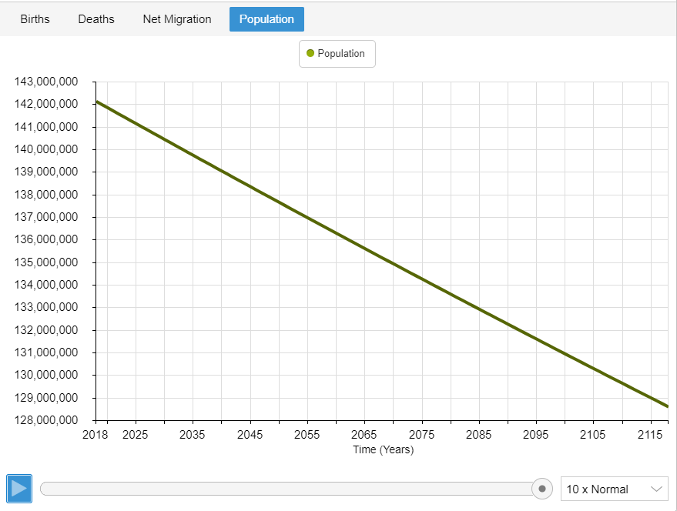

**Figure 4:** Population estimates; 100-year forecast

**Births**

The birth rate suggests that Russia’s 10.7 births per 1,000 people is rather low. The CIA World Factbook ranks it 184th; as there are only 195 countries in the world, Russia is quite low on the list (Hayes, 2019). Figure 6 shows the birth rate input into the model, which flows into the population stock. In the simulation (Figure 7), the number of births declines slowly, from approximately 1.5 million total births for the year 2018 to nearly 1.38 million births in the year 2116.

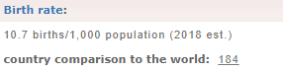

**Figure 5:** Birth rate value (CIA, 2019)

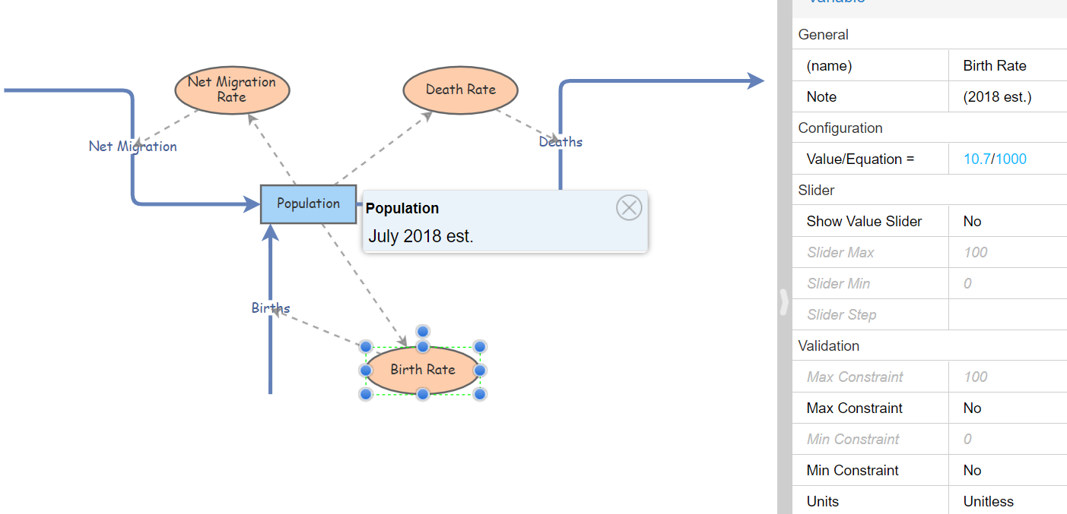

**Figure 6**: Birth rate input

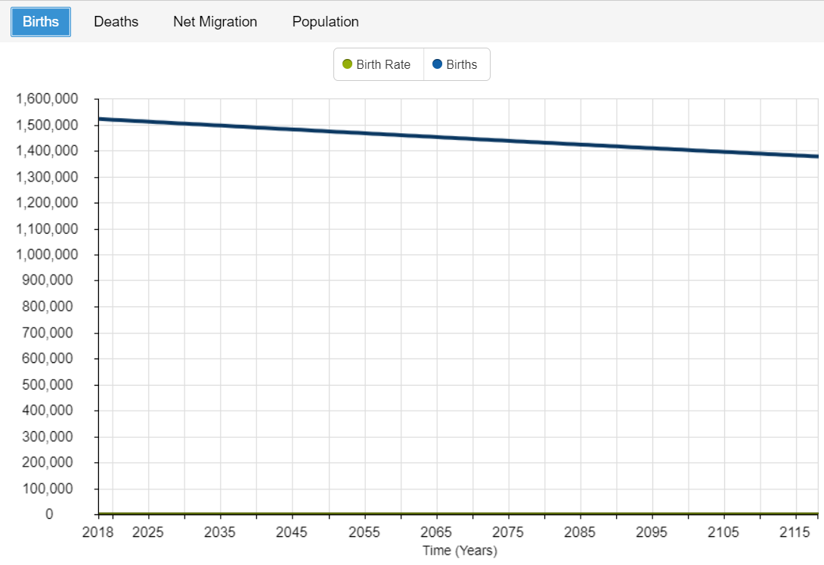

**Figure 7:** Birth estimates based on current birth rate; 100-year forecast

As noted, a global trend towards lower births has been reported for multiple reasons; education and healthcare are increasingly expensive and young people’s behavior and cultures are changing, amongst others (Yegorov, 2018). There are other reasons specific to Russia, however, such as an aging population; with a large proportion of the population who are past childbearing age, birth rate naturally decreases. Additionally, Russia has a high abortion rate (Rosenberg, 2019).

**Deaths**

The death rate (Figure 8) in Russia is quite high, caused partly by high levels of alcoholism, at 13.4 deaths per 1,000 people (CIA, 2019; Rosenberg, 2019). The reported rate was input into the stock and flow model as shown in Figure 9. Out of 195 countries, Russia places 8th on the list; in other words, only seven other countries have higher death rates. As comparison, the United States’s death rate is approximately 8.2 deaths per 1,000 people (Rosenberg, 2019). However, Russia’s death rate has decreased over the years, from a high of 15 deaths per 1000 people in the year 2010 (Rosenberg, 2019). A continued gradual decline in the number of deaths is noted by the simulation in Figure 10, from a current 1.9 million yearly deaths to approximately 1.7 million around 2115.

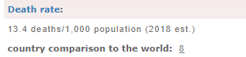

**Figure 8:** Death rate value (CIA, 2019)

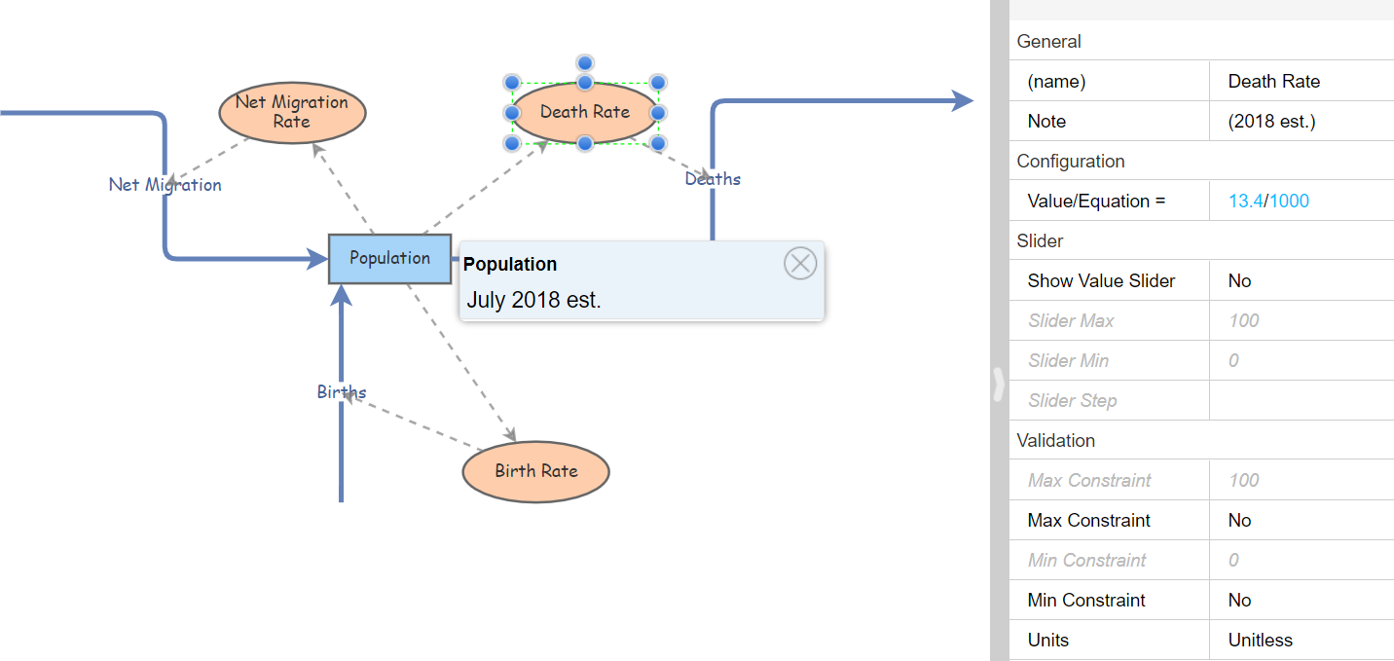

**Figure 9:** Death rate input

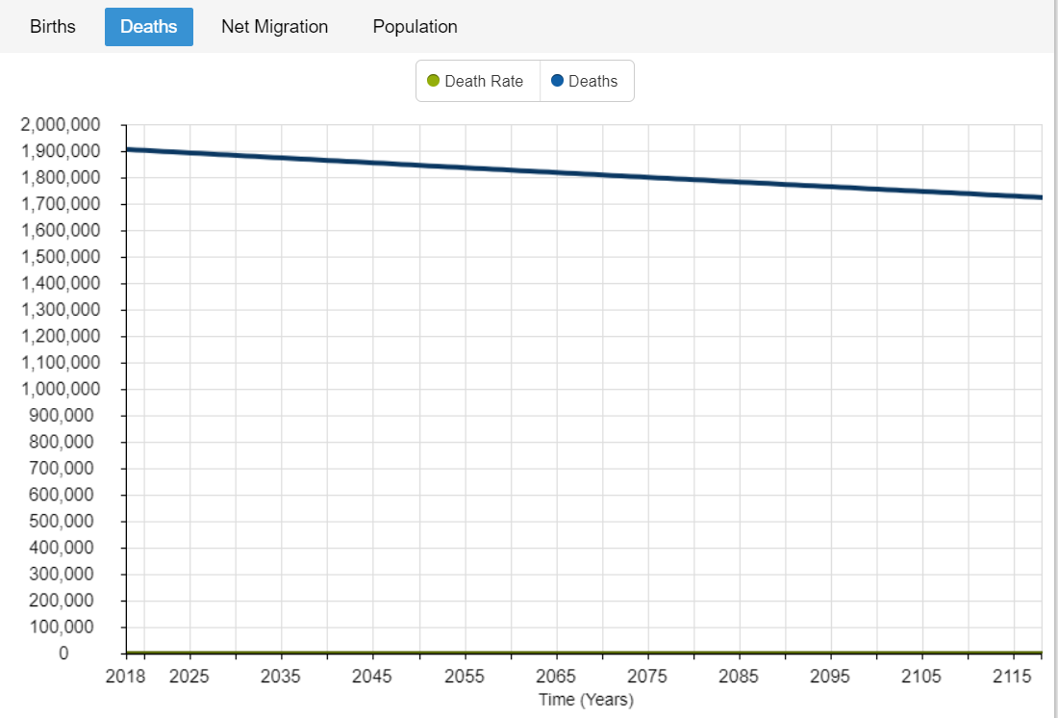

**Figure 10:** Death estimates based on current death rate; 100-year forecast

**Net Migration**

Net migration rate (Figures 11-13) is the difference between the number of persons entering and leaving a country during the year per 1,000 persons (CIA, 2019). Recently, Russia has experienced a very low rate of immigration into and high emigration out of Russia, mostly for political and economic reasons (Rosenberg, 2019). At a rate of 1.7 migrants per 1,000 people into the model (Figure 12), Russia’s net migration is moderately low, lowering slightly from previous years (CIA, 2019). In fact, it is more than half the United States’s rate (3.8/1000; CIA, 2019). Overall, the simulation in Figure 13 suggests that migration in Russia will continue to decline. In 2018, net migration numbers were slightly greater than 240,000, dropping to just around 220,000 for the year 2115.

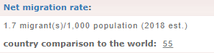

**Figure 11**: Net migration value (CIA, 2019)

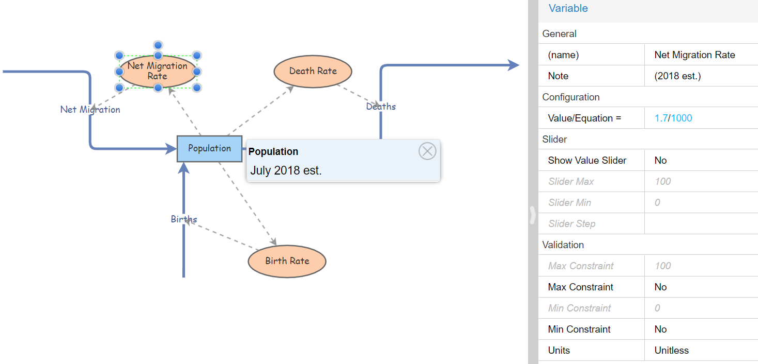

**Figure 12**: Net migration variable inputs

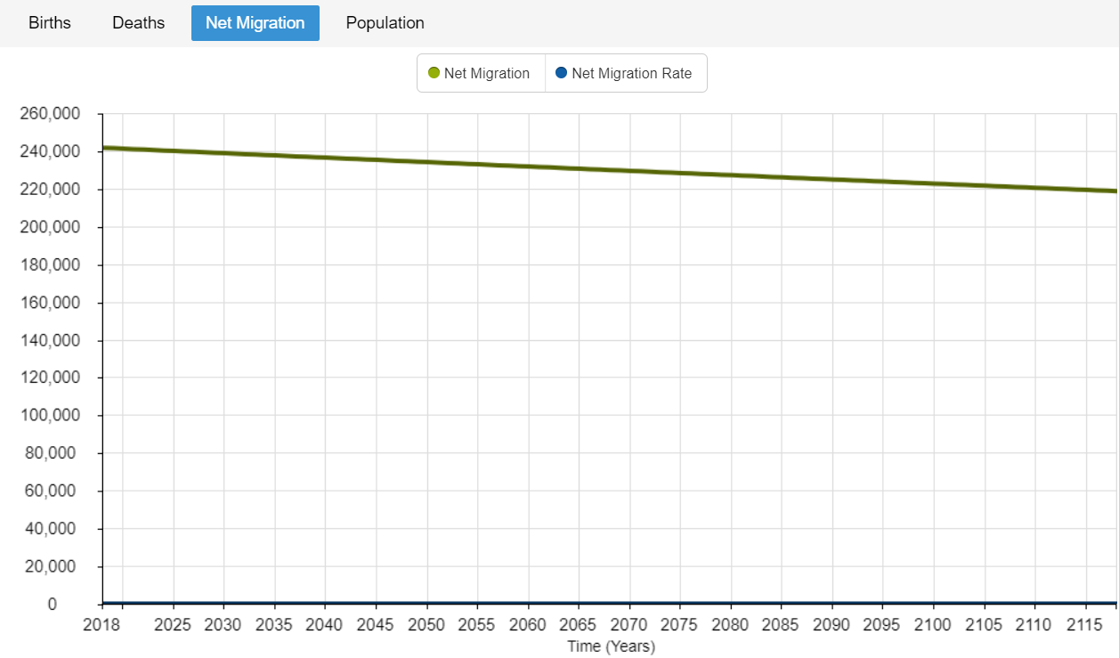

**Figure 13:** Net migration

**Discussion**

Three major issues are contributing to Russia’s population decline: low birth rates, high death rates, and high emigration coupled with low immigration. Low birth rates have been caused by worldwide trends, high abortion rates, the “graying” of the Russian population, and other demographic transitions, e.g., more women entering the workforce (DaVanzo & Adamson, 1997). High death rates have been due in part to high alcohol consumption, violence, and other non-natural causes (DaVanzo & Adamson, 1997). Other deaths have been attributed to poor healthcare systems. While birth and death rate are likely the largest contributors to Russian population decline, more Russians are leaving the country than people are moving to Russia for political, social, and economic reasons.

Russia’s population decline is so worrisome that many reports remark on how dire the situation is. Anatoly Vishnevsky, the Director of the Institute of Demography of the Higher School of Economics in Moscow, suggested that Russia is simply part of a global trend that indicates that population growth in developed countries has already stopped, and that ‘forcing people to have more children’ is impossible; families know their limits and will not exceed them (Yegorov, 2018). While citizens cannot be forced to grow their families, governments may provide initiatives to citizens who do. Russian President Vladimir Putin has addressed the issue in his speeches, openly discussing barriers such as low income, lack of housing, education and healthcare costs, and committing to improving them so families are more likely to have children (Rosenberg, 2019; The Moscow Times, 2019). He has also addressed ways to improve life expectancy, reduce the rate of alcoholism and other non-natural deaths, and improve migration to the country (Timofeychev, 2019). However, the decreasing population, increased aging, and shifting family compositions experienced by Russia are not that different than those being seen in other nations. Only time will tell if Russia will overcome such barriers to their population growth.

**References**

Central Intelligence Agency (CIA). (2019). Russia. *In The world factbook.* Retrieved from https://www.cia.gov/library/publications/the-world-factbook/geos/rs.html

DaVanzo, J. & Adamson, D. (1997). Russia’s demographic “crisis”: How real is it? Retrieved from https://www.rand.org/pubs/issue_papers/IP162/index2.html

Hayes, M. (2019, July 17). How many countries are there in the world? Retrieved from <https://www.worldatlas.com/articles/how-many-countries-are-in-the-world.html>

Insightmaker.com (n.d.). Insight Maker [Computer software]. Retrieved from https://insightmaker.com/

Rosenberg, M. (2019, September 2). Population decline in Russia. *ThoughtCo.* Retrieved from <https://www.thoughtco.com/population-decline-in-russia-1435266>

Stock and flow. (n.d.) in *Wikipedia.* Retrieved from https://en.wikipedia.org/wiki/Stock_and_flow

The Moscow Times. (2019, June 18). UN predicts Russia’s population could halve by 2100. Retrieved from https://www.themoscowtimes.com/2019/06/18/un-predicts-russias-population-could- halve-2100-a66035

Timofeychev, A. (2019, February 3). Why is Russia’s population destined for a sharp decline? *Russia Beyond.* Retrieved from https://www.rbth.com/lifestyle/329934-will-russias-population-decline

Yegorov, O. (2018, November 27). Why is Russia’s population (relatively) small and declining? *Russia Beyond.* Retrieved from https://www.rbth.com/lifestyle/329586-russia-population-small