Lindsay Sheppard

Soc 565: Demography

Demography Exercise #2: Statistical Analysis

IBM SPSS Statistics Version 24 was used to examine a file titled wdi.sav, which contained a multitude of variables pertaining to world development in 214 countries and territories. Specifically, SPSS analyzed the relationship between the variables 2000.405 and 2000.247, or, *GDP per capita (current US$* (USD)*)* and *Death rate, crude (per 1,000 people)*, respectively. GDP per capita is a measure of a nation’s economic output; it accounts for its number of people by dividing the country’s gross domestic product by its total population, making it a solid measurement of a country’s standard of living (Amadeo, 2019). Though there were multiple GDP per capital variables from which to choose, the variable using current US dollars was chosen for familiarity and ease of comparison.

The other variable, crude death rate, is considered the best-known measure of mortality in a population and is calculated using the following:

$${CDR}_{t}= \frac{D_{t}}{P_{t }} ×1000$$

where CDRt is the crude death rate of a given population during year t, Dt is the number of deaths which occurred during that year, and Pt is the midyear total population size (Weinstein & Pillai, 2016). One may hypothesize that GDP will have some sort of effect on a country’s crude death rate, perhaps with poorer economies experiencing higher crude death rates than richer ones. In fact, the relationship has been studied and historically, the conclusion has been that the relationship is very complex; overall, more money tends to be better on health outcomes, yet when economies do well and grow faster than average, mortality rates tend to increase (Guo, 2016; Morin, 2016). Examining and visualizing all country’s GDP and crude death rates may provide a description of what, on average, a country may experience in this regard. Furthermore, analyzing the correlation between the two variables is necessary to acquire a better understanding of their true relationship.

**Description**

The data remained unscaled and untransformed for analysis. The year of the data was unknown but considered relatively recent. Using SPSS’s ‘Analyze’ drop-down menu, followed by choosing ‘Descriptive Statistics’ and then ‘Frequency’ allowed for a side-by-side comparison of the variables’ individual statistics as seen in Figure 1.

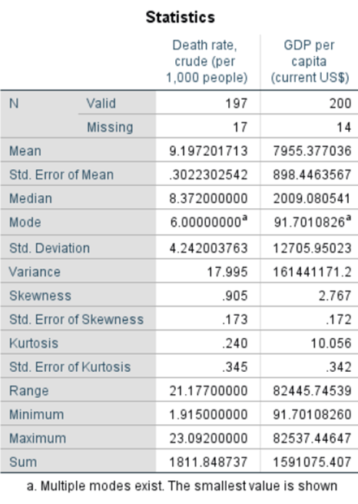

**Figure 1:** Descriptive statistics of variables 2000.405 and 2000.247

The means of each variable suggest an average crude death rate (CDR) of approximately 9.20 per 1,000 people and an average GDP per capita nearing 8,000 USD. Both variables are wide-ranging. CDR ranges from a minimum of approximately 1.92 deaths per 1,000 people (United Arab Emirates) up to a maximum of 23.09 deaths per 1,000 people (Sierra Leone); GDP ranges from a low of 91.70 USD (Congo, Dem. Rep.) to a maximum of 82537.45 USD (Monaco). Already one can determine, at least with the current dataset, that the minimums and maximums of each variable do not necessary correspond with each other directly, i.e. Sierra Leone with the highest crude death rate did not report the lowest GDP. An overall relationship may be determined with further examination.

Additionally, the standard deviations and variances reported above suggest that crude death rates among countries tend to be closer than the mean death rate, while GDP’s are spread out more over a wider range of values. Both variables show positive skewness, with the mean greater than the median and mode in both cases; GDP per capita shows greater skewness at 2.767 than the crude death rate (.905).

To examine the two variables visually, Figures 2 and 3 display histograms created using SPSS, allowing insight into each individual variable as well as the type and number of reported responses. In general, Figure 2 and 3 validate the aforementioned skewness, with Figure 2 suggesting that many of the countries report a crude death rate between 5 and 10 deaths per 1,000 people, and fewer than 5 deaths per 1,000 being reported at fewer frequency than those between 10-20 deaths per 1,000 people.

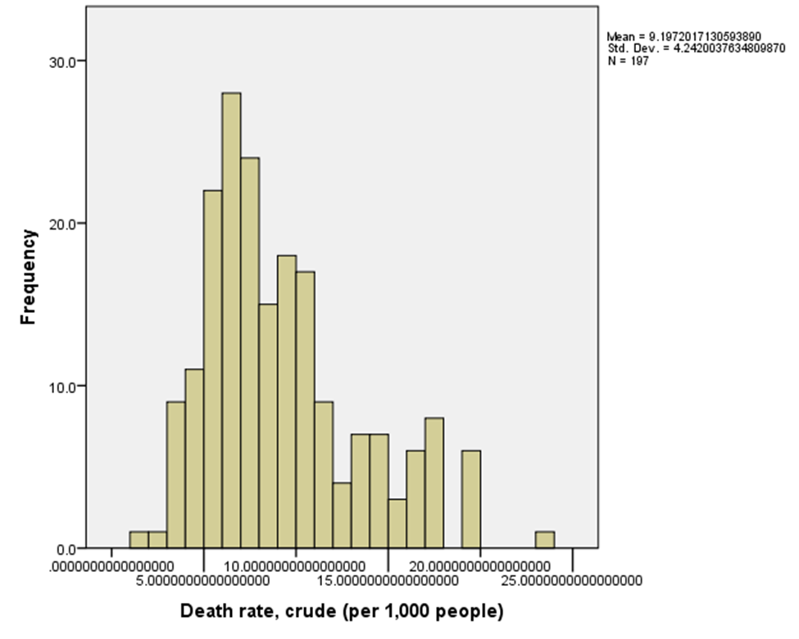

**Figure 2:** Histogram of *Death rate, crude (per 1,000 people)*

Figure 3 indicates that most countries reported a GDP per capita less than 20,000 USD. Visually speaking, looking at the two variables separately provides insight that the relationship between them is not linear, but may be as complex as previous research suggested.

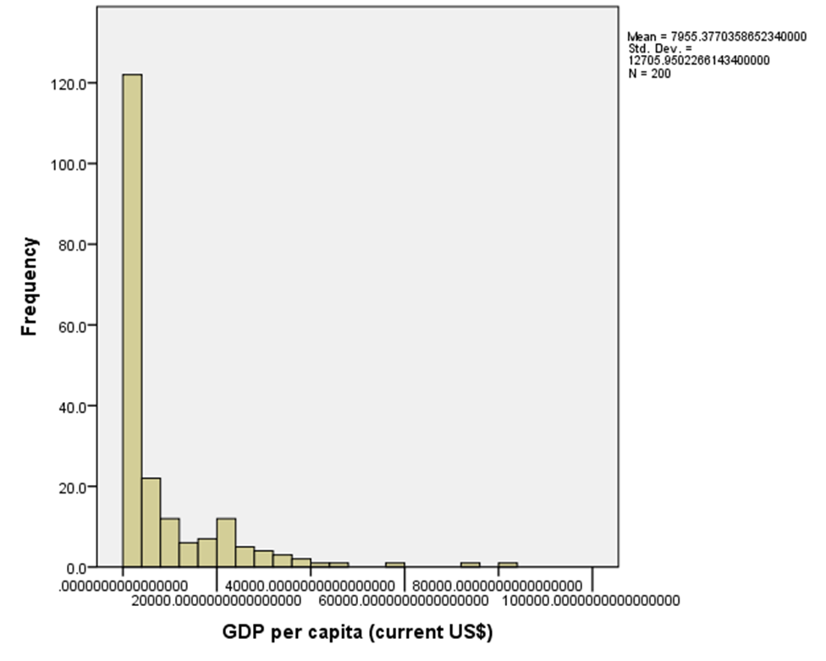

**Figure 3:** Histogram of *GDP per capita* *(current US$)*

Figure 4’s scatterplot was developed to answer whether a relationship between the two variables exist prior to conducting a bivariate correlation (Figure 5). In Figure 4, a greater concentration of data values are plotted where GDP is reportedly the lowest, with the points becoming shorter and sparser as GDP increases. This suggests that there seems to be higher crude death rates reported in countries with lower GDPs, overall. However, the correlation between the two required examination through bivariate correlation.

Figure 5 displays correlation results; a statistically significant correlation between the two variables of -.248 was reported (p < 0.001). The negative indicator suggests an inverse relationship; that is, as GDP increases, death rate decreases. However, this value falls between +/- 0.00 to 0.30, suggesting that the correlation between the two is relatively weak.

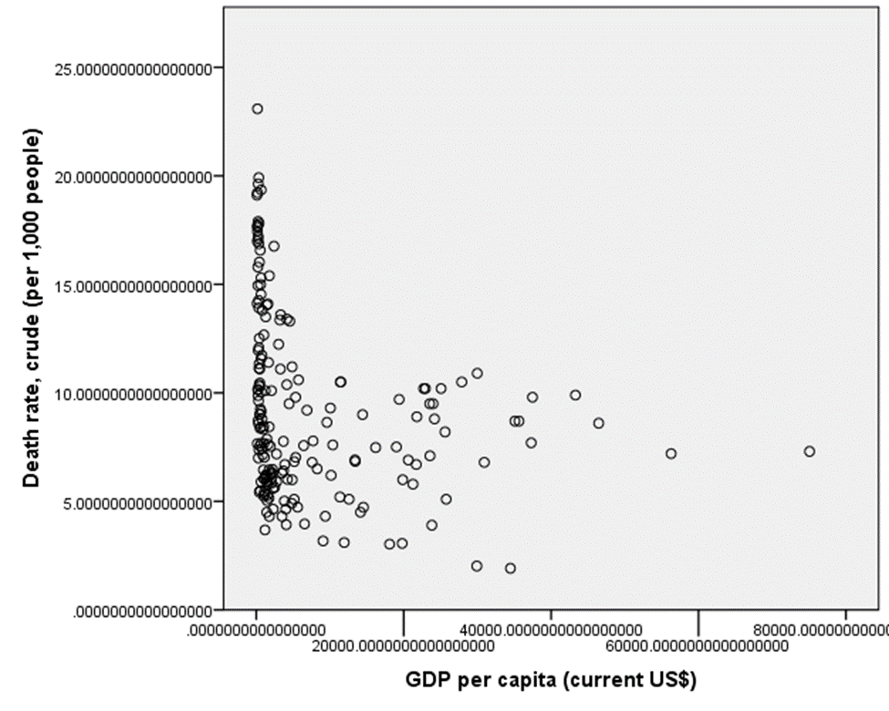

**Figure 4:** Scatterplot examining the relationship between CDR and GDP

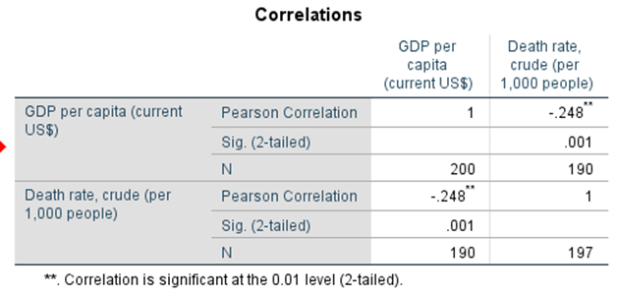

**Figure 5:** Bivariate correlation

**Interpretation**

Overall, the results generated by SPSS agree with previous research that suggests that while there is, for the most part, an inverse relationship between GDP and CDR, it is somewhat weakened by complicating factors that come into play, with a tendency toward increasing death rates when economies are at their best. The latter is surprising, as one may think that poorer economies with lower standards of living would suffer more morbidity and mortality than countries with thriving economies and the best standards of living. However, while research on the relationship between GDP and CDR has not quite yet determined what complicating factors contribute to this phenomenon, a few emerging trends have been noted.

Cutler, Huang, & Lleras-Muney (2016) attempted to investigate the occurrence quite comprehensively, searching over 200 years of data and using cohort life tables to determine what economic conditions affect mortality. As expected, they determined that generally, with large recessions, mortality increases and in large economic booms, mortality falls. However, in terms of death rates, it appears economic growth is a double-edged sword; the turning point tends to occur during the time at which a nation’s wealth becomes reliant on factory output. Increased mortality rates may be attributed to increased pollution; when economies grow particularly fast, emissions and pollutions tend to rise (Guo, 2016). Other considerations are the increased workplace stresses and worsening conditions that economic booms can initiate: people drive more (increasing traffic and accidents), spend more time at their jobs (causing overwork stress, reduced sleep, poor dietary habits, etc.), and increase alcohol consumption (engaging in other unhealthy behaviors and risk-taking). Similarly, other studies have found that mortality increases after receiving tax rebates; greater income may increase engagement in risky behaviors (Evans & Moore, 2009).

Therefore, further research may include determining which, if any, of the proposed factors are the strongest in predicting increased mortality during economic booms, as well as attempting to manage the downsides of growth. Examining which countries do a better job at ‘buffering their residents from the health consequences of booms and recessions’ would be quite helpful (Guo, 2016). Perhaps the countries that are affected less by economic ups and downs are stricter in pollution policies, have been social systems, or greater equality in other areas yet to be determined. Whatever the reason, solving the mystery once and for all may be beneficial to overall world development and improvement.

**References**

Amadeo, K. (2019, August 8). GDP per capita with its formula and country comparisons: Why the world’s largest economies aren’t the richest. Retrieved from https://www.thebalance.com/gdp- per-capita-formula-u-s-compared-to-highest-and-lowest-3305848

Cutler, D.M., Huang, W., & Lleras-Muney, A. (2016, September). Economic conditions and mortality: Evidence from 200 years of data. *National Bureau of Economic Research.* Retrieved from https://pdfs.semanticscholar.org/bb8f/e8acd9b7da2d41dcd04434f70ecd841ca18a.pdf

Evans, W.N., & Moore, T.J. (2009, September). The short-term mortality consequences of income receipt. *Journal of Public Economics, 95* (11): 1410-1424. doi: 10.3386/w15311

Guo, J. (2016, October 18). The relationship between GDP and life expectancy isn’t as simple as you might think. *World Economic Forum.* Retrieved from https://www.weforum.org/agenda/2016/10/the-relationship-between-gdp-and-life-expectancy- isnt-as-simple-as-you-might-think

Morin, R. (2013, October 16). A downside to an up economy? Mortality rates increase in better times. Retrieved from https://www.pewresearch.org/fact-tank/2013/10/16/a-downside-to-an-up- economy-mortality-rates-increase-in-better-times/

Weinstein, J. & Pillai, V.K. (2016). *Demography: The science of population* (2nd ed.). Lanham, MD: Rowman & Littlefield.