Lindsay Sheppard

Sociology 565: Demography

Demography Report 4: Fertility

**Overview**

Fertility is defined as the quality of being able to produce offspring (Fertility, n.d.) It is the condition necessary for births, which are vital events of great interest to demographers. While births are often viewed from the perspective of the newborn, fertility puts emphasis on the status of a parent, usually the mother (Weinstein and Pillai, 2016). In other words, when a birth occurs, the fertility level of a mother increases by one (Weinstein and Pillai, 2016).

Births are often measured by crude birth rate (CBR) which derives from the total population, but “fertility” rates are calculated from a population of fertile women. The most common period measure of fertility is known as the total fertility rate (TFR), which estimates the average number of children born to a woman over her lifetime if she experiences exact age-specific fertility rates (ASFR) through her lifetime, and if she survives from birth to the end of her reproductive period (Total fertility rate, n.d.). In fact, the TFR is a weighted sum that is calculated through adding together all ASFRs for each cohort, and then multiplying the sum by the size of each age interval (Weinstein and Pillai, 2016).

There are other fertility measures, such as the general fertility rate (GFR), the gross reproduction rate (GRR), and the net reproduction rate (NRR). In particular, the gross reproduction rate is similar to the TFR, but accounts for only female births. It looks specifically at reproduction, or, the ability for a population to sustain its size over time (Weinstein and Pillai, 2016). The NRR is the same as the GRR but suggests the average number of daughters a woman would have ‘if she survives her lifetime subject to the age-specific fertility rate and mortality rate throughout that period’ (Gross reproduction rate, n.d.).

According to Weinstein and Pillai (2016), CBRs and TFRs are correlated with other factors, such as a nation’s per-capita gross domestic product (GDP per capita). In the table provided by Weinstein and Pillai (2016, pp. 105-106), countries with high birth rates had low GDP per capita and varying TFRs, though many of the countries with high CBRs also have high TFRs. To examine the relationship between fertility rate, reproduction rate, and GDP, a file titled wdi.sav was uploaded into IBM SPSS version 24 and analyzed using descriptive statistics and Pearson’s correlation. The variables *@2010.399 (GDP (Current US$))*, *@2010.1104 (School enrollment, primary, female (% net)*, and *@2010.358 (Fertility rate, total (births per woman))*, or *GDP, primary,* and *fertility,* respectively were chosen. As the variables contained ‘2010’ in their labels, the data was assumed to be from the year 2010.

The variable *GDP (current US dollars* (*USD*)) was selected due to familiarity with that particular currency. The GDP, or total economic output of a country, was used instead of GDP per capita. The *primary* variable provided an idea of the number of female primary school-aged children in each nation, regardless of age, to examine reproduction rate (i.e. NRR). There are “gross” school enrollment variables as well; the gross (GER) includes students regardless of age and those who have repeated grades, net enrollment does not (Huebler, 2005). The variable *fertility* is self-explanatory.

**Descriptive Statistics**

Using the steps Analyze -> Descriptive Statistics -> Frequencies, SPSS generated a table (Figure 1) that provided information on the three variables. Each variable is missing some values; by default, SPSS ignored them. As the current report was concerned with determining a basic relationship between these variables, missing values were not imputed; this may slightly bias parameter estimates or lead to a decrease in statistical power, yet for the current analysis the bias may be trivial (Lodder, 2013).

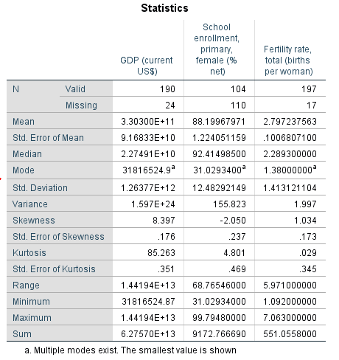

**Figure 1**: Descriptive statistics for *GDP, primary,* and *fertility*

GDP

The mean GDP for the countries in the dataset reported to be approximately 3.30 x 1011 (330 billion) USD. However, the standard deviation, which measures how widely spread the data is, is very large at 1.26 x 1012 (over 1 trillion) USD. The large reported variance and range indicate there are both extremely wealthy countries and relatively poor countries, with a maximum of over 14 trillion USD (United States of America) and a minimum of 31 million USD (Tuvalu). The substantial positive skewness and kurtosis values indicated that the GDP variable benefitted from normalization using a logarithmic transformation.

The distribution of *GDP* prior to normalization can be viewed in Figure 2. The post-normalization (Figure 3) statistics showed a new skewness value of .027 and kurtosis value of -.281. Figure 4 displays the distribution of *GDP* (log@2010.399) after the log transformation.

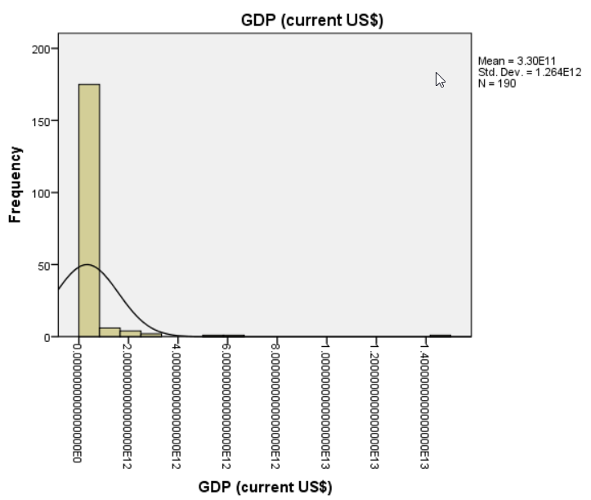

**Figure 2:** Histogram of *GDP* prior to normalization

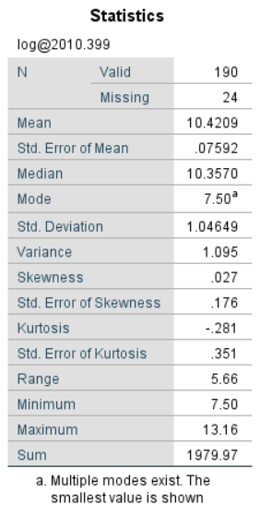

**Figure 3:** Statistics for the log-transformed variable *GDP (*[*log@2010.399*](mailto:log@2010.399)*)*

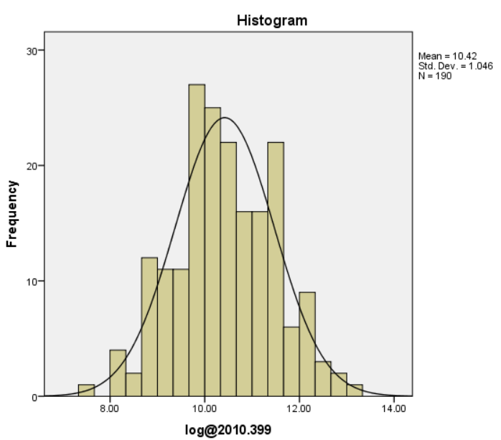

**Figure 4:** Histogram for the log-transformed GDP variable ([*log@2010.399*](mailto:log@2010.399)*)*

Primary

Referring back to Figure 1, the variable *primary* reported a mean of approximately 88.20% female primary education students, with the median of 92.41% and the mode substantially lower (31.03%). The reported standard deviation (approximately 12.48%) indicated that the reported percentages in the dataset varied moderately from the mean. Spain reported the maximum value (99.80%); Eritrea reported the lowest female net primary enrollment rate (31.03%). The histogram for *primary* (Figure 5)*,* along with the reported skewness and kurtosis values, determined that the variable was substantially negatively skewed, with a skewness of -2.050. For this reason, a logarithmic transformation was performed on the variable using a constant (k) equal to 100.7948; the resulting skewness reported to be -.104 (Figure 6) and the distribution appeared more normal (Figure 7).

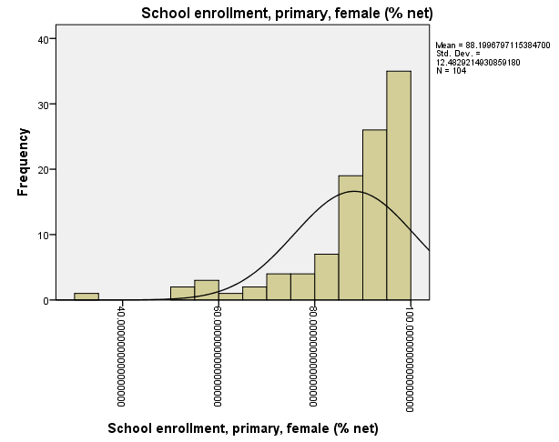

**Figure 5:** Histogram for *primary (@2010.1104)*

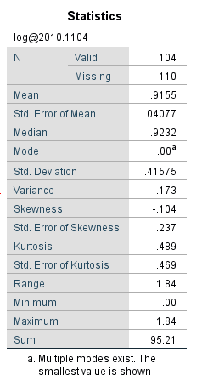

**Figure 6:** Statistics for the log-transformed *primary* variable (*log@2010.1104*)

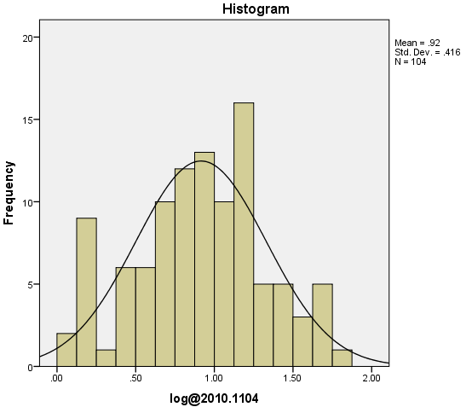

**Figure 7:** Histogram of the log-transformed *primary* variable (*log@2010.1104*)

Fertility

Looking once more at Figure 1, the *fertility* variable reported a mean of approximately 2.80 children per women, with a median of 2.29 children and a reported modal value of 1.38, though multiple modes exist. Because the mean is slightly greater than the median and the reported mode, the distribution is positively skewed; the skewness value of 1.034 concurred. Though the standard deviation is relatively small, indicating that most data points in the variable do not vary wildly from the mean, there is a large range of 5.97 reported, with the minimum births per woman of 1.09 (Macao SAR, China), and the maximum reported at 7.06 (Niger).

Because the skewness value in Figure 1 and initial histogram (Figure 8) determined positive skewness, the *fertility* variable underwent a logarithmic transformation like the other two variables. The resulting statistics (Figure 9) and histogram (Figure 10) indicate that the variable is more normally distributed post-transformation.

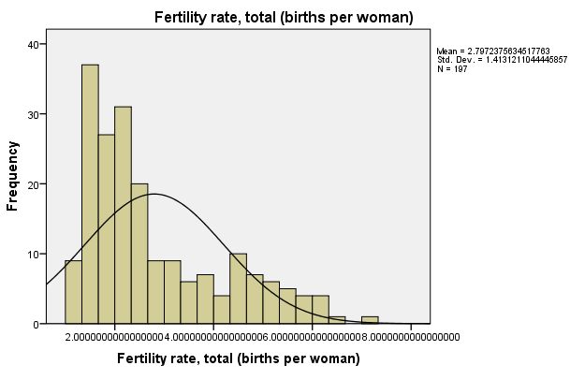

**Figure 8:** Histogram of the pre-transformed *fertility* variable

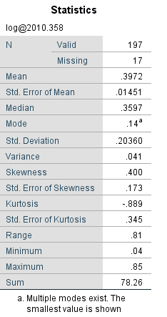

**Figure 9:** Statistics for the log-transformed *fertility* variable (*log@2010.358)*

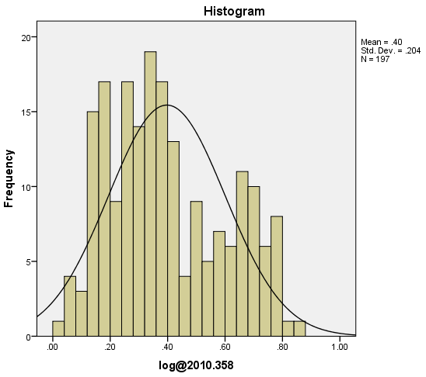

**Figure 10:** Histogram of the log-transformed *fertility* variable (*log@2010.358)*

**Correlation**

Using the steps Analyze -> Correlate -> Bivariate, the new variables *log@2010.399 (logGDP), log@2010.1104 (logprimary), and log@2010.358 (logfertility)* were examined using Pearson’s correlation. The results are shown in Figure 11.

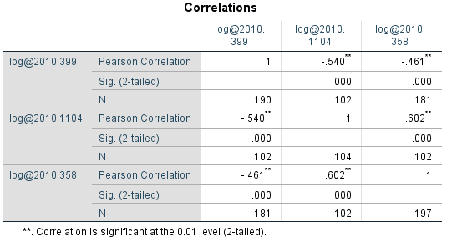

**Figure 11:** Correlation results

The results of bivariate correlation indicate that there are significant correlations between the variables. *LogGDP* has a statistically significant moderate negative correlation with both *logprimary* (r(102) = -.540, p <.001) and *logfertility* (r(179) = -.461, p <.001)*.* This finding suggests that as the GDP of a nation increases, both the number of female children enrolled in primary school and the number of children born per woman tend to decrease. *Logfertility* and *logprimary* also report a moderate to strong positive correlation (r (102) =.602, p < .001), indicating that as a woman’s total fertility rate increases, the number of female school-age children enrolled in primary school increases as well.

**Discussion**

As discussed, fertility and reproduction are related; one examines how many children, on average, that a woman bears during her reproductive years, the other measures how many females are born to replace her. Therefore, it seems logical that the *fertility* variable reported a positive correlation with the net percentage of females who are enrolled in primary school in each country. Countries with higher fertility rates will be more likely to bear more female children, leading to continued reproduction.

The relationship between GDP, fertility, and reproduction is more complex. Poorer nations tend to report higher total fertility rates and, subsequently, increased reproduction rates. The question is whether the countries are poorer because people are having too many children, or if people have more children because their countries are poor. It seems that both are reasonable. Countries may be poor because they have too many children that use up most of the available resources. There might be little to no extra income for people to save or invest. The economy may suffer as parents struggle to make ends meet. Mothers may not be able to work because childcare is unavailable or unaffordable. They may also be un- or undereducated and not able to seek education due to a lack of finances, transportation, and/or time. On the other hand, poor countries may have inadequate resources, such as contraception, family planning services, or other health services; both of these could contribute to an increase in births as well as infant mortality.

The demographic transition model suggests that increased GDP plays a role in increased life expectancy, greater access to contraception, increased female literacy, independence, and employment, increased urbanization, and reductions in infant and child mortality (Demographic transition, n.d.). Enhanced economic, technological, and education conditions set the stage for these improvements. Interestingly, the theory contains only four stages, but additional stages have been proposed due to current trends, such as sub-replacement fertility in many countries. Though children tend to be expensive, wealthier couples are having fewer children, and several countries report higher death rates than birth rates. In what will eventually become “Stage Five,” both more-fertile and less-fertile futures have been proposed. Though a few models propose that modernization exerts evolutionary and cultural pressures for fertility, most models suggest that “birth rate will stabilize at a low level indefinitely” (Demographic transition, n.d.).

**References**

Demographic transition. (n.d.). in *Wikipedia.* Retrieved from https://en.wikipedia.org/wiki/Demographic_transition

Fertility. (n.d.). in *Cambridge Dictionary.* Retrieved from https://dictionary.cambridge.org/us/dictionary/english/fertility

Gross reproduction rate. (n.d.). in *Wikipedia.* Retrieved from https://en.wikipedia.org/wiki/Gross_reproduction_rate

Huebler, F. (2005, April 23). Primary school gross and net enrollment. *International Education Statistics* [Blog post]*.* Retrieved from https://huebler.blogspot.com/2005/04/primary-school-gross-and- net.html

Lodder, P. (2013). To impute or not impute: That’s the question. Retrieved from https://www.paultwin.com/wp-content/uploads/Lodder_1140873_Paper_Imputation.pdf

Total fertility rate, (n.d.). in *Wikipedia.* Retrieved from

Weinstein, J. & Pillai, V.K. (2016). *Demography: The science of population* (2nd ed). Lanham, MD: Rowman & Littlefield.