Lindsay Sheppard

Sociology 565: Demography

Demography Report #5: Demographic Transition and Georgia

**Overview**

The term “demographic transition” is defined as the “change in the human condition from high mortality and high fertility to low mortality and low fertility (Caldwell, Caldwell, Caldwell, McDonald, and Schindlmayr, 2006). Essentially, the demographic transition model (DTM) attempts to explain why rapid population growth happens (Roser, Ritchie, and Ortiz-Ospina, 2019). A formal theory was developed by Notestein during the mid-twentieth century, which postulated that there are four predictable stages of population growth (The demographic transition, n.d.).

Stage 1 depicts a pre-industrial society, with high birth and death rates and slow population growth due to constraints in food production (Caldwell et al., 2006). Stage 2 describes developing countries that see declines in death rates and increased life expectancies due to improvements in food supply due to improved farming techniques and water supply, hygiene, and sanitation. Stage 3 notes a decrease in birth rates due to changes in values, increased access to contraception, increased urbanization, increased women’s education and independence, increased education for children, and increases in wages (Demographic transition, n.d.). Population growth begins to level off. Stage 4 is the final formal stage where both low birth rates and low death rates occur; birth rates may drop to below replacement level, leading to a shrinking population. Death rates may remain low or begin to rise again from lifestyle diseases and aging populations. Scholars have debated this existence of Stage 5 and have proposed arguments for both increasing and decreasing fertility levels. Figure 1 shows an illustration of the DTM (Roser et al., 2019).

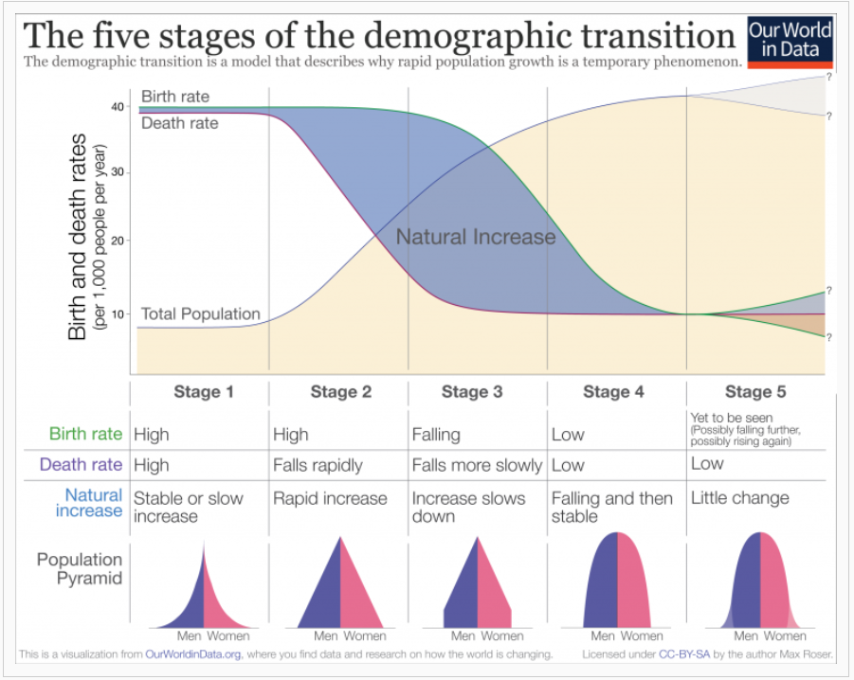

**Figure 1:** The five stages of the demographic transition. Reprinted from Roser et al., 2019.

To examine the DTM, the World Bank Databank website provided data from the country of Georgia (World Bank, 2019a-c). Georgia is a small country located in the Caucasus mountains at the crossroads of Europe and Asia. The data was input into a clone of an insight titled, “Demographic Transition- Bangladesh” (Fulkerson, 2018) which was developed using Insightmaker.com. The same website was also used to generate Figures 2-8. The cloned model is shown in Figure 2. It has been slightly modified from the original and the Georgia data values replaced those from Bangladesh.

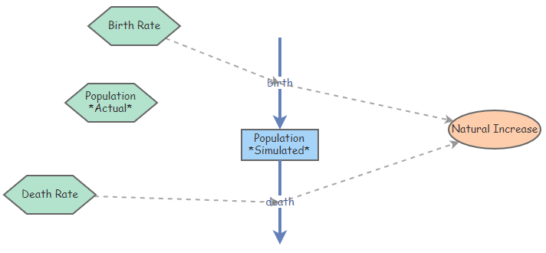

**Figure 2:** Cloned insight model. Adapted from Fulkerson, 2018.

**Description**

Figure 3 is a simulation of the demographic transition from 1960 to 2015. If Georgian actual population values matched the simulated population values, the model in Figure 3 would be quite similar to the theoretical DTM shown in Figure 1. Because the birth and death rates were spaced far apart and the simulated population grew quite rapidly, it seemed that Georgia was already in Stage 3 of DTM in the 1960s. The DTM in Figure 3 indicated that from the 1990s to the early 2000s, Georgia passed through Stage 4, where the death rate slightly increased but remained low overall, and birth rates continued to decline. Around 2004, the birth rate and death rate were nearly the same, indicating no net gain in population during that year. In most recent times, Georgia appears to be in or approaching Stage 5, with low birth and low death rates; birth rates appear to be slightly higher than death rates, though not by much. Stage 5 societies typically experience little to no population growth (The demographic transition, n.d.). The simulated population growth levels off near the year 2000 and beyond.

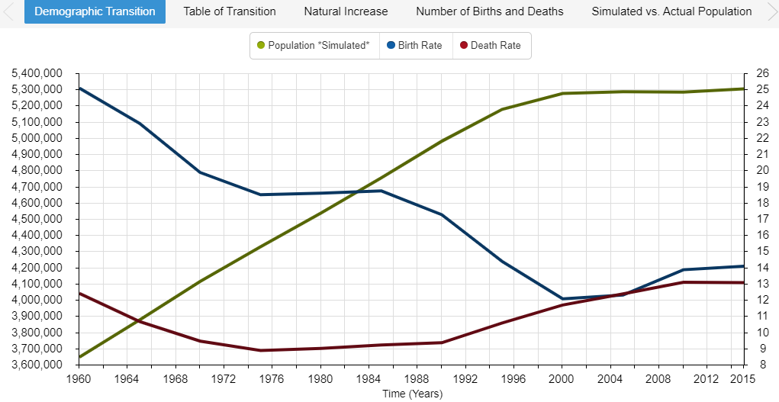

**Figure 3**: Demographic Transition (Simulated)

A brief look at a DTM using actual population values (Figure 4) tells a somewhat different story. Around 1990, population peaked in Georgia but then experienced a somewhat rapid decline that has continued in recent years. While the simulated population estimated that Georgia would be near its peak in population size (approximately 5.3 million) in the year 2015, the actual population figure was estimated near 3.75 million. Reasons for this difference are discussed further in the Interpretation section.

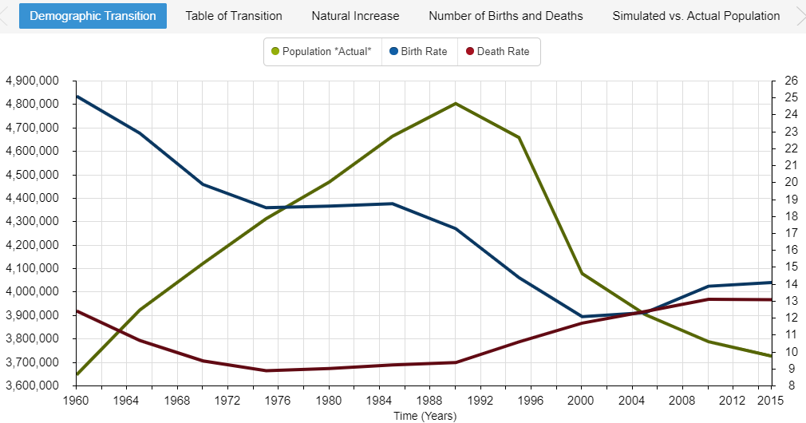**Figure 4:** Demographic Transition (Actual Population)

Figure 5 is a table that reports the simulated population data values as well as the inputted birth rate and death rate values. Again, the simulated population values anticipated the Georgian population to continue growth past the year 1990 instead of experience the decline that it did. The birth rate has steadily fallen from a high of 25.078 per 1,000 in 1960 to a low of 12.063 per 1,000 in 2000, followed by a very small increase back up to 14.078 per 1,000 in 2015. This indicates that perhaps Georgia may experience a resurgence in fertility, in line with a few scholars who have argued that Stage 5 of the DTM is marked by fertility increase.

Crude death rates had fallen from 1960 (12.402 per 1,000) to a minimum value of 8.871 per 1,000 in the year 1975. Since then, death rates rose until 2010. In the past few years, it appears the death rate has been leveling off.

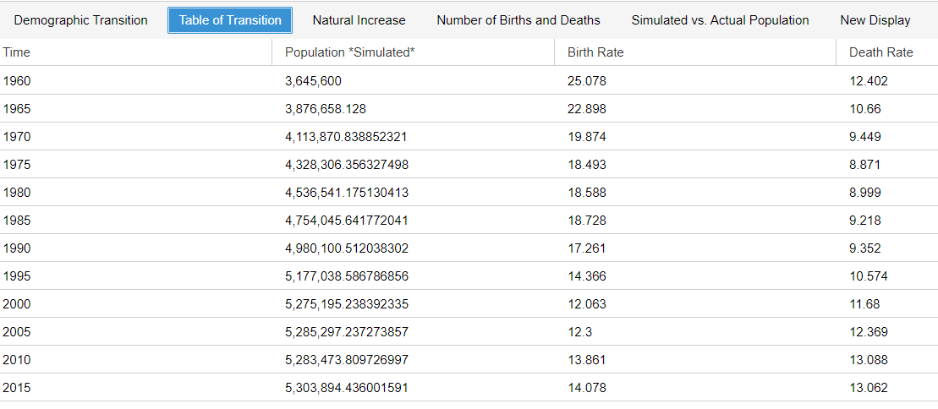

**Figure 5:** Table of Transition

Figure 6 demonstrates the rate of natural increase, or, the difference between the crude birth rate and the crude death rate. As apparent from the graph, Georgia experienced a sharp decline from the late 1980s to the early 2000s and has only recently seen an uptick in the rate of natural increase. With fertility rates increasing, it may be that Georgia’s population will grow in future years. However, this depends on factors such as maintaining higher fertility rates, low crude death rates, and low emigration levels.

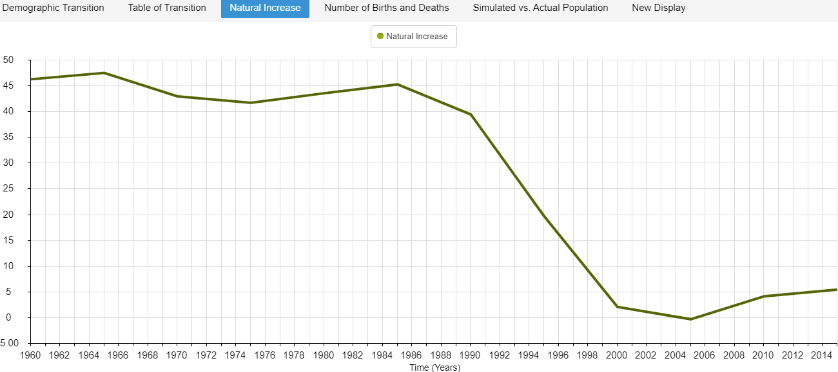

**Figure 6**: Natural Increase

Figure 7 displays the number of births and deaths in the population based on the crude birth and death rates, respectively. It provides an additional demonstration for how births and deaths have changed over the years, with sharp declines in births from the mid- to late 1980s to the early 2000s and increasing deaths over the same time period. Since 2004, births and deaths have increased.

Figure 8 provides a comparison of the simulated (green) versus actual (blue) population levels. The simulation does not account for any factors that play into population calculations, such as increased migrations, changes in culture, the economy, or other social conditions. The actual population graph indicates that something occurred around 1990 that changed Georgian society drastically.

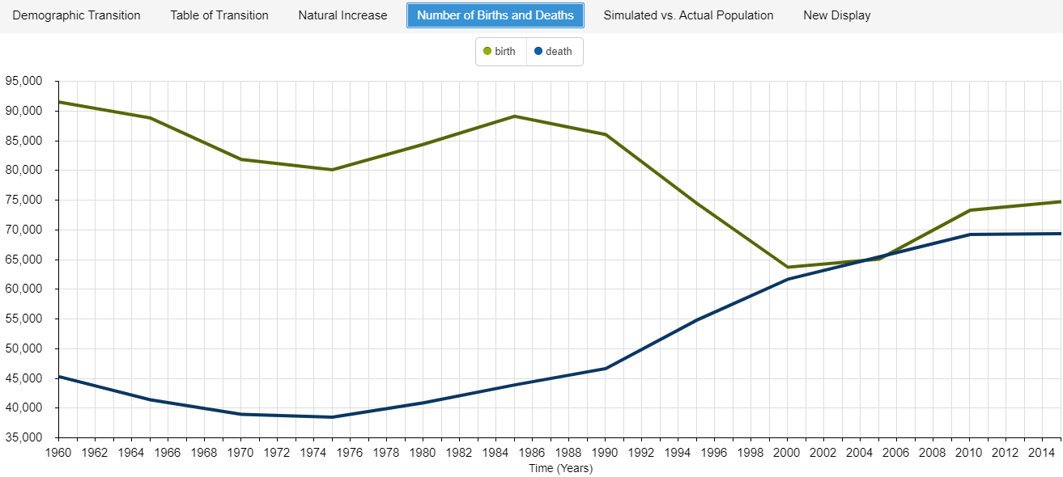

**Figure 7:** Number of Births and Deaths

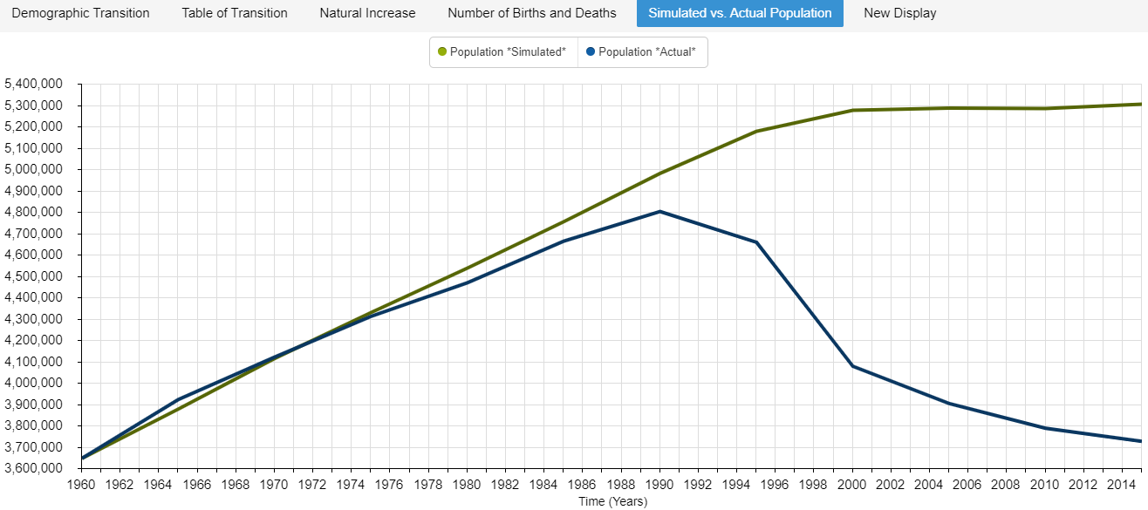

**Figure 8:** Simulated versus Actual Population

**Interpretation**

From 1921-1990, Georgia was the Georgian Soviet Socialist Republic (SSR). The population grew over the years, rising from less than 4 million in the 1950s to 5.5 million in 1992 (Demographics of Georgia, n.d.). Referring back to Georgia’s placement at Stage 3 of the DTM in the 1960s, this makes logical sense from a historical perspective. Even though the official economic growth rate appeared low, Georgia was actually one of the most economically successful Soviet republics (History of Georgia, n.d.). Soon after the end of the SSR, the population began to decline due to increased emigration and a sharp decline in birth rates; in 2005, the total population was estimated to be around 4.5 million. Around the 1990s, Georgians began migrating in search of employment; over the years, Georgia experienced a net migration loss around 1.1 million persons (Demographics of Georgia, n.d.).

That is one reason why the simulated versus the actual population of Georgia showed a drastic difference around the early 1990s. Another reason is that around the same time, not only was Georgia restructuring its economy, but it was experiencing hardship in the form of civil war that lasted until 1995. Regions of South Ossetia and Abkhazia remain disputed territories to this day from the conflict; at the time, many residents of the areas were forced to flee the territories. Several of them migrated to neighboring Russia (Georgian Civil War, n.d.). Others were killed from the military coup d’état, which occurred around the same time. At the end of the war, Georgia was left politically, financially, economically, and socially unstable (Georgian Civil War, n.d.). As previously mentioned, many Georgians migrated to other countries, seeking better economic and financial opportunities. Referring back to Figure 8, Georgian population experienced its most rapid decline in recent times during this period.

However, the DTM also indicates the year 2004 as a turning point as well, where birth and death rates remained relatively low but rising, and the population began to decline at a slower pace. At the end of 2003, Georgia experienced what is now known as the “Rose Revolution,” which marked the peaceful transition to a Pro-Western government in Georgia as well as prioritized integration into Europe through membership in the European Union (Navarro, 2017).

To conclude, the demographic transition theory does seem to apply to a simulated version of Georgia. It explains the effect of modernization, urbanization, and changing value systems over time. Yet, the reality of Georgia’s experience suggests that the theory falls shorts when unexpected instances of economic, political, or social turmoil occur. In that case, other theories seem to better explain demographic trends. For example, religion and other cultural norms, as Coale suggested (1958, cited by Weinstein and Pillai, 2016) play a role in the recent increase in fertility rates (Stone, 2017). Additionally, Georgians have been promised financial incentives by the government for family expansion as well (Stone, 2017), suggesting that economic and wealth theories may also play a role in Georgia’s current demographic trends. Finally, migration theories that consider economics and societal factors, such as Lee’s push-pull factors, social network theories, or Todaro’s migration model (Weinstein and Pillai, 2016) may also be considered as the driving force behind the changes to Georgian society that have been and still are taking place.

**References**

Caldwell, J.C., Caldwell, B.K., Caldwell, P., McDonald, F., and Schindlmayr, T. (2006). *Demographic transition theory.* Retrieved from <https://pdfs.semanticscholar.org/0b7d/69de3accd30e2f40272acdef435b8f43fb28.pdf>

Demographics of Georgia (country). (n.d.). in *Wikipedia.* Retrieved from <https://en.wikipedia.org/wiki/Demographics_of_Georgia_(country)>

Demographic transition. (n.d). in *Wikipedia.* Retrieved from <https://en.wikipedia.org/wiki/Demographic_transition>

Fulkerson, G. (2018). Demographic Transition – Bangladesh on *Insightmaker.com*. Retrieved from <https://insightmaker.com/insight/94558/Demographic-Transition-Bangladesh>

Georgian civil war. (n.d.). in *Wikipedia.* Retrieved from <https://en.wikipedia.org/wiki/Georgian_Civil_War>

History of Georgia (country). (n.d.). in *Wikipedia.* Retrieved from <https://en.wikipedia.org/wiki/History_of_Georgia_(country)#Modern_history>

Navarro, L. (2017, February 6). The end of the rose for Saakashvili. *Atlantic Council.* Retrieved from <https://www.atlanticcouncil.org/blogs/ukrainealert/the-end-of-the-rose-for-saakashvili/>

Roser, M., Ritchie, H., and Ortiz-Ospina, E. (2019). World population growth. Retrieved from <https://ourworldindata.org/world-population-growth>

Stone, L. (2017, October 11). In Georgia, a religiously-inspired baby boom?

Stone, L. (2017, October 16). Yes, religious influence boosted Georgia’s birth rate. Retrieved from <https://medium.com/migration-issues/yes-religious-influence-boosted-georgias-birth-rate-b5637b1d6858>

The demographic transition. (n.d.). Retrieved from <http://papp.iussp.org/sessions/papp101_s01/PAPP101_s01_090_010.html>

The World Bank, World Development Indicators (2019a). *Birth rate, crude (per 1,000 people) – Georgia* [Data file]. Retrieved from <https://data.worldbank.org/indicator/SP.DYN.CBRT.IN?locations=GE>

The World Bank, World Development Indicators (2019b). *Death rate, crude (per 1,000 people) – Georgia* [Data file]. Retrieved from <https://data.worldbank.org/indicator/SP.DYN.CDRT.IN?locations=GE>

The World Bank, World Development Indicators (2019c). *Population, total – Georgia* [Data file].Retrieved from <https://data.worldbank.org/indicator/SP.POP.TOTL?locations=GE>

Weinstein, J. and Pillai, V.K. (2016). *Demography: The science of population* (2nd ed.). Lanham, MD: Rowman & Littlefield.