Lindsay Sheppard

Sociology 565: Demography

Demography Report 6

**Introduction**

Population projections are tools used by demographers, governments, policymakers, and other agencies that require information on population growth to guide decision-making (Weinstein and Pillai, 2016). While projections are not always accurate, reliable and clean data can be used, along with external information about factors that affect population size, to publish some scenarios of what population growth may look like depending on birth rates, death rates, and sometimes, migration rates.

To examine the science of population projections, the country of Georgia’s birth rates, death rates, and population size data from the World Bank (2019a-c) were used to first create a model on Insightmaker.com that depicted Georgia’s demographic transition, a table of transition, natural increase, numbers of births and deaths, and the simulated versus the actual population. The latter was found to be quite different for Georgia, as Georgia has experienced high rates of migration as well as political and economic turmoil in the past two to three decades (History of Georgia, n.d.); these were not included in the current model. The original model was then extended 30 years to the year 2045 to create a population projection.

**Baseline Model**

Initially, the model held the birth and death rate from the year 2015 constant (14.078 and 13.062, respectively) as no new information had yet been entered. This model (Figure 1) served as the baseline for other population projections that considered other factors, such as past trends and current events, which may not be adequately represented on demographic transition models.

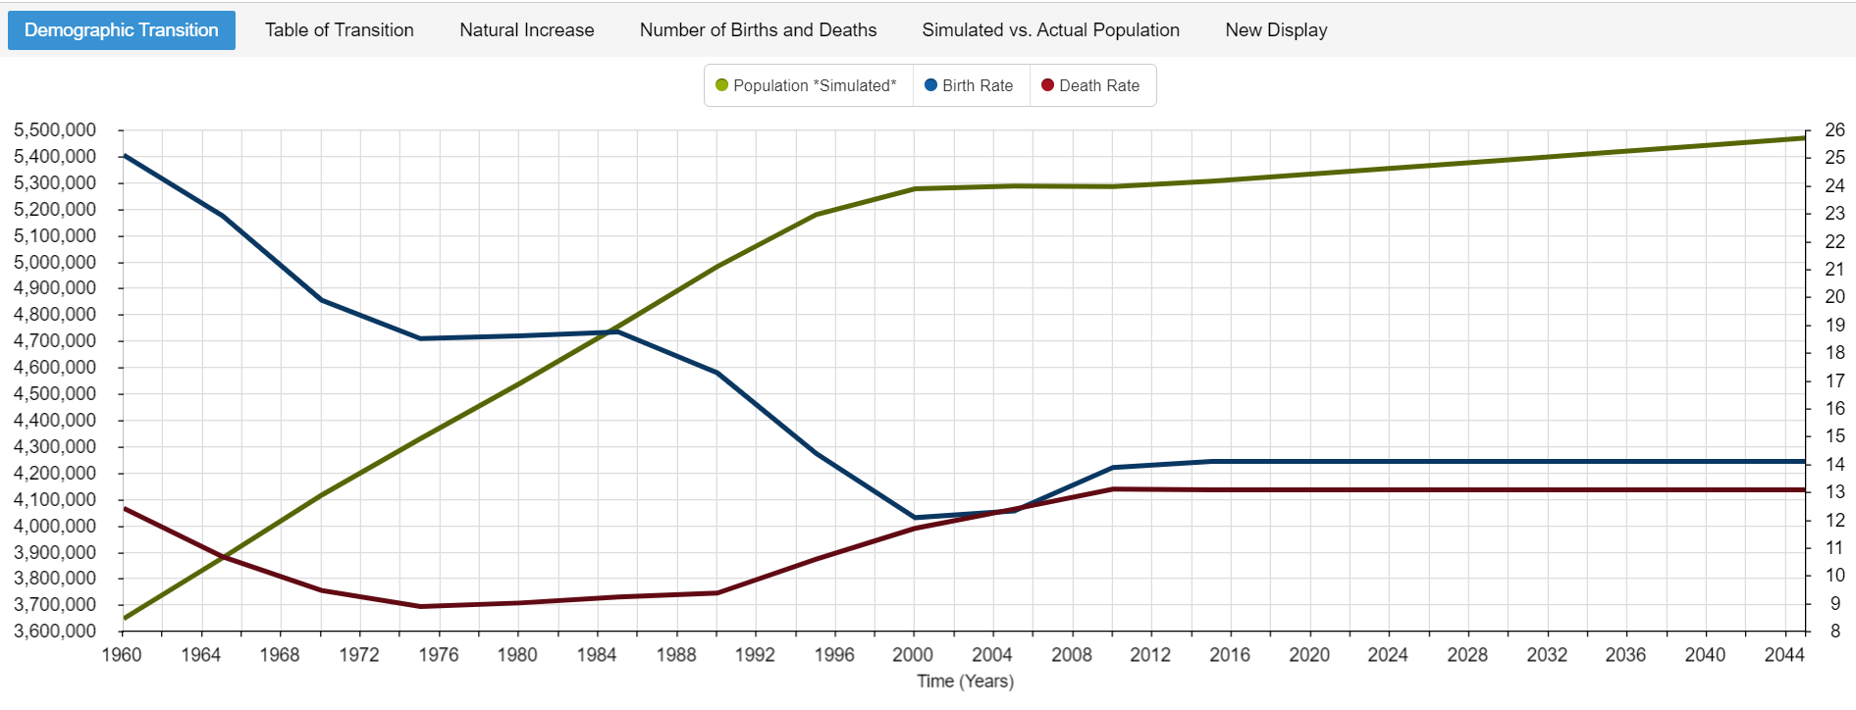

**Figure 1**: Simulated Georgian population growth through 2045 (flat model with no predictions for the year 2045

Natural increase (Figure 2) is another consideration when determining a baseline for future projections. If the birth and death rates from 2015 held constant until 2045, the natural increase would increase minimally over that time period. The rate of Georgia’s projected natural increase using 2015 birth and death rates was calculated as follows:

$Rate of Natural Increase= 14.078-13.062 ÷10 =1.016 ÷10= 0.1016 \%$

As one may ascertain, a natural increase of only 0.10% will not greatly increase the population over time, depicted in Figure 2 by almost imperceptible population growth. The graph demonstrates that the natural increase changes from a rate of approximately 5.39 in 2015 to 5.56 in 2045. The baseline model maintains that the simulated population will remain near 5.303 million.

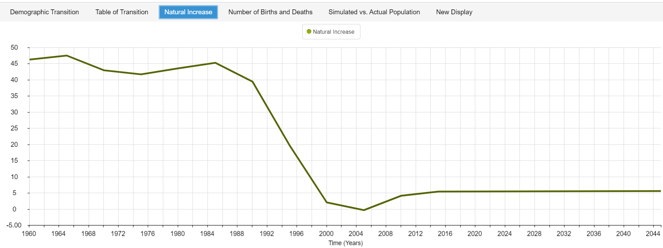

**Figure 2**: Natural increase of Georgian population if 2015 birth and death rates held constant over the next 30 years

**Past Trends Model**

The most likely scenario is that the birth and deaths rates will not remain constant over the next thirty years, so the model and natural increase in Figures 1 and 2, respectively, are likely fairly inaccurate. Extrapolating past trends into the future is one way that demographers mitigate this inaccuracy (Lesson 6, n.d.; Weinstein and Pillai, 2016). Historically, the country of Georgia saw its lowest birth rate in 2005 (12.3 per 1000), an increase in 2013 (14.186), and a recent decline (13.718) as of 2017. The Central Intelligence Agency (2019) World Factbook provided an even lower estimate for 2018 around 12.1. The lowest death rate of 8.871 per 1000 was reported in 1975, increased steadily to 2012, and then began to decline again. The World Bank data reported a 2017 crude death rate of 12.918, with the World Factbook estimate for 2018 even lower around 11. If we consider the current slow data trends downward for both rates, and we assume that no other external factors --migrations, disasters, political or economic issues, etc.-- will affect population size, we may suggest appropriate birth and death rates for the year 2045, input these guesses into the model, and the projection in Figure 3 is produced. Figure 2 uses a projected 2045 birth rate of 13 per 1000 and death rate of 10 per 1000.

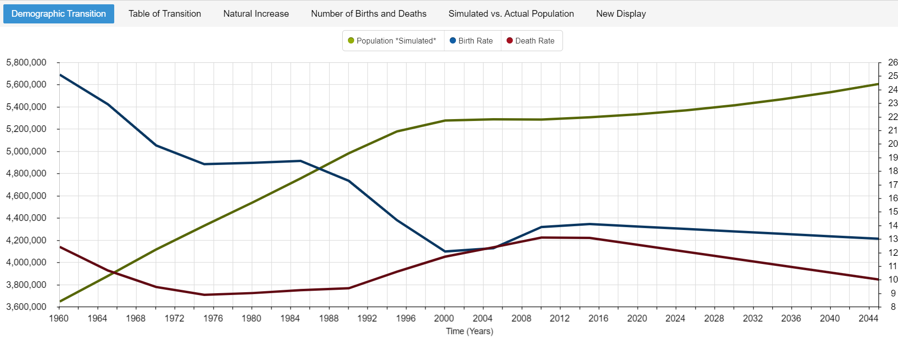

**Figure 3:** Simulated Georgian population growth through 2045 using projected birth rate of 13 and death rate of 10 per 1000, based on current downward trends.

The natural increase for the model based on past trends is shown in Figure 4. The graph is different from that in Figure 2 as the natural increase is more prominent. The rate of natural increase reported by Figure 4 changed from the same 5.39 in 2015 to 16.81 in 2045, a much larger result than was obtained initially. Just by examining previous year’s data and using it to project, the new model substantially changed from baseline. If this particular model were to hold true, assuming a closed population and no unexpected catastrophes, the simulated population of Georgia would increase by approximately 0.6 million over the next 30 years from more than 5.3 million to over 5.6 million people.

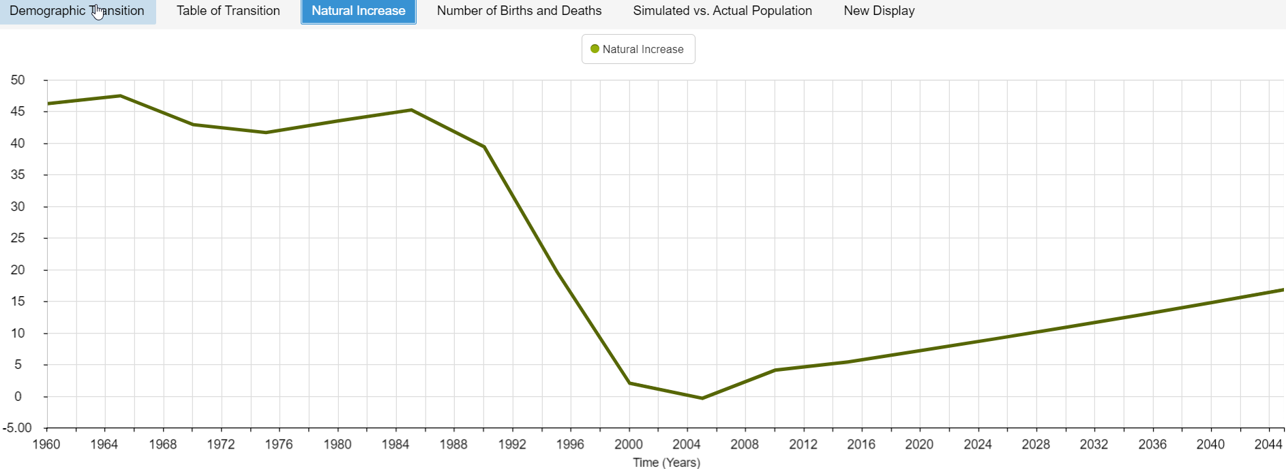

**Figure 4**: Natural increase using projected birth rates based on recent trends

**Simple Exponential Growth Model**

While the past trends, components-based model used a more subjective and intuitive approach to population projection, a simple growth model using an exponential growth equation allowed for a more objective, mathematical approach. For this, the following equation was utilized:

Pt = P0ert

where Pt is the total population at some time, t, in the future, P0 is the starting, current population, e is the mathematical constant that is the base of the natural logarithm and equal to approximately 2.71828, r is the current population growth rate, and t is the number of years over which that growth occurs. According to the World Factbook, Georgia has a current population of approximately 4,003,000 people (July 2018 estimate). The current population growth rate, which includes births, deaths, and migrations is estimated around 0.01%. Using these numbers in the exponential growth equation, we find the following:

P2045 = P2015 e .0001(30)

P2045 = 4,003,000 * 2.718.0001(30)

P2045 = 4,003,000 * 1.00300419

P2045 = 4015025.77

The equation determined that Georgia’s population around 2045 would be around 4,015,026 people, an increase of approximately 12,026 people, if the population grew exponentially. Figure 5 displays the difference between the simulated population (green) of Georgia, holding 2015 birth and death rates constant, and the actual population. Only the difference between the birth and death rates increases the simulated population over time. The increase in the actual population (blue) has been calculated mathematically and is not directly comparable to the simulated population, as the latter does not account for migration but the actual starting population, P0, does include migration in its total. However, comparing the simulated and actual population growth allows one to understand the expected overall rate of growth in either scenario with all other possible deviations not considered. Both the simulated and actual population growths show population increase as opposed to decline, despite having very different starting numbers in the year 2015.

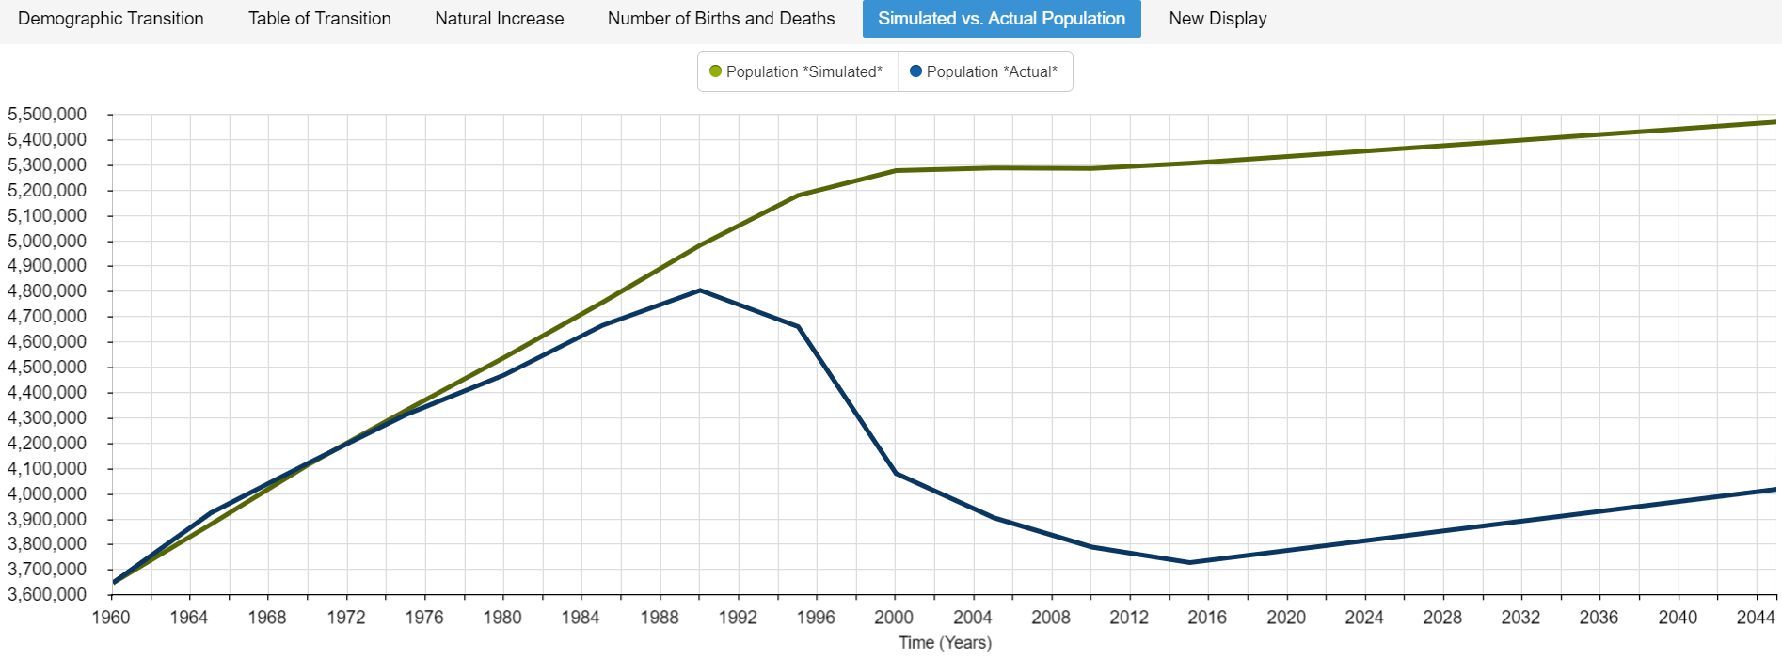**Figure 5:** Graph depicting the simulated (baseline) versus the *actual* population of Georgia by 2045 (5,467,624 vs. 4,015,026, respectively) using the simple exponential growth equation.

**Interpretation**

A variety of population projection methods can be used by demographers in an attempt to examine several potential population scenarios that may arise in the future. None of the methods produce answers with certainty, they only provide educated guesses as to what may happen should certain assumptions hold (Weinstein and Pillai, 2016). The two methods in the current report approached population projection quite differently; the first model used subjective prior knowledge and rate trends to extrapolate into the future, while the second model attempted to determine a more accurate population projection mathematically. While both models have their merit, it is possible that a combination of the two models, and further research into current political, economic, and other social states in one’s nation of interest, will serve to make better population projection predictions for those who are interested.

For the country of Georgia, migration and non-demographic factors such as civil war, political problems, and economic instability have played a role in their population growth (History of Georgia, n.d.). Models that do not incorporate this type of information produce a projected population growth that is far higher than what reality would suggest. Using the past trends model to extrapolate into the future suggested that Georgia will experience significant population growth (over a half a million people) in the next 30 years. The model also starts with a high initial population without migration considered, rendering the model less accurate. Moreover, this model is subject to the subjectivity and potential bias of the researcher developing it. Due to the subjective nature, the approach will offer differing results between researchers. The model may benefit from additional research aside from only looking at past numerical trends. Incorporating knowledge of a nation’s current events may improve a researcher’s inferences.

In contrast, the simple exponential growth model begins with the current population estimate of over 4 million, which – according to the World Factbook -- accounts for migration that Georgia is experiencing. It then uses a mathematical approach to predict future population using the current growth rate. This approach suffers in its lack of flexibility to alter the growth rate over the time period, requiring either an average to be used for more accuracy or multiple predictions from multiple equations. Another downside is that future birth, death, or natural increase rates are not immediately known or estimated using this method; additional calculations are required for that. Lastly, population growth is not always exponential, so by its very nature, a model based on exponential growth may be inherently inaccurate.

For Georgia, it may be that using the exponential growth approach is the better method for projection population. Georgia remains a developing but improving country that still faces political disputes and instability that may keep its population lower than expected. For that reason alone, the extrapolation method using past trends may be too optimistic for this particular country; it may offer growth rates that are too high. That is not to say that the extrapolation method is less valid; for another country with fewer external factors to consider, it may be the better choice.

**References**

Central Intelligence Agency. (2019). Georgia. in The World Factbook. Retrieved fromhttps://www.cia.gov/library/publications/the-world-factbook/geos/gg.html

History of Georgia (country). (n.d.). in *Wikipedia.* Retrieved from https://en.wikipedia.org/wiki/History_of_Georgia_(country)#Modern_history

Lesson 6. (n.d.). Measure Evaluation. Retrieved from https://www.measureevaluation.org/resources/training/online-courses-and-resources/non- certificate-courses-and-mini-tutorials/population-analysis-for-planners/lesson-6

The World Bank, World Development Indicators (2019a). *Birth rate, crude (per 1,000 people) – Georgia* [Data file]. Retrieved from https://data.worldbank.org/indicator/SP.DYN.CBRT.IN?locations=GE

The World Bank, World Development Indicators (2019b). *Death rate, crude (per 1,000 people) – Georgia* [Data file]. Retrieved from <https://data.worldbank.org/indicator/SP.DYN.CDRT.IN?locations=GE>

The World Bank, World Development Indicators (2019c). *Population, total – Georgia* [Data file].Retrieved from <https://data.worldbank.org/indicator/SP.POP.TOTL?locations=GE>

Weinstein, J. and Pillai, V.K. (2016). *Demography: The science of population* (2nd ed.). Lanham, MD: Rowman & Littlefield.