Lindsay Sheppard

Sociology 565: Demography

Demography Report #7: Examining the Sustainability Triad

**Introduction**

A report titled “Our Common Future”, also known as the Brundtland Report (World Commission on Environment and Development (WCED), 1987), defined ‘sustainable development’ as that which ‘meets the needs of the present without compromising the ability of future generations to meet their own needs’. The report noted that the optimization of sustainable development lies in the harmonious interplay of economic, social (e.g. inequality), and environmental factors, known as the sustainability triad (Hecht, 1999).

The sustainability triad is affected greatly by population growth. Population growth exerts pressure on natural resources and contributes to climate change. Population growth, aging, and decline, migration, and urbanization affect development objectives: consumption and production, employment, income and retirement (Albrectsen, 2013). It also complicates access to health, education, housing, sanitation, clean and sufficient water and food, and energy.

To examine the correlation between population growth and the sustainability triad, IBM SPSS Statistics version 24 imported the World Development Indicators dataset, titled wdi.sav. The variable @2000.903 (*Population, total)* was chosen as the independent variable and is a representation of the total population reported in the year 2000 in all 214 countries listed in the dataset. The dependent variables are those that make up the sustainability triad. The variable @2000.399, *GDP (current US$),* which is the gross domestic product (GDP) of each nation reported in the year 2000, represented economy. Gross domestic product was selected as it “provides a more accurate picture of a nation’s total economic activity and is a better indicator of an economy’s overall health” (Krugman, 2019). The variable @2000.876, *PM10, country level (micrograms per cubic meter)* represented the environmental status of a nation. PM10 refers to particle pollution, or particulate matter concentrations, which are fine, suspended, inhalable particulates less than 10 microns in diameter capable of causing significant health problems.

Finally, the variable @2000.422, *GINI index*, was used to represent inequality. According to the World Bank (2009), the GINI index measures “the extent to which the distribution of income (or, in some cases, consumption expenditure) among individuals or household within an economy deviates from a perfectly equal distribution”, with a GINI index of 0 representing perfect equality, and 100 representing perfect inequality.

**Description**

SPSS generated a table (Figure 1) that provided descriptive statistics for the four variables aforementioned, using the steps Analyze -> Descriptive Statistics -> Frequencies and selecting every available option in the “Statistics” menu except for those in the “Percentile Values” subheading. Histograms were also generated using the same steps; a normal curve was inserted for reference.

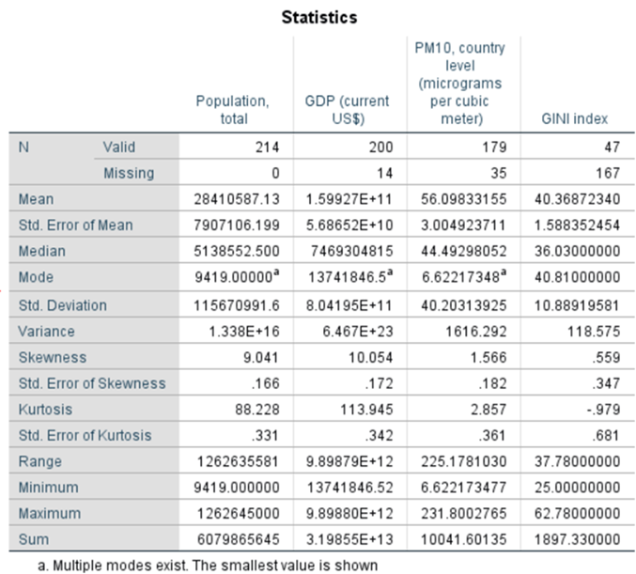

**Figure 1**: Descriptive stats for variables pertaining to population, economy, environment, and inequality

**Population**

The *Population, total* variable did not contain missing values. The average country population was reported at approximately 28.4 million; the extremely large standard deviation (greater than 115.6 million) suggested that there is a very wide range of population sizes amongst the countries in the dataset. Tuvalu reported the smallest total population of 9,419 people; China reported the largest at over 1.26 billion. The reported skewness value of 9.041 suggested the variable was substantially positively skewed; the histogram (Figure 2) concurred. A logarithmic transformation improved normality and the variable was renamed *logpopulation*. The results of the transformation are shown in Figures 3 and 4.

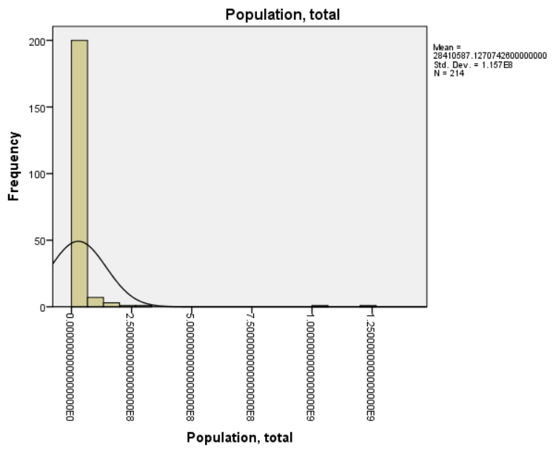

**Figure 2:** Histogram of *Population, total*

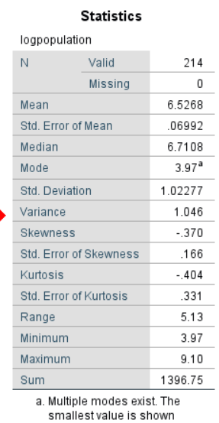

**Figure 3:** Descriptive statistics of *logpopulation*

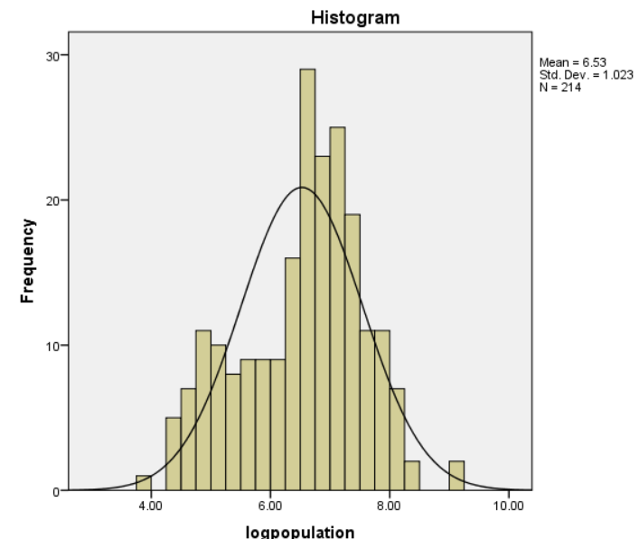

**Figure 4:** Histogram of *logpopulation*

**Economy**

Aside from population, the remaining variables contained missing values that were ignored by SPSS. The GDP variable only contained 14 missing values. The mean reported GDP was approximately 159.9 billion, with a substantial standard deviation of approximate 804.2 billion. The latter indicated there are extremely wealthy countries, respectively poor countries, and values in-between. Tuvalu again reported the minimum value, with a GDP of approximately 13.7 million; the United States of America reported the largest GDP (approximately 10 trillion). Like the population variable, the GDP variable was also positively skewed (10.054). Figure 5 displays the histogram of the untransformed GDP variable. A logarithmic transformation was performed on GDP as well, creating the variable *log* improving the normality (Figures 6 and 7).

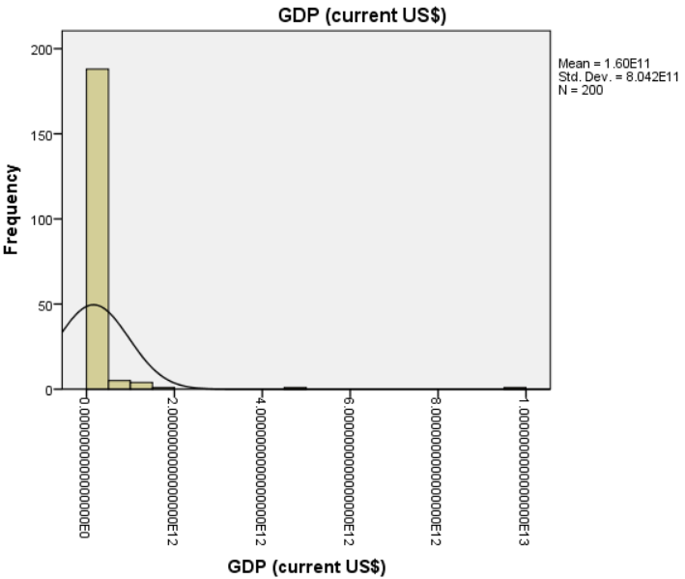

**Figure 5:** Histogram of *GDP*

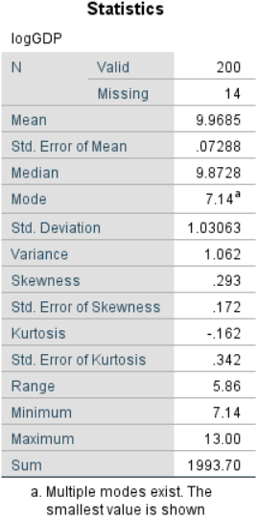

**Figure 6:** Descriptive statistics of *logGDP*

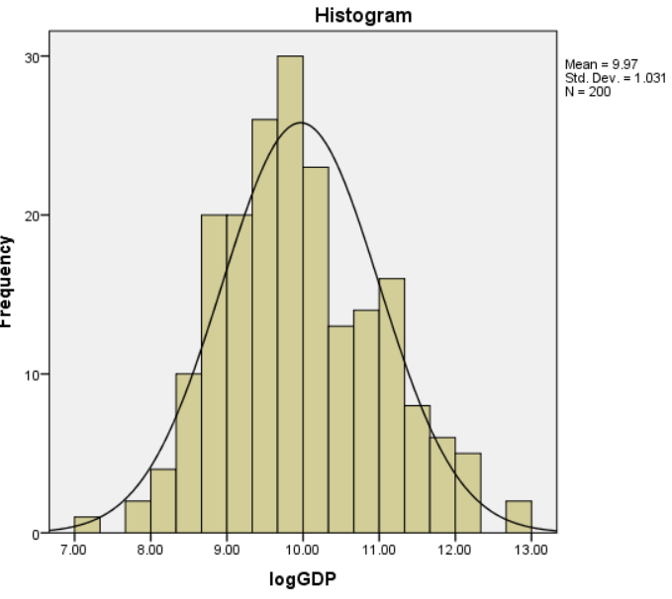

**Figure 7:** Histogram of *logGDP*

**Environment**

The variable PM10, which provided information on a country’s pollution levels, contained 35 missing values. The mean was approximately 56.10 micrograms per cubic meter annually. The WHO Air Quality Guideline values suggest an annual mean of approximately 20 micrograms per cubic meter (Air pollution, 2018). Therefore, the average reported for the countries in the dataset was fairly high. The standard deviation of 40.2 micrograms per cubic meter suggests the data values are spread out more from the mean. Pollution levels reported a range of 225.18, with a minimum of 6.62 micrograms per cubic meter (Gabon) and maximum of 231.8 micrograms per cubic meter (Sudan). The histogram (Figure 8) and reported skewness value (1.566) suggested a moderate to substantial positive skewness. The PM10 variable was transformed to a new variable, logPM10, using a logarithmic transformation (Figures 9 and 10).

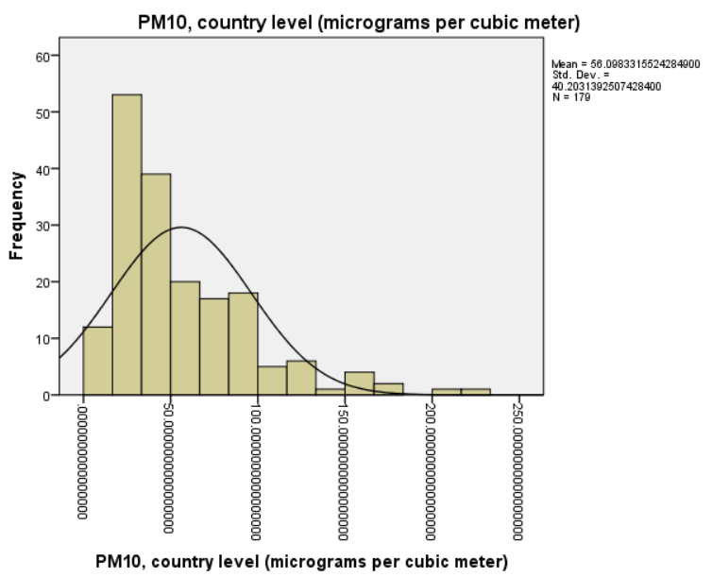

**Figure 8**: Histogram of PM10

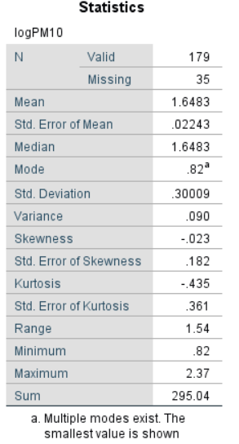

**Figure 9**: Descriptive statistics of logPM10

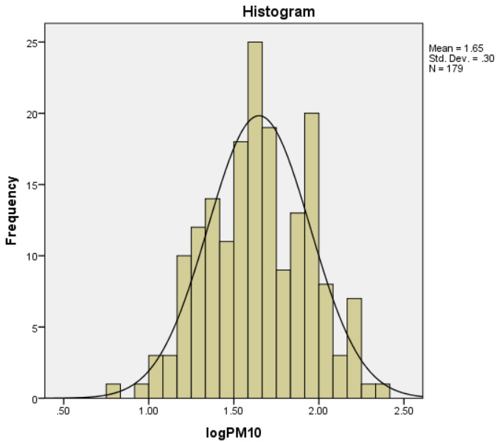

**Figure 10**: Histogram of logPM10

**Inequality**

The inequality variable used the GINI coefficient, or GINI index, which is a commonly used measure of a country’s economic inequality (Chappelow, 2019). However, the variable was missing quite a few values (167), leaving only 47 countries with a reported GINI index value. That being said, it is the only variable in the dataset that provides a fairly strong estimate of inequality and with so many values missing, imputation is likely not the best approach. Therefore, the variable was used with the knowledge that results may be biased due to a lack of data.

A mean of approximately 40.37 was reported, with a standard deviation of 10.89. The GINI index ranges from 0% to 100%, with 0 representing perfect equality and 1 representing perfect inequality. Therefore, the 47 countries that reported a value tended to be more equal than less, with most values ranging between approximately 30-50%. The range of values reported was 37.78, with a minimum of 25 reported in Sweden, the most “equal” country with GINI index values in the dataset, and a maximum of 62.78 in Bolivia, the most “unequal” country in the dataset. The variable was moderately positively skewed, as shown in the histogram in Figure 11 and by the reported skewness value of 0.559. The variable benefitted by a logarithmic transformation (Figures 12-13) and was renamed *logGINI*.

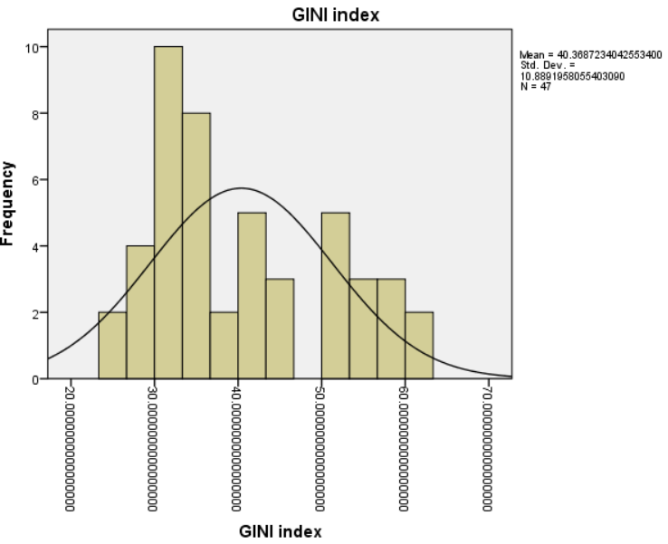

**Figure 11:** Histogram of GINI Index

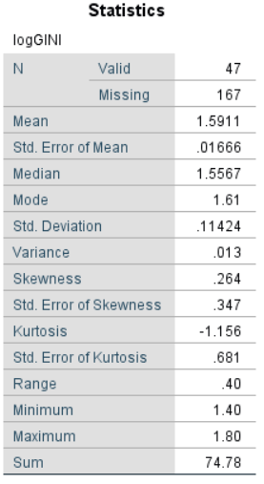

**Figure 12:** Descriptive statistics of logGINI

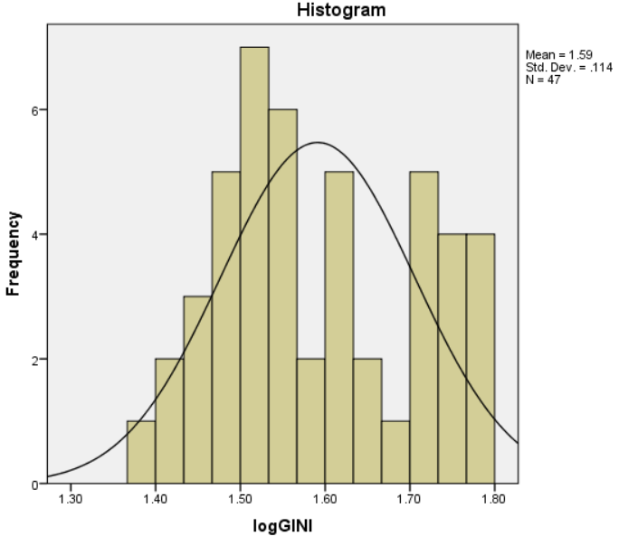

**Figure 13:** Histogram of logGINI

**Correlation**

Once transformations rendered the variables more “normal,” Pearson’s correlation was performed to examine the relationship between the variables. In SPSS, the correlation is performed using the steps Analyze -> Correlate -> Bivariate and selecting “Pearson” as the desired correlation coefficient. The results are displayed in Figure 14.

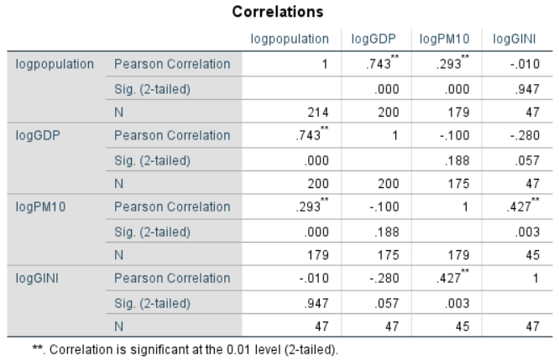

**Figure 14:** Pearson’s correlation results

The strength of the correlations are denoted by the “Pearson Correlation” row. Weak ranges from 0-.3, moderate from .31-.70, and strong is over .70. Population and GDP reported a strong, positive correlation (r = 0.743, n = 200, p < .001). Population also reported a weak to moderate, positive correlation with pollution (r =0.293, n= 179, p<.001). There was no significant correlation between population and the GINI index. There was also no significant correlation between GDP and PM10 or GDP and inequality, though that result may be changed with more GINI index data values. Pollution did report a moderate, positive correlation with inequality (r = 0.427, n = 45, p =.003).

**Interpretation**

The correlation results provide insight into the impacts of population on the economy, the environment, and inequality. They suggest that population growth leads to economic growth; the greater a country’s population, the higher GDP it may have. This does not suggest that overpopulation in a country leads to a higher GDP, because overpopulation in a country that has outstripped its carrying capacity may struggle economically. Yet, countries that have the ability to successfully grow their population and remain resourceful can grow their economy as well.

Increased population due to migrants may lead to migrants who work in and contribute to the economy. With more workers, more goods may be produced, and with increased population, there is more demand for such goods and services. However, periods of baby booms or populations where young people are the majority may not face the same GDP growth. Still, older persons in the population may be able to contribute to the economy if proper financial, social, and/or retirement services are in place. Furthermore, as populations continue to grow, limited resources can put pressure on economic development. However, if the age structure changes from population growth, then demographic dividends will occur due to an increase in the working-age population, and the economy will grow.

Population growth and air pollution were also correlated in the bivariate correlation result. Generally, population growth occurs alongside economic development, including urbanization, increased energy consumption, transportation, etc. The latter three contribute to increased levels of pollution. How economic development and air pollution relate is often studied using the Kuznets curve (Chen and Kan, 2008). Population growth leads to increased use of goods and services that increase pollution, until at least better environmental awareness and “relevant control measures taken in protecting the environment” occur (Chen and Kan, 2008). Population growth also causes deforestation and land clearing for modernization/urbanization; deforestation is a major contributor of climate change. Pollution can have an effect on population growth, causing morbidity and mortality that might not otherwise occur in its absence. Increasing education about air and water pollution and why efforts to reduce it are important may be necessary so that premature deaths may be reduced, and the Earth continue to be a safe, clean place to live.

Like economy and pollution, the last piece of the sustainability triad—inequality -- has a bidirectional relationship with population growth. From the correlation results, only pollution reported a significant correlation with inequality. The most unequal affluent countries contribute more to climate change than more equal affluent countries (Dorling, 2017). People in ‘more equal’ countries tend to consume less, waste less, and emit less carbon, on average. On a related note, climate change will “perpetuate inequality,” especially in areas plagued by rising sea levels and intense weather conditions, as well as rising temperatures that threaten agricultural patterns and productivity and increase energy costs and demands (Nikolau, 2017).

In terms of population growth, however, the correlation results may have been somewhat unreliable; GINI indices were missing for a large number of countries in the dataset and there may be a bias toward certain levels of inequality. Overall, demographic changes, such as lower mortality and lower fertility rates, may lead to demographic growth in developing countries and population aging in more developed countries; economic and social inequality results when rich people become richer on average, or when wealthier countries began to contain more of the world’s population. Kuznets, the economist whose curve was mentioned earlier, suggested that inequality is low in pre-industrial societies, but gaps widen with industrialization because of increasing factory worker wages compared to workers in agricultural jobs, and increasing specialization causes the gaps to widen even more (Keeley, 2015). Population age structure and size changes can lead to problems with savings, investments, and general economic growth. Additionally, calculations of income per capita and the productivity of laborers is related to population age structure and size changes as well. Age structure is important due to the demographic dividend, mentioned previously, which influences economic equality.

Population growth and the sustainability triad are inextricably linked. The world population surpassed the 7 billion mark in the early 2010s and will continue to grow; we must recognize that population dynamics have great influence on sustainable development and therefore must be considered in any sustainability efforts. We may be able to alter the bleak destinies forecasted by models such as World3 (Meadows, Meadows, Randers, and Behrens, 1972), which predicted eventual societal collapse; policies that target fertility reduction, improve education and access to healthcare resources (especially reproductive health services), female empowerment, and the respect of human rights are essential for the change that must occur so that the growing global population can maintain their well-being and live the productive lives to which they are entitled.

**References**

Air pollution. (2018, May 2). *World Health Organization.* Retrieved from https://www.who.int/news- room/fact-sheets/detail/ambient-(outdoor)-air-quality-and-health

Albrectsen, A. (2013, June 19). Sustainable development and population dynamics: Placing people at the centre. *United Nations Population Fund.*

Chappelow, J. (2019, September 18). Gini index. *Investopedia.* Retrieved from https://www.investopedia.com/terms/g/gini-index.asp

Chen, B. and Kan, H. (2008, February 28). Air pollution and population health: a global challenge. *Environ Health Prev Med. 13* (2): 94-101. Retrieved from https://www.ncbi.nlm.nih.gov/pmc/articles/PMC2698272/

Dorling, D. (2017, July 4). Is inequality bad for the environment? Retrieved from https://www.theguardian.com/inequality/2017/jul/04/is-inequality-bad-for-the-environment

Hecht, A.D. (1999, June 1). The triad of sustainable development: Promoting sustainable development in developing countries. *The Journal of Environment & Development.* Retrieved from https://journals.sagepub.com/doi/10.1177/107049659900800202

Keeley, B. (2015). How does income inequality affect our lives? in *Income Inequality: The gap between rich and poor.* OECD Publishing, Paris. doi: https://doi.org/10.1787/9789264246010-6-en

Krugman, P. (2019, July 2). Economics 101: What is the difference between GDP and GNP? Retrieved from https://www.masterclass.com/articles/economics-101-what-is-the-difference-between- gdp-and-gnp#how-is-gnp-calculated

Meadows, D.H., Meadows, D.L., Randers, J. and Behrens III, W.W. (1972). *The limits to growth*. New York, NY: Universe Books. Retrieved from http://www.donellameadows.org/wp- content/userfiles/Limits-to-Growth-digital-scan-version.pdf

Nikolau, L. (2017, June 30). Study: Climate change will perpetuate U.S. inequality. Retrieved from http://www.humanosphere.org/environment/2017/06/study-climate-change-will-perpetuate-u- s-inequality/

World Bank. (2019, October 16). GINI Index (World Bank Estimate).Retrieved from https://datacatalog.worldbank.org/gini-index-world-bank-estimate- 1#targetText=Thus%20a%20Gini%20index%20of,of%20100%20implies%20perfect%20inequality .&targetText=Indicator%20source%3A,and%20World%20Bank%20country%20departments.

World Commission on Environment and Development (WCED). (1987). *Our Common Future.* Retrieved from https://www.are.admin.ch/are/en/home/sustainable-development/international- cooperation/2030agenda/un-_-milestones-in-sustainable-development/1987—Brundtland- report.html