Lindsay Sheppard

Sociology 565: Demography

Demography Report #8: Russia’s Ecological Footprint

**Introduction**

According to the Global Footprint Network (GFN) (2019a), sustainable development is development which must occur within the bounds of nature so as not to cause future generations harm. The ecological footprint is one way that sustainability is assessed. The ecological footprint measures “human impact on the Earth’s ecosystem,” (Ecological footprint, n.d.) tracked by examining the usage of crop lands, grazing pastures, forests, fishing areas, developed land, and carbon demand (Global Footprint Network, 2019b). The footprint is used for myriad reasons, including national and international sustainability and well-being efforts, public project optimization, and education.

While the ecological footprint tracks demand, biocapacity, or the “productivity” of the crops, grazing pastures, fishing areas, and developed land, measures supply. Both the ecological footprint and biocapacity are measured in the unit ‘global hectares’ that standardizes productivity globally. The measurement of ecological usage is straightforward; for ecological deficit to occur, the footprint must exceed the region’s biocapacity. Ecological reserve occurs when a locale’s biocapacity is in excess of its footprint.

To simulate the ecological impacts of population over time, the Russian Federation’s (Russia) population growth was compared to its current ecological footprint and biocapacity using Insightmaker.com. A clone of the insight titled “Population Ecological Impact – Bangladesh” (Fulkerson, 2018) was used to create a new insight titled “Population Ecological Impact – Russia” (Figure 1). GFN provided data on the ecological footprint and biocapacity (Figure 2); Russia reported a biocapacity of 7.0 global hectares (gha) and an ecological footprint of 5.2 gha, leaving it with an ecological reserve equal to 1.8 gha, approximately. These figures were input into the model in the variables “Biocapacity” and “Ecological Footprint,” respectively.

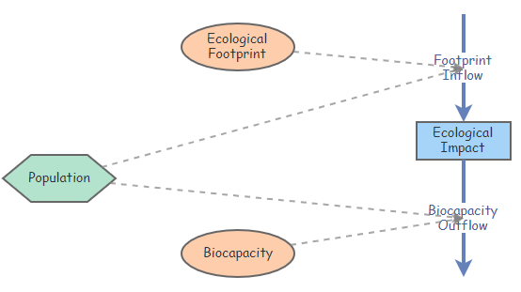

**Figure 1:** Cloned model produced using Insightmaker.com

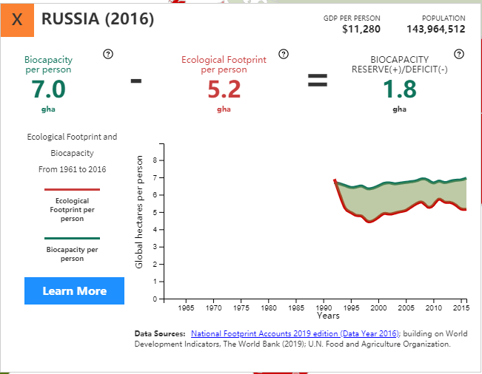

**Figure 2**: Russia’s ecological footprint and biocapacity as reported by GFN (2019b).

The World Bank (2019) provided data on Russia’s population from 1960-2015, which was entered into the ‘Population’ converter on the model (Figure 3). The flow ‘Footprint Inflow’ was calculated using a flow rate equal to each ecological footprint value multiplied by the respective population values; the flow ‘Biocapacity Outflow’ was similar, with biocapacity values multiplied by population values.

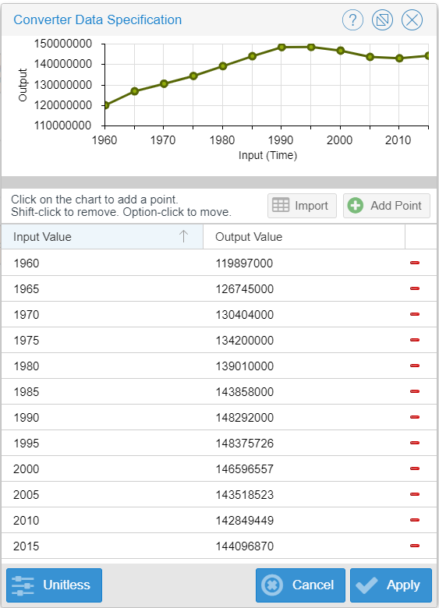

**Figure 3:** Population data supplied by World Bank (2019), entered into Insightmaker.com

**Description**

**Population**

Once the model contained values pertaining to the Russian Federation, a simulation produced three graphs: Population, Footprint and Biocapacity, and Ecological Impact. The population graph (Figure 4) displayed how the Russian population has changed from 1960 to 2015. The 1960 population of over 119.8 million experienced moderate growth until the late 1980s to early 1990s when the population leveled off around 148.3 million and then slowly declined until around the year 2010 (142.8 million), when it started to grow again. The 2015 population was reported to be approximately 144.1 million people. Despite what appears to be a recent upswing, Russia is one of the few countries with undisputable negative population growth (Shapiro and Yefimova-Trilling, 2019).

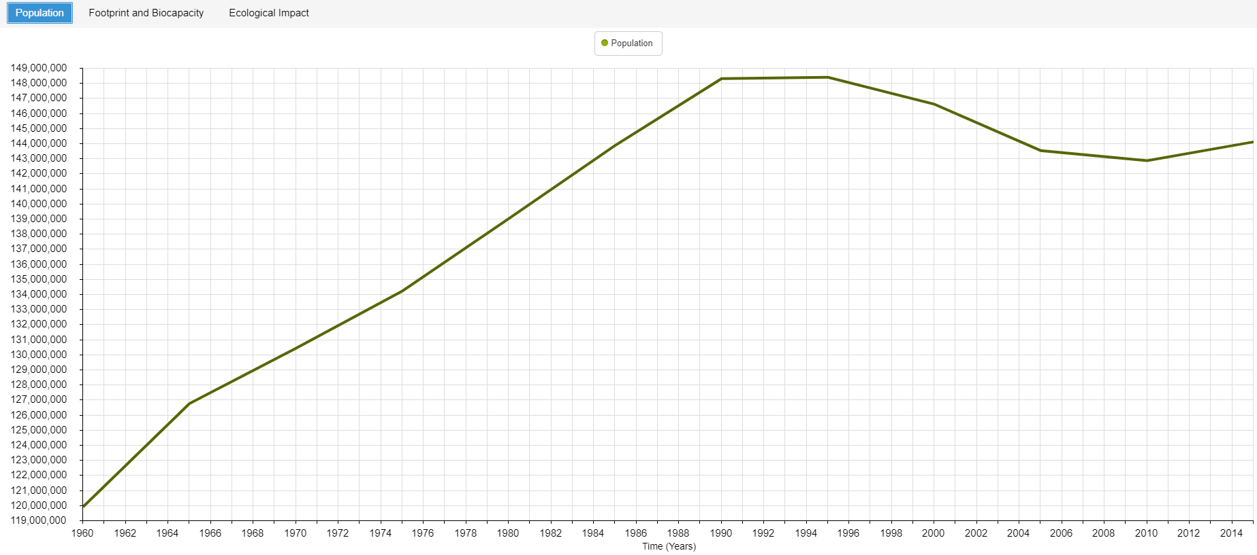

**Figure 4:** Russian Federation -- Population (1960-2015)

**Biocapacity and Footprint**

As the biocapacity and footprint out- and inflow equations, respectively, depended on population totals, both measures follow a curve very similar to that of population (Figure 5). However, the biocapacity outflow runs parallel to the footprint inflow, with the former consistently larger than the latter. In 1960, the biocapacity outflow was approximately 839.3 million, rising to 1.04 billion around 1990-1995. After a slow decline, recent biocapacity is estimated to increase, reporting an estimated 1.01 billion in the year 2015.

The ecological footprint in 1960 was approximately 623.5 million, increasingly over time to 771.1 million in the early 1990s, and decreasing down to over 742.8 million around 2010. The simulation reported that 2015 saw a footprint inflow of approximately 749.3 million.

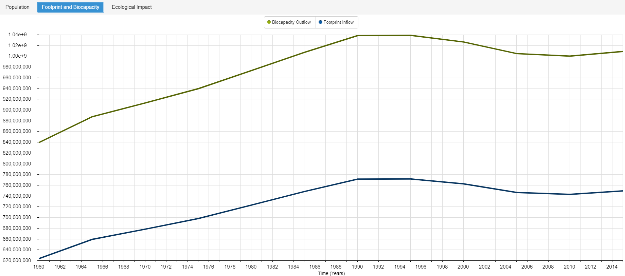

**Figure 5:** Russian Federation – Footprint and Biocapacity (1960-2015)

**Ecological Impact**

Lastly, the ecological impact graph suggested that the Russian Federation was experiencing a linear decline of ecological impact over time. Extrapolating from the graph, it seems the Russian Federation will continue to harbor more natural resources than the population will use in the foreseeable future, providing Russia with that sizeable ecological reserve of 1.8 gha reported by the GFN. The simulation results suggested Russia had an ecological impact of 0 in 1960, and as of 2015, reported the impact to be over -13.7 billion.

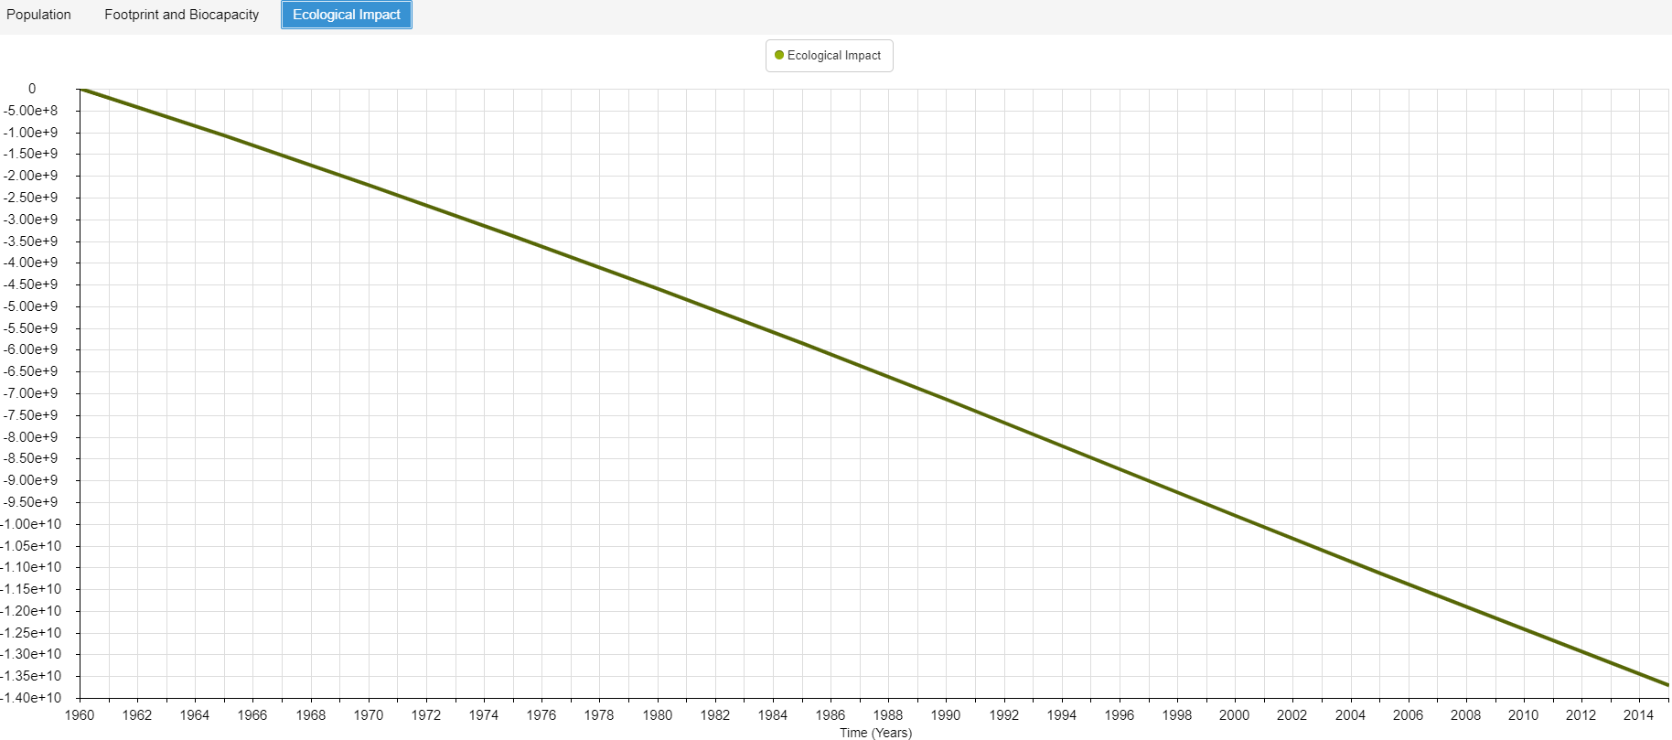

**Figure 6:** Russian Federation --Ecological impact (1960-2015)

**Interpretation**

The Russian Federation presents an interesting case. Though the population is relatively large, biocapacity reserves are also relatively large. The GFN stated that Russia ‘is among a minority of countries with more natural resources than its population consumes,” (GFN, 2016) which is evident with the Insightmaker.com simulation output. Russia’s abundance of biocapacity reserves likely stems from a few factors. One contributor is the declining population and related decline in demand for renewable resources. A second factor is the low population density Russia maintains, due to a large total land area with vast amounts of forests and uninhabitable land. In fact, the Russian Federation is ‘one of the World’s most biocapacity-rich nations, ranked number 4 globally after Brazil, China, and the United States’, and one of only a handful of countries projected to remain stable (Boev, Shvarts, Burenko, Lin, Neill, and Hanscom, 2018). Russia has been and continues to be a biocapacity donor nation, providing a wealth of resources – especially fossil fuel -- to the world for economic gain.

In contrast, Russia’s total ecological footprint has increased slightly over time by approximately 0.8%; this is forecasted to increase by 2.8% by 2020 due to increased forest product and carbon footprints. Forest biocapacity is predicted to decrease by 0.6% by 2020, while the demand for forest products will increase by over 6%. Other lands, such as crop lands and grazing pastures may be a risk due to the deforestation and commercial logging occurring in the area. Since forests make up such a large part of the Russian land mass and is the largest source of biocapacity for Russia (Boev et al., 2018), focusing on forest conservation and preservation is incredibly important.

Additionally, Russia’s per capita ecological footprint (5.57 gha) is almost three times greater than the “sustainable” level of 1.7 gha. The GFN suggested that if every inhabitant of Earth lived like the average Russian, humanity would require approximately 3.3 planets to meet the demand. Compared to some countries, this figure is mediocre; we would need five planets to meet the demand if we all lived like Americans (Smith, 2018).

Yet, it suggests no matter the bioavailability, humans will always pressure on the Earth, through increasing population and ever-increasing anthropogenic activities, to deliver its resources for consumption. If resources eventually run out, then we will suffer greatly. However, acting now to affect change in the future is a possibility; our most important responsibility is to “leave the planet as a self-sustainable system providing equal opportunities of survival not only to our future generations but also to all other species co-habiting with us” (Arora, 2018).

**References**

Arora, N.K. (2018, March). Environmental sustainability – necessary for survival. *Environmental Sustainability. 1*(1): 1-2. https://doi.org/10.1007/s42398-018-0013-3.

Boev, P., Shvarts, E., Burenko, D., Lin, D., Neill, E. and Hanscom, L. (2018). Russia’s biocapacity and ecological footprint: Nowcasting and forecasting from the National Footprint Accounts. Retrieved from https://wwf.ru/upload/iblock/756/wwf_footprint_2018_eng_net.pdf

Ecological footprint. (n.d.). in *Wikipedia.* Retrieved from https://en.wikipedia.org/wiki/Ecological_footprint

Fulkerson, G. (2018). Population ecological impact – Bangladesh. *Insight Maker.* Retrieved from https://insightmaker.com/insight/151666/Population-Ecological-Impact-Bangladesh

Global Footprint Network. (2016). New report: Russia sees decline in ecological reserve since 2009. Retrieved from https://www.footprintnetwork.org/2016/12/21/russia-footprint-report-decline- ecological-reserve/

Global Footprint Network. (2019a). Sustainable development. Retrieved from https://www.footprintnetwork.org/our-work/sustainable-development/

Global Footprint Network. (2019b). Ecological footprint. Retrieved from https://www.footprintnetwork.org/our-work/ecological-footprint/

Shapiro, D., and Yefimova-Trilling, N. (2019, September 13). Russian population decline in spotlight again. *Russia Matters.* Retrieved from https://www.russiamatters.org/blog/russian-population- decline-spotlight-again

Smith, K. (2018, August 1). We would need 5 planets if the rest of the world at as much meat as the U.S., new report says. Retrieved from https://www.livekindly.co/we-need-5-planets-meat- consumption-earth-overshoot-day/

The World Bank, World Development Indicators (2019c). *Population, total – Russian Federation* [Data

file].Retrieved from https://data.worldbank.org/indicator/SP.POP.TOTL?locations=RU