**Introduction**

The playwrightGuirgis (2006) once wrote, “No parent should have to bury a child”. Though the past few decades have shown enormous progress, the parents and caregivers of an estimated 6.2 million children and adolescents under the age of 15 unfortunately did just that in the year 2018, with approximately 5.3 million of those children under five years old; nearly half of those deaths occurred in sub-Saharan Africa (Under-five mortality, 2019; World Health Organization, 2019). Therefore, under-five mortality rates were the focus of the current research. The problem is not specific to Africa, however. Developing nations have much higher infant mortality rates than industrialized nations (Boehmer and Williamson, 1995). The World Health Organization (WHO) reported that most of these unfortunate deaths are *preventable* with access to clean water and food, proper nutrition, healthcare, and immunizations.

The complexities of acquiring necessary resources in developing countries are often a hindrance to societal progress; political, economic, and religious conflicts that either cause or contribute to corruption, war, poverty, hunger, and issues with healthcare, safety, and education play a significant role (Neethling, 2017). Although all aforementioned factors affect a nation’s development, educational improvement has been linked to other areas of improvement, such as literacy, poverty, inequality, fertility, and health (Roser and Ortiz-Ospina, 2019). As a result, focus on education is a Millennium Development Goal (UNICEF) and a Sustainable Development Goal (UN); the world is more educated than ever before (Roser and Ortiz-Ospina, 2019). Many governments now ensure access to basic education, considering it not only a human right but a duty. As education is often the link to the factors mentioned, all of which are deeply intertwined in child mortality rates and therefore, a nation’s entire development, the correlation between them has been extensively studied. Particularly, maternaleducation has consistently demonstrated a significant negative correlation with child mortality and has been deemed the “single biggest factor, by far” in reducing under-five mortality rates (Fischetti, 2011).

Why Maternal Education?

Much attention falls on maternal education, as opposed to paternal or parental. Abuqamar, Coomans, and Louckx (2011) stated, “maternal education has been accepted almost unanimously as a major socio-economic factor in infant mortality.” Boehmer and Williamson (1995) concurred, stating that women’s educational status and other dimensions, such as economic status and autonomy, are important predictors of infant mortality rates. While Abuqamar et al., and others have found that the education of both parents does seem to have an inverse relationship with the risk of infant and child mortality, numerous studies suggest that maternal education alone correlates most strongly to child mortality. For example, Akter, Hoque, Chowdhury, Rahman, Russell, and Arifeen (2015) examined a rural area of Bangladesh with a relatively high child mortality rate (41 deaths per 1,000 live births). After adjusting for confounding variables, the researchers found that a mother’s education has a very strong association with “under-five” mortality, or, those children under 5 years of age. Furthermore, this relationship strengthens over time. Paternal education, on the other hand, showed a weaker association that did not strengthen with time. Their results agreed with other studies, such as Cochrane et al. (1982), who found that the association of a father’s education and child mortality is approximately half that of a mother’s.

Both studies concur with Caldwell and McDonald (1982), who suggested that paternal education is important but not as important as maternal education in terms of child health and mortality. Paternal education has been studied less than maternal education, so the mechanisms of the role it plays is not yet well-understood (Cochrane et al, 1982). Speculation exists that paternal education plays a less important role because, though fathers indirectly contribute through their socioeconomic impact on the household, they are often less associated with childcare (Akter et al., 2015). Breierova and Duflo (2004) suggested that the link between parental education and child mortality is influenced by “unobserved background variables”, and these omitted variables introduce bias into research that is larger for females than for males. Caldwell and McDonald ultimately concluded that a causal relationship exists between maternal education and child mortality. Andriano and Monden (2019) explored this relationship through data from Malawi and Uganda, determining that maternal education reduces child mortality through six pathways of influence improved by education: socioeconomic status, attitude toward modern health services, personal illness control, environmental factors, health knowledge, and women’s empowerment and autonomy. Furthermore, the “step from primary to secondary schooling is more important than that from illiteracy to primary schooling” (Andriano and Monden, 2019; Akter et al., 2015; Caldwell and McDonald, 1982; Hobcraft, 1993; Lochner, 2011).

**Hypothesis**

The expected results of the study will demonstrate that maternal education does reduce under-five mortality rates due to multiple pathways of influence, regardless of regional differences. Increasing levels of maternal education will correspond to increased acquisition of health knowledge and acceptance of modern health services, increased preventative care and personal illness control, increased sanitation and hygiene practices in the home, and increased empowerment and autonomy.

**Methods**

Mothers aged 15-49 (N=286,695) provided responses (mean RR= 97.56%) to questions assessing Millennium Development Goals (MDGs) set by UNICEF through their Multiple Indicator Cluster Surveys (MICS). MICS monitors progress towards MDGs, which are closely tied to the United Nations’ (UN) Sustainable Development Goals (SDGs). For this reason, certain analyses were performed at the SDG regional level, as defined by UN. The study utilized data from the MICS of twenty-five countries in nine different SDG regions (Figure 1) from multiple years ranging from 2010 to 2019; the research utilized the most recent survey for each country when possible. Excel, SPSS, and Alteryx Designer cleaned and analyzed the data as necessary. No transformations were performed on any variable.

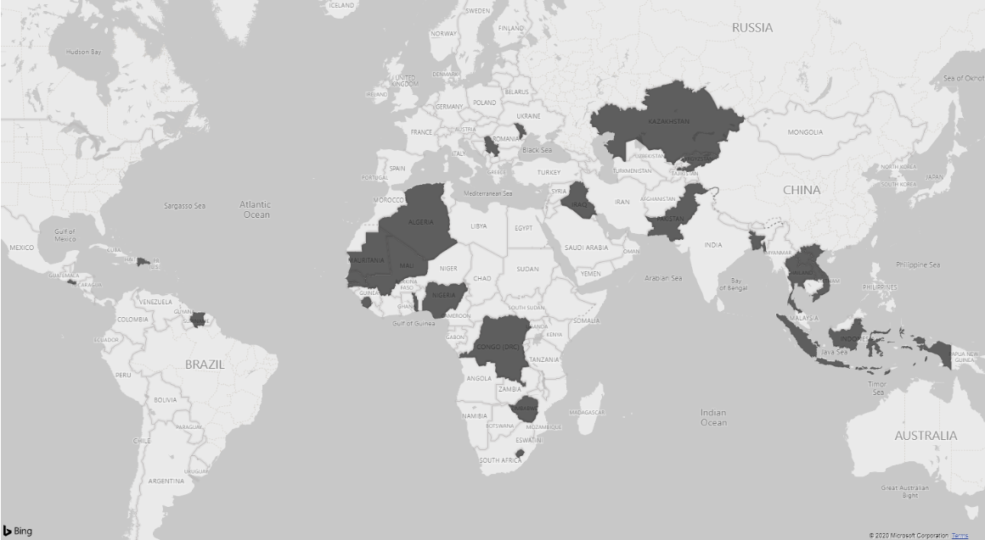

**Figure 1:** The twenty-five countries (dark grey) examined in the study

Table 1 lists individual countries and the year of survey completion. As the data was pooled from these surveys, the actual sampling procedures vary between surveys, which introduces uncertainty about the national representation of the final sample and the direction or size of any potential bias. South-Eastern Asia and Sub-Saharan Africa are represented strongly in the data, as they have the highest child mortality rates and are a primary focus of MDG monitoring.

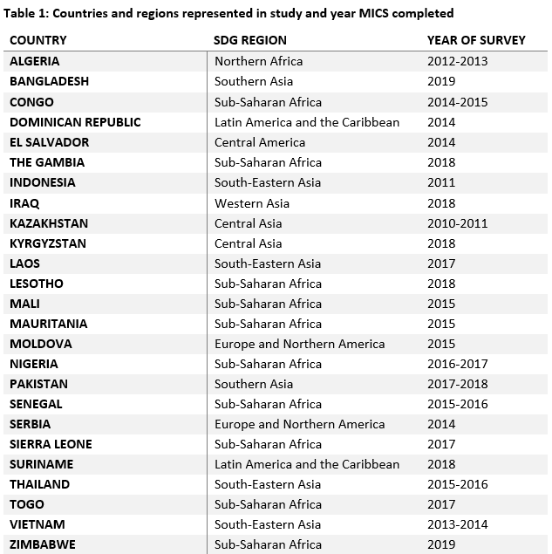

Maternal education’s pathways of influence were examined through responses to questions regarding full immunization (to examine acceptance of modern health services, preventative care, and personal illness control), access to handwashing facilities in the home that have soap and water (to examine sanitation and hygiene practice), attitudes toward domestic violence and level of decision-making (to assess empowerment and autonomy). Other variables were also examined, such as mother’s children’s educational benefits, if any, fertility rates, and literacy rates, as well as gender inequality in education, as these play into other pathways like socioeconomic status which was not directly addressed by the current study. The World Health Organization data examined global data to provide visualizations on the latter variables aforementioned. Linear regression and association analyses using Alteryx Designer analyzed relationships between pathways; these models have been utilized in previous research. Other pathway predictors not utilized in result visualizations, such as rate of reported diarrheal illness, child marriage, knowledge of HIV, use of modern health facilities postpartum, and use of contraception, were used in the linear regression model. A model approach similar to Gakidou et al (2010) provided guidance for the study.

**Results**

Linear regression (OLS) calculated the prediction of under-five mortality rates based on the specified maternal education predictor variables. A significant regression equation was found (F(11, 65) = 23.67, p < .001) with an R2 of .800. Predicted under-five mortality rate is equal to 59.322 + -.090 (literacy) + -.074 (reported diarrheal illness) + .390 (comprehensive knowledge of HIV) + -.405 (antenatal care) + -.505 (use of any contraception) + .013 (post-partum stay in health facility) + .228 (receipt of full immunizations) + .455 (domestic violence justification attitude) + -.243 (handwashing facility) + .415 (child marriage) +.011 (adolescent birth rate). However, only comprehensive knowledge of HIV, use of contraception, postpartum stay in health facility, domestic violence attitude, handwashing, and child marriage were significant (p < .05) predictors of the under-five mortality rate.

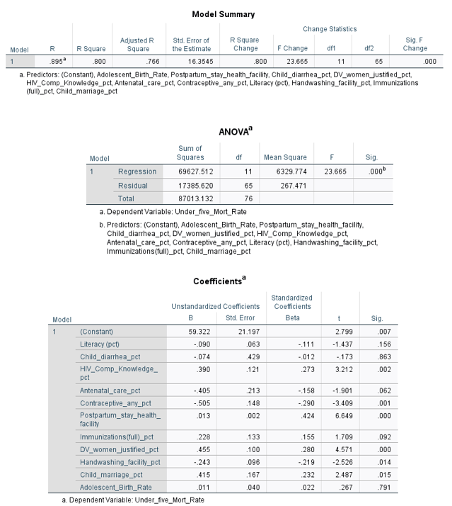

**Figure 2**: SPSS Regression Output

Results of the Pearson correlation determined a significant correlations existed for all pathway variables except comprehensive HIV knowledge and under-five mortality rate, as shown in Figure 3. The strongest predictor was having a handwashing facility at the home that has soap and water, demonstrating a strong negative correlation with under-five mortality rate (r = -.663, n = 94, p < .001). Alteryx provided a heatmap with slightly different correlations (Figure 4).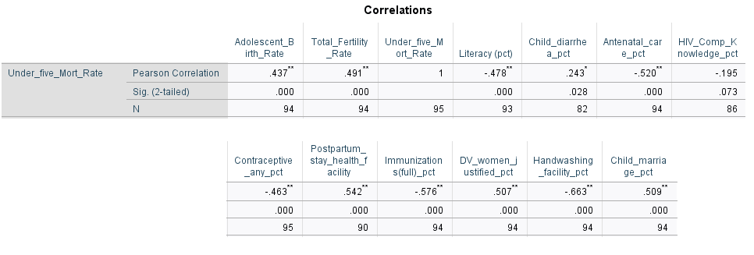

**Figure 3:** SPSS correlation results for U5MR and pathway variables

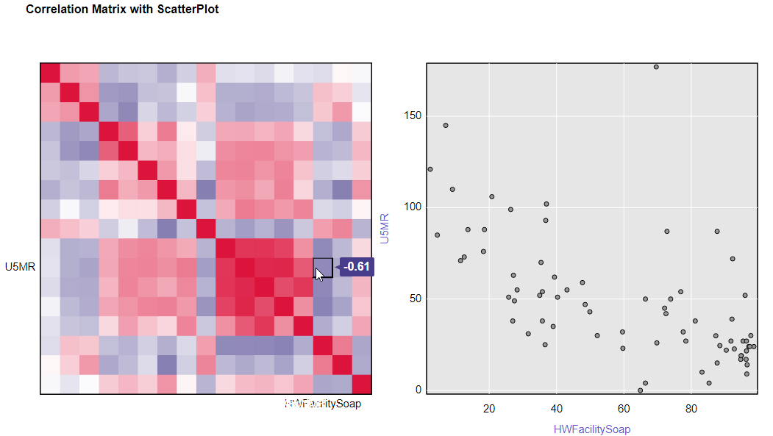

**Figure 4:** Sample Alteryx correlation matrix result – U5MR and handwashing facility access

**Visualizations of Findings**

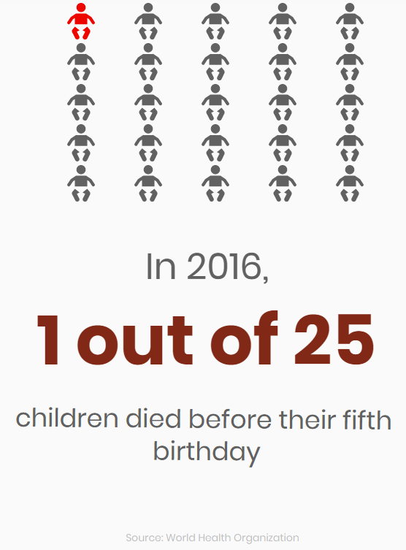

**Figure 5:** Icon chart that establishes why under-five mortality rate was the focus of the study

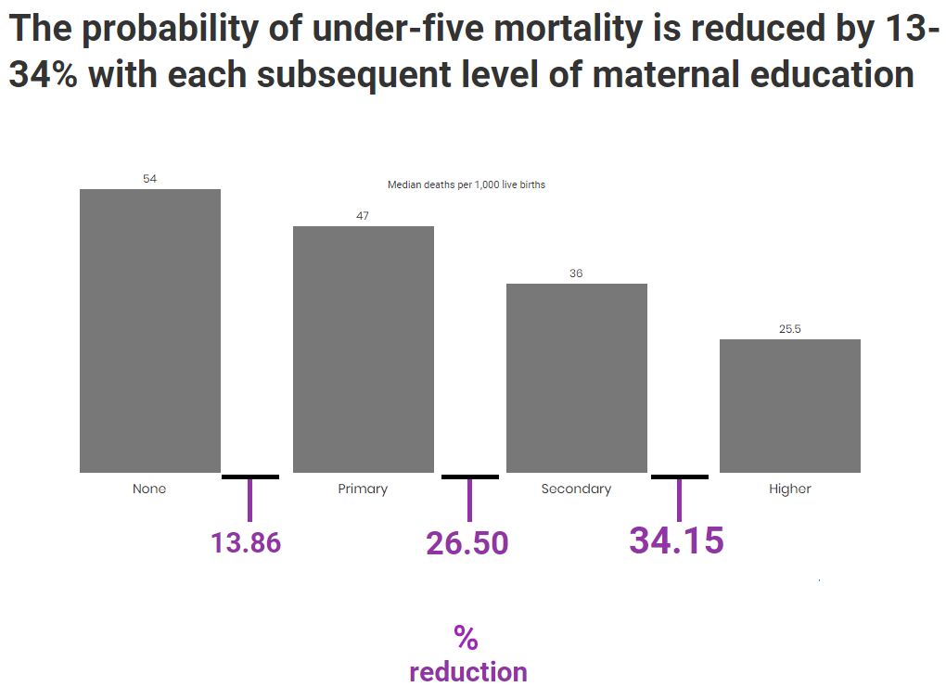

**Figure 6** Chart demonstrating the direct effect of maternal education on child mortality rates

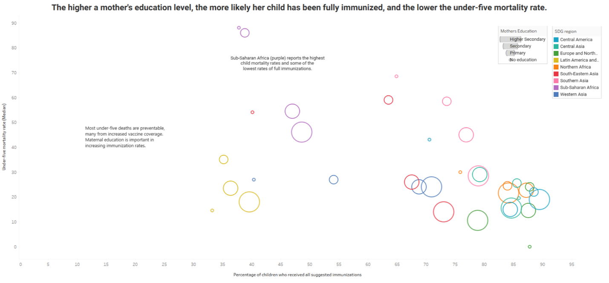**Figure 7** Chart showing the relationship between maternal education, child mortality, and the “acceptance of modern health, increased preventative care, and personal illness control” pathway of influence on child mortality rates**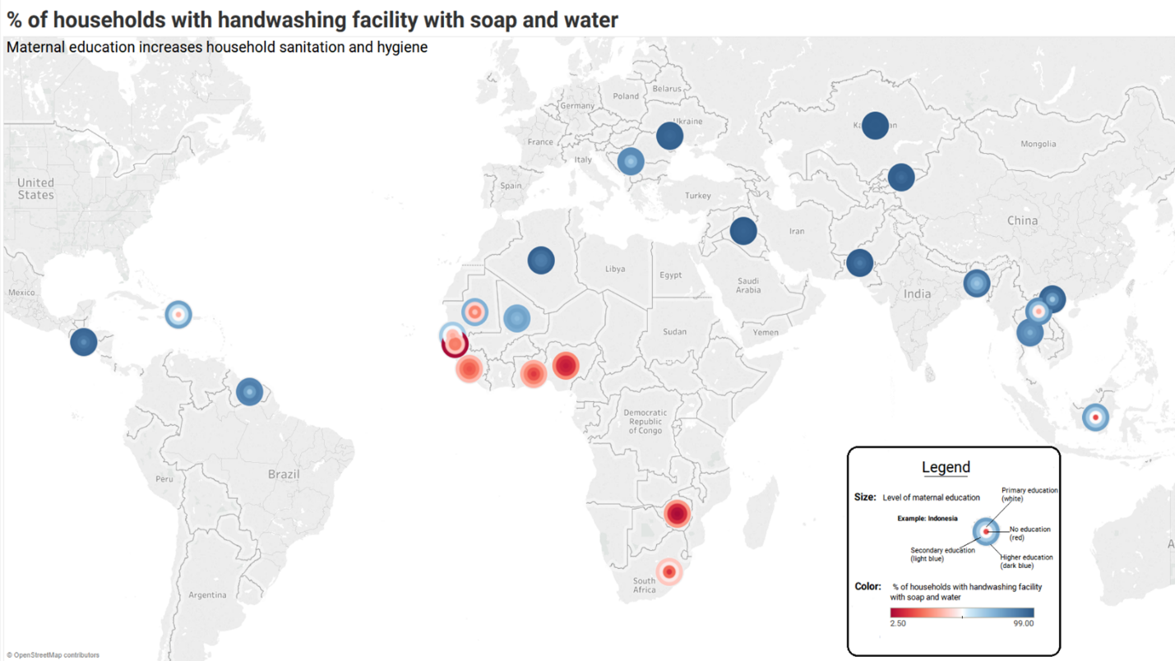Figure 8** Chart depicting the relationship between maternal education and the “sanitation and hygiene” pathway

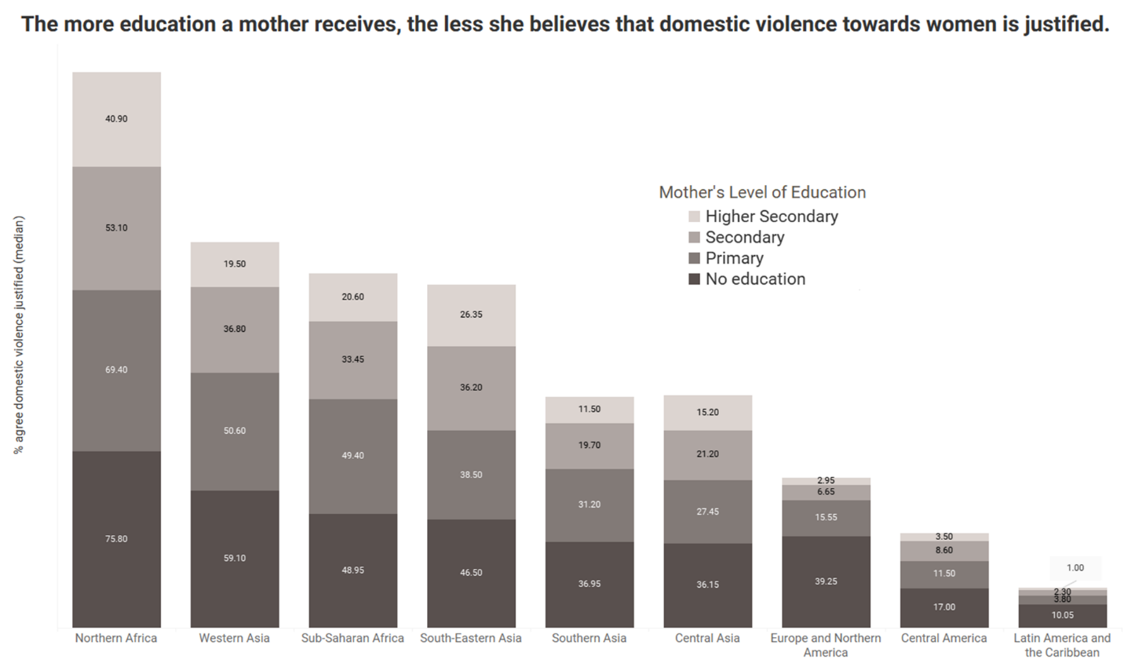 **Figure 9** Chart showing the relationship between maternal education and the “empowerment and autonomy” pathway

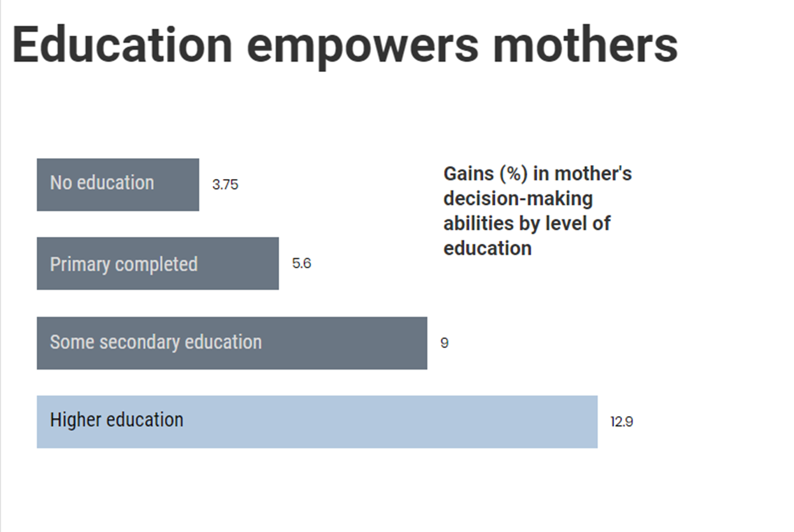

**Figure 10** Another chart to support the empowerment pathway

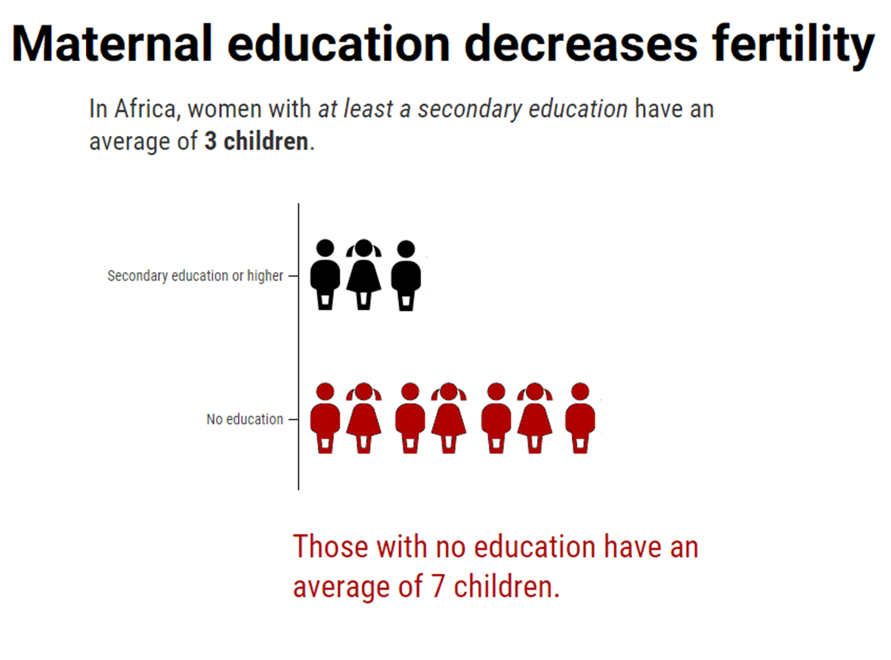**Figure 11** Chart that demonstrates a beneficial outcome of maternal education

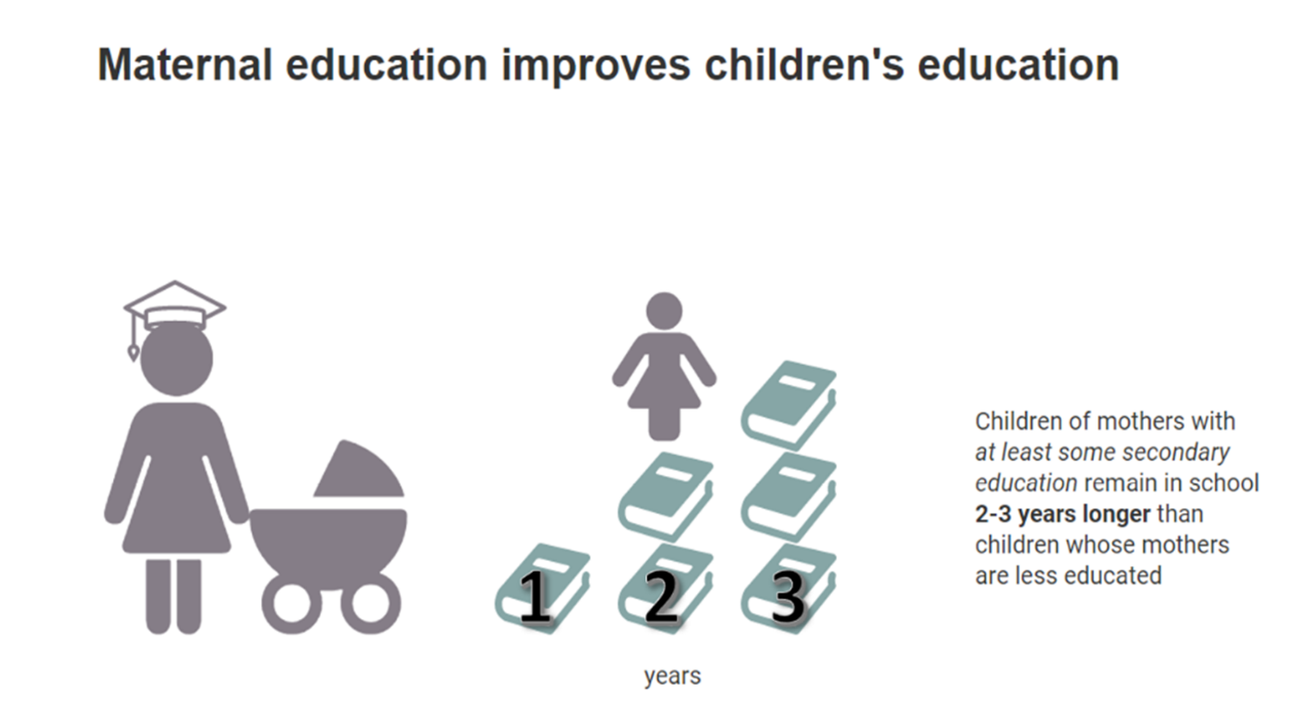

**Figure 12** Another chart reiterating beneficial outcomes of maternal education

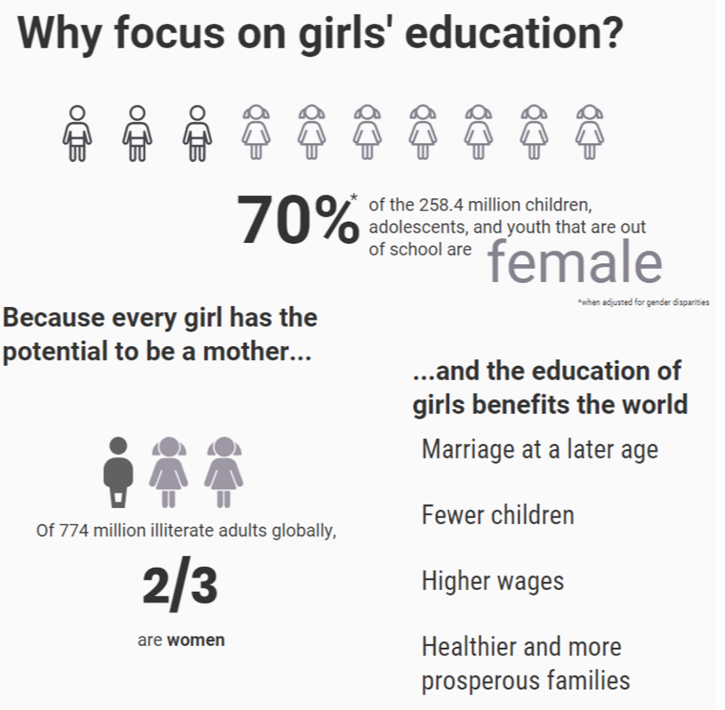

**Figure 13** An infographic that provides reasons to focus on the education of girls’, drawing attention to literacy and out-of-school rates for girls worldwide and reiterating the benefits of higher education for mothers and all women.

**Discussion**

**The Importance of Maternal Education**

Maternal education derives from the initial, basic education of girls and has the potential to have “considerable public health implications” (Akter et al., 2015). Educated females tend to live longer, healthier lives and give birth to fewer, but healthier children (Grossman, 2006; cited by Grepin and Bharadwaj, 2015). Veneman (2007) noted that the education should be of good quality and provide basic services such as usable, working facilities. When mothers or would-be mothers receive proper education, it influences children’s health and mortality rates through several pathways, which include: general literacy; acquiring and using health knowledge and health services; increasing financial, social, and other resources; increasing gender empowerment, female autonomy and independence; and improvement in decision-making in regard to family planning (Abuqamar et al., 2011; Veneman, 2007; Vikram, Desai, & Vanneman, 2010).

**Literacy**

One reason maternal education is thought to reduce child mortality rates is that improved education access for females leads to the acquisition by said females of new, important, and useful information that they apply to their everyday lives. For this, literacy is key. Literacy empowers and emancipates (Shetty and Shetty, 2014). Literacy rate has been linked to birth rates and infant mortality in India; researchers found that female literacy is highly important for population stabilization and better infant health (Saurabh, Sarkar, and Pandey, 2013). The same researchers found that reduction of infant mortality rates through literacy occur independent of socioeconomic status or urban-rural residency. Interestingly, female literacy is more significantly associated with reduced fertility and infant mortality rates than male literacy. Some researchers (Sandiford, Cassel, Montenegro, and Sanchez, 1995; Shetty and Shetty, 2014) consider literacy and education one in the same in regard to their effects on child mortality. That is not the case. One requires education to be literate, but the reverse is not true; one can be illiterate and still be educated. Literacy simply provides women with the ability to read pertinent information that assists them in knowledge attainment and subsequent decision-making, especially in regard to nutrition, immunizations, and preventative health (Saurabh et al., 2013). Literacy also allows women to self-educate.

Adding just one year of maternal education improves literacy levels, along with prenatal care-seeking, the father’s educational level, and fertility behaviors as well (Makate and Makate, 2016). Female literacy and education allows women to perform better developmentally and socially, enjoy greater autonomy, and greater decision-making involvement. It leads women to marry later and have smaller families, as well as be more proactive about the health and well-being of themselves and their family members (Shetty and Shetty, 2014). Kateja (2007) found similar results, suggesting that the role of female literacy is directly related to a woman’s status, age at which she marries, decision-making power, chances of meaningful employment, number of children, and health-seeking behavior.

**Acquisition and use of health knowledge, health services utilization**

Literate or not, girls and women who receive at least a basic education are more likely to utilize health services available to them (Lindeboom et al., 2009; Veneman, 2007), regardless of socioeconomic status, age, ethnicity, or other intermediate variables (Ngatchou and Van der Pol, 1988). Grossman (2006) suggested that educational advancements impact health outcomes through two potential, broad pathways: allocative efficiency and productive efficiency. Allocative efficiency allows highly educated individuals to perceive risks and benefits associated with health behaviors and ultimately, make better choices. Productive efficiency allows the “same individuals to make the most out of any given set of health inputs” (Grossman, 2006).

Grossman’s pathways may explain why education increases health services utilization. Highly-educated women understand health-related information, communicate better with healthcare providers, and make better health and parenting choices (Lindeboom et al., 2009; Makate and Makate, 2016). Prenatal care is sought more by educated females than their uneducated counterparts (Ngatchou and Van Der Pol, 1988). Adequate prenatal care is extremely important in reducing infant and child mortality (Makate and Makate, 2017). Additionally, women who have greater knowledge of pre- and postnatal care are more likely to breastfeed, vaccinate their children, and provide them boiled or mineral water (Cochrane et al., 1982; Ngatchou and Van Der Pol, 1988). Breastfeeding and adequate nutrition have demonstrated to be crucial in lowering infant and child mortality rates (Cochrane et al., 1982; Ngatchou and Van Der Pol; 1988), as well as minimizing low birthweights among newborns, another contributor of infant mortality (Martinson and Choi, 2019).

Educated mothers, compared to the uneducated, are more conscious about health and nutrition, have greater decision-making ability, are more knowledgeable about disease prevention, recovery, and cure, are more likely to use contraception, and teach their children about good hygiene and health practices (Akter et al., 2015; Grepin and Bharadwaj, 2015; Makate and Makate, 2016). Amongst women stratified into three economic groups (poor, middle income, and rich), and controlling for age, parity, marital status, religion, health insurance, access to health facilities, current place of residence, and partner’s education, researchers found an obvious gradient among socioeconomic status, with women who were “better-off” accessing and utilizing more health services (Dimbuene, Amo-Adjei, Amugsi, Mumah, Izugbara, and Beguy, 2018). The Dimbuene et al. study did not determine whether education increased socioeconomic status, or vice versa, but it did find that the more education a woman had received, the better antenatal care she obtained.

**Access and use of resources**

Universal basic education reduces poverty and increases productivity, which contributes to economic growth (Veneman, 2007). Indirectly, education may influence child health through its effect on labor market opportunities (Aslam and Kingdon, 2012); mothers with higher education tend to qualify for better jobs, have higher incomes, or marry into higher incomes (Abuqamar et al., 2011). They tend to have health insurance or better benefits than under- or uneducated peers. They live in areas that have improved healthcare resources or that facilitate access to such resources (Rosenzweig and Schultz, 1982). They are more likely to have suitable transportation that allows them to go to scheduled appointments or seek medical assistance when necessary. Interestingly, the link between economic status or resource access, maternal education, and child immunizations is weak; immunizations are the only area where paternal education seems to play a larger role (Abuqamar et al., 2011) but again, the mechanism is not quite understood.

One theory questions whether maternal education is a cause of reduced infant mortality, or if it coincides with it as part of societal progress at large. Industrialism theory suggests that the transition from lower levels of development to high levels cause countries to undergo structural changes related to industrialism (Boehmer and Williamson, 1995). Economic development increases and therefore, resources increase, improving nutrition, medical technology, and other aspects of healthcare and the economy. Areas urbanize, adding schools and improving proximity and physical access to educational buildings. Therefore, not only do females have increased access to education, but improvements are concurrently seen in public health, reducing child mortality rates in society at large. While reverse causality is not evident (Le Brun, Helper, and Levine, 2011), counterarguments to this theory is that industrialization alone does not improve education and/or reduce child mortality rates. The United States is an example of an industrialized country with a high infant mortality rate (Texas A&M University, 2016). Additionally, aspects of industrialization harm health, such as pollution, more than they help it (e.g. rising living standards) (Federman and Levine, 2005). These findings suggest that other factors, such as gender stratification, may be at play.

**Increased gender empowerment**

The gender stratification theory offers another overarching explanation about the relationship between maternal education and child mortality rates. The theory focuses on the educational, political, economic, and autonomous status women hold relative to the men in their societies. Gender stratification theory suggests that when “women hold more autonomy, more political influence, and control over economic resources” (Boehmer and Williamson, 1995), women are more likely to have greater say with respect to care for their children, utilize modern medical facilities, seek medical treatment for her children, and are more likely to ask for and understand explanations from healthcare providers and learn how to prevent issues (Caldwell and Caldwell, 1993).

Over the past few decades, female empowerment studies have grown exponentially (Visaria, 2012). Studies in select Asian and Pacific countries have demonstrated that where women have obtained literacy, higher education, reduced gender inequality, economic participation, and marriage choice, all of which are “empowerment measures,” their countries have seen substantial reductions in fertility, maternal mortality, infant mortality, and child mortality rates along with the increased use of contraception (Visaria, 2012). Countries that have not empowered women experience the opposite, with adverse implications for maternal and child health.

Many other empowerment studies have found significant associations along the same vein (Lan and Tavrow, 2017; Pratley, 2016; Visaria, 2012). Female empowerment provides women with the opportunities to receive education, which then leads to the aforementioned access to resources, improved health for themselves and their children, and other positive benefits that are experienced not only by the women themselves, but their society as a whole. Lan and Tavrow (2017) determined that maternal mortality rates, which are correlated significantly with child mortality rates (Veneman, 2007), decline significantly when women are ‘empowered’. Pratley (2016) found statistically significant associations between women’s empowerment and antenatal care, skilled attendance at birth, contraception, vaccination, nutritional status, violence exposure, and finally, child mortality.

**Enhanced decision-making**

A recurring theme in the literature is that maternal education improves decision-making capabilities. Decision-making is indeed a large part of the previously discussed pathways but important enough for elaboration. Veneman (2007) stated that when girls with at least a basic education reach adulthood, they are more likely than their uneducated peers to successfully manage family size based on their capacities. They are also more likely to provide better care for their children and ensure the children receive an education. They make better choices about their own health, the health of their children and families, contraceptive use and family planning, and financial management. They tend to display more rational thinking, which pervades all aspects of their lives (Namdeo, 2017). Higher levels of decision-making autonomy in mothers corresponds to an increase in primary school enrollment in children, which correlates to lower child mortality rates (Luz and Agadjanian, 2015; UNICEF, n.d.).

Hendrick and Marteleto (2017) found that maternal decision-making autonomy is not only linked to positive outcomes for children’s health and well-being but that adolescents, especially girls, benefit from their mother’s decision-making autonomy. Such autonomy “promotes adolescents’ school enrollment above and beyond other maternal, household, and regional influence” (Hendrick and Marteleto, 2017). Undergoing the process of education is thought to shape individual’s thoughts, behavior, and societal interactions, improving many aspects of life. From this, children reap the benefits of the positive effects that education has on their mothers’ decision-making powers and by extension, on themselves.

**Conclusion**

Education has been viewed as either a direct, causal factor or an indirect, mitigating factor on child health and mortality. Regardless, females who receive proper education suffer no drawbacks or risks from the education they receive (Veneman, 2007), but gain a plethora of benefits. Aside from the pathways and theories discussed in the current report, there are likely many other associations that could be considered. However, this study has attempted to examine the reviewed literature into and analyze MICS data within the main themes that account for the importance of maternal education and its effect on child mortality rates. The literature has demonstrated that maternal education is a more important predictor of child mortality than paternal education, though more research is required to obtain more certainty as to why. Many studies have concluded that *any* education is better than no education, whether maternal, paternal, or parental, but the more education mothers and potential mothers receive, the stronger the benefits of education become.

Universal primary education plays such an important role in other aspects of society that it was included in the Millennium Development Goals (MDGs) that the United Nations member states agreed to try to achieve by the year 2015 (World Health Organization, 2019). The reduction of child mortality was also an MDG. Other goals were intertwined in the two, such as the eradication of poverty and hunger, gender equality, and HIV/AIDS, malaria, and other diseases. The United Nations noted that the MDGs are inter-dependent; all of them influence health and health influences them.

The MDGs have been considered successful in that progress has been made. Universal primary education enrollment figures in developing regions is now over 91%, rising approximately 7% of the past decade or so (World Health Organization, 2019). However, most of the UN’s development goals were missed. Global child mortality rates have dropped significantly, but children continue to die from known causes, many of them preventable. Therefore, the important takeaway is not that the world missed the UN’s goals, but that we continue our progress through the relentless pursuit of achieving and surpassing those goals, no matter how long it takes.

**References**

Abuqamar, M., Coomans, D., and Louckx, F. (2011). The impact of parental education on infant mortality in Gaza strip, Palestine. *Journal of Public Health and Epidemiology. 3*(1): 28 33. Retrieved from https://www.researchgate.net/publication/228503138_The_impact_of_parental_educa

tion_on_infant_mortality_in_Gaza_strip_Palestine

Adlakha, A.L. and Suchindran, C.M. (1985, October). Factors affecting infant and child mortality. *Journal of Biosocial Science.* 17(4): 481-496. doi: https://doi.org/10.1017/S0021932000015996.

Andriano, L., and Monden, C.W.S. (2019, October 7). The causal effect of maternal education on

child mortality: Evidence from a quasi-experiment in Malawi and Uganda. Demography,

56 : 1765-1790. Retrieved from https://doi.org/10.1007/s13524-019-00812-3.

Aslam and Kingdon (2012). Parental education and child health – Understanding the pathways

of impact in Pakistan. *World Development. 40* (10): 2014-2032.

Akter, T., Hoque, D.M.E., Chowdhury, E.K., Rahman, M., Russell, M., Arifeen, S.E. (2015, September 9). Is there any association between parental education and child mortality? A study in a rural area of Bangladesh. *Public Health*. 129 (12): 1602-1609.

Boehmer, U. and Williamson, J.B. (1996, March). The impact of women’s status on infant mortality rate: A cross-national analysis. *Social Indicators Research. 37*(3): 333-360.

Retrieved from https://link.springer.com/article/10.1007/BF00286237

Breierova, L. and Duflo, E. (2004, May). The impact of education on fertility and child mortality: Do fathers really matter less than mothers? *National Bureau of Economic Research, 10513.* doi:10.3386/w10513

Caldwell. J. and McDonald, P. (1982, March). Influence of maternal education on infant and child mortality: levels and causes. *Health Policy Educ. 2*(3-4): 251-267.

https://doi.org/10.1016/0165-2281(82)90012-1.

Caldwell, J. and Caldwell, P. Women’s positions and child mortality and morbidity in less developed countries. In: Mason. N and Sogner. S,editor*s*. *Women’s Positions and Demographic Change*. Oxford: Clarendon Press; 1993. pp. 122–139.

Cochrane, S.H., Leslie, J., and O’Hara, D.J. (1982, March). Parental education and child health: Intracountry evidence. *Health Policy Educ. 2*(3-4): 213-250.

Desai, S. and Alva, S. (1998, February). Maternal education and child health: Is there a strong causal relationship? *Demography*. 35(1): 71-81.

Dimbuene, T., Amo-Adjei, J., Amugsi, D., Mumah, J., Izugbara, CO., and Beguy, D. (2018, November). *Women’s education and utilization of maternal health services in Africa: A multi-country and socioeconomic status analysis. J. Biosoc. Sci. 50* (6): 725-748. doi: 10.1017/S0021932017000505

Federman, M. and Levine, D.I. (2005). Industrialization and infant mortality. Unpublished manuscript, University of California. Retrieved from

https://are.berkeley.edu/~karp/20042005_seminars/infmort.pdf

Fischetti, M. (2011, July 7). Female education reduces infant and childhood deaths. *Scientific*

*American*. Retrieved from https://www.scientificamerican.com/article/graphic-science-

female-education-reduces-infant-childhood-deaths/

Gakidou, E., Cowling, K., Lozano, R., and Murray, C.J.L. (2010) Increased educational attainment

and its effect on child mortality in 175 countries between 1970 and 2009: a systematic

analysis. *Lancet, 376*: 959-974. Retrieved from https://doi.org/10.1016/S0140-6736(10)61257-3.

Grepin, K.A. and Bharadwaj, P. (2015, December). Maternal education and child mortality in Zimbabwe. *Journal of Health Economics*. 44: 97-117. https://doi.org.ezproxy.utica.edu/10.1016/j.jhealeco.2015.08.003

Grossman, M. (2006). Chapter 10 Education and nonmarket outcomes. *Handbook of the Economics of Education*. 1: 577:633.

Guirgis, S.A. (2006). The last days of Judas Iscariot*.* New York, NY: Farrar, Straus, and Giroux.’

Hendrick, C. Emily and Marteleto, L. (2017, March 28). Maternal household decision-making autonomy and adolescent education in Honduras. *Popul Res Policy Rev. 36* (3): 415-439.

Hobcraft, J.N. (1993, November). Women’s education, child welfare, and child survival: A review of the evidence. *Health transition review: the cultural, social and behavioral determinants of health. 3*(2): 159-175.

Kateja, A. (2007, June 1). Role of female literacy in maternal and infant mortality decline. *Social Change. 37* (2): 29-39.

Lan, Chiao-Wen and Tavrow, P. (2017, November 8). Composite measures of women’s empowerment and their association with maternal mortality in low-income countries.

Le Brun, A., Helper, S.R., and Levine, D.I. (2011). The effect of industrialization on children’s education: The experience of Mexico. *Review of Economics and Institutions. 2*(2), Article 1. doi: 10.5202/rei.v2i2.31.

Lindeboom, M. (2009). Parental education and child health: Evidence from a schooling reform. *Journal of Health Economics. 28 (*1): 109-131. https://doi.org/10.1016/j.jhealeco.2008.08.003.

Lochner, L. (2011). Nonproduction benefits of education. in *Handbook of the Economics of Education. 4*: 183-282.

Luz, L. and Agadjanian, V. (2015, March 24). Women’s decision-making autonomy and children’s schooling in rural Mozambique. *Demogr Res. 32:* 775-796.

Makate, M. & Makate, C. (2016, November). The causal effect of increased primary schooling on child mortality in Malawi: Universal primary education as a natural experiment. Social Science and Medicine. 168 72-83. Retrieved from https://doi.org.ezproxy.utica.edu/10.1016/j.socscimed.2016.09.003

Makate, M. & Makate, C. (2017, April 1). The impact of prenatal care quality on neonatal, infant, and child mortality in Zimbabwe: evidence from the demographic and health surveys. *Health Policy Plan. 32*(3): 395-404. doi: 10.1093/heapol/czw154.

Martinson, M.L. and Choi, K.H. (2019, September 19). Low birthweight and childhood health: The role of maternal education. *Annals of Epidemiology*. In press, Journal pre-proof. https://doi.org/10.1016/j.annepidem.2019.09.006

Namdeo, R.P. (2017, June). Impact of education on decision-making ability of women. *Educational Quest: An Int. J of Education and Applied Social Science. 8* (Special Issue): 431-434. doi: 10.5958/2230-7311.2017.00087.3

Neethling, S. (2017, July 12). A free, open resource to solve our third world problems. Retrieved from https://opensource.com/article/17/7/third-world-problems-project

Ngatchou, D.R. and Van Der Pol, H. (1988, June). Level of maternal education and mortality: a critical evaluation. Ann IFORD. 12(1): 25-47. Retrieved from https://www.ncbi.nlm.nih.gov/pubmed/12178524

Osili, U.O. and Long, B.T. (2008). Does female schooling reduce fertility? Evidence from Nigeria. Journal of Development Economics. 87(2008): 57-75. Retrieved from https://scholar.harvard.edu/files/btl/files/osili_long_2008_does_female_schooling_red

uce_fertility_-_jde.pdf

Puglisi, C. and Busetta, A. (2019). The effect of education on under-five mortality: Individual and community-level effects in Bangladesh. *Statistica. 79* (2): 181-200. Retrieved from https://rivista-statistica.unibo.it/article/view/8584

Roser, M. & Ortiz-Ospina, (2019). Global rise of education. *Our World in Data.* Retrieved from https://ourworldindata.org/global-rise-of-education

Roser, M. & Ritchie, H. (2019). Child and infant mortality. *Our World in Data.* Retrieved from https://ourworldindata.org/child-mortality

Rosenzweig, M.R., Schultz, T.P. (1982, March). Child mortality and fertility in Colombia: Individual and community effects. *Health Policy Educ. 2* (3-4): 305-348. Retrieved from https://www.ncbi.nlm.nih.gov/pubmed/10256651

Sandiford, P., Cassel, J., Montenegro, M., and Sanchez, G. (1995, March). The impact of women’s literacy on child health and its interaction with access to health services. *Population Studies. 49* (1): 5-17. Retrieved from https://www.jstor.org/stable/2175318

Saurabh, S. Sarkar, S. and Pandey, D.K. (2013, October-December). Female literacy rate is a better predictor of birth rate and infant mortality rate in India. *J Family Med Prim Care.*

*2* (4): 349-353. doi. 10.4103/2249-4863.123889.

Shetty, A. and Shetty, S. (2014). The impact of female literacy on infant mortality rate in Indian states. *Curr. Pediatr. Res. 18* (1): 49-56. Retrieved from https://www.alliedacademies.org/articles/the-impact-of-female-literacy-on-infant- mortality-rate-in-indian-states.pdf

Texas A & M University. (2016, October 13). Why American infant mortality rates are so high. *ScienceDaily.* Retrieved from

https://www.sciencedaily.com/releases/2016/10/161013103132.htm#targetText=These

%20premature%20births%20are%20the,within%20an%20expectant%20mother's%20control.

Under-five mortality. (2019). *UNICEF.* Retrieved from https://data.unicef.org/topic/child- survival/under-five-mortality/

UNICEF. (n.d.). Goal: Achieve universal primary education. Retrieved from <https://static.unicef.org/mdg/education.html>

UNICEF (2010-2019). Multiple Indicator Cluster Surveys; selections from 25 countries.

Veneman, A.M. (2007, December). Education is key to reducing child mortality: The link between maternal health and education. *UN Chronicle.* Retrieved from https://unchronicle.un.org/article/education-key-reducing-child-mortality-link-between maternal-health-and-education

Vikram, K., Desai, S., and Vanneman, R. (2010, September). Maternal education and child mortality: Exploring the pathways of influence. Unpublished manuscript, University of Maryland, College Park. Retrieved from https://paa2011.princeton.edu/papers/111195

Visaria, L. (2014, June 1). Empowerment of women and its impact on population. *Asia-Pacific Population Journal. 27*(1): 33-56. Retrieved from https://www.researchgate.net/publication/287410046_Empowerment_of_women_and

_its_impact_on_population

Watkins, W.J., Kotecha, S.J., Kotecha, S. (2016, May 10). All-cause mortality of low birthweight infants in infancy, childhood, and adolescence: Population study of England and Wales. *PLoS Med.* 13 (5): e1002018. doi: 10.1371/journal.pmed.1002018

World Health Organization. (2019, September 19). Children: reducing mortality. Retrieved from https://www.who.int/news-room/fact-sheets/detail/children-reducing- mortality#targetText=In%202018%20an%20estimated%206.2,the%20first%20month%2 0of%20lfe.