**Background**

The groundwork for the ethnobotany portion of the Garibaldi Alpine research was laid out in various email exchanges with representatives and members of the Squamish Nation dating back to December 2021. In the conversations that took place over the next while, it was expressed that the Nation would like to see funds from the Living Labs research grant allocated to benefit the Nation directly in a material way.

During the first half of 2023, the research team proposed a project to map barriers in land access in relation to culturally significant vegetation. The purpose of this map would be to both inform members of the Nation of these possible barriers but also serve as a tool for advocacy in challenging these barriers. This map would overlay data of culturally significant vegetation determined by the Squamish Nation with data relating to road conditions, access issues such as gates, local bylaws and jurisdictions, and other points of interest.

A proposal was drafted and sent out in June 2023. The Squamish Nation requested this proposal to be submitted on Squamish Connect, which the nation uses for their consulting processes for land use related issues. This was called *Mapping of Culturally Significant Vegetation and Barriers in Land Access for the Skwxwú7mesh-ulh Temíx̱w Nation.* This consultation was submitted in August 2023, and is currently in the preliminary review stage of the consultation process as of writing (October 2023).

**Further developments during 2023 field season**

While the approval to complete this project is still under review by the nation, the research team decided to begin exploring possible sources to obtain data for the map as well as drafting a prototype for further engagement.

This was started by working from a list provided on Squamish Connect of culturally significant vegetation to the Squamish Nation, compiled by Elizabeth Ross. Using iNaturalist, where users are able to upload observations of any species, the instances of the species of culturally significant vegetation as they were observed within the traditional territory of the Squamish Nation were extracted. iNaturalist allows users to download sets of data for specific areas, and also allows users to create new areas using polygons - however, this is highly discouraged as it significantly slows down the website.

I attempted to upload the polygon available publicly from native-land.ca for the Squamish traditional territory, but iNaturalist was unable to upload it as a place, likely due to the complexity of the polygon and the large number of observations it encompasses. It should also be noted that the polygon available on native-land.ca doesn’t necessarily represent the self-identified traditional territory of the Squamish Nation, as the description of the boundaries available on Squamish Connect is slightly broader than this.

Instead of uploading data directly from the Squamish traditional territory, I opted to download data from overlapping pre-existing polygons on iNaturalist simply for the sake of getting visual representation for what a prototype might look like, and overlaying them with the polygon of the Squamish traditional territory. Here is an image of what this looks like:

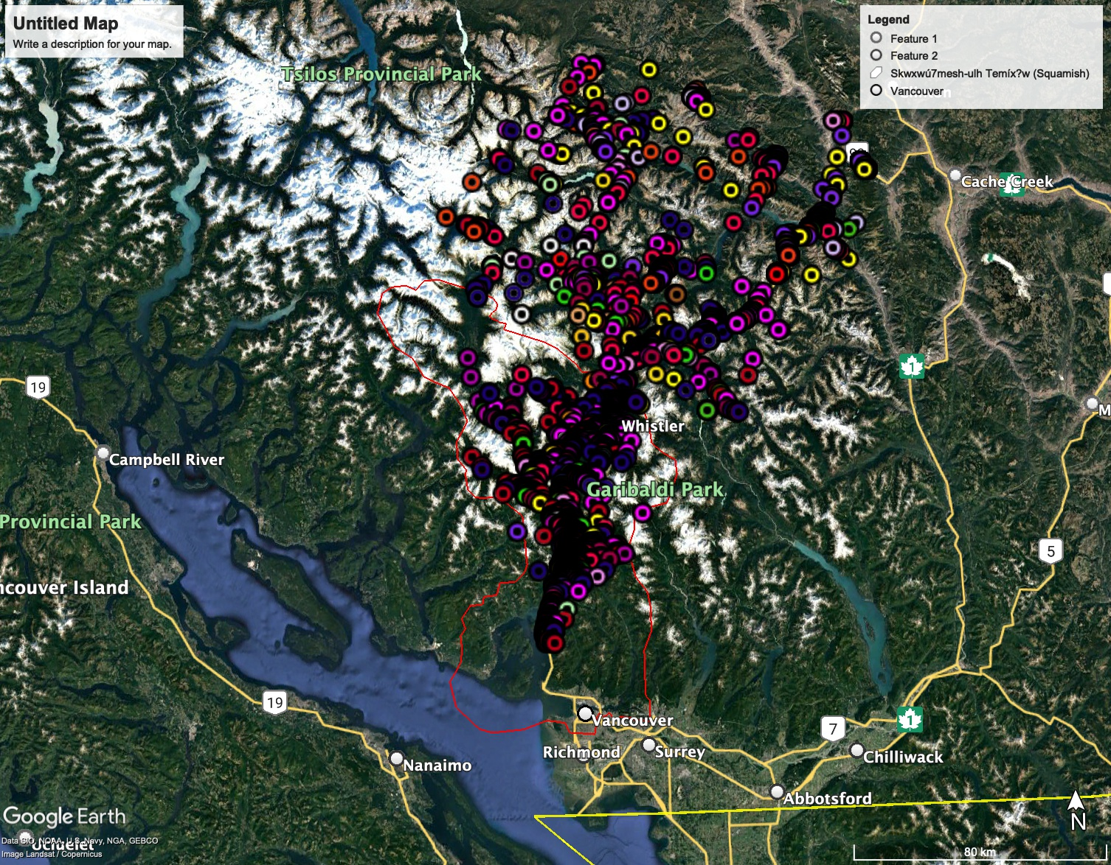

I’ve colour-coded different species, but this system can probably be improved (these were essentially picked at random, or based on an approximate colour of the species). iNaturalist itself colour codes observations based on kingdom classifications on their map, which could also be done at a narrower taxonomic level.

Overlaying this data was done solely for the purposes of what a map could look like. iNaturalist relies on user contributions for its services, and new data points are constantly being updated. Current files reflect the vegetation as recorded as of September 2023.

**Future developments**

Updated road data from the provincial government is available from the Digital Road Atlas (https://www2.gov.bc.ca/gov/content/data/geographic-data-services/topographic-data/roads). I’ve so far been unsuccessful in overlaying and visualizing this set of data on Google Earth.

OpenStreetMap has some excellent resources for the types of data needed for the continuation of this project, ranging from paved roads, logging/forest service roads, trails, to locations of gates, public/private property, and different jurisdiction borders. The latter might be a helpful tool in determining legality of harvesting and especially for the advocacy purposes of this map, in overlaying observations with whether they can actually be legally harvested by members of the Nation. Much of the information surrounding municipal bylaw isn’t actually readily available online in a format that is readily accessible by the public, and may require consultation from local authorities. These are resources I’ve looked into and compiled but haven’t yet incorporated into a draft. The list of municipalities to be incorporated and their respective legislative resources can be found on the proposal document submitted.

For community interviews, the following questions might be considered: what do members want to see on this map in terms of specific local issues to be addressed? What are concerns around recreation and tourism, and having road data publicly available? What information may be redundant and could be left out for the sake of having a product that is user-friendly and easy to read?