Elizabeth Parent – 40031343

Etude 1: Explore

Due: September 21, 2017

1. Bracelet from Peru

This is a woven bracelet made of cotton or a synthetic material. It has no conductive potential but it is very strong as it has stayed on my wrist for the past 3 years. It has a design of attached crosses with extra string connecting each X. It is made up of four shades of brown. I think this could be an interesting type of object to incorporate electronics into. I could add beads that are buttons or sensors which could record data in every day life. This object is meaningful because it reminds me of the trip I went on.

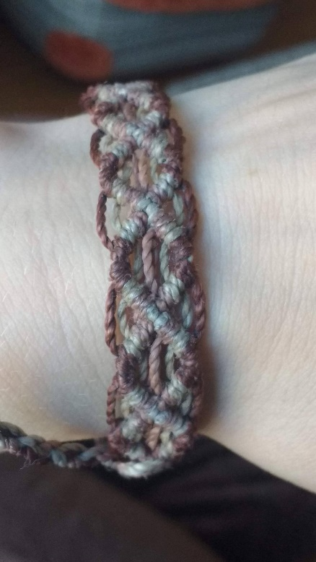

1. House key

This is the key to my apartment which I got in July this year when I moved. It is a golden color and is a very hard metal so that it never warps or chips with excessive use. It has extreme conductive potential, as much as a copper wire. It could be made of copper or brass as material. It is a slightly shiny key that has the power to open a lock fitted for it. A key is a powerful object which implies exclusive access to whatever it may unlock, often something valuable. In this case, it unlocks my home.

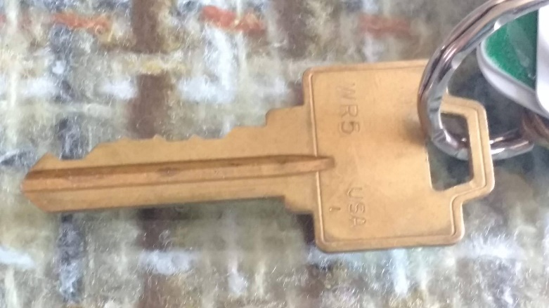

1. Tea strainer

I use this strainer every day when I pour myself tea, and I drink a lot of tea. It has a metal handle which is the part that I measured for conductivity. The handle has 2 ohms of resistance, making it a very conductive object. It is slightly malleable so it would not be a good material choice for anything requiring a tough material. It is a very shiny metal, I’d guess aluminum or stainless steel if it’s possible for it to be bendable. The handle wraps around the strainer part, which is a concave metal mesh about an inch deep at the center. The shape reminds of a net for catching bugs or a dipper spoon.

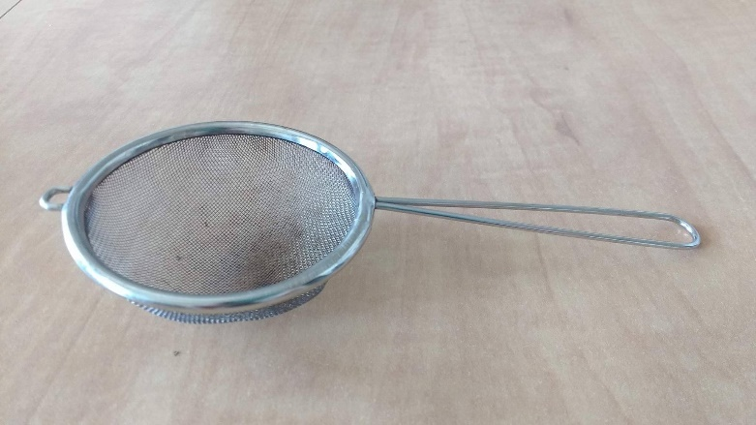

Favourite object: Bracelet from Peru

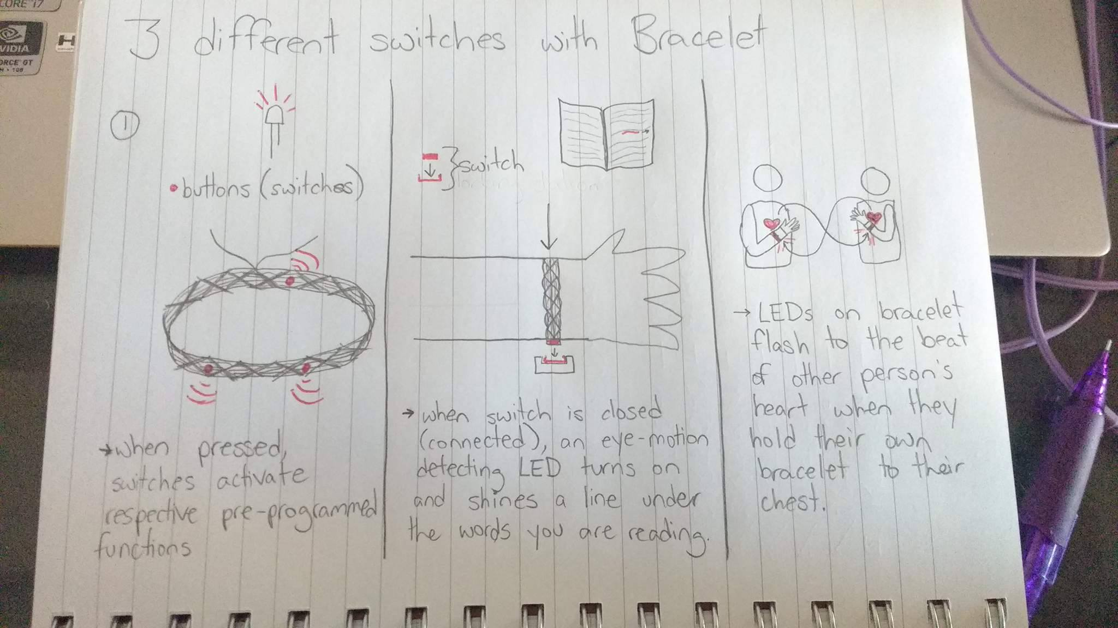

Story Board: Heartbeat Bracelets

