<DOCTYPE HTML>

<html lang = ‘*’en’’>*

*<head>*

*<meta charset = ‘’utf-8’’>*

*<meta name = ‘’viewport’’>*

*<tittle>NURU HAIR OIL COMPANY</tittle>*

*<link rel =’’stylesheet’’href=’’styles.css’’>*

*</head>*

*<body>*

*<header>*

*<h1>nuru hair oil company</h1>*

*<nav>*

*<ul>*

*<li><a href = ‘’index.html’’>home</*

*a></li>*

*<li><a href =’’about.html’’>about*

*Us</a></li>*

*<li><a*

*Href=’’products.html’’>products</a></li>*

*Href=’’contact.html’’>contact us</a></li>*

*</ul>*

*</nav>*

*</header>*

*<maim>*

*<section>*

*<h2>about us </h2>*

*<p>nuru oil company has been providing quality hair care products for over a an year. Our mission is to deliver the best natural oils for healthy and beautiful hair .</p.*

*,/section>*

*</main>*

*<footer>*

*<p>&copy: 2024 NURU hair oil company .all rights reserved .</p>*

*<footer>*

*</body>*

*</html>*

*Products.html(Products Page)*

*<!DOCTYPE html>*

*<html lang =’’en’’>*

*<head>*

*<meta charset = ‘’utf-8’’>*

*<meta name = ‘’viewport’’>*

*<tittle> nuru hair oil company- products</tittle>*

*<link rel = ‘’stylesheet’’ href =’’styles.css’’>*

*</head>*

*<body>*

*<header>*

*<h1>hair oil company</h1>*

*<nav>*

*<ul>*

*<li><a href =’’index.html’>home</*

*a></li>*

*<li>a href=’’about.html’’>about*

*Us</a></li>*

*<li><a*

*Href=’’products.html’’>products</a></li>*

*Href=’’contact.html’’>contact us >/a></li>*

*</ul>hat helps tto condition and strengthen your hair.<p.*

*</header>*

*<main>*

*<section>*

*<h2>our products</h2>*

*<ul>*

*<li><h3.argan oil</h3><p>rich in nourishing vitamins and antioxidants perfect for nourishing your hair.</p></li>*

*<li><h3>coconut oil</h3><p>A versatile oil that helps to condition and strengthen your hair .</p></li>*

*<li><h3>olive oil</*

*H3><p>moisturizes and adds shine to your hair .</p></li>*

*</ul>*

*</section>*

*</main>*

*<footer>*

*<P>&copy:2024 hair oil company. all rights reserved .</p>*

*</footer>*

*</body>*

*</html>*

*Contact.html(Contact us page)*

*<!DOCTYPE html>*

*<html lang=’’en’’>*

*<head>*

*<meta charset=’’utf-8’’>*

*<meta name =’’viewport’’*

*<tittle>hair oil company-contact us </tittle>*

*<link rel=’’stylesheet’’href=’’styles.css’’>*

*</head>*

*<body>*

*<header>*

*<h1>hair oil company</h1>*

*<nav>*

*<ul>*

*<li><a href=’’index.html’’>home</*

*a></li>*

*<li><a href =’’about.html’’>about*

*Us</a><li>*

*<li><a*

*Href=*



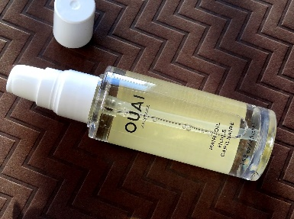

[This Photo](http://www.beautyblogofakind.com/2017/01/two-great-hair-styling-products-from.html) by Unknown Author is licensed under [CC BY-NC-ND](https://creativecommons.org/licenses/by-nc-nd/3.0/)

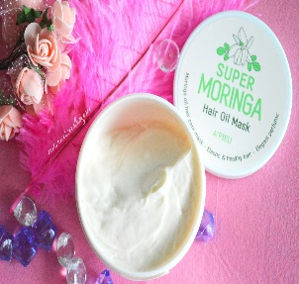

[This Photo](http://cosmeticadanjou.blogspot.com/2017/03/apieu-super-moringa-hair-oil-mask-210ml.html) by Unknown Author is licensed under [CC BY-NC-ND](https://creativecommons.org/licenses/by-nc-nd/3.0/)

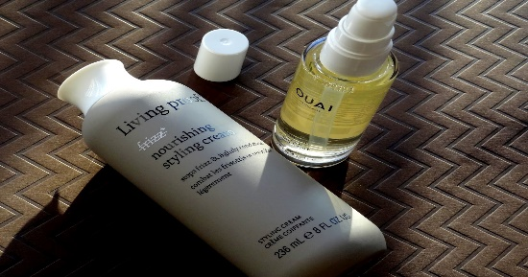

[This Photo](http://www.beautyblogofakind.com/2017/01/two-great-hair-styling-products-from.html) by Unknown Author is licensed under [CC BY-NC-ND](https://creativecommons.org/licenses/by-nc-nd/3.0/)

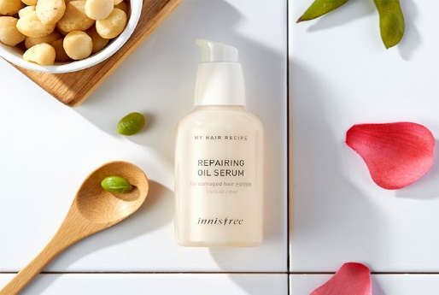

[This Photo](https://koreanbeautydream.blogspot.cl/2017/08/innisfree-my-hair-recipe-repairing-oil.html) by Unknown Author is licensed under [CC BY-SA-NC](https://creativecommons.org/licenses/by-nc-sa/3.0/)

Index.html

<!DOCTYPE html>

<html lang =’’en’’>

<head>

<meta charset = ‘’utf-8’’>

<meta name=’’viewport’’

<tittle>hair oil company</tittle>

<link rel=’’stylesheet’’href=’’styles.css’’>

</head>

<body>

<header>

<h1>welcome to my website</h1>

<nav>

<ul>

<li><a href=’’index.html’’>home</

a></li

<li><a href =’’about.html’’>about</

a></li

<li><a

Href=’’contact.html’’>contact</a><li>

</ul>

</nav>

<header>

<main>

<section>

<h2>table with borders</h2>

<table border =’’1’’>

<tr>

<th>header 1</th>

<th>header 2</th>

</tr>

<tr>

<td >row1 cell 1 </td>

<td>row 1 cell 2</td>

</tr>

<tr>

<td>row 2 cell 1</td>

<td>row 2 cell 2 </td>

</tr>

<tr>

</table>

</section>

<section>

<h2>table without borders</h2>

<table>

<tr>

<th>header 1 </th>

<th>header 2</th>

</tr>

<tr>

<td>row 1 cell 1</td>

<td>row 2 cell 2</td>

<?tr>

</table>

</section>

</main>

<footer>

<p>&copy: 2024 my website</p>

</footer>

</body>

</html>

About.html

<!DOCTYPE html>

<html lang =’’en’’>

<head>

<meta charset =’’utf-8’’>

<meta name= ‘’viewport’’

<tittle>about</tittle>

<link rel=stylesheet’’ href=’’styles.css’’>

</head>

<body>

<header>

<h1>about us </h1>

<nav>

<ul>

<li><a href =’’index.html’’>home</

a></li>

<li><a href =’’about .html’’>about</

a></li>  
 <li><a

href =’’contact.html’’>contact</a></li>

</ul>

</nav>

</header>

<main>

<p>this is my contact page .</p>

</main>

<footer>

<p>&copy:;2024 my website </p>

</footer>

</body>

</html>

Contact .html

<!DOCTYPE html>

<html lang = ‘’en’’>

<head>

<meta charset =’’utf-8’’>

<meta name = ‘’viewport’’

<tittle>contact</tittle>

<link rel =’’stylesheet’’ href=styles.css’’>

</head>

<body>

<header>

<h1>contact us<h1>

<nav>

<ul>

<li><a href =’’index.html’’>home</

a></li

<li><a href’’about .html’’>about<?

a></li>

<li><a

Href=’’contact.html’’>contact</a>?/li>

</ul>

</nav>

</header>

<main.

<p>thus is the about page.</p>

</main>

<footer>

<p>&copy;2024 my website</P>

</footer>

</body>

</html>

<!DOCTYPE html>

<html lang =’’en’’>

<hesd>

<meta charset = ‘’utf-8’’>

<meta name=’’viewport’’

<tittle>contact</tittle>

<link rel =’’stylesheet’’ href =’’styles.css’’>

<script src =’’scripts.js’’ defer></script>

<?head>

<body>

<header>

<h1>contact us </h1>

<nav>

<ul>

<li><a href=’’index.html’’>home</

a></li>

<li><a href=’’about.html’’>about<?

a></li>

<li><a

Href=’’contact.html’’>contact<?a></li>

</ul>

</nav>

</header>

<main>

<form id=’’contact form’’>

<label for=’’name’’>name:</label>

<input type =’’text’’ id =’’name’’

Name=’’name’’ required>

<label for=’’email’’>email:</label>

<input type =’’text’’id=’’name’’

Name=’’email’’required>

<label for =’’message’’>message:</label>

<text area id =’’message ‘’ name=’’message’’

Required></text area>

<button type=’’submit’’>submit</bbutton>

</form>

</main>

<footer>

<p>&copy; 2024 my website </p>

</footer>

</body>

</html>

Script.js

Document.addeventlistner(‘’DOMContenteloaded’’

Function() {

Const form=

Document.getelementbyid(‘’contactform’’);

Form.addeventlistener(‘’submit’’),

Function(event) {

//perform additional validation if needed

Const name=

Document.getelementbyid(‘’name’’).value;

Const message=

Document.getelementbyid(‘’message’’).value;

If(name===’’ ‘’||email====’’ ‘’ || message ==== ‘’ ‘’) {

Alert(‘’all fields are required.’’);

Event.(preventdefault(); // prevent form submission

}else{

Alert(‘’form submitted successfully!’’);

}

}};

}};