*Journal of Biogeography*

**SUPPORTING INFORMATION**

**The International Tree Ring Data Bank (ITRDB) revisited: Data availability and global ecological representativity**

Shoudong Zhao, Neil Pederson, Loïc D’Orangeville, Janneke HilleRisLambers, Emery Boose, Caterina Penone, Bruce Bauer, Yuan Jiang and Rubén D. Manzanedo

**Appendix S1: Corrected and harmonized dataset of the International Tree Ring Data Bank (ITRDB).**

See Appendix S1.zip accessible via dryad DOI:10.5061/dryad0kh0qh06, content:

* Cleaned datasets
* Conflictive dataset
* Duplicated (removed) datasets
* Sampling coordinates
* Error correction log
* .rwl files metadata

**Appendix S2: Supplementary figures and tables**

**Table S1** | Importance associated with having a representative sampling for the different environmental variables used in our bias analyses. See variable description and source in Table 2.

|  |  |  |
| --- | --- | --- |
| *Variable* | Code | Importance |
| *Continent* | C | Having a balance spatial distribution for climate reconstructions.  Representativity in terms of forest management and conservation policies. |
| *Temperature limitation on growth* | Tl | Important to ensure accurate representation of climate change responses |
| *Water limitation on growth* | Wl | Important to ensure accurate representation of climate change responses |
| *Elevation* | El | Include a diverse array of topographies and climate sensitivities (i.e. ensure that the ITRDB is not biased towards high-elevation, poor soils, sites).  Ensure representativity within the coordinate grid |
| *Climatic regions* | Cl | Include a response representative of all of earth’s biomes  Surrogate for forest types |
| *Vascular plant diversity* | Pdiv | Ensure that the response observed in ITRDB is meaningful to diversity conservation strategies, i.e., it also includes hotspots of biological diversity |
| *Associated forest diversity* | Assdiv | Ensure that the response observed in ITRDB is meaningful to diversity conservation strategies, i.e., it also includes hotspots of biological diversity |
| *Need to update* | U | Include response to climate change  Increase the overlap between instrumental data and tree ring data to increase the accuracy of climate reconstructions  Increase the spatial overlap with data from common period, particularly in recent years. |
| *Seasonality* | Seas | Include or eliminate areas where tree rings are likely to form, due to environmental seasonality that may promote a physiological pause and thus create observable tree rings. |
| *Vegetation cover* | Vcov | Include or eliminate areas where vegetation is likely to be arboreal, in order to work with species likely to have large tree ring series.  Eliminate areas without vegetation. |

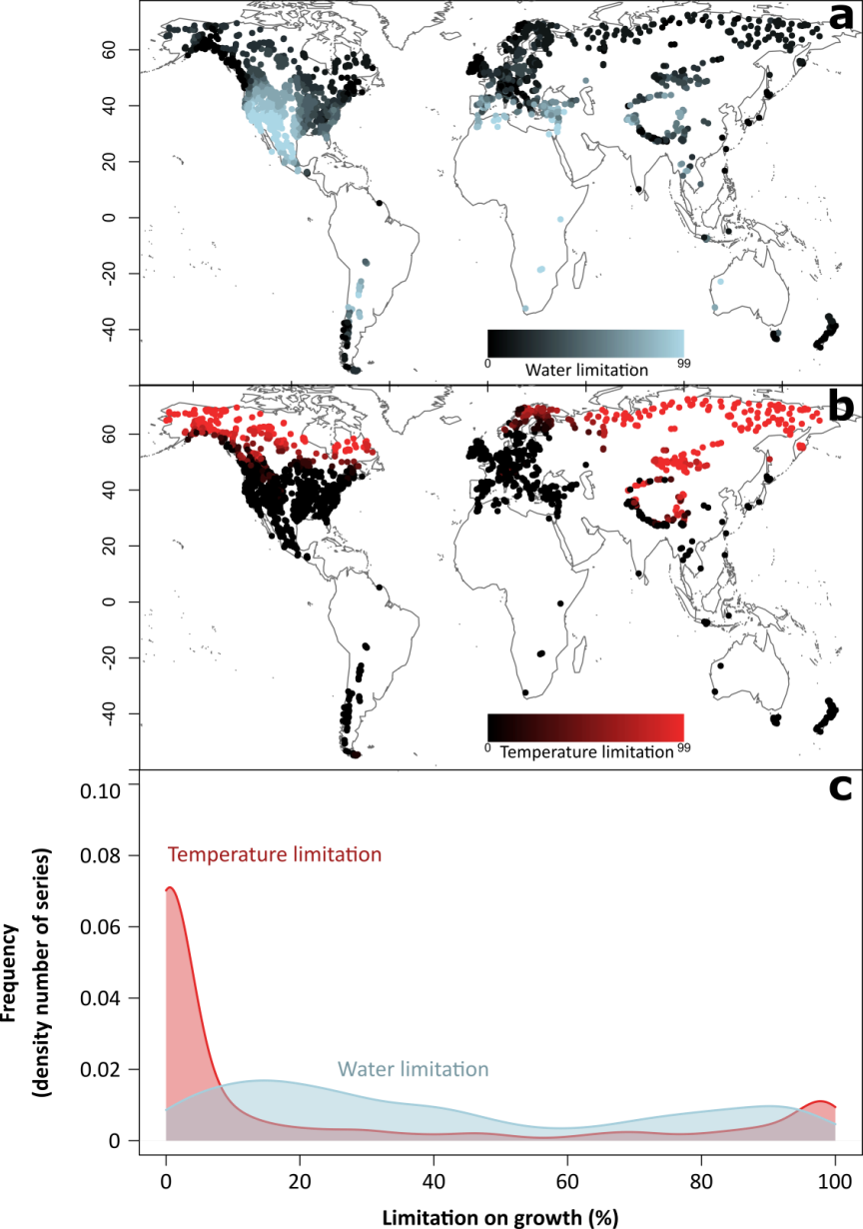

**Figure S1** | Growth limiting factors captured by the International Tree Ring Data Bank (ITRDB). The original ITRDB sampling preference towards locations with strong water limitation is evident in south western North America and the southern Mediterranean (**a**). On the other side, temperature limited sampling locations are concentrated in northern and high elevation areas (**b**). The frequency density distributions (**c**) show a rather uniform representation of different water limitation values (blue), while the temperature limitation (red) is imbalanced towards areas with low temperate sensitivity. Temperature and water limitation from Churkina & Running (1998).

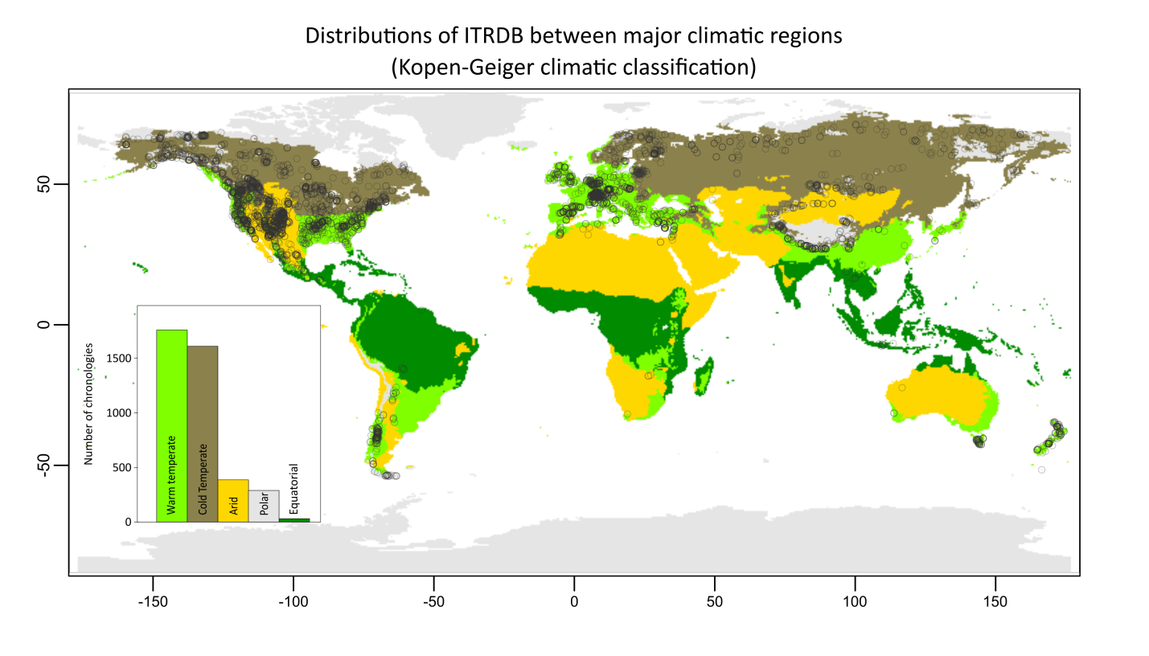**Figure S2** | Warm and cold temperate climatic regions are better represented in the ITRDB. Empty circles represent ITRDB unique locations, while colors represent main climatic regions across the World. Inlaid histogram shows absolute frequencies per climatic regions with consistent colors.

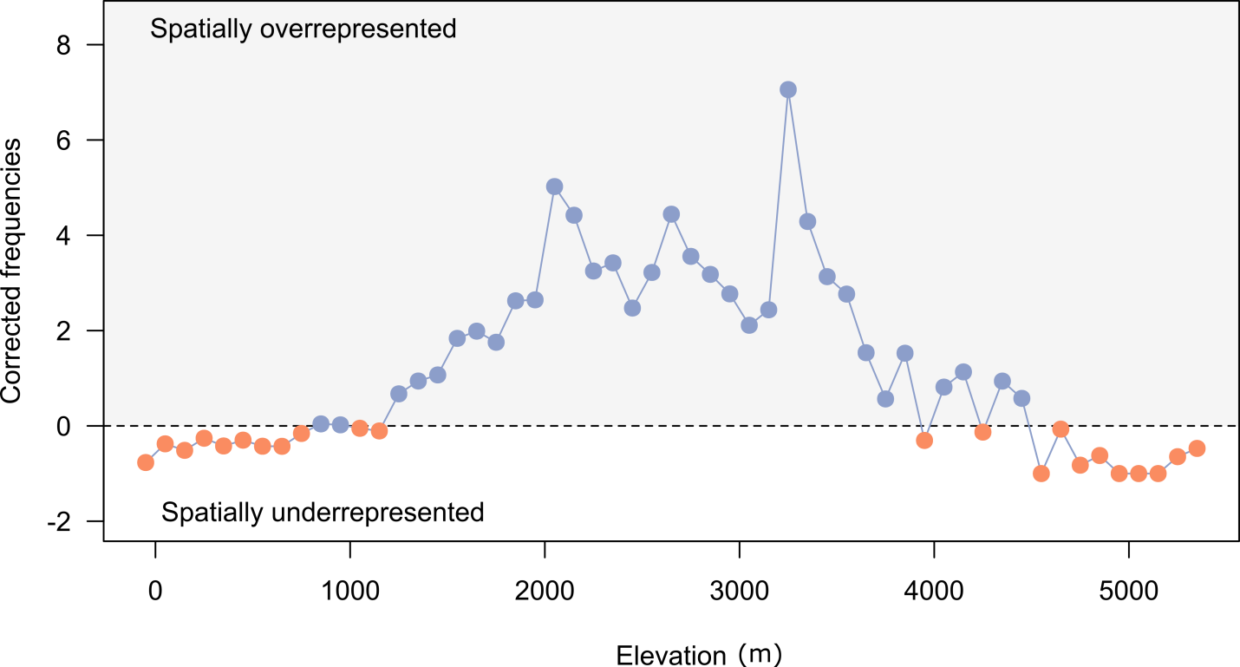

**Figure S3** | Elevation bias in the ITRDB. Few Elevations show frequencies sharply below what is expected by random chance. The corrected frequencies were calculated as the ratio between observed frequency and expected frequency by elevation. Consequently, negative values show underrepresented elevations in the ITRDB and positive values overrepresented ones.

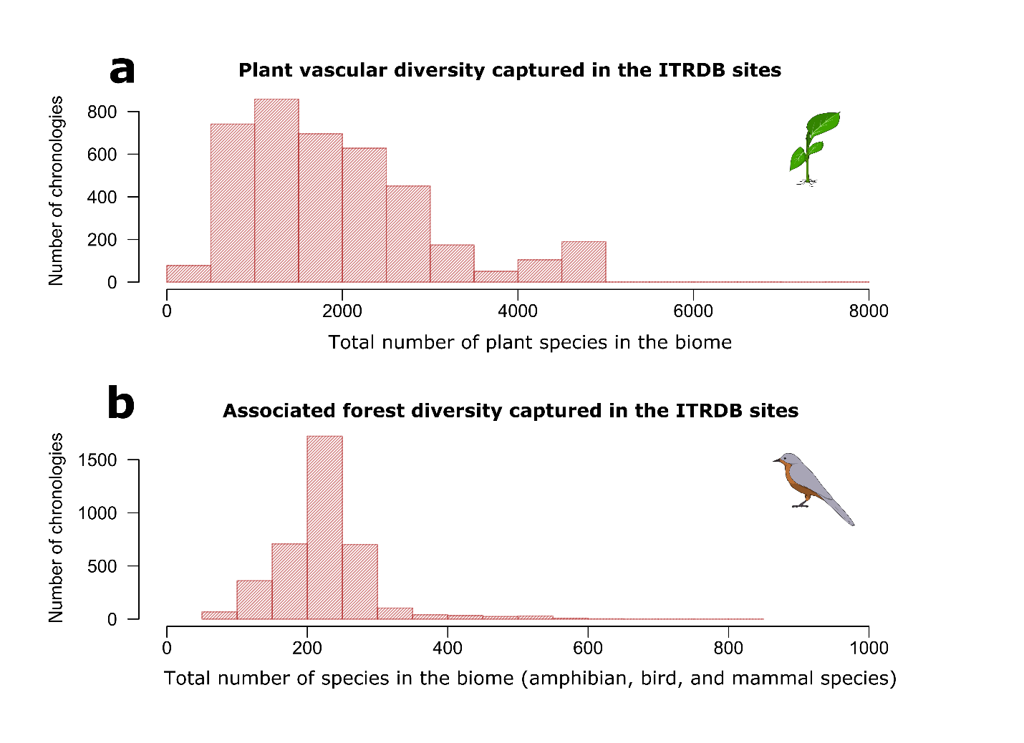**Figure S4** | Plant species and associated animal diversity in the locations covered by the ITRDB. Barplots show the absolute frequencies (number of unique chronologies for each diversity level). **a**, Vascular plant diversity from Kier et al. (2005). **b**, Associated forest diversity was calculated as the sum of amphibians, bird and mammal species diversity from data by [www.biodiversitymapping.org](http://www.biodiversitymapping.org).

D:\Analysis\itrdb\figS5.tiff

**Figure S5** | Data contributions to the ITRDB.

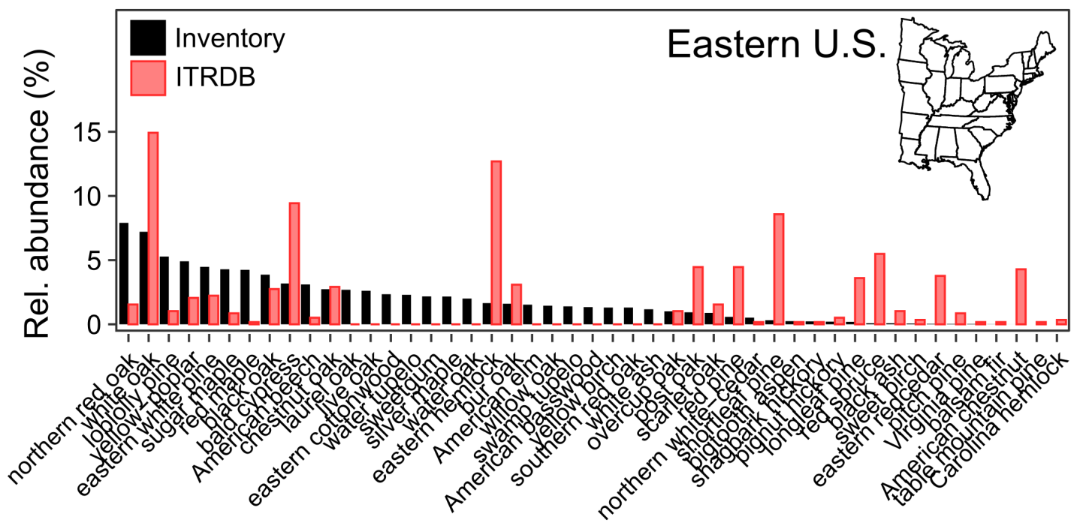**Figure S6** | Species relative abundance in the ITRDB relative to the current forest composition in the Eastern United States. Relative abundance of the ITRDB species is based on the number of sampled sites per species. Current forest composition was computed from the Forest Inventory and Analysis National Program (FIA) for the Eastern US, using the relative basal area of trees with diameter at breast height (DBH) ≥ 20 cm. Only FIA species with relative abundance higher than 1% are shown.

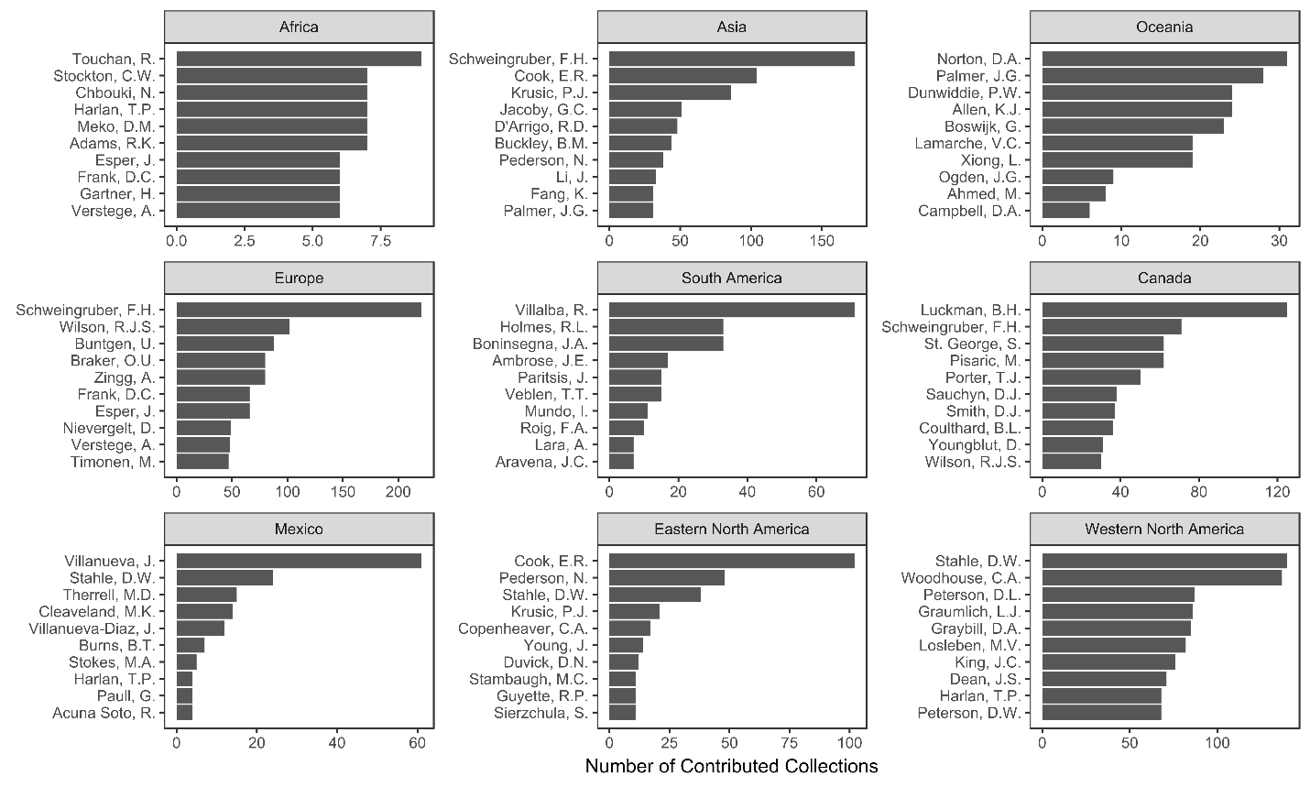

**Figure S7** | Top 10 contributors for the main geographical folders within the ITRDB original data.