Project description for CAREER: The Role of time in structuring Anthropocene plant communities
Responses to previous feedback:
Concerns about the research centered around four major points:
1. Research and teaching were not fully integrated. Response: (1) Undergraduate education and training now included to address data gaps in niche/neutral section via partnership with RMBL REU program and Harvard grants to support summer reseach at RMBL. (2) Summer course now integrates long-term datasets and uses students’ efforts to help determine best statistical models for end, peak and length of flowering (see niche/neutral section).
2. First part of proposal on field/greenhouse work was not sufficiently novel. Response: Have removed the whole section.
3. Analyses proposed for niche/neutral would not provide desired inference/conceptual framework inappropriate. Response: Have greatly extended this section to provide clarity on exact aims; now propose multiple, complementary methods to address question of interest and show clear links between aims and methods.
4. Detail on storage effect modeling insufficient. Response: Have greatly extended this section, now providing model equations and more detailed methods of approach and analyses.
Also, there were concerns over synthesis of the three research components.
The broader impacts were generally considered excellent (Lilacs at Arboretum) but needed better integration (see above) and concerns were raised that they were ‘overly ambitious,’ including especiall over time needed to run 3-week summer course. Response: Have piloted citizen science work in lab this year, it’s going well. Have gained support of six colleagues to co-teach course and gained one term of teaching release to prep and teach first version of course.
add in notes:
I sort of have two versions of how to write this: (a) as shown below, or (b) start with the role of time in coexistence theory.
1. Coexistence theory previously anchored by two extremes
(a) Hutchison’s n dimensional hypervolume
(b) Randomness and related models: Hubbell’s Neutral biodiversity theory
2. Today we recognize a spectrum (expand, give a few citations), meaning modern coexistence theory is focused on understanding the forces (or just knowing when/where) that control the relative influence of each driver. Here I can say ‘for clarity, I use null (sensu Gotelli) to refer to the full suite of X, Y, Z, unlike some authors (c.f., Kraft).” Or such ...
3. Tyranny of space in all this work
4. Role of time in coexistence theory (old to newer theory order):
(a) A niche axis
(b) old work on random models
(c) storage effect
(d) priority effects? (eh, no)
5. Note growing interest in storage effect but much uses space or space for time substition via altered mixtures (Adler paper I think proposes it, then all of Levine’s work)
6. Note: The storage effect is not neutral—species coexist via blah, blah—but it does allow coexistence of species which would appear identical if observed outside of germination rates across time (short snapshots etc.).
I. Career development plan
A. Overview, driving questions & goals
Thirty years ago a transformation in ecology was underway. Spurred in part by increasing rates of anthropogenic habitat change and loss, ecologists were changing their plot sizes ( Soulé et al., 1992; Terborgh et al., 2001), their statistical methods (Legendre, 1993) and questioning many of their fundamental concepts and theories. The outcome of this transformation was the rise of spatial ecology as a major, cross-disciplinary field that addressed both basic and applied questions in ecology with new vigor, methods and theories, and fundamentally reshaped ecology’s view of the role of space in structuring populations and communities (Doak, 1989; Turner, 1989).
Questions of how altered habitat space affected communities occupied me as I started my research career, working in the fragmentation system of San Diego, California. Since then, however, my focus has shifted to questions of time, how it structures ecological systems, and how human modification of the earth system—the hallmark of the epoch known as the Anthropocene—has altered it.
I argue that recent climate change (at least partially associated with increases in anthropogenic greenhouse gases, see Trenberth and Josey, 2007) has produced dramatic shifts in how organisms experience time. Anthropogenic climate change represents a fundamental transition in most ecosystems from a long period of relative stationarity in climate to a period of dramatic nonstationarity (Figure 1). Across many ecosystems this period of nonstationarity includes lengthening growing seasons and altered climatic variability, with such changes projected only to increase in the future (Knutti and Sedlacek, 2013). Climate change has created a pressing need for ecology to better understand how time—both within and across years—shapes ecological systems. My research program is anchored by this need and guided by the critical question: How do communities dis-assemble and assemble due to the shifting temporal dimensions of climate change? I address this question through the lens of plant phenology—the timing of recurring life history events—and the most reported biological indicator of climate change.
Understanding how temporal plant community assembly is affected by climate change requires integrating direct impacts on phenology due to climate change with new approaches in coexistence theory to accommodate non-stationarity. In the next five years I propose to make major strides in this research plan by:
1. How does climate change alter the phenological assembly of flowering plant communities? ... Testing how climate change alters the prevalence of niche versus random temporal assembly by examining shifting patterns of phenological overlap in a 38-year community phenology dataset of alpine meadow species.
2. How does non-stationarity in climate dyanmics alter long-term coexistence mechanisms? .... Examining how non-stationarity in the climate impacts long-term coexistence mechanisms by adapting the storage effect model to include phenology and nonstationarity in the environment.
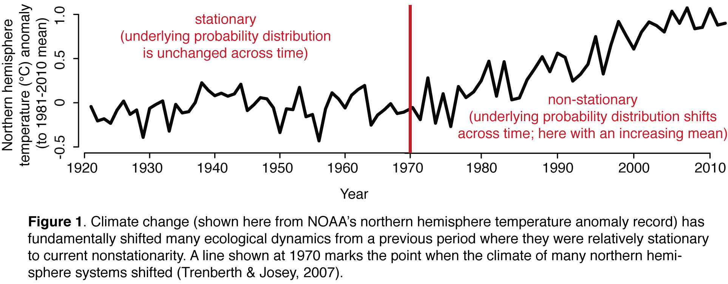
These research goals will at once make major advances in our understanding of phenology and its fundamental role in coexistence, with cascading effects for our ability to understand and predict shifts in phenology and community structure with climate change. My approach would adapt coexistence theory for the Anthropocene by redeveloping three major models—niche, neutral (random) and storage effect—for nonstationary climate dynamics.
These research goals are complemented by major educational goals that leverage the tangible and personal nature of plant phenology and its related wealth of long-term records. Phenology is the most reported biological indicator of climate change, which I believe is because it is tied inherently to how humans mark the passage of time. It thus benefits from records covering thousands of species and hundreds of years (Chuine et al., 2004; Wolkovich et al., 2014). Such records highlight the impact of anthropogenic climate change, but also the difficulties of working with time-series data, especially when such data contain nonstationary periods as seen with climate change. I believe many ecologists are undertrained in how to handle such data—which most often violates assumptions of independence and stationarity. Elevating temporal ecology, thus, requires a fundamental advance in ecological theory, as proposed above, and in how students and the public alike understand time-series data. In my educational component I thus propose to:
0em
1. Train a new generation of ecologists in time-series methods that are applicable to both fundamental ecological research and climate change research (with a focus on autocorrelation, scaling and nonstationarity)
2. Bring this fundamental understanding of nonstationarity seen with climate change, which is effectively a way to emphasize how there can be both variability but also a strong—and important—trend over time, to the public.
B. Results from prior NSF support: Award # 0905806
My research career is focused on understanding community assembly through the lens of plant phenology. To date I have been struck by a disconnect in the amount of data we have on plant phenology and our understanding of findings from those data. In particular, while ecological research on the effects of global climate change has highlighted that ‘biological spring’ has shifted earlier in most parts of the world, with plants leafing and flowering approximately one week earlier than a century ago (Menzel et al., 2006) our ability to explain and predict phenological variation across species, habitats and time has been remarkably poor (Wolkovich et al., 2012). I believe much of this unexplained variation is caused by a fundamental lack of understanding of how plant phenology affects and is itself shaped by community structure (Wolkovich et al., 2014). In my career I have worked to address this by first documenting the variation and then testing for evidence that phenology is an important force structuring plant communities, using the special case of plant invasions. Both of these components were supported by a Postdoctoral Research Fellowship in Biology (Award # 0905806) that I received in 2009. I review below the two major research questions I addressed with this grant, which resulted in 14 papers on which I was an author—7 of which I was first author.

Question 1. What are the direct phenological effects of climate change on plant communities?

To answer this question I tested how climate (temperature, precipitation, irradiance) alters plant phenology and which attributes of species and habitat predict plant responses. In collaboration with an NCEAS working group that I led with Ben Cook (climatologist, NASA GISS and Lamont-Doherty), I conceptualized, collected and compiled phenological data on >5,000 plant species with >30 years of data on approximately 2,000 of those species. This is by far the most species-rich phenological database available. Combined with climate data and the phylogenetic tree we built encapsulating their evolutionary relationships (Davies et al., 2013a) it is a powerful resource for testing how plants respond to climate change.
Analyses from this database revealed compelling patterns that have formed the foundation of my proposed research. Across habitats, many species exhibit a wide but predictable set of responses to temperature and precipitation (Cook et al., 2012a; Pau et al., 2013), sensitivity to temperature is greatest in northern hemisphere communities (Cook et al., 2012a), and for early-flowering species (Wolkovich et al., 2012), approximately 20% of temperate species have chilling requirements that delay flowering with global warming (Cook et al., 2012b), and flowering time is phylogenetically conserved, but such conservation varies across sites and the phylogenetic tree itself (Davies et al., 2013b).
Additionally, to better understand our ability to predict phenological responses to warming in the future, I conceptualized and led the first large-scale effort to compare phenological responses in warming experiments to observational trends (Wolkovich et al., 2012). Contrary to expectations, I found that experiments underpredicted, by at least four-fold, plant responses to temperature; a finding consistent across studies of different designs, durations and when considering species for which we had both experimental and observational data. Such differences between observed and experimentally-estimated responses to temperature highlight the need for better theory and models in the area of phenological research. An improved ability to understand and model these differences has implications not just for predicting phenological responses to climate, but also how they will affect species abundances and distributions, and ecosystem processes, including water, energy and chemical fluxes.
Question 2. How does phenological assembly in an era of changing climate contribute to plant invasions?

Understanding the direct effects of climate on phenology provides only the first piece of the puzzle in predicting community shifts with climate change: while species may directly respond to climate, they may also respond to the temporal shuffling of other species. As an initial approach to test for such indirect effects I used the special case of plant invasions. I hypothesized that exotic species can invade and increase in their introduced communities because they (a) occupy vacant temporal niches—especially if climate change has created ‘novel niche space’ at the start and end of the growing season—or (b) because they are more flexible in their phenological response to climate (Wolkovich and Cleland, 2011). My research, using long-term community datasets, found that exotic species in some habitats have distinctly earlier phenologies compared to their introduced communities and across habitats appear to be more flexible in their phenologies than native species (Wolkovich and Cleland, 2014). Experimental field studies, in collaboration with Elsa Cleland (University of California, San Diego) and a student in her lab, further supported this hypothesis (Wainwright et al., 2012), and highlighted how understanding phenological windows of vulnerability may provide novel management opportunities.

II. Project components: Integrated research & educational goals

A. Overview
Community assembly in ecology today is anchored by two extremes. On one side is the Hutchinson niche world (Hutchinson, 1959), where a community of species—each with its own n-dimensional niche—may coexist forever. On the other side is neutral assembly (Watterson, 1974; Caswell, 1976)—where species with identical niches may co-occur for long periods of time until demographic stochasticity yeilds the rise of one species. Under the neutral model, communities are a random assortment of species that depend on dispersal into a site and demographic stochasticity—thus the resulting communities should appear random with respect to their traits as opposed to carefully ordered, as predicted by niche theory. One version of the neutral model, neutral biodiversity theory (Hubbell, 2001), has received particular attention of late (note that I use the term ‘neutral’ and ‘random’ to refer to any model where species’ traits do not impact long-term co-occurrence, sensu Kraft et al., 2008) and spurred many studies on ‘niche’ versus ‘neutral’ communities. The end result has been the realization that nature rarely appears to settle upon such extremes and most communities exist, instead, in the spectrum in between (Chase, 2007; Vergnon et al., 2009).
Both these extremes, and intemediate positions in between, however, assume the environment allowing long-term species co-existence or co-occurence does not shift dramatically over short timespans (e.g., several years or decades). Such environmental shifts could easily lead to the favoring or dis-favoring of some species over others in a niche-world or precipitate a rapid rate change—such that some species’ slow walk to extinction could accelerate to a quick jog—in a neutral world. As climate change is defined by its rapid environmental change, a driving question is: how does climate change alter coexistence?
Addressing this question requires overcoming two major limitations of current coexistence theory: its emphasis on space, and its assumptions of generally stationary envrionments. While coexistence theory is inherently temporal—as it is the long-term nature of species co-occurrence the theory aims to explain—much recent work has focused on space, from predicting and explaining spatial patterns to using space to promote coexistence (Gilbert and Lechowicz, 2004). In contrast many of the changes organisms experience with climate change involve altered temporal dimensions: longer growing seasons or altered rainfall patterns, for example.
These changes represent an important temporal nonstationarity rarely considered in coexistence theory, as they effectively stretch or shorten the amount of temporal niche space available—temporal space which has been relatively constant in most systems over the last 11,000 or more years of community assembly (Trenberth and Josey, 2007). Alongside these warped temporal spaces are additional shifts in climate fluctuations—more frequent or extreme rare events such as major droughts, cold snaps or heat waves. While some coexistence theory is built on environmental fluctuations (Chesson and Huntly, 1997), these shifts still represent important departures from the current realm of ecological theory as most theory to date assumes the environment is stationary, it may fluctuate from day to day or year year, but the underlying distribution that describes the fluctuations does not shift.
Addressing these limitations requires research with a distinctly temporal approach that explicitly examines the impacts of nonstationary environments. Research in plant phenology is particularly promising to take on this challenge as it is supported by a suite of previous work on the temporal nature of community assembly via phenology (Gleeson, 1981; Rathcke, 1988), and is an area where the nonstationarity of climate in recent decades has had clear, documented impacts (Menzel et al., 2006). Efforts to document these impacts have also highlighted the limitations of simply predicting phenological shifts via shifts in the abiotic environment and suggested other factors—especially biotic interactions—may underlie many species’ responses to climate change (Pau et al., 2011).
My proposed work will combine the common climatological focus on understanding phenological shifts with inferences from coexistence theory. In two complementary areas I will advance coexistence theory to more explicitly consider phenological assembly and nonstationarity. First, I will re-approach niche-neutral theory to examine community assembly of a flowering plant community both within years—examining phenological assembly within a growing season—and across years—looking at shifts in assembly alongside shifting climate. This work will provide fundamental insight on how phenology affects community assembly via temporal niche space while addressing how such assembly may have shifted over recent decades in one system (Gothic, Colorado). To understand how assembly may shift over longer timescales and in other habitats I will adapt a fundamental model of community assembly to nonstationary environments. This model integrates several mechanisms for coexistence, including one directly dependent on a fluctuating environment (Chesson and Huntly, 1997) and will allow tests of how dominant coexistence mechanisms change as the environment shifts from stationary to nonstationary.
B. Phenological niches in shifting environments
Introduction: Decades of research have documented shifts in plant phenology with climate change across the globe, but have also continually noted significant unexplained variation—suggesting phenology may be shaped by factors beyond the abiotic environment (Pau et al., 2011). Ecological theory suggests phenology should be a major component of plant species’ temporal niche (Gotelli and Graves, 1996). Through the phenological temporal niche model total niche space—which is limited in many habitats by abiotic forces (e.g., frost) that define growing season length—is divided such that species limit interspecific competition by avoiding phenological overlap (Pau et al., 2011; Wolkovich et al., 2014). Trophic factors are expected to play an important role, by controlling the optimal time for each species for pollination (Brody, 1997), for example. Under this model, climate change would alter phenological niches by stretching and distorting the abiotic environment but the ultimate prediction of the expressed phenological niche for each species would depend also on its surrounding community—in short, it would depend on direct climate effects and indirect assembly effects.
Predicting phenological assembly is not a new concept. Thirty years ago, following on MacArthur’s formalization of the broken-stick model (MacArthur, 1957), a community assembly model based on random breaks of niche space, ecologists studied the pattern of flowering times of species in a number of communities. They questioned whether patterns indicated phenological niches, their timing carefully shaped by natural selection to minimize overlap, or simply randomness (Cole, 1981). The debate featured prominently in ecology for some years (Gleeson, 1981; Fleming and Partridge, 1984), yet it quieted without any clear resolution and the study of flowering times moved away from understanding how phenology may affect community assembly.
Advances in ecological theory provide the opportunity to revisit the debate in a new light, while the rise of climate change offers new data and new urgengy. Current research suggests most communities operate somewhere between the extremes of niche versus neutral assembly (Chase, 2007; Ellwood et al., 2009) and suggest the environment may be key in determining how much communities are dominated by niche versus random forces (Chase and Myers, 2011). Thus, shifts in the environment with climate change may shift the degree to which communities are determined by these two processes.
I propose to test for evidence of shifting phenological assembly with climate change using a long-term community flowering phenology dataset from Gothic, Colorado (Inouye, 2008; CaraDonna et al., 2014). Using two null models—one based on a mid-domain model (Morales et al., 2005) and the other on sorting from a regional species pool—I will test for the apparent roles of niche versus random assembly across the past 40 years. While this work is focused on one particular community the methods developed will be applicable across communities and will provide a major new method to examine shifts in phenology with climate change—integrating both impacts from the abiotic and biotic environment.
Predictions: Addressing the question of how assembly may have shifted with climate change requires first considering what factors shape flowering phenology under a stationary environment. Critical for predictions from niche theory is the idea of limiting similarity (Hutchinson and MacArthur, 1959; Abrams, 1980): species co-occurring must diverge in at least some of their traits to prevent competition for the same niche space. Thus when considering any one trait it is important to consider additional traits that delimit which species may actually compete via the trait of interest—in this case phenology. As flowering is a critical component of pollination (Brody, 1997; Botes et al., 2008) a major trait to consider is how species are pollinated (wind or animal) and for animal (zoophilous)-pollinated species, which plant species share the same pollinators. Much ecological research has focused on predictions of phenology from pollination resulting in two major predictions for how flowering times within a community of zoophilous species should be distributed:
Prediction 1a – If plants compete for pollinators then limiting similarity theory predicts flowering times must diverge to prevent competition for the same niche space. Thus species that share pollinators would show overdispersion.
Prediction 1b – Alternatively, if plants do not compete for pollinators and instead large multispecies floral displays increase pollinator visiting, then coflowering is expected. Thus species that share pollinators would show underdispersion.

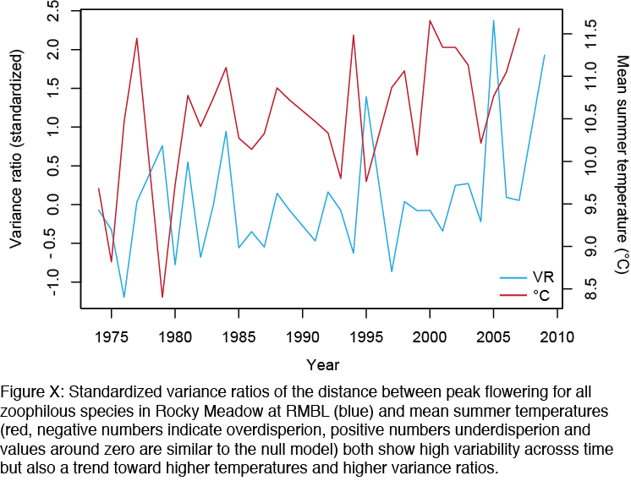
Additional traits, however, may play a role in shaping flowering phenology. Seed size may interact strongly with flowering time—as large seeds require sufficient time to grow each season and cannot easily be produced by species that flower at the end of the growing season (Mazer, 1989). Second, research suggests a fundamental trade-off where species with a trait syndrome of rapid return on investment traits (e.g. lower leaf mass area, lower C:N etc.) may also flower early while the reverse trait syndrome is predicted for species flowering later (Craine et al., 2012; Wolkovich et al., 2014). Additionally, for systems with a significant drought period some species may only flower before or after the drought, depending on their drought tolerance (Craine et al., 2012). If phenology is constrained by these other traits than it follows that:
Prediction 2 – Flowering phenology will be strongly correlated with other major plant traits and will show underdispersion such that flowering times will be similar among species with shared traits. (Meh? )
Alternatively, if phenology is not tied strongly to other traits nor under selection to maximize pollinator access it may drift with evolution (Lechowicz, 1984) or be structured simply by stochastic forces. Under these two scenarios:
Prediction 3 – Over or underdisperion of flowering phenology would be predicted by the phylogenetic relatedness of the particular community (SuggestCitations).
Note that this prediction assumes phylogenetic conservatism of flowering phenology, which to date has been found to be weak (Davies et al., 2013b), especially in the proposed community of study (Davies et al., 2013b; CaraDonna and Inouye, 2014).
Prediction 4 – Flowering phenology would be random with respect to its distribution across the growing season.
Next comes the question of how climate change may impact phenological assembly. Recent work suggests the environment may drive the degree to which communities are structured by niche versus neutral forces. In one example, communities in ‘harsh’ environments appear governed more by niche forces after some time (Chase, 2007), thus predictions with climate change would depend upon the exact local nature of climate change and the community. However, predictions based on niche theory (via pollinators or other related traits, predictions 1-2) implicitly assume some level of equilibrium conditions—as they assume phenology has been shaped by long-term dyanmics of pollinators and the environment. Thus, I predict that:
Prediction 5 – Climate change should shift the flowering phenology towards more random assembly.
Methods: I propose to test predictions using David Inouye’s 38 year dataset (1974-2014, no data collected in 1978 or 1990) of flowering phenology from the Rocky Mountain Biological Lab in Gothic, Colorado. The dataset records flowering phenology in 2 x 2 m plots distributed across a variety of habitats including date of observations (with observations generally every other day throughout the growing season) and total number of flowers or flowering inflorescences. Number of individuals is not currently available though as part of the proposed work I will work with programmers to attempt to extract this information which are generally embedded in the original Excel workbook cells’ formulas. For this analysis I plan to focus on the ‘Rocky Meadow’ and ‘Wet Meadow’ plots as they represent the longest term data and two distinct habitats.
Climate data include long term precipitation and temperature data from the local Crested Butte National Oceanic and Atmosphere Administration weather station and measure of snowmelt date each year noted each year by Billy Barr. Working with students from the Summer Institute (see below) I also plan to create back-projected weather data for the ‘Rocky Meadow’ and ‘Wet Meadow’ areas by using data from Crested Butte and plot-level data collected by David Inouye over several years.
Pollinator and other additional trait data will be collected through two means. To assign pollinators to plant species I plan to draw on available data on bee species local to the Inouye plots from Dr. Becky Irwin who has been collecting data for five years and Dr. Berry Brosi who has been collecting data on bees and their plant networks at RMBL. Next, over two summers a postdoctoral fellow and several undergraduate students will collect pollinator data from ‘Rocky Meadow’ and ‘Wet Meadow’ plots including overall pollinator estimated visitation rates and identification of pollinators (when possible) via catch and release. These researchers will also collect needed data on seed mass, metrics of tissue return on investment (Perez-Harguindeguy et al., 2013) in the ‘Rocky Meadow’ and ‘Wet Meadow’ plots. We plan to collect data from at least 10 individuals of each species adjacent but not in plots with species collected from both habitats if present in both.
To test predictions for the dispersion of flowering phenology I will build null models. Traditional null model methods are often use mean trait values (e.g. see Fig InDevelopment), while in contrast theory considers the full trait space occupied. The Inouye dataset is very rare among long-term phenology datasets because it includes data on number of flowers produced every other day, this should allow estimates of species’ full phenological niches year to year. Total overlaps among these curves (see figure) will then be estimated for each plot and compared to predictions from two overarching null models.
I propose two null models that test for community dispersion (1) given the resident community of a plot and (2) given the regional species pool. While many null models are possible for these data I believe these two bracket the two most important extremes. The first null model is akin to a mid-domain model of the growing season (Morales et al., 2005). This model will thus test if communities appear random or overdispersed at the plot level given the established species composition. The next null model will examine community dispersion compared to the regional species pool (SuggestCitations? ). For this I will consider all species from both the ‘Rocky Meadow’ and ‘Wet Meadow’ areas as the regional species pool. The phenological curve for each species each year to be used in the null model will be calculated by (1) first caculating the curve for each species within each habitat (across all plots), then (2) averaging the two curves for species present across both habitats. With these curves in hand each plot’s null model will be determined each year by repeated random draws from the regional species pool based on the total number of species present per plot. These two overaching models will be adjusted to test specific predictions: for example, they may be repeated using only species that share pollinators and I will control for varying numbers of plots across years and habitats.
Analyzing results of the null model tests will lead to several statistical challenges, but also the opportunity to refine null models and develop our methods to consider them in their increasing complexity. It will require a high number of tests and thus care and continual re-evaulation of the best approach to robustly comparing the full suite of predictions will be taken. Currently, I plan to consider plots as replicates within habitats, though I will also examine variance among plots within habitats. I plan to use habitat and year as the main predictor variables—and with support of students in the Statistical Institute will narrow climate variables to 2-3 that best describe variation across space and time. I plan to use resampling and Monte-Carlo methods to examine effects. An additional challenge may be applying null models to separate suites of species that share pollinators—as some sets of species with a shared pollinator may be quite small. I hope the measurement of full phenological curve overlap (versus simple means) and the plot-level replication will provide some statistical leverage for this issue but I also plan to look for creative approaches. In the end this is a fundamental issue in assessing limiting similarity as at the appropriate level each species shoud be alone with its particular set of traits thus tackling this challenge is an important part of the project.
Links to educational goals: This project will benefit from support by one postdoctoral fellow, 3-4 undergraduate researchers and the efforts of all the students of the Statistical Institute. The postdoctoral fellow will work for 28 months that will encompass three summer field seasons in RMBL. The first year will be devoted to training on the plants and pollinators and pilot work; undergraduate researchers will join the following year and data collection will begin in earnest. I will work closely with all these researchers to define the full scope of the project and will travel with them to Gothic, Colorado to work on the project with collaborator Dr. Inouye. Students from the Statistical Institute will (1) develop methods to back-estimate habitat level climate data and (2) will help narrow the list of climatic factors to 2-3 primary, possible aggregate, measures that best describe variation across years and habitats.
Preliminary results: Preliminary results using a simple method of variance ratios across peak flowering dates show overall evidence of weak overdisperion in ‘Rocky Meadow’ (standardized variance ratio mean ± SD: −0.13±0.75) and ‘Wet Meadow’ (−0.20±0.85) but high variability across years and habitats (see Fig. X for one example). This variability appears possibly related to shifts in climate (Fig. X) and preliminary analyses suggest communities may shift from moderate overdispersion and towards more random or clumped dispersion in extreme climate years.
Expected outcomes & significance: Understanding how niche and neutral processes may structure the phenological diversity of plant communities—and how these processes may shift with climate change—has profound implications for predicting future community and ecosystem responses, as well as fundamental repercussions for basic ecology. The proposed work will test a basic premise of the role of phenology in structuring a plant’s temporal niche but will also test whether climate change fundamentally disrupts any niche structuring. Given these results it should be possible to determine how well we may be able to predict future plant communities at RMBL under continuing climate change. Further, the new methods developed and applied to the RMBL plant community should be applicable to other systems and hopefully spur more studies of how assembly itself is altered by climate change.

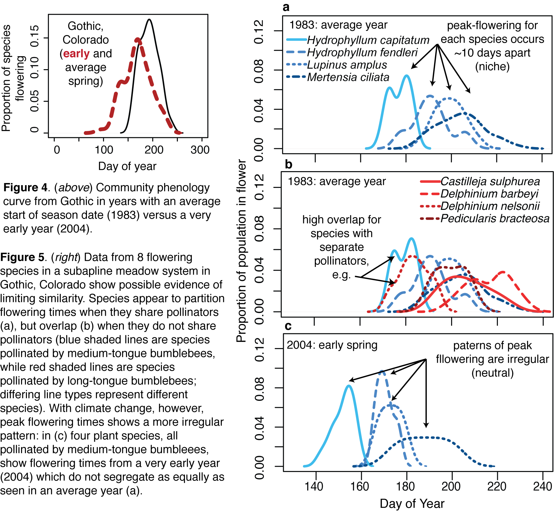

D. A storage effect model for the Anthropocene
Introduction: Predicting community shifts with climate change requires fundamental appreciation of the diverse mechanisms that govern how communities assemble—within any community varying forces may be at play for different species or subsets of species (MacArthur, 1958). Thus a complete view of community assembly through the lens of phenology and climate change requires consideration, integration and development of several major models. My above-work will examine two major mechanisms: neutrality and niche, with a major focus on testing for evidence of within-year temporal niches via phenology. A species’ temporal niche, however, may also occur across timescales much longer than a year. This is considered in another major mechanism by which species may co-exist—one with an intrinsically temporal focus—the storage effect (Chesson and Huntly, 1997). Under this model highly similar species coexist via small differences in how they respond to temporal variability in the environment.
The storage effect model has found increasing support in recent years (Angert et al., 2009; Levine and HilleRisLambers, 2009), suggesting it may be an important mechanism underlying how communities assemble, however, the model rests on one major assumption that is violated in most environments: it assumes a stationary environment. Climate change has shifted most systems to nonstationary climate dynamics (Stocker et al., 2013; Knutti and Sedlacek, 2013). Thus, understanding how communities may assemble via the storage effect requires extending the model to nonstationary environments, then examining how communities assemble via the model under stationary and nonstationary environments. Importantly, as climate in many regions of the globe was relatively stationary for thousands of years until recent climate change (Stocker et al., 2013), such an extension of the model allows testing how communities built on coexistence via variable environments respond when the environment switches from stationary to nonstationary.
I will develop theory for and build a new version of the storage effect model to predict how communities will respond to climate change. The model will include both within-year (via an R* model) and between year dynamics, thus including possibilities for species coexistence via within-year niche and storage effect mechanisms and one other mechanism for species coexistence based on variable environments—relative nonlinearity. I plan to focus on both (1) abiotic drivers that shape the environment, including shifts in climate variability and extreme events that link to stabilizing coexistence mechanisms (Figure 6), and (2) species’ traits that may make species more or less vulnerable to local extinction with climate change.
In addition to examining how coexistence shifts under nonstationary climate regimes, I will also build the model to include phenology via phenological tracking. Specifically, the model will include a way to allow certain species to shift their germination timings to track the environment each year. A number of recent empirical studies have found that the species that phenologically track climate change most closely also appear to increase in abundance (Cleland et al., 2012; Wolkovich et al., 2013), while species that do not phenologically shift with climate change may go locally extinct (Willis et al., 2008). Yet there is little current theory to test under what environmental regimes phenological tracking may be favored. Thus, this model will provide a major way to test the role of phenological tracking in assembling plant communities, by allowing studies of how a species’ level of phenological tracking impacts its coexistence and abundance under varying environmental regimes.

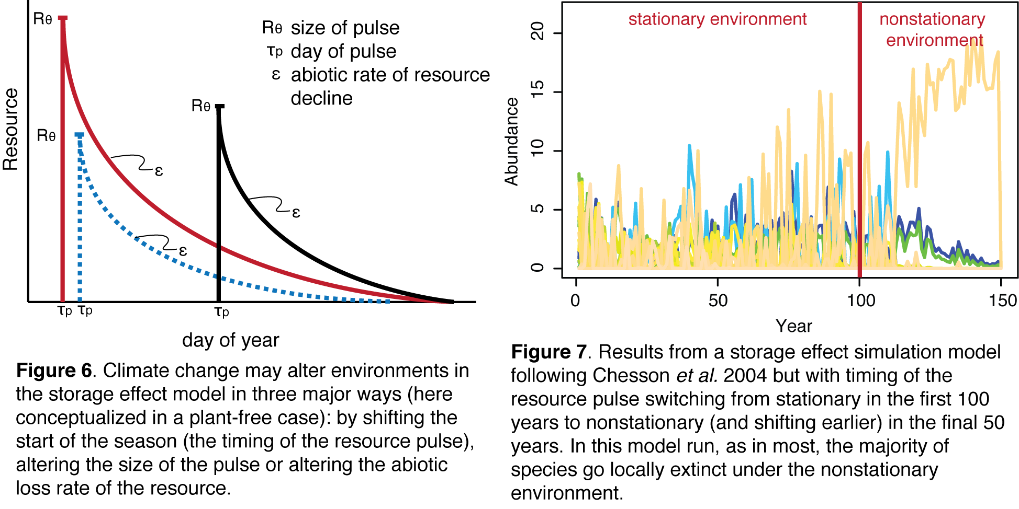
Plan of work: I propose to build a version of the storage effect model that merges within-year dynamics—thus allowing integration of phenological tracking into the model—with between-year dynamics, thus allowing studies of how the storage effect functions in nonstationary environments. Within-year dynamics will be based on R* coexistence (following Chesson et al., 2004). As I propose two major new extensions of the storage effect model—extending the model to a nonstationary environment and adding phenological tracking—I have already begun work on this project to show proof of concept. In consultation with Dr. Donahue (see letter of support), I developed the basic suite of equations which can be adapted to n species and have begun to examine the model with an environment that switches from stationary to nonstationary (Figure 7).
Building from this pilot model to a full model incorporating nonstationary dynamics and phenological tracking requires extensive further work. Critically, it requires examining how model assumptions are affected by a nonstationary environment and how the model functions under such an environment compared to the stationary environment all other studies of the storage effect have assumed. It also requires calculations of the three coexistence mechanisms encapsulated in the model (within-season niche, storage effect and relative nonlinearity) and studies of how they shift with a changing environment. While analytical solutions of these models are not possible I do plan to provide equations to calculate these three mechanisms based on the full suite of equations. Additionally, I plan a suite of studies to examine, and understand, what species traits are favored under a changing environment. Related to this, much work is required to successfully incorporate phenological tracking into the model and test under what environment tracking is favored.
Finally, because my goal is to catalyze further research with this modeling approach towards validation and prediction I plan to parameterize the model robustly, and transparently. Full parameterization of the model is a complex challenge as the model requires linking data on the environment, germination rates and curves, and R* metrics. Thus, I plan to compile all available data to inform parameterization whenever possible and when not possible I will highlight these gaps and test in the model a large range of parameter space to understand how such missing data impacts model outcomes. For all climate change scenarios that I use I will make simulations realistic by using existing data to identify which environmental variables have and will most likely change (e.g., Figure 6) and I will use actual projections to bracket my simulations.
Expected outcomes & significance: I believe this project will start a major shift in how ecologists think about coexistence via environmental variability—by introducing nonstationarity into models where stationarity has always been previously assumed. While climate change represents one major and recent example of such nonstationarity, the paleorecord shows that many ecosystems have appeared nonstationary over timescales relevant to community assembly (e.g., Jackson et al., 2009; Cook et al., 2010). I believe robust coexistence theory thus must embrace nonstationarity. In addition this project will demonstrate and stress how to connect climate change projections to coexistence modeling. Finally, I expect this project will highlight a number of previously un- or under-recognized assumptions and highlight data needs to build models that may usefully project community shifts with climate change. Related to this, all R code for the model and all climate change scenarios used for simulations will be made public to encourage other researchers to build upon the work.
Links to educational goals: I currently feature the concept of how temporal variability in the environment may produce coexistence in my major public outreach lecture (The Race for Spring: How climate change alters plant communities). Using examples from several sites I introduce the concept of how species may coexist through time to produce diverse communities and build this into a discussion of climate variability and climate change. Thus I expect this project to be a major foundational part of my future public outreach talks, including a new series of public lectures I plan to develop where I explain both climate projections and introduce my results as a starting point for building ecological projections at the community-level.
III. Project components: Cross-component educational goals

A. Overview
In addition to the educational goals embedded in the research projects described above I propose several major educational components that cut across the proposed projects and build on my desire to develop a new approach to temporal ecology and to educating the public on climate change. The proposed activities below also build on unique attributes of my home organization—the Arnold Arboretum—which provides special opportunities to run intensive short courses and to reach a diverse public audience. In addition I plan to leverage outreach opportunities through the Arboretum’s regular programs: I and the postdoctoral researchers will lead tours at the Arboretum, which are often requested by local schools, colleges and groups, lead Tree Mobs (this is a type of outdoor informal lecture given at a particular tree in the Arboretum, the tree can be discussed in depth or used simply as a launching off point for the lecture) and give public evening lectures as part of the regular Arboretum series or those related to specific events (e.g., the Cambridge Science Festival).
B. Academic year teaching in statistics & conservation
Over the next five years I will teach and develop three new courses in my department. Statistics for Biology, the basic statistical course offered, aims to provide foundational knowledge for graduate and undergraduate students. This fall I am teaming up with Professor John Wakeley to develop the course—it will include foundations in probability theory, emphasize the interaction between statistics and experimental design and teach the R programming language. This fall I am also launching a seminar course in Modern Conservation Biology, that will examine what are the foundational and contemporary concepts and literature of conservation biology—over the next three years I plan to develop this into a undergraduate interactive lecture course with an emphasis on spatial and temporal ecology in conservation.
C. Summer institute: Analytical methods in modern temporal ecology
A major component of my proposed program is to develop a three-week summer training course in temporal ecology. I believe moving forward in climate change research, as well as other areas of global change ecology where humans have modified the temporal dynamics of ecosystems, requires a major shift in the foundational training of ecologists in time, especially its unique statistical properties. Most students in ecology that I have worked with have at most used a repeated-measures ANOVA and have only a loose understanding of the common, and statistically important attributes of time-series data: their usual violation of independence assumptions because of autocorrelation, which can appear as cycles, trends and some colors of noise. Such trends also bring up the issue of stationarity (Figure 1) which is a major assumption of most statistical analyses and even most time-series approaches.
As time-series are now a major type of ecological data, and are an extremely prevalent type of data in climate change ecology, the average ecologist is now routinely challenged to work with both ecological and climatological time-series. I propose to train a new generation of ecologists in time-series methods with a special emphasis on ecological and climate data and on models that can accommodate nonstationarity. The course will include a basic introduction to time series focused on autocorrelation—cycles, trends, red and blue noise; basic classes of autoregressive models and their assumptions; modeling autocorrelation and non-stationarity; wavelet and cross-wavelet analyses; climate data: where to find it, re-use policies and important attributes (seasonal variation etc.); handling data of varying temporal scales (e.g., hourly climate data and weekly ecological data); data management of time-series data: metadata, scripting of cleaning and publication. The course will be open to students (maximum of 15 each year, drawn from across the country following information on the course and application process being posted on Ecolog and related listservs) from the early years of graduate school through to those within one year of their PhDs and will include lectures and hands-on training in R. I will teach all courses with guest lectures from 1-2 local colleagues and one guest lecturer each year, who will visit for 3-5 days, to cover special topics (e.g., my colleague Ben Cook, a climatologist, may visit to discuss climate data and wavelet methods). I will assess the impact of the course by evaluations before and after the course to gauge what students learned; I will additionally use these assessments to guide what to teach at conference workshops on time-series methods (see D immediately below).
D. Annual workshop: Analytical methods in modern temporal ecology
I plan to extend the number of students reached beyond those trained in my course by linking the course to a workshop at an annual ecological conference (expected to be the annual Ecological Society of America summer meeting). Each year 3 students from the course will be selected to lead an ESA workshop the year following their course on one topic the students found most relevant. I and a postdoctoral fellow will work with students the 3 months before the conference to organize materials and will attend the workshop as assistants both years. I will again gauge success of the course by evaluations of knowledge before and after the workshop.

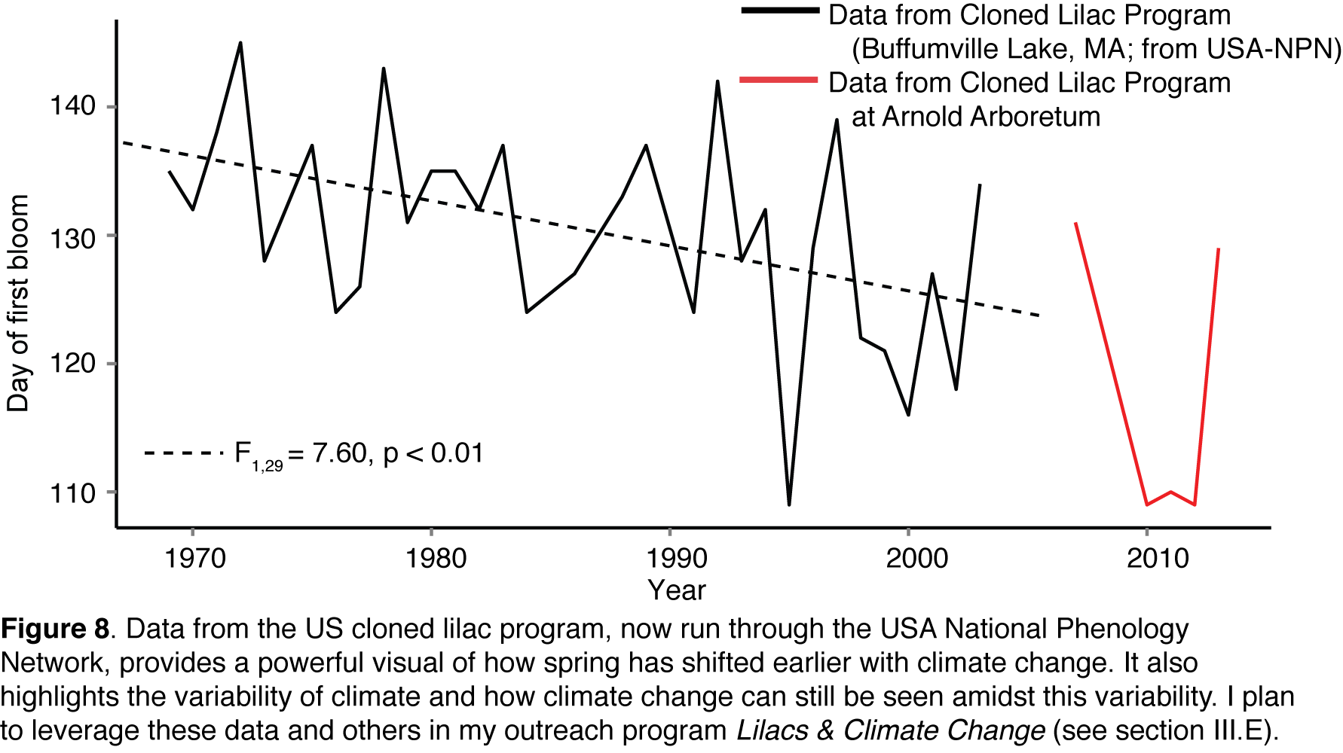
E. Lilacs & climate change: Outreach at Arnold Arboretum
My lab is fortunate to be based at an institution focused both on research and on education of all sectors of the population. The Arnold Arboretum is an iconic outdoor space for residents of Boston with thousands of visitors each month. It has a tremendous diversity of outreach events through links with K-12 schools, colleges and universities and its adult education programs. Faculty, however, have only been based at the Arboretum for less than 3 years and the Arboretum is still working to best integrate its on-site research programs with its outreach programs.
I plan to capitalize on this new opportunity and meet a major outreach need of the Arboretum by building a new program about climate change around lilac (Syringa vulgaris) phenology and the Arboretum’s largest annual event—Lilac Sunday. Lilac Sunday is a spring event where the Arboretum celebrates its lilac collection. The event is always held on Mother’s Day in May, which previously has been during the usual period of peak bloom for the lilac collection. With climate change, however, the event now may fall well after peak bloom as lilac bloom dates march earlier and earlier. Across the US a major network of cloned lilacs established over 50 years ago has been a sentinel indicator of this march towards earlier springs with climate change (Schwartz and Reiter, 2000; Schwartz and Hanes, 2010). Since 2007 the Arboretum has joined this program—now based through the USA National Phenology Network (with which I have worked with since 2009)—contributing data (Figure 8) but has not publicized this program and has little information for visitors on climate change. I believe the combination of this record—combined with other local records from the lilac network (Figure 8) and the public interest in Lilac Sunday—provide a major opportunity to reach out to the public and educate them on climate change.
I will launch a new program on climate change with several major components. The first component will be an outreach exhibit on climate change as seen through lilac phenology with links to impacts on wild plant species and communities (building on the Fitness & phenology project and my previous work), which will be based at the Arboretum’s Hunnewell Building Visitor Center from March to June of the three years where I will also have a major effort to reach the public on Lilac Sunday. I and one postdoctoral fellow will lead a team of undergraduates on developing materials and staffing the exhibit on Lilac Sunday. I also plan to develop a tour of the Arboretum focused on climate change that will visit various plants to understand climate variability and climate change and to introduce citizens to collecting their own phenology data at the Arboretum via the USA National Phenology Network’s Nature Notebook (see letter of support). A postdoctoral fellow and trained undergraduates will be available to help visitors get started with Nature’s Notebook each year of the exhibit. Success of the outreach program will be gauged by involvement in Nature’s Notebook based at the Arboretum and through paper surveys after tours and on Lilac Sunday.
IV. Timetable for major components

Table 1: Note: Light shading indicates year(s) when component will mainly occur.

Component | Year 1 | Year 2 | Year 3 | Year 4 | Year 5
Fitness & phenology research | blue! 35 | blue! 35 | blue! 35
Train postdoc researcher 1 |  | blue! 35 | blue! 35
Storage effect research | blue! 35 | blue! 35 | blue! 35
Summer institute |  |  | blue! 35 | blue! 35
Lilacs & climate change |  |  | blue! 35 | blue! 35 | blue! 35
Niches & neutrality research |  |  |  | blue! 35 | blue! 35
Train postdoc researcher 2 |  |  |  | blue! 35 | blue! 35
Summer conference workshop |  |  |  | blue! 35 | blue! 35
Train undergraduate researchers | blue! 35 | blue! 35 | blue! 35 | blue! 35 | blue! 35

References cited:
References
Abrams, P. A. 1980. Some comments on measuring niche overlap. Ecology 61:44–49.
Angert, A. L., T. E. Huxman, P. Chesson, and D. L. Venable. 2009. Functional tradeoffs determine species coexistence via the storage effect. Proceedings of the National Academy of Sciences of the United States of America 106:11641–11645.
Botes, C., S. D. Johnson, and R. A. Cowling. 2008. Coexistence of succulent tree aloes: partitioning of bird pollinators by floral traits and flowering phenology. Oikos 117:875–882.
Brody, A. K. 1997. Effects of pollinators, herbivores, and seed predators on flowering phenology. Ecology 78:1624–1631.
CaraDonna, P. J., A. M. Iler, and D. W. Inouye. 2014. Shifts in flowering phenology reshape a subalpine plant community. Proceedings of the National Academy of Sciences 111:4916–4921.
CaraDonna, P. J., and D. W. Inouye. 2014. Phenological responses to climate change do not exhibit phylogenetic signal in a subalpine plant community. Ecology 96:355–361.
Caswell, H. 1976. Community structure - neutral model analysis. Ecological Monographs 46:327–354.
Chase, J. M. 2007. Drought mediates the importance of stochastic community assembly. Proceedings of the National Academy of Sciences of the United States of America 104:17430–17434.
Chase, J. M., and J. A. Myers. 2011. Disentangling the importance of ecological niches from stochastic processes across scales. Philosophical Transactions of the Royal Society B-Biological Sciences 366:2351–2363.
Chesson, P., R. L. E. Gebauer, S. Schwinning, N. Huntly, K. Wiegand, M. S. K. Ernest, A. Sher, A. Novoplansky, and J. F. Weltzin. 2004. Resource pulses, species interactions, and diversity maintenance in arid and semi-arid environments. Oecologia 141:236–253.
Chesson, P., and N. Huntly. 1997. The roles of harsh and fluctuating conditions in the dynamics of ecological communities. American Naturalist 150:519–553.
Chuine, I., P. Yiou, N. Viovy, B. Seguin, V. Daux, and E. Le Roy Ladurie. 2004. Grape ripening as a past climate indicator. Nature 432:289–290.
Cleland, E. E., J. M. Allen, T. M. Crimmins, J. A. Dunne, S. Pau, S. E. Travers, E. S. Zavaleta, and E. M. Wolkovich. 2012. Phenological tracking enables positive species responses to climate change. Ecology 93:1765–1771.
Cole, B. J. 1981. Overlap, regularity, and flowering phenologies. American Naturalist 117:993–997.
Cook, B. I., E. M. Wolkovich, T. J. Davies, T. R. Ault, J. L. Betancourt, J. M. Allen, K. Bolmgren, E. E. Cleland, T. M. Crimmins, N. J. B. Kraft, L. T. Lancaster, S. J. Mazer, G. J. McCabe, B. J. McGill, C. Parmesan, S. Pau, J. Regetz, N. Salamin, M. D. Schwartz, and S. E. Travers. 2012a. Sensitivity of spring phenology to warming across temporal and spatial climate gradients in two independent databases. Ecosystems 15:1283–1294.
Cook, B. I., E. M. Wolkovich, and C. Parmesan. 2012b. Divergent responses to spring and winter warming drive community level flowering trends. Proceedings of the National Academy of Sciences of the United States of America 109:9000–9005.
Cook, E. R., R. Seager, R. R. Heim, R. S. Vose, C. Herweijer, and C. Woodhouse. 2010. Megadroughts in north america: placing ipcc projections of hydroclimatic change in a long-term palaeoclimate context. Journal of Quaternary Science 25:48–61.
Craine, J. M., E. M. Wolkovich, E. G. Towne, and S. W. Kembel. 2012. Flowering phenology as a functional trait in a tallgrass prairie. New Phytologist 193:673–682.
Davies, T. J., E. M. Wolkovich, N. J. B. Kraft, N. Salamin, J. M. Allen, T. R. Ault, J. L. Betancourt, K. Bolmgren, E. E. Cleland, B. I. Cook, T. M. Crimmins, S. J. Mazer, G. J. McCabe, S. Pau, J. Regetz, M. D. Schwartz, and S. E. Travers. 2013a. Generic level phylogenetic tree.
———. 2013b. Phylogenetic conservatism in plant phenology. Journal of Ecology 101:1520–1530.
Doak, D. 1989. Spotted owls and old growth logging in the Pacific Northwest. Conservation Biology 3:389–396.
Ellwood, M. D. F., A. Manica, and W. A. Foster. 2009. Stochastic and deterministic processes jointly structure tropical arthropod communities. Ecology Letters 12:277–284.
Fleming, T. H., and B. L. Partridge. 1984. On the analysis of phenological overlap. Oecologia 62:344–350.
Gilbert, B., and M. Lechowicz. 2004. Neutrality, niches, and dispersal in a temperate forest understory. Proceedings of the National Academy of Sciences 101:7651–7656.
Gleeson, S. K. 1981. Character displacement in flowering phenologies. Oecologia 51:294–295.
Gotelli, N. J., and G. R. Graves. 1996. The temporal niche. Pages 95–111 in N. J. Gotelli and G. R. Graves, eds. Null Models in Ecology. Smithsonian Institution, Washington, DC.
Hubbell, S. P. 2001. The Unified Neutral Theory of Biodiversity. Princeton University Press, Princeton.
Hutchinson, G. E. 1959. Homage to Santa-Rosalia or why are there so many kinds of animals. American Naturalist 93:145–159.
Hutchinson, G. E., and R. H. MacArthur. 1959. A theoretical ecological model of size distributions among species of animals. American Naturalist 93:117–125.
Inouye, D. W. 2008. Effects of climate change on phenology, frost damage, and floral abundance of montane wildflowers. Ecology 89:353–362.
Jackson, S. T., J. L. Betancourt, R. K. Booth, and S. T. Gray. 2009. Ecology and the ratchet of events: Climate variability, niche dimensions, and species distributions. Proceedings of the National Academy of Sciences of the United States of America 106:19685–19692.
Knutti, R., and J. Sedlacek. 2013. Robustness and uncertainties in the new CMIP5 climate model projections. Nature Climate Change 3:369–373.
Kraft, N. J. B., R. Valencia, and D. D. Ackerly. 2008. Functional traits and niche-based tree community assembly in an amazonian forest. Science 322:580–582.
Lechowicz, M. J. 1984. Why do temperate deciduous trees leaf out at different times - adaptation and ecology of forest communities. American Naturalist 124:821–842.
Legendre, P. 1993. Spatial autocorrelation - trouble or new paradigm. Ecology 74:1659–1673.
Levine, J. M., and J. HilleRisLambers. 2009. The importance of niches for the maintenance of species diversity. Nature 461:254–U130.
MacArthur, R. H. 1957. On the relative abundance of bird species. Proceedings of the National Academy of Sciences of the United States of America 43:293–295.
———. 1958. Population ecology of some warblers of northeastern coniferous forests. Ecology 39:599–619.
Mazer, S. J. 1989. Ecological, taxonomic, and life-history correlates of seed mass among Indiana dune angiosperms. Ecological Monographs 59:153–175.
Menzel, A., T. H. Sparks, N. Estrella, E. Koch, A. Aasa, R. Ahas, K. Alm-Kubler, P. Bissolli, O. Braslavska, A. Briede, F. M. Chmielewski, Z. Crepinsek, Y. Curnel, A. Dahl, C. Defila, A. Donnelly, Y. Filella, K. Jatcza, F. Mage, A. Mestre, O. Nordli, J. Penuelas, P. Pirinen, V. Remisova, H. Scheifinger, M. Striz, A. Susnik, A. J. H. Van Vliet, F. E. Wielgolaski, S. Zach, and A. Zust. 2006. European phenological response to climate change matches the warming pattern. Global Change Biology 12:1969–1976.
Morales, M. A., G. J. Dodge, and D. W. Inouye. 2005. A phenological mid-domain effect in flowering diversity. Oecologia 142:83–89.
Pau, S., E. M. Wolkovich, B. I. Cook, T. J. Davies, N. J. B. Kraft, K. Bolmgren, J. L. Betancourt, and E. E. Cleland. 2011. Predicting phenology by integrating ecology, evolution and climate science. Global Change Biology 17:3633–3643.
Pau, S., E. M. Wolkovich, B. I. Cook, C. J. Nytch, J. Regetz, J. K. Zimmerman, and S. J. Wright. 2013. Clouds and temperature drive dynamic changes in tropical flower production. Nature Climate Change 3:838–842.
Perez-Harguindeguy, N., S. Diaz, E. Garnier, S. Lavorel, H. Poorter, P. Jaureguiberry, M. S. Bret-Harte, W. K. Cornwell, J. M. Craine, D. E. Gurvich, C. Urcelay, E. J. Veneklaas, P. B. Reich, L. Poorter, I. J. Wright, P. Ray, L. Enrico, J. G. Pausas, A. C. de Vos, N. Buchmann, G. Funes, F. Quetier, J. G. Hodgson, K. Thompson, H. D. Morgan, H. ter Steege, M. G. A. van der Heijden, L. Sack, B. Blonder, P. Poschlod, M. V. Vaieretti, G. Conti, A. C. Staver, S. Aquino, and J. H. C. Cornelissen. 2013. New handbook for standardised measurement of plant functional traits worldwide. Australian Journal of Botany 61:167–234.
Rathcke, B. 1988. Flowering phenologies in a shrub community - competition and constraints. Journal of Ecology 76:975–994.
Schwartz, M., and B. Reiter. 2000. Changes in North American spring. International Journal of Climatology 20:929–932.
Schwartz, M. D., and J. M. Hanes. 2010. Continental-scale phenology: warming and chilling. International Journal of Climatology 30:1595–1598.
Soulé, M. E., A. C. Alberts, and D. T. Bolger. 1992. The effects of habitat fragmentation on chaparral plants and vertebrates. Oikos 63:39–47.
Stocker, T., D. Qin, and G. Platner. 2013. Climate change 2013: The physical science basis. Working Group I Contribution to the Fifth Assessment Report of the Intergovernmental Panel on Climate Change. Summary for Policymakers (IPCC, 2013) .
Terborgh, J., L. Lopez, P. Nunez, M. Rao, G. Shahabuddin, G. Orihuela, M. Riveros, R. Ascanio, G. H. Adler, T. D. Lambert, and L. Balbas. 2001. Ecological meltdown in predator-free forest fragments. Science 294:1923–1926.
Trenberth, K. E., and S. A. Josey. 2007. Observations: Surface and atmospheric climate change. Pages 235–336 in S. Solomon, D. Qin, M. Manning, Z. Chen, M. Marquis, K. B. Averyt, M. Tignor, and H. L. Miller, eds. Climate Change 2007: The Physical Science Basis: Contribution of Working Group I to the Fourth Assessment Report of the Intergovernmental Panel on Climate Change. IPCC, Cambridge, UK.
Turner, M. G. 1989. Landscape ecology - the effect of pattern on process. Annual Review of Ecology and Systematics 20:171–197.
Vergnon, R., N. K. Dulvy, and R. P. Freckleton. 2009. Niches versus neutrality: uncovering the drivers of diversity in a species-rich community. Ecology Letters 12:1079–1090.
Wainwright, C. E., E. M. Wolkovich, and E. E. Cleland. 2012. Seasonal priority effects: implications for invasion and restoration in a semi-arid system. Journal of Applied Ecology 49:234–241.
Watterson, G. A. 1974. Models for the logarithmic species abundance distribution. Theoretical Population Biology 6:217–250.
Willis, C. G., B. Ruhfel, R. B. Primack, A. J. Miller-Rushing, and C. C. Davis. 2008. Phylogenetic patterns of species loss in Thoreau’s woods are driven by climate change. Proceedings of the National Academy of Sciences of the United States of America 105:17029–17033.
Wolkovich, E. M., and E. E. Cleland. 2011. The phenology of plant invasions: A community ecology perspective. Frontiers in Ecology and the Environment 9:287–294.
———. 2014. Phenological niches and the future of invaded ecosystems with climate change. AoB Plants 6:plu013.
Wolkovich, E. M., B. I. Cook, J. M. Allen, T. M. Crimmins, J. L. Betancourt, S. E. Travers, S. Pau, J. Regetz, T. J. Davies, N. J. B. Kraft, T. R. Ault, K. Bolmgren, S. J. Mazer, G. J. McCabe, B. J. McGill, C. Parmesan, N. Salamin, M. D. Schwartz, and E. E. Cleland. 2012. Warming experiments underpredict plant phenological responses to climate change. Nature 485:494–497.
Wolkovich, E. M., B. I. Cook, and T. J. Davies. 2014. Progress towards an interdisciplinary science of plant phenology: building predictions across space, time and species diversity. New Phytologist 201:1156–1162.
Wolkovich, E. M., T. J. Davies, H. Schaefer, E. E. Cleland, B. I. Cook, S. E. Travers, C. G. Willis, and C. Davis. 2013. Temperature-dependent shifts in phenology contribute to the success of exotic species with climate change. American Journal of Botany 100:1407– 1421.
Wolkovich, E. M., S. Pau, B. I. Cook, T. J. Davies, N. J. B. Kraft, K. Bolmgren, J. L. Betancourt, and E. E. Cleland. in prep. Predicting phenology: Integrating climatology and evolution to im- prove forecasting in ecology. Global Change Biology .

