1 Early leafout extends calendar but not thermal growing seasons

2 D.M. Buonaiuto 1,2,3, C.J. Chamberlain 2,3,4, Deirdre Loughnan5, E.M. Wolkovich2,3,5

3 January 2, 2026

4 Author affiliations:

5 1Department of Plant Science and Landscape Architecture, University of Maryland, College Park, Maryland,

6 USA. ORCID: 0000-0003-4022-2591

7 2Arnold Arboretum of Harvard University, Boston, Massachusetts, USA.

8 3Department of Organismic and Evolutionary Biology, Harvard University, Cambridge, Massachusetts, USA

9 4The Nature Conservancy, Cat should add, USA

10 5Forest & Conservation Sciences, Faculty of Forestry, University of British Columbia, Vancouver, British

11 Columbia, Canada

12 aCorresponding author: 301.405.1061; dbuona@umd.edu

13

14 Abstract

15 Recent results suggest earlier leafout does not always increase plant growth, but have struggled to

16 explain why. Here, using rarely available plant-level phenology from a common garden of 13 woody

17 species, we show that earlier leafout leads to earlier growth cessation (budset), and thus longer but cooler

18 growing seasons, especially for early-leafing species. These results challenge fundamental assumptions

19 about calendar versus thermal growing seasons with implications for carbon models.

20 Terrestrial forests are a major mitigation pathway for climate change, sequestering 20% of greenhouse

21 gas emissions (1). Most models of climate change assume warming will drive longer seasons, more tree

22 growth and, thus, more carbon storage ( 1a), following decades of evidence from ecosystem-scale studies

23 (2; 3). However, recent findings from observations of individual trees have questioned this assumption

24 (4; 5). At the same time new experiments on saplings have suggested that plants may adjust their end of

25 season timing dynamically such that longer seasons do not increase total productivity ( 1b), though the

26 mechanism—and prevalence—of this effect is unclear (6; 7; 8).

27 These results suggest fundamental gaps in our understanding of how early-season events and the

28 environment of the growing season shape end-of-season events, but addressing these gaps requires working

29 across plant strategies (e.g., ruderal vs. competitive species) and varying definitions of a growing season.

30 The timing of leafout and senescence are critical components of plant growth strategies they vary strongly

31 across species (9). Within species, populations also vary (10), especially because end-of-season events are

32 usually locally adapted

33 (e.g. budset 11; 12). Increasing evidence also suggests local climate may define narrow periods of

34 growth for many species, with most significant growth earlier in the growing season (8). These results

35 suggest the calendar growing season (i.e., the number of days between the start and end of the growing sea-

36 son) may be less informative to predicting growth than estimates that directly incorporate environmental

37 conditions (13).

38 The thermal growing season—a period of favorable meteorological conditions for plant growth (13)—

39 offers an alternative to the calendar growing season. It is widely used, most commonly in the metric of

40 growing degree days, as a temperature-derived measure of time that accumulates when temperatures are

41 above a certain minimal threshold (14; 15). Because plant photosynthetic rates increase with temperature

42 (16) the thermal growing season is mechanistically related to primary productivity, and thus may be a

43 better proxy than calendar time for relating growing season length to carbon gain. Yet we generally lack

44 plant-level phenological data for the start and end of season to examine how the calendar and thermal

45 seasons of species and populations compare across years.

46 Here, we use rarely available plant-level data from three years of a multi-species, multi-population

47 common garden to test how variation in start and end of season events drive shifts in calendar and

48 thermal growing seasons. Our results leverage phenological observations of leafout and growth cessation

49 (budset) at the individual tree-level to understand how growing seasons scale across populations, species

50 and communities, and may thus enhance our understanding of ecosystem measures to improve forecasting.

51 Across three years and 13 co-occurring species (Tab: 1) collected from four populations across a 3.5◦

52 latitudinal gradient (Figure S1), our common garden (located in Boston, Massachusetts) captured high

53 variation in the timing of both start (leafout) and end of season (budset) events (Figure S2). Result-

54 ing calendar and thermal growing seasons varied almost two-fold across individual trees (2.1x and 1.8x

55 respectively), with earlier leafout leading to longer calendar growing seasons (Figure 1c,d), as routinely

56 seen with anthropogenic climate change (17; 18).

57 Longer calendar growing seasons did not lead to higher thermal growing seasons, as generally assumed;

58 instead early calendar growing seasons led to lower—cooler—thermal growing seasons (Figure 1c,d, this

59 and other results were similar when we determined the growing season length with leaf coloration instead

60 of budset, Figure S3). This was driven by a relationship between leafout and budset at the individual level

61 combined with differences in thermal conditions of the early season during leafout and later in the season

62 during budset. When plants leafed out earlier in the spring they stopped growth (budset) earlier, but

63 the additional days of growth in the spring—when temperatures were cool—were rarely offset thermally

64 by the days lost in the later season to earlier budset, which occurred in warmer months (July-August,

65 Figure 2).

66 Differences between thermal and calendar growing seasons were strongest in the earlier-leafout species,

67 which leaf out during the coolest part of the spring (Figure 1-2). For later leafing species, earlier leafout

68 did not substantially reduce their thermal growing season, bit it also did not increase it—suggesting

69 thermal seasons do not increase with calendar growing seasons for any of our studied species. Species

70 was the a major predictor of variation in leafout and budset(σspecies days for leafout: 8.1,UI90[5.5, 11.6],

71 days for budset: 9.7, UI90[7, 13.6]).

72 These results suggest that some of the apparently conflicting recent findings of whether longer seasons

73 increase growth or productivity may be due to different scales of observation, including the different

74 species they integrate over. Our result that individual trees appear to accelerate their end of season

75 events with earlier start of season events supports other studies conducted on a small number of species

76 (using alternative metrics of senescence, 19; 6). Thus, we may expect that studies of individual trees

77 could find little relationship between earlier leafout and growth (20; 21; 6), which could be driven by

78 currently unstudied shifts in the thermal seasons. Additionally, because differences between thermal and

79 calendar growing seasons were species-dependent, previous findings may depend on the species studied

80 (20; 21). This cross-species variation likely scales up to affect ecosystem-level estimates, which generally

81 have one measure of the start of season—for the earliest leafout species—and one for the end of season,

82 likely capturing the later-leafout species.

83 Beyond species-level variation, we found high interannual variation in both leafout and budset. We

84 expected large differences across years in leafout (σyear : 10.7 days, UI90[4.9, 20.9], Figure S2b), because

85 it varies strongly with local climatic conditions—one of the reasons it is the most consistent biological

86 indicator of anthropogenic climate change (22). Similarly, we found little variation across populations in

87 leafout (σ_{population}: 0.6 days, UI₉₀[0, 1.8], Figure S2a). Yet our finding of 15 days of variation across

88 years in budset was surprising (σyear : 15 days, UI90[6.4, 30.8], Figure S2b) because budset is generally

89 thought to be strongly locally adapted and controlled by photoperiod, which does not vary year to year

90 (12; 10). We did find evidence of local adaptation (σ_{population}: 2.3 days, UI₉₀[0.4, 6.1], Figure S2a), with

91 populations from the site with the fewest frost free days (FFD, Figure S4) setting buds approximately

92 two days before the site with next fewest FFD. These differences, however, were weak (Figure S2a) and

93 7X and 4X smaller than the variation due to year and species (respectively) We observed similar patterns

94 with leaf coloration as the end of season phase (Figure S5).

95 The shift in budset with earlier leafout suggests a potential pathway to better understand and predict

96 ecosystem dynamics, given additional research. While most work on budset has stressed the role of

97 photoperiod (12), other studies have found evidence of temperature control (23; 24). Our results suggest

98 an additional potential role of leafout timing, which could be confounded with temperature. Teasing apart

99 these potential cues while also testing these relationships for other end of season events could help resolve

100 connections between start and end of season events with growth. While we found similar findings using

101 leaf coloring, there are many ways that plants transition from growth to dormancy each year (24)—with

102 different implications for carbon gain (13).

103 Our multi-species common garden study showed that earlier leafout does not extend their thermal

104 growing season—a proxy for potential carbon uptake period—despite extending the calendar growing

105 season. Given that photosynthesis is limited by cold temperatures in early spring, earlier leafout appears

106 to provide limited opportunity for substantial growth and may especially deprive early-leafing species from

107 fully using late-season warmth. While this may explain why multiple studies have failed to find correlations

108 between longer calendar seasons and increased plant growth (4; 5), it generates a new question of why

109 any species leafs out when thermal conditions are unfavorable. Varying light availability over the early

110 season combined with different plant strategies may alter this equation, however, potentially making this

111 a successful strategy for some species. Supporting this, we found understory species often showed the

112 strongest relationship, suggesting they leaf out in thermally poor conditions to maximize access to light

113 before the upper canopy closes.

114 The link between earlier leafout and lower thermal seasons was driven by variation across years at

115 the individual and species levels—scales that are not always well studied in phenology research (17).

116 While satellite observations can document intriguing trends (e.g., 8), observations that include far more

117 species at a finer scale are likely critical for mechanistic understanding. Sampling across species of different

118 leafout and growth strategies appears especially important, alongside studies of how different communities

119 and climates may shape the relationship between calendar and thermal growing seasons. Understanding

120 whether thermal responses are consistent across species with different strategies could also inform how the

121 thermal season varies over time and space, improving our ability to accurately model biological carbon

122 fluxes.

123 1 Figures

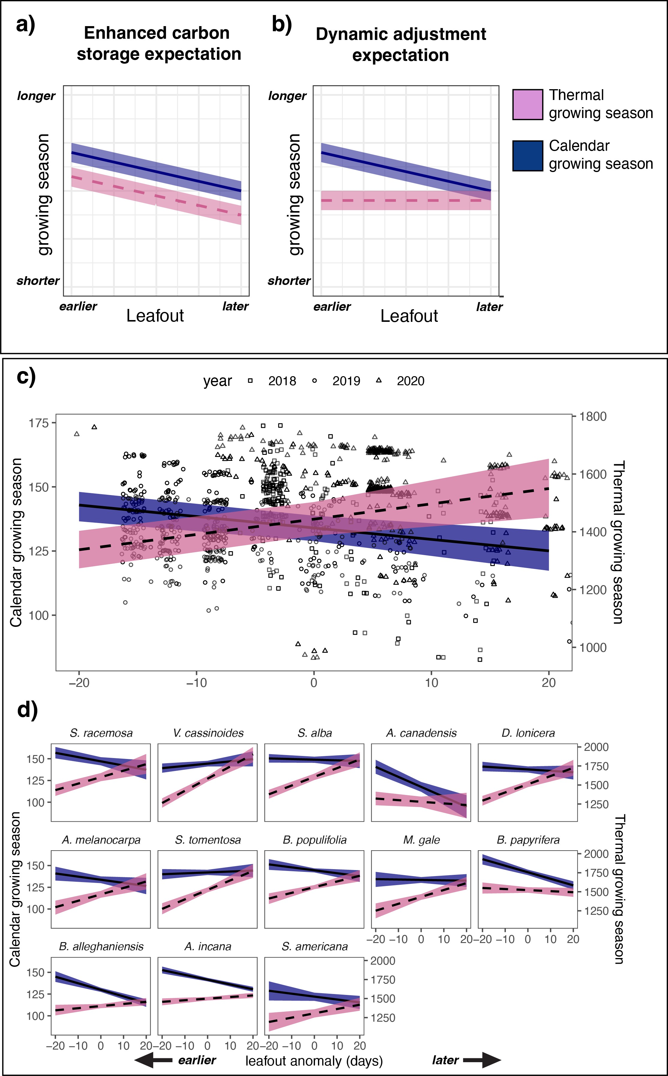

Figure 1: The relationship between leafout timing and growing season length differs between the calendar and the thermal growing seasons. Panels (a) and (b) conceptually demonstrate the expected relationships between leafout timing and both calendar and thermal growing seasons under two different expectations, with
(a) showing the expectation that longer seasons lead to increased carbon storage, while panel (b) shows the expectation that plant dynamically adjust the end of their growing season such that longer growing seasons do not increase carbon storage. In our study, later leafout resulted in a shorter calendar growing season (median estimated effect: -0.4 days, UI₉₀[−0.7, −0.2]) (c) and this pattern was consistent across species in our study
(d). In contrast, later leafout resulted in a longer thermal growing season (median estimates effect: 5.3 growing-degree days, UI₉₀[2.1, 8.4]) (d), an effect that was stronger for species that typically leafout earlier in the season—panels in (d) display in the typical order of leafout among species. The black trend lines represent the median effect of leafout timing on growing season length and shaded region 90% uncertainty intervals. Points in (c) represent the raw data (per individual tree per year).

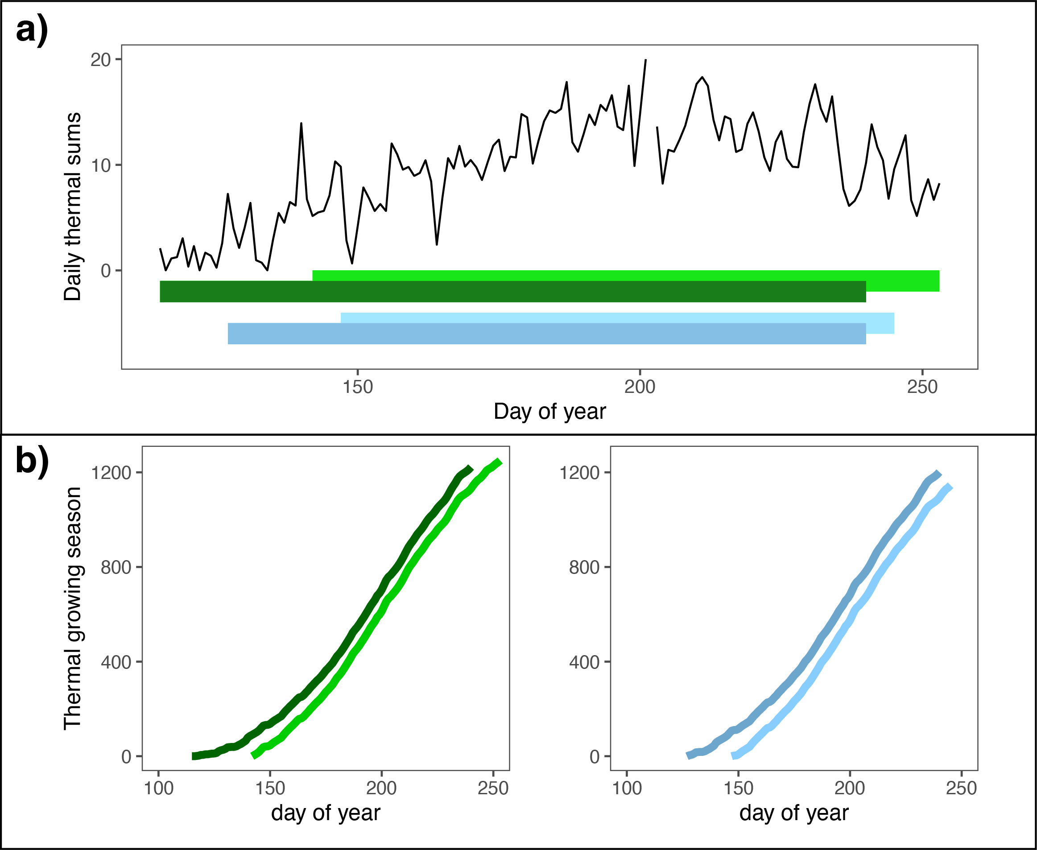

Figure 2: Varying thermal conditions across the calendar growing season combined with correlated leafout and budset can generate complex relationships between the calendar and thermal growing seasons. Panel a) depicts the daily heat sums from the location of a common garden in Boston (MA, USA) in 2019 and the calendar growing season of early and late leafing individuals within two species, one that leafs out earlier, Aronia melanocarpa (green bars) and one that leafs out later, Myrica gale (blue bars). Panel b) depicts the relationships between the calendar and thermal growing season for each of these individuals. Despite the earlier individual (dark green line) of Aronia melanocarpa having a 10 day longer growing season (by leafing out 28 days earlier and setting bud 18 days earlier) than the later leafing individual (light green line), it has a lower (cooler) thermal season because most of its early growth advantage takes place in the thermally unfavorable early spring. In contrast, for Myrica gale, both the early (dark blue) and later (light blue) individuals leaf out later in the spring, such that the 11 day longer calendar growing season (from a 15 day leafout and 4 day earlier budset) of the earlier individual results in only slightly warmer thermal season.

124 References

125 [1] Roe, S., Streck, C., Beach, R., Busch, J., Chapman, M., Daioglou, V., Deppermann, A., Doelman,

126 J., Emmet-Booth, J., Engelmann, J., Fricko, O., Frischmann, C., Funk, J., Grassi, G., Griscom, B.,

127 Havlik, P., Hanssen, S., Humpenöder, F., Landholm, D., Lomax, G., Lehmann, J., Mesnildrey, L.,

128 Nabuurs, G.-J., Popp, A., Rivard, C., Sanderman, J., Sohngen, B., Smith, P., Stehfest, E., Woolf,

129 D., and Lawrence, D. Land-based measures to mitigate climate change: Potential and feasibility by

130 country. Global Change Biology 27(23), 6025–6058 (2021).

131 [2] White, M. A., Running, S. W., and Thornton, P. E. The impact of growing-season length variability

132 on carbon assimilation and evapotranspiration over 88 years in the eastern us deciduous forest.

133 International Journal of Biometeorology 42(3), 139–145 (1999).

134 [3] Keenan, T. F., Gray, J., Friedl, M. A., Toomey, M., Bohrer, G., Hollinger, D. Y., Munger, J. W.,

135 O’Keefe, J., Schmid, H. P., Wing, I. S., Yang, B., and Richardson, A. D. Net carbon uptake has

136 increased through warming-induced changes in temperate forest phenology. Nature Climate Change

137 4(7), 598–604 (2014).

138 [4] Dow, C., Kim, A. Y., D’Orangeville, L., Gonzalez-Akre, E. B., Helcoski, R., Herrmann, V., Harley,

139 G. L., Maxwell, J. T., McGregor, I. R., McShea, W. J., et al. Warm springs alter timing but not

140 total growth of temperate deciduous trees. Nature 608(7923), 552–557 (2022).

141 [5] Silvestro, R., Zeng, Q., Buttò, V., Sylvain, J.-D., Drolet, G., Mencuccini, M., Thiffault, N., Yuan, S.,

142 and Rossi, S. A longer wood growing season does not lead to higher carbon sequestration. Scientific

143 reports 13(1), 4059 (2023).

144 [6] Zani, D., Crowther, T. W., Mo, L., Renner, S. S., and Zohner, C. M. Increased growing-season

145 productivity drives earlier autumn leaf senescence in temperate trees. Science 370(6520), 1066–1071

146 (2020).

147 [7] Norby, R. J. Comment on “increased growing-season productivity drives earlier autumn leaf senes-

148 cence in temperate trees”. Science 371(6533), eabg1438 (2021).

149 [8] Zohner, C. M., Mirzagholi, L., Renner, S. S., Mo, L., Rebindaine, D., Bucher, R., Palouš, D., Vitasse,

150 Y., Fu, Y. H., Stocker, B. D., and Crowther, T. W. Effect of climate warming on the timing of autumn

151 leaf senescence reverses after the summer solstice. Science 381(6653), eadf5098 (2023).

152 [9] Grime, J. P. Evidence for existence of 3 primary strategies in plants and its relevance to ecological

153 and evolutionary theory. American Naturalist 111(982), 1169–1194 (1977).

154 [10] Aitken, S. N. and Bemmels, J. B. Time to get moving: assisted gene flow of forest trees. Evol Appl

155 9(1), 271–90 (2016).

156 [11] Bauerle, W. L., Oren, R., Way, D. A., Qian, S. S., Stoy, P. C., Thornton, P. E., Bowden, J. D., Hoff-

157 man, F. M., and Reynolds, R. F. Photoperiodic regulation of the seasonal pattern of photosynthetic

158 capacity and the implications for carbon cycling. Proceedings of the National Academy of Sciences

159 109(22), 8612–8617 (2012).

160 [12] Soolanayakanahally, R. Y., Guy, R. D., Silim, S. N., and Song, M. Timing of photoperiodic com-

161 petency causes phenological mismatch in balsam poplar (populus balsamifera l.). Plant, cell &

162 environment 36(1), 116–127 (2013).

163 [13] Körner, C., Möhl, P., and Hiltbrunner, E. Four ways to define the growing season. Ecology Letters

164 26(8), 1277–1292 (2023).

165 [14] Chuine, I. A unified model for budburst of trees. Journal of Theoretical Biology 207(3), 337–347

166 (2000).

167 [15] Yang, S., Logan, J., and Coffey, D. L. Mathematical formulae for calculating the base temperature

168 for growing degree days. Agricultural and Forest Meteorology 74(1), 61–74 (1995).

169 [16] Farquhar, G. D., von Caemmerer, S., and Berry, J. A. A biochemical model of photosynthetic co2

170 assimilation in leaves of c3 species. Planta 149(1), 78–90 (1980).

171 [17] Menzel, A. and Fabian, P. Growing season extended in europe. Nature 397(6721), 659–659 (1999).

172 [18] Liu, B., Henderson, M., Zhang, Y., and Xu, M. Spatiotemporal change in china’s climatic growing

173 season: 1955–2000. Climatic Change 99(1), 93–118 (2010).

174 [19] Liu, Q., Fu, Y. H., Zhu, Z., Liu, Y., Liu, Z., Huang, M., Janssens, I. A., and Piao, S. Delayed autumn

175 phenology in the northern hemisphere is related to change in both climate and spring phenology.

176 Global Change Biology 22(11), 3702–3711, 2024/12/03 (2016).

177 [20] Cuny, H. E., Rathgeber, C. B., Lebourgeois, F., Fortin, M., and Fournier, M. Life strategies in

178 intra-annual dynamics of wood formation: example of three conifer species in a temperate forest in

179 north-east france. Tree physiology 32(5), 612–625 (2012).

180 [21] Michelot, A., Simard, S., Rathgeber, C., Dufrêne, E., and Damesin, C. Comparing the intra-annual

181 wood formation of three European species (Fagus sylvatica, Quercus petraea and Pinus sylvestris) as

182 related to leaf phenology and non-structural carbohydrate dynamics. Tree physiology 32(8), 1033–

183 1045 (2012).

184 [22] Pörtner, H. O., Roberts, D. C., Tignor, M., Poloczanska, E. S., Mintenbeck, K., Alegría, A., Craig,

185 M., Langsdorf, S., Löschke, S., Möller, V., Okem, A., and Rama, B. Climate Change 2022: Impacts,

186 Adaptation and Vulnerability. Contribution of Working Group II to the Sixth Assessment Report of

187 the Intergovernmental Panel on Climate Change. Cambridge University Press, (2022).

188 [23] Rohde, A., Bastien, C., Boerjan, W., and Thomas, S. Temperature signals contribute to the timing

189 of photoperiodic growth cessation and bud set in poplar. Tree Physiology 31(5), 472–482, 05 (2011).

190 [24] Michelson, I. H., Ingvarsson, P. K., Robinson, K. M., Edlund, E., Eriksson, M. E., Nilsson, O., and

191 Jansson, S. Autumn senescence in aspen is not triggered by day length. Physiologia Plantarum

192 162(1), 123–134 (2018).

