Elizabeth Perez

CMSC 204

Professor Monshi

11/9/2020

Assignment 4 Design Document

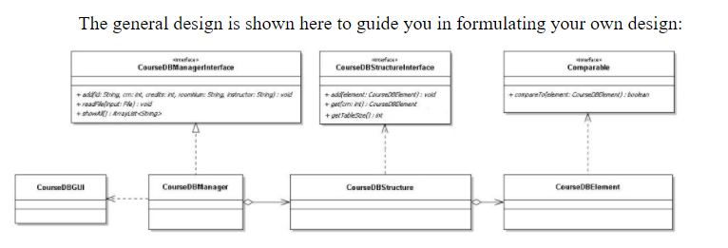

|  |
| --- |
| CourseDBElement |
| String id  int crn  int credits  String roomNum  String instructor |
| CourseDBElement(String courseID, int courseCRN, int courseCredits, String courseRoom, String courseInstructor)  Set id to courseID  Set crn to courseCRN  Set credits to courseCredits  Set roomNum to courseRoom  Set instructor to courseInstructor  compareTo(CourseDBElement element)  Declare and set an int called otherCRN to the element’s crn  If crn is equal to otherCRN  Return 0  Else If crn is greater than otherCRN  Return 1  Else  Return –1  hashCode()  Declare and set a String called key  Return hash code of key  getCRN()  Return crn  toString()  Declare and set a String called course to a String with the id, crn, credits, roomNum, and instructor  Return course |

|  |
| --- |
| CourseDBStructure |
| LinkedList<CourseDBElement>[] hashTable |
| CourseDBStructure(String test, int numOfCourses)  Initialize hashTable array with size numOfCourses  For i less than numOfCourses  Initialize the linked list at index i of the hashTable array  CourseDBStructure(int numOfCourses)  Initialize hashTable array with size numOfCourses  For i less than numOfCourses  Initialize the linked list at index i of the hashTable array  add(CourseDBElement element)  Declare and set an int called hashCode to the hashCode of element  Declare and set an int called index to hashCode modulo hashTable size  If linked list at index index of the hashTable is empty  Add element to the linked list at index index of the hashTable  Else  Declare and set a boolean called elementExists to false  For i less than linked list size at index index of the hashTable  If data at index of i the linked list at index index of the hashTable compared to element is 0  Set elementExists to true  If elementExists is false  Add element to the linked list at index index of the hashTable  get(int crn)  Declare and set a string called key to crn as a string  Declare and set an int called hashCode to the hashCode of key  Declare and set an int called index to hashCode modulo hashTable size  For i less than linked list size at index index of the hashTable  If data’s crn at index i of the linked list at index index of the hashTable equals crn  Return data at index i of the linked list at index index of the hashTable  Throw an IOException  getTableSize()  Return size of hashTable array |

|  |
| --- |
| CourseDBManager |
| CourseDBStructure courseDataStructure  int DEFAULT_SIZE = 10 |
| CourseDBManager()  Initialize courseDataStructure to size DEFAULT_SIZE  add(String id, int crn, int credits, String roomNum, String instructor)  Declare and initialize a CourseDBElement to element with id, crn, credits, roomNum, and instrucor  Add element to courseDataStructure  get(int crn)  Try  Return CourseDataStructure get function with crn  Catch exception  Handle exception  readFile(File input)  Try  Create a scanner to read input called reader  While reader has a next line  Declare a string called line and set to reader’s next line  Declare an array of strings called data with the separated info from line  Create a CourseDBElement called element with data  Add element to courseDataStructure  Catch file not found exception  showAll()  Declare and initialize an array list of CourseDBElements called courses  For i less than courseDataStructure getTableSize  If courseDataStructure’s hashTable at index i is not empty  For j less than size of linked list at index i of hashTable  Add element of linked list at index j at index i of hashTable to courses  Declare and initialize an array list of strings called list  For i less than courses size  Add the toString of element at index i of courses  Return list |