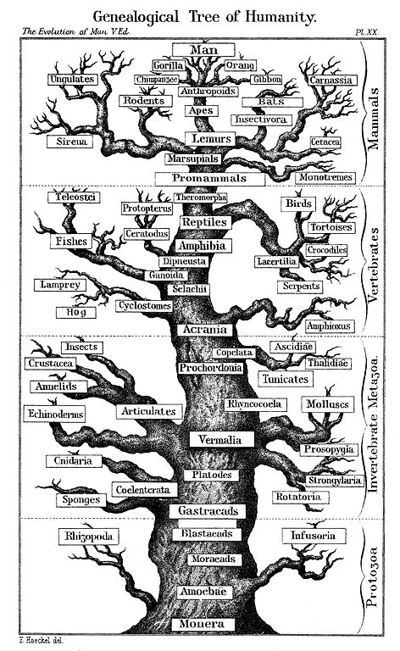**EVOLUTION FOR STUDENTS**

3447890760

123 Main ST, NY, NY, 11563

September 29, 2016

Stu Asser

Queens borough Community College

234st 56th Avenue

Bayside, NY 11364

Dear Mr. Asser,

My name is Elizabeth Perez, and I’m currently taking Biology 120 at QCC. I’m also a member of an organization that focuses on implementing and expanding evolutionary courses in two year colleges. The course Biology 120 is an evolutionary course that focuses on the evolution of man. The course is taught by Doctor Eugene Harris and it has been a very educational and entertaining course so far.

The only complaint I have is that the course teaches very general topics and doesn’t really go into detail about abstract evolutionary concepts. Hopefully this can change. The organization “Evolution for Students”, can help QCC set up a curriculum dedicated to the study of evolution. This way evolution can be taught through many different courses instead of trying to fit it all in one class. I hope you consider this recommendation.

Sincerely,

Elizabeth Perez