**THE JAZZICIANS**

*present the*

4th Annual Festival of *Jazz*

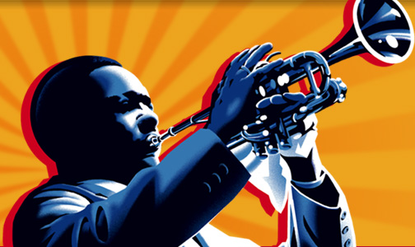

* Join us for a fun filled day of entertainment for the whole family.
* The fun starts at 10:00 a.m. and ends at 11:00 p.m. on **Saturday, October 14, 2012**, at Riverfront Park.
* Festival attractions include games, rides, food, crafts, and live music from the talented artists of The Brass Beat, Dave and the Hornets, and The Nance Lance Band.

Hope to see you there!