**MISSING DOG**

**Friendly and kind Great Dane is missing**

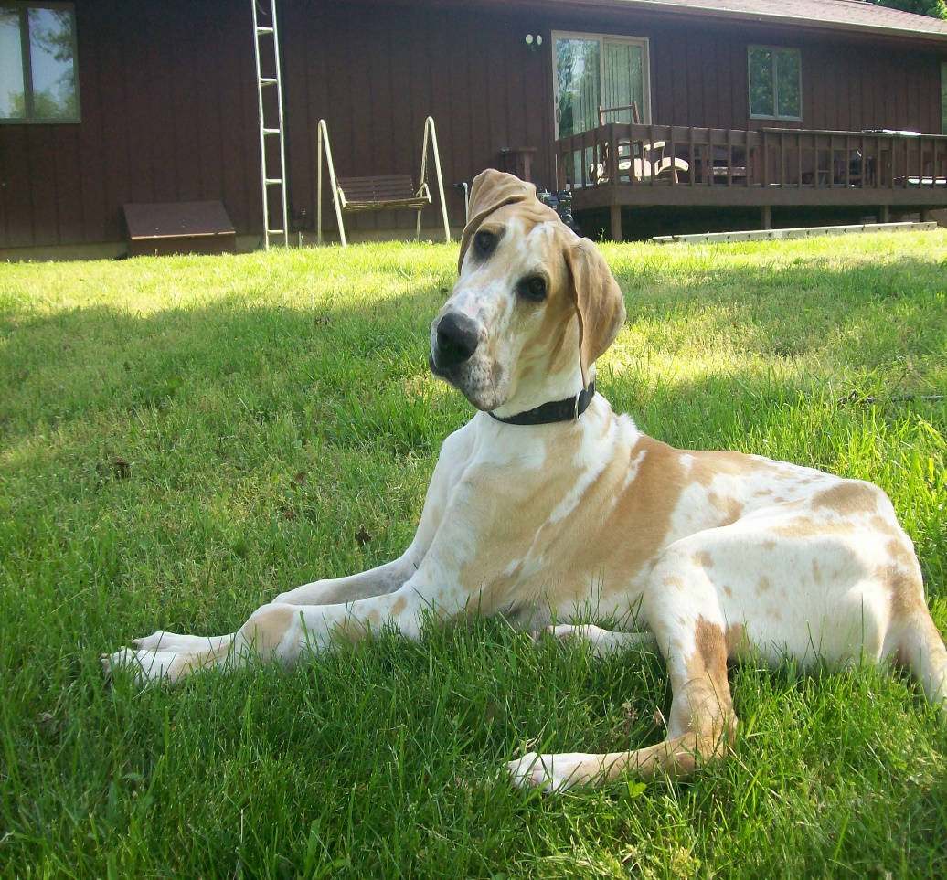

* Misty is a 3 year old Great Dane that was last seen on September 13th, 2016, around Main St
* Misty has a beige or tan coat
* Her favorite food is apples and peanut butter

If found or spotted please call **678-908-8766**

**Reward Offered**

*Your kindness is appreciated*