Data Analysis Reporting Template using MIDAS authoring tool

## Pretreatment of data:

## 

## Univariate Data Analysis

## 

## Unsupervised Analysis

## 

## Supervised Analysis

## 

## ROC Analysis

### Workflow Diagram of Pretreatment Phase of Data Analysis

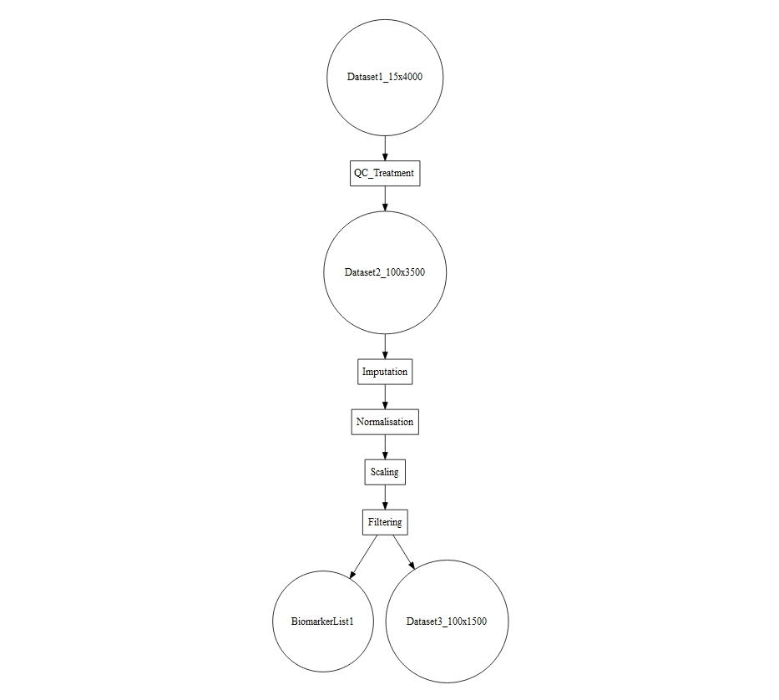

### Workflow Diagram of all major steps of the Data Analysis

