Lizzy Hanna

CSE 3342

Programming Languages

2/9/2019

Assignment 2

1. **Python Code:**

#turns word list into a dictionary of key, value pairs based on number of names

def word_freq(items):

dictionary ={}

for x in items:

if(dictionary.get(x) == None):

dictionary[x] = 1

else:

dictionary[x] = dictionary.get(x) + 1

return dictionary

#arranges dictionary from smallest to largest by value

def asc_word_freq(dictionary):

my_list = list(dictionary.items())

my_list.sort(key=lambda x: x[1])

return my_list

#arranges dictionary from largest to smallest by value

def desc_word_freq(dictionary):

dictionary.reverse()

print(dictionary)

return dictionary

#trims dictionary based on user input

def size_dict(dictionary, n):

if(n<0): #returns a blank dictionary if user gives a negative number

return []

#returns entire dictionary if user's number is longer than length of dictionary

elif(n > len(dictionary)):

return dictionary

else: #trims dictionary to desired length

i = 0

dict = []

for x in dictionary:

if i == n:

break

else:

dict.insert(i, dictionary[i])

i += 1

return dict

def main():

#list of words

items = ["Liam", "Mason", "William", "Noah", "William", "James", "Sophia","Logan", "Benjamin", "Mason", "Elijah", "Oliver", "Jacob", "Emma","Olivia", "Ava", "William", "Isabella", "Oliver", "Sophia", "Mia", "Charlotte", "Amelia", "William", "Evelyn", "Abigail", "Olivia", "Ava", "Mason", "Isabella", "Noah", "William", "James", "Olivia",

"Amelia", "Oliver", "William"]

#send to function that will turn list into dictionary by

#counting number of words in list

dictionary = word_freq(items)

print(dictionary)

#sorts by value lowest to highest

dictionary = asc_word_freq(dictionary)

print(dictionary)

#sorts by value highest to lowest

dictionary = desc_word_freq(dictionary)

print(dictionary)

#receives int n from user to determine length of dictionary

while True:

try:

n = int(input("Enter the number of terms to be displayed from the dictionary: "))

except ValueError: #if user enters something other than a number, ask again

print("Error: please enter a number.")

else:

#adjusts length of dictionary based on input

dictionary = size_dict(dictionary, n)

print(dictionary)

#runs main

if __name__ == "__main__":

main()

1. **Output:**

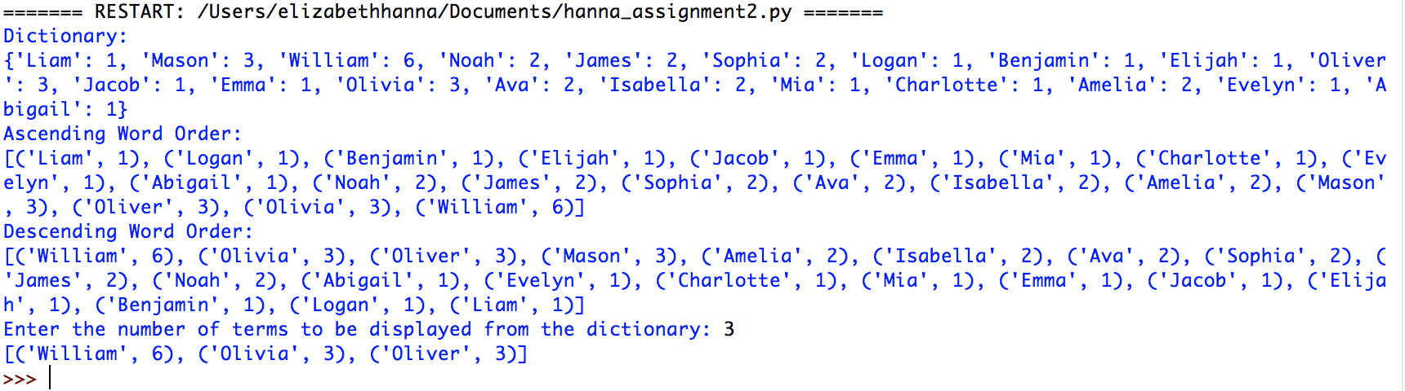

1. **Test Cases:**

* Test Case 1: n = 4



* Test Case 2: n = 250



* Test Case 3: n = -1



* Test Case 4: n = 0



* Test Case 5: n = ABC

