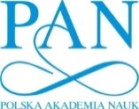RAN_En**XII International Symposium on Explosive Production of New Materials:**

**Science, Technology, Business, and Innovations**

**(EPNM-2014)**

**Cracow, Poland, May 2014**

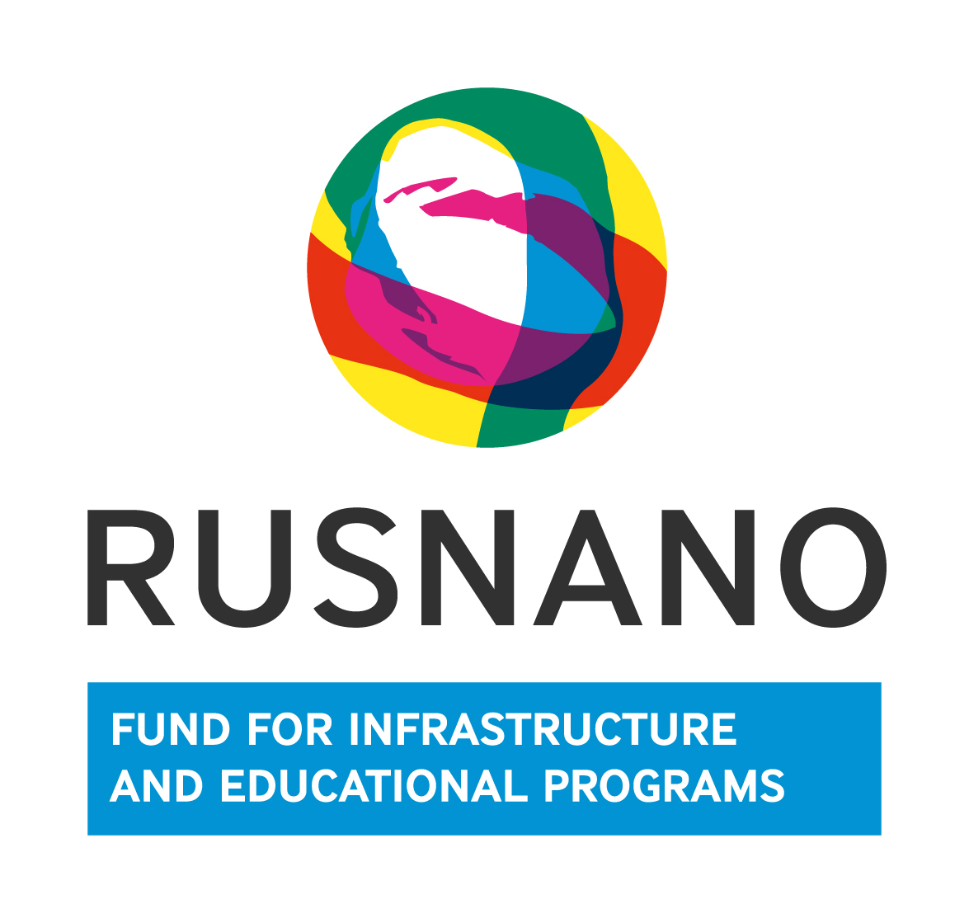

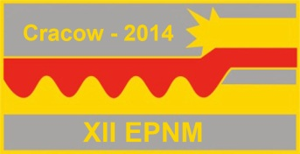

Dear Colleagues:

We are pleased to inform that the oncoming XII International Symposium on Explosive Production of New Materials: Science, Technology, Business, and Innovations (EPNM-2014) will be held on May 25–30, 2014 in Cracow, Poland.

The meeting will be organized by Institute of Structural Macrokinetics and Materials Science (ISMAN), Russia, and Institute of Metallurgy and Materials Science (IMIM), Poland in one of hotels in the historical city center.

Information concerning symposium history, scope, etc. can be found at our website:

<http://www.ism.ac.ru/events/EPNM2014/index_en.html>

The Organizing Committee of EPNM-2014 looks forward with a hope to see in Cracow the participants of previous Symposia held in Russia, the Netherlands, Montenegro, and France, and also the new members of the rallied international community active in the field.

Join us in Cracow to have fruitful discussion on the latest advance in the field of explosive production of materials aiming at establishing new and strengthening existing links between scientists and engineers from various countries.

We are looking forward to seeing you in Cracow!

Co-chairmen of Organizing Committee,

Prof. Mikhail ALYMOV Prof. Paweł ZIĘBA

All correspondence and queries should be addressed to

Mrs. Olga Likhanova

[likhanova@ism.ac.ru](mailto:likhanova@ism.ac.ru)

ISMAN, Chernogolovka, Moscow, 142432 Russia

Tel.: +7 496 52 46 475

Fax: +7 496 52 46 222